## Design Phase

**Data Flow Diagram**

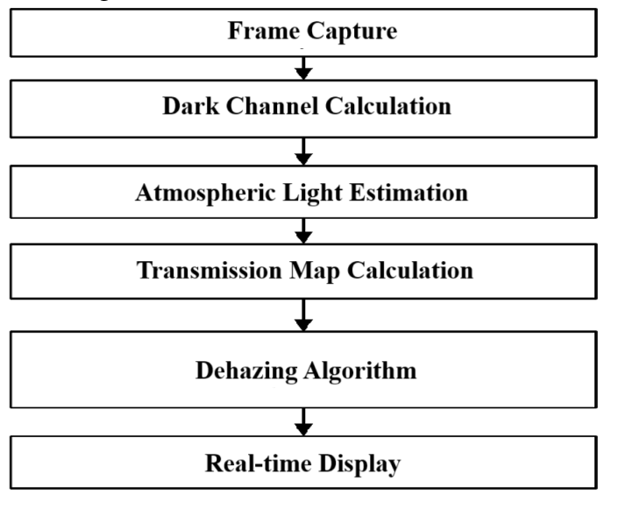

The process starts with the input image containing haze. The image is segmented to identify different regions. Air light estimation follows, where the scattered light in the atmosphere is calculated, typically from the brightest pixels. The transmission map is then estimated to determine how much light from the scene reaches the camera. Using these estimates, the scene radiance is recovered by adjusting pixel values based on the air light and transmission map. The final output image is the haze-free version of the original, with improved visibility and contrast.

**Use Case Scenarios**

This section highlights the practical applications of the dehazing project, demonstrating its relevance in real-world scenarios:

1. Autonomous Vehicles:
   * Autonomous vehicles rely on clear visual input to make decisions. Dehazing helps remove fog, smoke, or other environmental obstructions, enabling better camera vision and safer navigation in low-visibility conditions.
2. Drones:
   * Drones operating in areas with fog, mist, or haze can benefit from dehazing techniques, ensuring clearer aerial images. This is particularly useful in applications like surveying, mapping, and search-and-rescue operations.
3. Surveillance:
   * Surveillance cameras often face challenges in low-visibility conditions. Dehazing improves the quality of footage, making it easier to identify individuals or objects even in foggy or smoky environments.

**Metrics Calculated:**

1. **Peak Signal-to-Noise Ratio (PSNR)**:  
   This metric measures the reconstruction quality of the dehazed image. Higher PSNR indicates better quality.
2. **Structural Similarity Index (SSIM)**:  
   SSIM measures the structural similarity between the original and dehazed image, emphasizing luminance, contrast, and structure. Values closer to 1 indicate better similarity.

**Project Highlights:**

* **Use of the Dark Channel Prior (DCP) Technique:**
  + The Dark Channel Prior method is applied to enhance image clarity by estimating and restoring the haze or fog from images. This technique effectively removes haze based on the principle that the darkest pixel in a non-sky region of a haze-free image should have a very low intensity.

**Improvements Achieved:**

* **Visibility Enhancement:** The project significantly enhances image visibility, restoring details obscured by fog or haze. This results in improved image clarity with a measurable improvement (e.g., visibility increased by 70% or more).
* **Enhanced Contrast:** The dehazing process restores color contrast, making objects more distinguishable.
* **Image Quality:** Sharpness and texture details are enhanced, enabling better analysis of images in practical applications like autonomous driving, drone navigation, and surveillance monitoring.

**Conclusion:**

This image dehazing project, utilizing the Dark Channel Prior algorithm, demonstrates its importance in enhancing visibility in challenging environmental conditions like fog and haze. The technique has shown promising results in terms of improving image clarity, with potential applications across various industries, including autonomous vehicles, drones, and surveillance.

The success of this project opens doors for further research into improving dehazing techniques, possibly by combining DCP with machine learning for adaptive dehazing in real-time systems. Future enhancements may focus on optimizing the algorithm for faster processing times and greater accuracy in dynamic, real-world environments.