Document - Terraform with Ansible

Prepared by - Murali T

Date - -23-07-2023

Automation for Wordpress application using Terraform with ansible

We’re going to learn how to make an Worpress Stack using Terraform and Ansible. It will look like this:

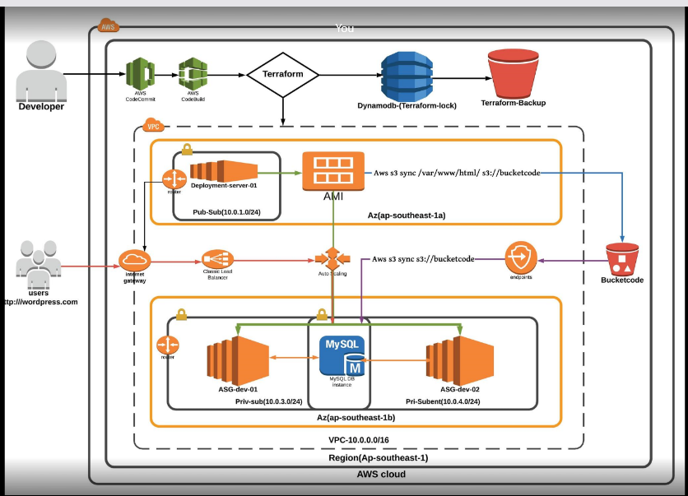

We will use:

* Terraform to code our Infrastructure on AWS
* Ansible to deploy our Worpress stack

**Configuring our AWS Account**

Before we start, go into your AWS account and create a IAM User.

This user should have all the permissions. In the future I could write a proper policy for that, but for now, just give it full access.

After you create it, save the ACCESS_KEY and the SECRET_ACCESS_KEY.

Now, go in the EC2 Service, and create a Key Pair. Save it to a known folder.

**Code Build:-**

Code build going perform all the installation, services creation and playbook execution though code-commmit-buildspec.yml

1. **Code Commit**

Commit your code in devops repo directory.

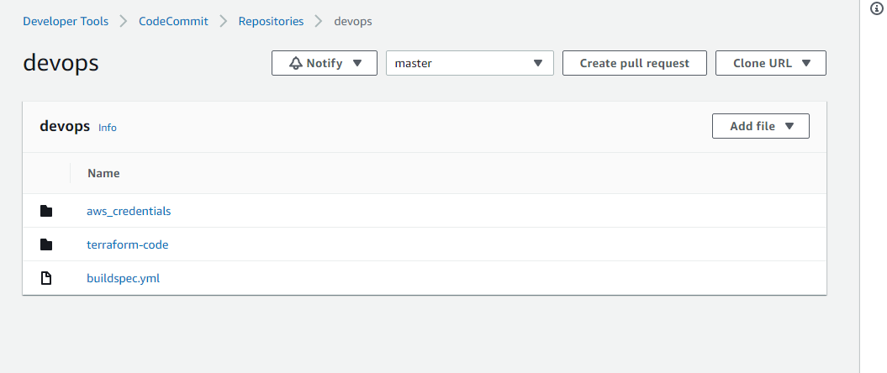

**BuildSpec -File**

Buildspec.yml file going to install the following application and execute the ansible playbook.

* Terraform
* Python-PiP
* Ansible
* Aws-cli



