**Assignment**

**Java Selenium**

**Documentation: -**

**Prerequisites: -**

* Run this program must be need Eclipse and Java.
* Create maven project in eclipse.
* Add dependencies in POM.xml Selenium, TestNG.

1. **Navigate to the FitPeo Homepage:**

Open the web browser and navigate to [FitPeo Homepage](https://www.fitpeo.com/).

import java.time.Duration;

import java.util.List;

import org.openqa.selenium.By;

import org.openqa.selenium.JavascriptExecutor;

import org.openqa.selenium.Keys;

import org.openqa.selenium.WebDriver;

import org.openqa.selenium.WebElement;

import org.openqa.selenium.chrome.ChromeDriver;

import org.openqa.selenium.interactions.Actions;

import org.openqa.selenium.support.ui.ExpectedConditions;

import org.openqa.selenium.support.ui.WebDriverWait;

import dev.failsafe.internal.util.Assert;

**public** **class** NavigateToHomePage {

**public** **static** **void** main(String[] args) {

WebDriver driver = **new** ChromeDriver();

driver.get("https://www.fitpeo.com/");

}

}

1. **Navigate to the Revenue Calculator Page:**

From the homepage, navigate to the [Revenue Calculator Page](https://fitpeo.com/revenue-calculator).

import java.time.Duration;

import java.util.List;

import org.openqa.selenium.By;

import org.openqa.selenium.JavascriptExecutor;

import org.openqa.selenium.Keys;

import org.openqa.selenium.WebDriver;

import org.openqa.selenium.WebElement;

import org.openqa.selenium.chrome.ChromeDriver;

import org.openqa.selenium.interactions.Actions;

import org.openqa.selenium.support.ui.ExpectedConditions;

import org.openqa.selenium.support.ui.WebDriverWait;

import dev.failsafe.internal.util.Assert;

**public class** NavigateToRevenueCalculatorPage {

public static void main(String[] args) {

WebDriver driver = new ChromeDriver();

driver.get("https://www.fitpeo.com/");

driver.manage().window().maximize();

driver.manage().timeouts().implicitlyWait(Duration.ofSeconds(15));

driver.findElement(By.xpath("//div[text()='Revenue Calculator']")).click();

}

}

1. **Scroll Down to the Slider section:**

Scroll down the page until the revenue calculator slider is visible.

import java.time.Duration;

import java.util.List;

import org.openqa.selenium.By;

import org.openqa.selenium.JavascriptExecutor;

import org.openqa.selenium.Keys;

import org.openqa.selenium.WebDriver;

import org.openqa.selenium.WebElement;

import org.openqa.selenium.chrome.ChromeDriver;

import org.openqa.selenium.interactions.Actions;

import org.openqa.selenium.support.ui.ExpectedConditions;

import org.openqa.selenium.support.ui.WebDriverWait;

import dev.failsafe.internal.util.Assert;

**public class** NavigateToRevenueCalculatorPageAndScroll {

public static void main(String[] args) throws InterruptedException {

WebDriver driver = new ChromeDriver();

JavascriptExecutor js = (JavascriptExecutor) driver;

driver.get("https://www.fitpeo.com/");

driver.manage().window().maximize();

driver.manage().timeouts().implicitlyWait(Duration.ofSeconds(15));

driver.findElement(By.xpath("//div[text()='Revenue Calculator']")).click();

Thread.sleep(1000);

js.executeScript("window.scrollBy(0,400)");

}

}

1. **Adjust the Slider:**

Adjust the slider to set its value to 820. we’ve highlighted the slider in red color, Once the slider is moved the bottom text field value should be updated to 820

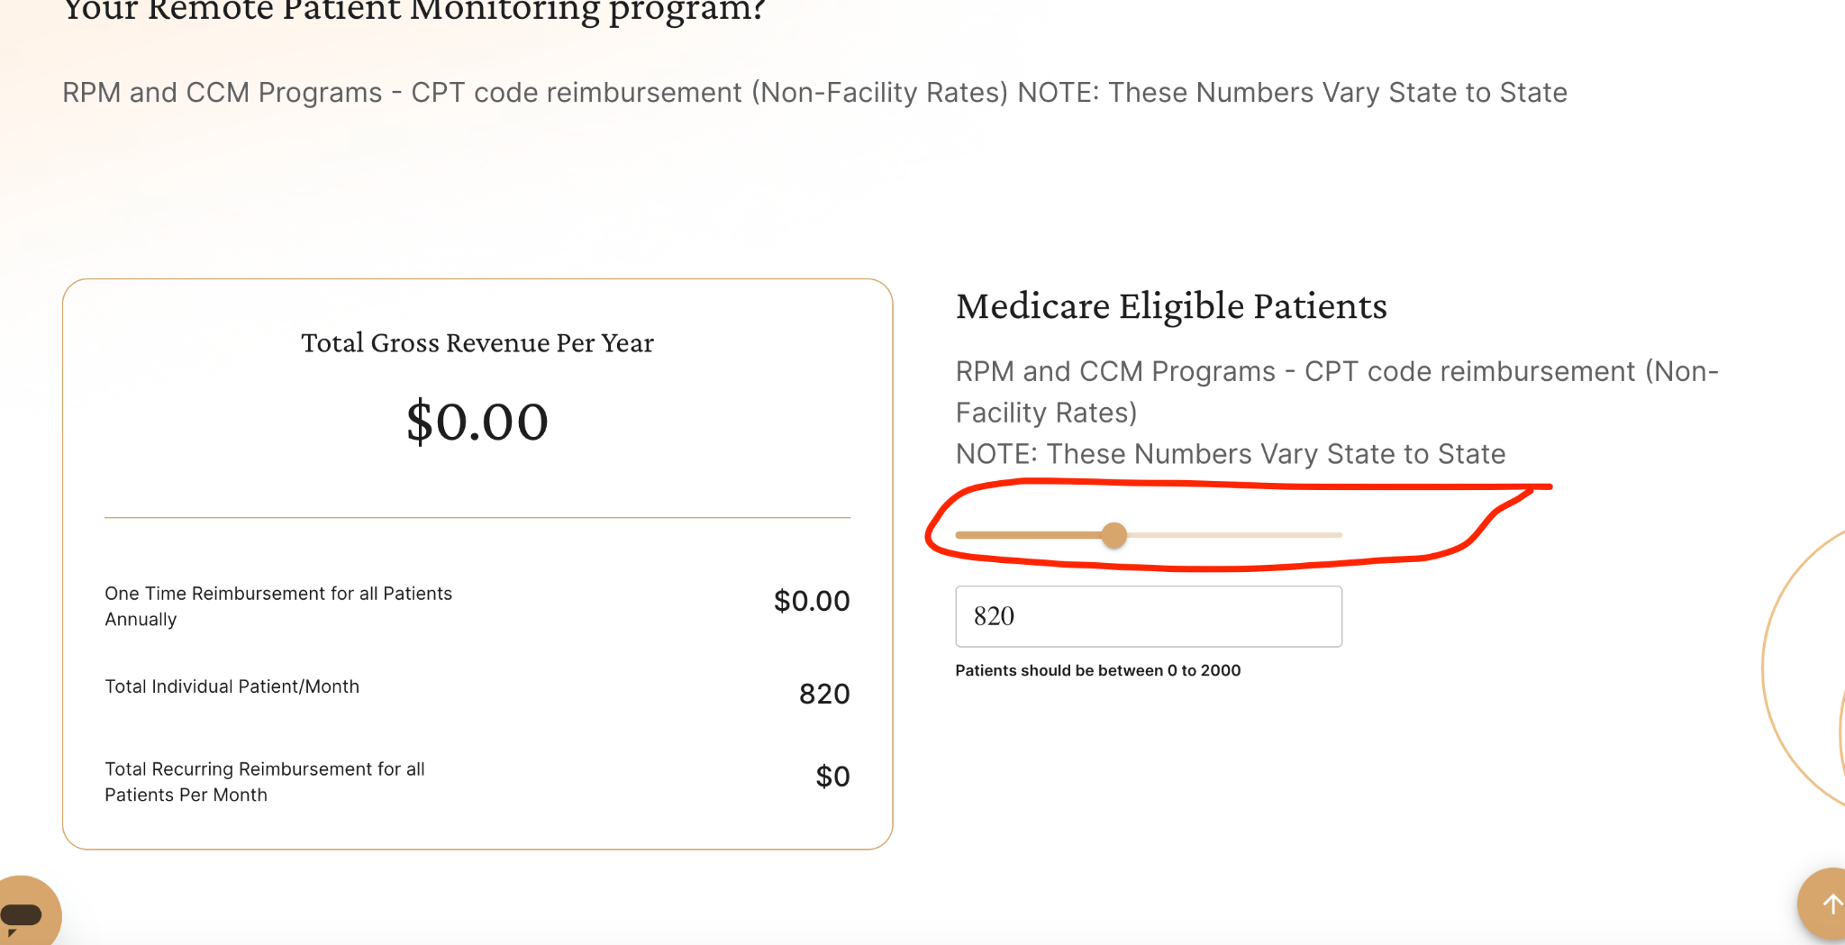

import java.time.Duration;

import java.util.List;

import org.openqa.selenium.By;

import org.openqa.selenium.JavascriptExecutor;

import org.openqa.selenium.Keys;

import org.openqa.selenium.WebDriver;

import org.openqa.selenium.WebElement;

import org.openqa.selenium.chrome.ChromeDriver;

import org.openqa.selenium.interactions.Actions;

import org.openqa.selenium.support.ui.ExpectedConditions;

import org.openqa.selenium.support.ui.WebDriverWait;

import dev.failsafe.internal.util.Assert;

**public class** AdjustSlider {

public static void main(String[] args) throws InterruptedException {

WebDriver driver = new ChromeDriver();

WebDriverWait wait = new WebDriverWait(driver, Duration.ofSeconds(30));

Actions ac = new Actions(driver);

JavascriptExecutor js = (JavascriptExecutor) driver;

driver.manage().window().maximize();

driver.manage().timeouts().implicitlyWait(Duration.ofSeconds(15));

driver.get("https://www.fitpeo.com/");

Thread.sleep(1000);

driver.findElement(By.xpath("//div[text()='Revenue Calculator']")).click();

Thread.sleep(1000);

js.executeScript("window.scrollBy(0,300)");

Thread.sleep(2000);

WebElement slider = driver.findElement(By.xpath("//input[@type='range']"));

Thread.sleep(2000);

ac.dragAndDropBy(slider, 94, 0).perform();

js.executeScript("window.scrollBy(0,300)");

}

}

1. **Update the Text Field:**

Click on the text field associated with the slider.

Enter the value 560 in the text field. Now the slider also should change accordingly

import java.time.Duration;

import java.util.List;

import org.openqa.selenium.By;

import org.openqa.selenium.JavascriptExecutor;

import org.openqa.selenium.Keys;

import org.openqa.selenium.WebDriver;

import org.openqa.selenium.WebElement;

import org.openqa.selenium.chrome.ChromeDriver;

import org.openqa.selenium.interactions.Actions;

import org.openqa.selenium.support.ui.ExpectedConditions;

import org.openqa.selenium.support.ui.WebDriverWait;

import dev.failsafe.internal.util.Assert;

**public class** UpdateTextField {

public static void main(String[] args) throws InterruptedException {

WebDriver driver = new ChromeDriver();

WebDriverWait wait = new WebDriverWait(driver, Duration.ofSeconds(30));

Actions ac = new Actions(driver);

JavascriptExecutor js = (JavascriptExecutor) driver;

driver.manage().window().maximize();

driver.manage().timeouts().implicitlyWait(Duration.ofSeconds(15));

driver.get("https://www.fitpeo.com/");

Thread.sleep(1000);

driver.findElement(By.xpath("//div[text()='Revenue Calculator']")).click();

js.executeScript("window.scrollBy(0,300)");

Thread.sleep(1000);

driver.findElement(By.xpath(

"//input[@class='MuiInputBase-input MuiOutlinedInput-input MuiInputBase-inputSizeSmall css-1o6z5ng']")).clear();

Thread.sleep(3000);

driver.findElement(By.xpath(

"//input[@class='MuiInputBase-input MuiOutlinedInput-input MuiInputBase-inputSizeSmall css-1o6z5ng']")).click();

driver.findElement(By.xpath(

"//input[@class='MuiInputBase-input MuiOutlinedInput-input MuiInputBase-inputSizeSmall css-1o6z5ng']")).sendKeys(Keys.BACK_SPACE);

driver.findElement(By.xpath(

"//input[@class='MuiInputBase-input MuiOutlinedInput-input MuiInputBase-inputSizeSmall css-1o6z5ng']")).sendKeys(Keys.BACK_SPACE);

driver.findElement(By.xpath(

"//input[@class='MuiInputBase-input MuiOutlinedInput-input MuiInputBase-inputSizeSmall css-1o6z5ng']")).sendKeys(Keys.BACK_SPACE);

driver.findElement(By.xpath(

"//input[@class='MuiInputBase-input MuiOutlinedInput-input MuiInputBase-inputSizeSmall css-1o6z5ng']")).sendKeys("560");

}

}

1. **Validate Slider Value:**

Ensure that when the value 560 is entered in the text field, the slider's position is updated to reflect the value 560.

import java.time.Duration;

import java.util.List;

import org.openqa.selenium.By;

import org.openqa.selenium.JavascriptExecutor;

import org.openqa.selenium.Keys;

import org.openqa.selenium.WebDriver;

import org.openqa.selenium.WebElement;

import org.openqa.selenium.chrome.ChromeDriver;

import org.openqa.selenium.interactions.Actions;

import org.openqa.selenium.support.ui.ExpectedConditions;

import org.openqa.selenium.support.ui.WebDriverWait;

import dev.failsafe.internal.util.Assert;

**public class** ValidateSliderValue {

public static void main(String[] args) throws InterruptedException {

WebDriver driver = new ChromeDriver();

WebDriverWait wait = new WebDriverWait(driver, Duration.ofSeconds(30));

Actions ac = new Actions(driver);

JavascriptExecutor js = (JavascriptExecutor) driver;

driver.manage().window().maximize();

driver.manage().timeouts().implicitlyWait(Duration.ofSeconds(15));

driver.get("https://www.fitpeo.com/");

Thread.sleep(1000);

driver.findElement(By.xpath("//div[text()='Revenue Calculator']")).click();

js.executeScript("window.scrollBy(0,300)");

Thread.sleep(3000);

driver.findElement(By.xpath(

"//input[@class='MuiInputBase-input MuiOutlinedInput-input MuiInputBase-inputSizeSmall css-1o6z5ng']")).clear();

Thread.sleep(3000);

driver.findElement(By.xpath(

"//input[@class='MuiInputBase-input MuiOutlinedInput-input MuiInputBase-inputSizeSmall css-1o6z5ng']")).click();

driver.findElement(By.xpath(

"//input[@class='MuiInputBase-input MuiOutlinedInput-input MuiInputBase-inputSizeSmall css-1o6z5ng']")).sendKeys(Keys.BACK_SPACE);

driver.findElement(By.xpath(

"//input[@class='MuiInputBase-input MuiOutlinedInput-input MuiInputBase-inputSizeSmall css-1o6z5ng']")).sendKeys(Keys.BACK_SPACE);

driver.findElement(By.xpath(

"//input[@class='MuiInputBase-input MuiOutlinedInput-input MuiInputBase-inputSizeSmall css-1o6z5ng']")).sendKeys(Keys.BACK_SPACE);

driver.findElement(By.xpath(

"//input[@class='MuiInputBase-input MuiOutlinedInput-input MuiInputBase-inputSizeSmall css-1o6z5ng']")).sendKeys("560");

WebElement slider = driver.findElement(By.xpath("//input[@type='range']"));

String slidervalue = slider.getAttribute("Value");

int value = Integer.parseInt(slidervalue);

System.out.println(slidervalue);

assertEquals(560, value);

}

}

1. **Select CPT Codes:**

Scroll down further and select the checkboxes for CPT-99091, CPT-99453, CPT-99454, and CPT-99474.

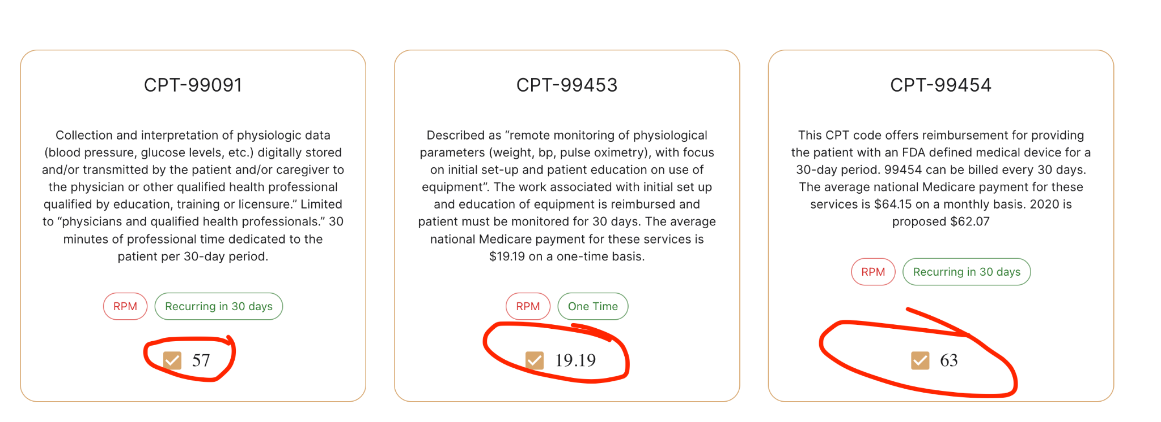

import static org.testng.Assert.assertEquals;

import java.time.Duration;

import java.util.List;

import org.openqa.selenium.By;

import org.openqa.selenium.JavascriptExecutor;

import org.openqa.selenium.Keys;

import org.openqa.selenium.WebDriver;

import org.openqa.selenium.WebElement;

import org.openqa.selenium.chrome.ChromeDriver;

import org.openqa.selenium.interactions.Actions;

import org.openqa.selenium.support.ui.ExpectedConditions;

import org.openqa.selenium.support.ui.WebDriverWait;

import dev.failsafe.internal.util.Assert;

**public class** SelectCPTCodes {

public static void main(String[] args) throws InterruptedException {

WebDriver driver = new ChromeDriver();

WebDriverWait wait = new WebDriverWait(driver, Duration.ofSeconds(30));

Actions ac = new Actions(driver);

JavascriptExecutor js = (JavascriptExecutor) driver;

driver.manage().window().maximize();

driver.manage().timeouts().implicitlyWait(Duration.ofSeconds(15));

driver.get("https://www.fitpeo.com/");

Thread.sleep(1000);

driver.findElement(By.xpath("//div[text()='Revenue Calculator']")).click();

js.executeScript("window.scrollBy(0,300)");

Thread.sleep(3000);

driver.findElement(By.xpath(

"//input[@class='MuiInputBase-input MuiOutlinedInput-input MuiInputBase-inputSizeSmall css-1o6z5ng']"))

.clear();

Thread.sleep(3000);

driver.findElement(By.xpath(

"//input[@class='MuiInputBase-input MuiOutlinedInput-input MuiInputBase-inputSizeSmall css-1o6z5ng']"))

.click();

driver.findElement(By.xpath(

"//input[@class='MuiInputBase-input MuiOutlinedInput-input MuiInputBase-inputSizeSmall css-1o6z5ng']"))

.sendKeys(Keys.BACK_SPACE);

driver.findElement(By.xpath(

"//input[@class='MuiInputBase-input MuiOutlinedInput-input MuiInputBase-inputSizeSmall css-1o6z5ng']"))

.sendKeys(Keys.BACK_SPACE);

driver.findElement(By.xpath(

"//input[@class='MuiInputBase-input MuiOutlinedInput-input MuiInputBase-inputSizeSmall css-1o6z5ng']"))

.sendKeys(Keys.BACK_SPACE);

driver.findElement(By.xpath(

"//input[@class='MuiInputBase-input MuiOutlinedInput-input MuiInputBase-inputSizeSmall css-1o6z5ng']"))

.sendKeys("820");

WebElement slider = driver.findElement(By.xpath("//input[@type='range']"));

String slidervalue = slider.getAttribute("Value");

int value = Integer.parseInt(slidervalue);

System.out.println(slidervalue);

assertEquals(820, value);

js.executeScript("window.scrollBy(0,400)");

Thread.sleep(3000);

List<WebElement> checkboxes = driver.findElements(By.xpath("//input[@type='checkbox']"));

int[] indicesToSelect = { 0, 1, 2, 7 };

Thread.sleep(1000);

for (int index : indicesToSelect) {

WebElement checkbox = checkboxes.get(index);

if (!checkbox.isSelected()) {

checkbox.click();

}

}

1. **Validate Total Recurring Reimbursement:**
2. Verify that the header displaying Total Recurring Reimbursement for all Patients Per Month: shows the value $110700.



import static org.testng.Assert.assertEquals;

import java.time.Duration;

import java.util.List;

import org.openqa.selenium.By;

import org.openqa.selenium.JavascriptExecutor;

import org.openqa.selenium.Keys;

import org.openqa.selenium.WebDriver;

import org.openqa.selenium.WebElement;

import org.openqa.selenium.chrome.ChromeDriver;

import org.openqa.selenium.interactions.Actions;

import org.openqa.selenium.support.ui.ExpectedConditions;

import org.openqa.selenium.support.ui.WebDriverWait;

import dev.failsafe.internal.util.Assert;

**public class** ValidateTotalRecurringReimbursement {

public static void main(String[] args) throws InterruptedException {

WebDriver driver = new ChromeDriver();

WebDriverWait wait = new WebDriverWait(driver, Duration.ofSeconds(30));

Actions ac = new Actions(driver);

JavascriptExecutor js = (JavascriptExecutor) driver;

driver.manage().window().maximize();

driver.manage().timeouts().implicitlyWait(Duration.ofSeconds(15));

driver.get("https://www.fitpeo.com/");

Thread.sleep(1000);

driver.findElement(By.xpath("//div[text()='Revenue Calculator']")).click();

js.executeScript("window.scrollBy(0,300)");

Thread.sleep(3000);

driver.findElement(By.xpath(

"//input[@class='MuiInputBase-input MuiOutlinedInput-input MuiInputBase-inputSizeSmall css-1o6z5ng']"))

.clear();

Thread.sleep(3000);

driver.findElement(By.xpath(

"//input[@class='MuiInputBase-input MuiOutlinedInput-input MuiInputBase-inputSizeSmall css-1o6z5ng']"))

.click();

driver.findElement(By.xpath(

"//input[@class='MuiInputBase-input MuiOutlinedInput-input MuiInputBase-inputSizeSmall css-1o6z5ng']"))

.sendKeys(Keys.BACK_SPACE);

driver.findElement(By.xpath(

"//input[@class='MuiInputBase-input MuiOutlinedInput-input MuiInputBase-inputSizeSmall css-1o6z5ng']"))

.sendKeys(Keys.BACK_SPACE);

driver.findElement(By.xpath(

"//input[@class='MuiInputBase-input MuiOutlinedInput-input MuiInputBase-inputSizeSmall css-1o6z5ng']"))

.sendKeys(Keys.BACK_SPACE);

driver.findElement(By.xpath(

"//input[@class='MuiInputBase-input MuiOutlinedInput-input MuiInputBase-inputSizeSmall css-1o6z5ng']"))

.sendKeys("820");

WebElement slider = driver.findElement(By.xpath("//input[@type='range']"));

String slidervalue = slider.getAttribute("Value");

int value = Integer.parseInt(slidervalue);

System.out.println(slidervalue);

assertEquals(820, value);

js.executeScript("window.scrollBy(0,400)");

Thread.sleep(3000);

List<WebElement> checkboxes = driver.findElements(By.xpath("//input[@type='checkbox']"));

int[] indicesToSelect = { 0, 1, 2, 7 };

Thread.sleep(1000);

for (int index : indicesToSelect) {

WebElement checkbox = checkboxes.get(index);

if (!checkbox.isSelected()) {

checkbox.click();

}

}

int[] selectedIndexes = { 0, 2, 7 };

Thread.sleep(3000);

double sum = 0;

List<WebElement> checkboxesvalues = driver.findElements(By.xpath(

"//span[@class='MuiTypography-root MuiTypography-body1 MuiFormControlLabel-label css-1s3unkt']"));

for (int index : selectedIndexes) {

if (index < checkboxesvalues.size()) {

WebElement values = checkboxesvalues.get(index);

String CPTvalue = values.getText();

double Fvalue = Double.parseDouble(CPTvalue);

sum += Fvalue;

System.out.println(CPTvalue);

}

}

System.out.println("Sum of CTP: " + sum);

double TotalRecurringReimbursementSelected = value * sum;

Thread.sleep(1000);

System.out.println(TotalRecurringReimbursementSelected);

WebElement TotalRecurringReimbursement = driver

.findElement(By.xpath("(//p[@class='MuiTypography-root MuiTypography-body1 inter css-1bl0tdj'])[4]"));

String finaltotal = TotalRecurringReimbursement.getText();

System.out.println(finaltotal);

String actual = "$110700";

assertEquals(actual, finaltotal);

}

}