**CS5540 - PRINCIPLES OF BIG DATA MANAGEMENT**

**Twitter Data Analysis Project**

**Docker Container Execution in AWS EC2 Instance - Ubuntu Server 18.04**

**Docker Image:** docker pull smpf4/pb-project:v1

Team Members:

|  |  |  |
| --- | --- | --- |
| **Name** | **ID** | **Email ID** |
| Shiva Kumar Murarishetti | 16296890 | [smpf4@mail.umkc.edu](mailto:smpf4@mail.umkc.edu) |
| Lavanya Gadde | 16298160 | [lavanya.gadde@mail.umkc.edu](mailto:lavanya.gadde@mail.umkc.edu) |
| Sravani Garikapati | 16296889 | [sg324@mail.umkc.edu](mailto:sg324@mail.umkc.edu) |

$ sudo apt-get remove docker docker-engine docker.io containerd runc

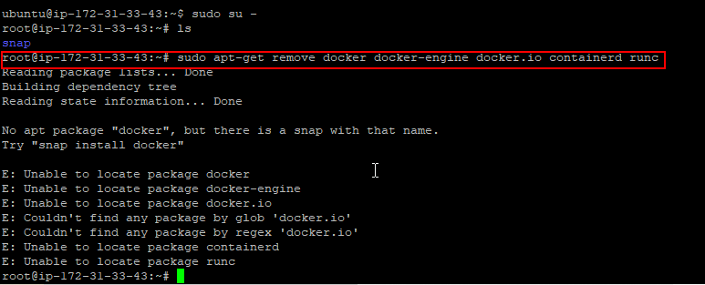

$ sudo apt-get update

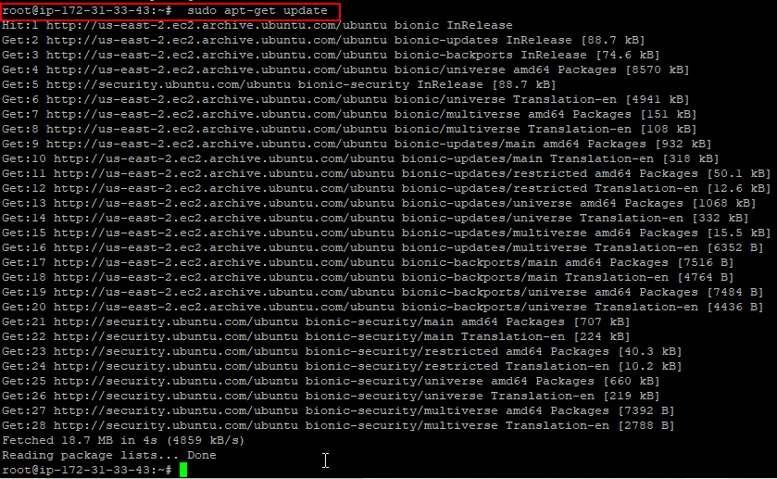

$ sudo apt-get install \

apt-transport-https \

ca-certificates \

curl \

gnupg-agent \

software-properties-common

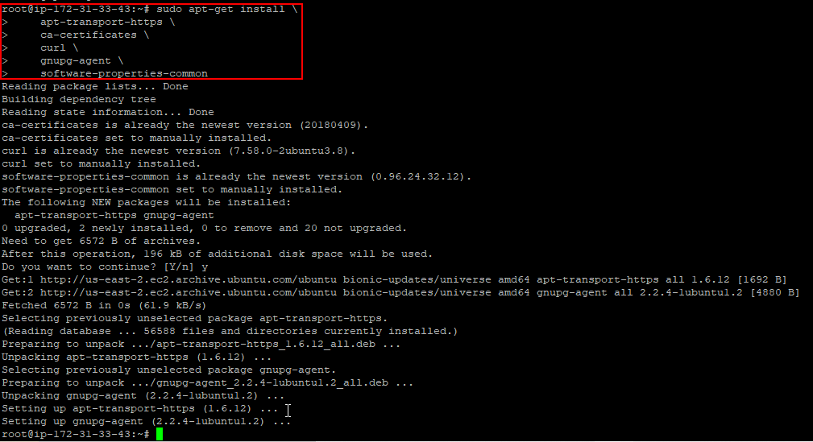

$ curl -fsSL https://download.docker.com/linux/ubuntu/gpg | sudo apt-key add -



$ sudo apt-key fingerprint 0EBFCD88

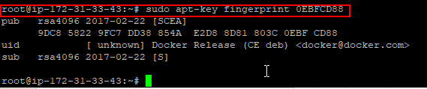

$ sudo add-apt-repository \

"deb [arch=amd64] https://download.docker.com/linux/ubuntu \

$(lsb_release -cs) \

stable"

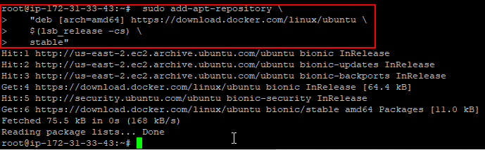

$ sudo apt-get update

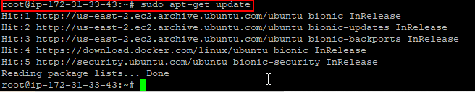

$ sudo apt-get install docker-ce docker-ce-cli containerd.io

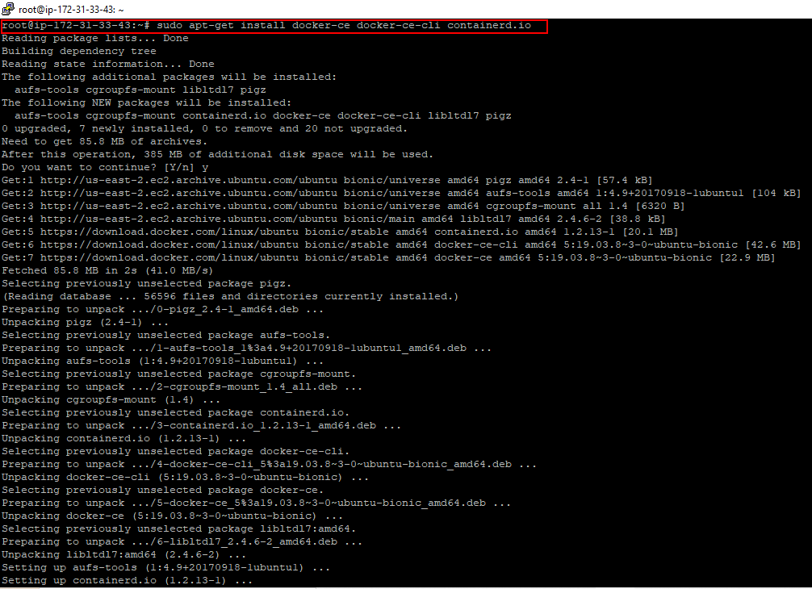

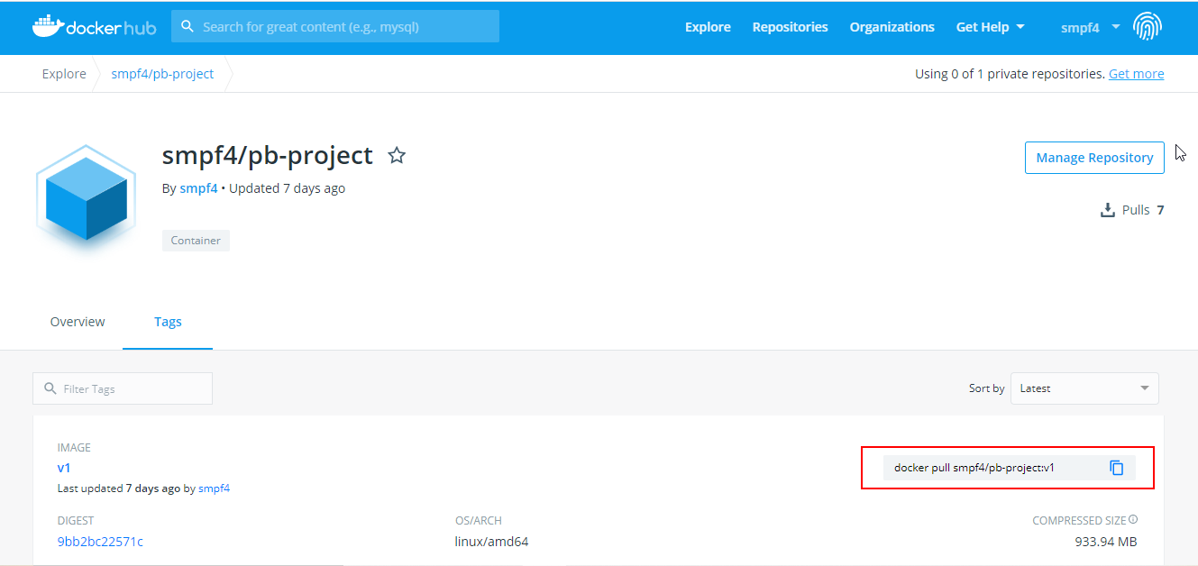

docker pull smpf4/pb-project:v1

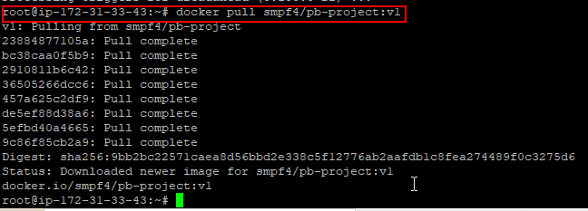

docker run -itd -P smpf4/pb-project:v1





