Causal Relationship Between Gross Savings and External Debt
Akmyrat Tirkeshov
Abstract: This study examines whether higher domestic savings reduce external debt levels using panel data from 60 countries for 27 years, totaling 1,609 observations. using both first differences and fixed effects models, we analyze the impact of gross savings on external debt stocks. The findings from cross-sectional OLS for the year 2006 reveal that one USD increase in gross savings is associated with an approximate 0.58 USD decline in external debt, after controlling for GDP, trade, and inflation. Fixed effects estimations further reveal that short-term changes in savings also contribute to reductions in external debt, though with varying magnitudes depending on economic conditions. These results suggest that higher domestic savings can help lower external debt, but the extent of this effect may differ across countries and time periods.

- Introduction
Since the seminal work of Lewis (1955), the role of savings in fostering economic development has been central to policy debates. While much attention has focused on how savings drive growth through capital accumulation, a critical yet underexplored question persists: Does higher savings reduce a country’s external debt? This question carries major impact for nations grappling with debt sustainability. High external debt, as seen in countries like Argentina and Sri Lanka, often cause fiscal crises, currency instability, and constrained public investment. On the other hand, economies with robust savings rates, such as South Korea and Singapore, have historically leveraged domestic capital to limit reliance on foreign borrowing. Yet, the causal mechanisms linking savings to external debt remain uncertain.
Existing literature offers divergent perspectives. Some theories suggest that higher savings increase the amount of money available for loans within the country, reducing the need for borrowing from other countries (Bacha, 1990; DeGregorio, 1992). However, some critics believe that borrowing from other countries could reduce savings, as countries with debt focus more on paying off their loans than domestic capital formation (Reinhart & Rogoff, 2010). The evidence is unclear, with studies like Saltz (1999) showing that the relationship between savings and debt could be reverse causality.
This study addresses this gap by analyzing panel data from 60 countries (1996–2022), sourced from the World Bank. We use fixed effects models to isolate the causal link between gross savings and external debt stocks, controlling for GDP, trade volumes, and inflation. Preliminary findings reveal a robust negative association: a 1% rise in savings correlates with a 0.131% decline in external debt (Appendix 5). However, heterogeneity emerges—effects are stronger in high-income economies with high GDP per capita (Appendix 9)—suggesting structural factors affect this relationship.
The paper proceeds as follows: Section 2 details the data and sample selection. Section 3 outlines the empirical framework, emphasizing fixed effects. Section 4 presents core findings, including heterogeneity across income groups. Section 5 discusses robustness checks and limitations. Section 6 concludes with policy implications, arguing that while savings incentivization can curb debt, tailored strategies are essential for diverse economic contexts.
- Data
This study utilizes panel data spanning from 1996 to 2022, sourced from the World Bank’s World Development Indicators. The initial dataset included a broad range of macroeconomic variables for over 200 countries. However, due to extensive missing values—particularly in recent years like 2023—and inconsistencies across time series, the sample was refined to ensure robustness. Countries with more than 2 missing observations were excluded, and 2023 was dropped entirely. The final dataset includes 60 countries over 27 years, with 1,609 observations.
To fix differences in scale and avoid problems with non-linear relationships, the data for external debt, savings, GDP, and trade were adjusted using log transformations (Appendix 3). Also, the nominal values (e.g., GDP and debt in USD) were adjusted to constant 2015 USD to make them comparable over time. Variables that didn’t explain much or were too similar to others were removed from the analysis to simplify the model. Gross savings and external debt are right skewed in levels. Log transformations reduced skewness, as evidenced by the tighter standard deviations for log variables (e.g., log of debt: SD = 1.78, Appendix 1). This cleaned dataset provides a reliable foundation for analyzing the relationship between savings and external debt.
- Model
To estimate how gross savings affect external debt, this study uses a fixed effects panel regression model. The fixed effects estimator is chosen to avoid omitted variable bias by isolating within-country variation over time. This approach controls for unobserved country-specific factors that could simultaneously influence savings and debt (e.g., cultural attitudes toward savings, long-term fiscal policies). By including year fixed effects (Time_Trend_{t}), the model accounts for global events like financial crises, changes in commodity prices, or shifts in international interest rates that affect all countries at the same time. By differencing out these effects, the model focuses on how changes in savings correlate with changes in external debt, strengthening causal inference. The basic equation is:
ln (External debt_{it}) = α_{i} + β₁ln (Gross savings_{it}) + Time_Trend_{t} + β₂ X_{it} + ε_{it} (1)
Where: ln (External debt_{i}) is the log of external debt stocks for country i in the year t, ln (Gross savings_{it}) is the log of gross savings for country i in the year t, Time_Trend_{t} is year dummies, X_{it} represents the set of control variables, confounders including log of trade, log of GDP and inflation, ε_{i} is the error term.
Confounders: Log of GDP: A country's size affects both its savings (larger economies can save more) and its need for borrowing (larger economies can access international markets more easily). Ignoring GDP could mix up the effects of economic size with the savings-debt link. Inflation (GDP deflator): High inflation reduces real savings and increases the cost of foreign debt. Without controlling for inflation, it's hard to know if debt reduction comes from savings or overall economic stability. Log of Trade: Trade openness influences foreign reserves and debt repayment ability, and trade balances (exports or imports) can affect savings. Not including trade could wrongly link debt changes to savings when trade is a major factor.
- Results
The result of the model (1) is presented in Appendix 5. To ensure robustness, two different models are estimated by adding variables into regression. In both models, the regression coefficients remain consistent, indicating our model is robust. Our main model is the second regression estimated in the Appendix 5.
Table 1 Impact of Gross Savings on External Debt
Fixed Effects Model | Coefficient (Log of Gross Savings) | Standard Error | Significance
Full Sample | -0.131 | 0.064 | **
High GDP per capita | -0.218 | 0.081 | ***
Low GDP per capita | 0.009 | 0.070 | N.S.
Notes: ***p < 0.01, **p < 0.05, N.S. = Not Significant.
The analysis shows a significant negative relationship between gross savings and external debt, with notable differences across different economies. Table 1 summarizes the main findings from the fixed effects log model.
The fixed effects model demonstrates that a 1% increase in gross savings is associated with a 0.131% reduction in external debt stocks (p < 0.05), after controlling for GDP, trade, and inflation. This aligns with the hypothesis that higher domestic savings reduce reliance on foreign borrowing. The log of GDP has a positive and strong result (1.346, p < 0.01), suggesting that larger economies can still accumulate debt even with higher savings, likely because they have better access to international capital markets.
Heterogeneity
The split-sample analysis (Appendix 9) shows big differences:
- High-income countries: A 1% increase in savings leads to a 0.218% drop in external debt (p < 0.01), showing a strong connection. Wealthier countries benefit from strong financial systems and stable institutions, making savings more effective in reducing debt.
- Low-income countries: The relationship is not statistically significant (coefficient = 0.009, p > 0.1). Factors like limited access to credit, unstable income, or dependence on foreign loans may weaken the link between savings and debt
- Robustness
To check the robustness of the baseline fixed effects results, this study uses a first-differences model (Appendix 8), which looks at how short-term changes in savings relate to changes in external debt. The effect of savings in this model is smaller than in the fixed effects model. For example, a 1% increase in savings is linked to 0.064% reduction in external debt, compared to a 0.131% reduction in the fixed effects model.
Despite these differences, the first-differences model confirms the negative direction of the savings-debt relationship, with coefficients remaining statistically significant in key specifications. This consistency across methods supports the conclusion that higher savings reduce external debt, though the effect might take time to show.

Internal Validity
We use fixed effects models to control for differences between countries—such as culture and institutions and added year dummies to capture global events. First-differences models help focus on short-term changes to reduce reverse causality. Still, some issues remain: high debt might lower savings, missing factors like political stability could influence both, and measurement errors (especially with inflation) may occur.
External Validity
Our findings mostly apply to middle- and high-income countries. Our sample of 60 diverse, stable countries (1996–2022) shows a clear link between savings and debt in high-income nations, but the effect is weaker in low-income countries with less developed financial systems. Also, excluding countries with many missing values and relying on World Bank data might limit the results for unstable or informal economies.
- Conclusion
This study provides robust evidence that higher domestic savings reduce external debt, particularly in high-income economies. Utilizing panel data from 60 countries (1996–2022) and fixed effects models, the analysis reveals that a 1% increase in gross savings correlates with a 0.131% decline in external debt stocks. This relationship strengthens in high-GDP per capita nations, where savings reduce debt by 0.218%, likely due to mature financial systems and stable institutions that efficiently channel domestic capital into productive investments. However, in low-income countries, the impact is not statistically significant, likely due to issues like limited access to credit and economic instability.
Policy Implications
For high- and middle-income countries, incentivizing savings through tax benefits, pension reforms, or financial literacy programs can help reduce external debt risks. However, in low-income countries, improvements in financial inclusion, economic stability, and governance are necessary to make savings policies effective.
While our analysis controls for key factors like GDP, trade, and inflation, issues such as reverse causality between debt and savings remain. Also, since we rely on World Bank data and exclude fragile states, our results may not apply to all economies. Future research should include a broader range of countries, examine possible non-linear effects, and consider the roles of political stability and institutional quality.

References
- Bacha, E. L. (1990). A three-gap model of foreign transfers and the GDP growth rate in developing countries. Journal of Development Economics, 32(2), 279–296.
- DeGregorio, J. (1992). Economic growth in Latin America. Journal of Development Economics, 39(1), 59–84.
- Lewis, W. A. (1955). The theory of economic growth. Routledge.
- Reinhart, C. M., & Rogoff, K. S. (2010). Growth in a time of debt. American Economic Review, 100(2), 573–578.
- Saltz, I. S. (1999). An examination of the causal relationship between savings and growth in the Third World. Journal of Economics and Finance, 23(1), 90–98.

APPENDIX
Appendix 1. Descriptive statistics
 | count | mean | std | min | 25 % | 50 % | 75 % | max
Gross savings (% of GDP) | 1,609.00 | 20.92 | 9.07 | 0.30 | 14.65 | 19.12 | 26.58 | 51.79
GDP per capita, PPP (constant 2021 international $) | 1,609.00 | 9,564.79 | 6,674.34 | 829.39 | 3,871.45 | 8,455.18 | 13,659.64 | 33,506.26
External debt stocks (% of GDP) | 1,609.00 | 48.51 | 32.00 | 3.68 | 26.49 | 39.10 | 62.84 | 259.01
GDP (constant 2015 US$)* | 1,609.00 | $28.689 | $119.148 | $0.047 | $1.057 | $3.108 | $13.966 | $1,631.900
External debt* | 1,609.00 | $729.025 | $1,897.874 | $0.852 | $44.635 | $140.067 | $524.930 | $24,233.092
Gross savings* | 1,609.00 | $953.977 | $5,335.106 | $0.015 | $19.010 | $55.399 | $318.801 | $74,763.561
Trade | 1,609.00 | $1,375.326 | $4,975.979 | $4.170 | $73.739 | $208.115 | $807.734 | $62,585.767
Log variables
Log of debt | 1,609.00 | 28.09 | 1.78 | 22.87 | 26.82 | 27.97 | 29.29 | 33.12
Log of savings | 1,609.00 | 27.32 | 2.09 | 18.80 | 25.97 | 27.04 | 28.79 | 34.25
Log of GDP | 1,609.00 | 8.88 | 0.80 | 6.72 | 8.26 | 9.04 | 9.52 | 10.42
Log of Trade | 1,609.00 | 28.53 | 1.75 | 24.45 | 27.33 | 28.36 | 29.72 | 34.07
*In 10¹⁰$
Appendix 2. Distribution of Gross savings and External debt stocks (% of GDP)
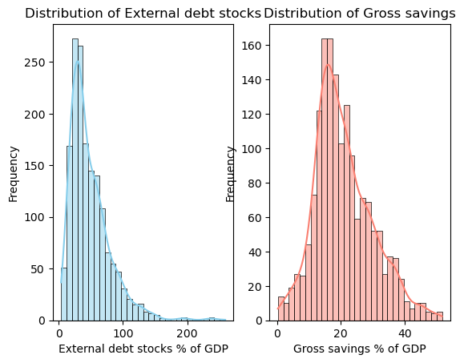
Appendix 3. Distribution of Gross savings and External debt stocks and their logs
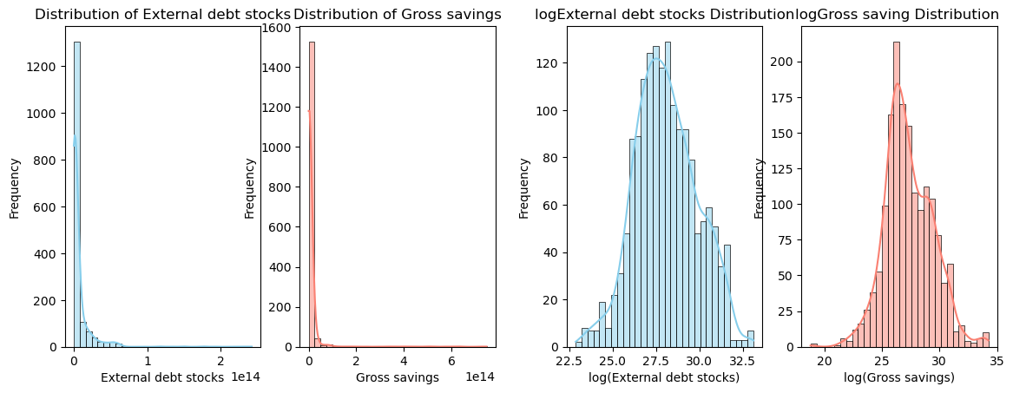
Appendix 4. Cross-section OLS for the year 2005, regression for external debt stocks
Dependent variable: External debt stocks | (1)
Gross savings | -0.580***
 | (0.092)
GDP (constant 2015 US$) | 25.943***
 | (2.826)
Inflation, GDP deflator (annual %) | 29157041921.687
 | (33484088496.021)
Trade | 0.216***
 | (0.074)
Intercept | 436252246169.356
 | (531442330225.073)
Observations | 60
R² | 0.921
Adjusted R² | 0.915
Residual Std. Error | 2836705126711.564
F Statistic | 159.879***
*p<0.1; **p<0.05; ***p<0.01
Source: Student calculation based on World Bank data

Appendix 5 Fixed effects results Log model
 | Dependent variable: Log of External debt stocks
 |  | (1) | (2)
Log of Gross savings |  | -0.127** | -0.131**
 |  | (0.063) | (0.064)
Log of GDP |  | 1.385*** | 1.346***
 |  | (0.227) | (0.251)
Log of Trade |  |  | 0.033
 |  |  | (0.130)
Inflation, GDP deflator (annual %) |  |  | -0.001
 |  |  | (0.001)
Year dummies |  | YES | YES
Observations |  | 1609 | 1609
Number of groups |  | 60 | 60
R square |  | 0.551 | 0.552
Residual std. error |  | 0.398 | 0.398
F Statistic |  | 66.584*** | 62.378***
*p<0.1; **p<0.05; ***p<0.01
Source: Student calculation based on World Bank data
Appendix 6. Fixed effects results % model
Dependent variable: External debt stocks (% of GDP)
 | (1)
Gross savings (% of GDP) | -0.839**
 | (0.373)
Log of GDP | 40.607***
 | (15.588)
Trade (% of GDP) | 0.224*
 | (0.128)
Inflation, GDP deflator (annual %) | -0.019
 | (0.061)
Year dummies | YES
Observations | 1609
Number of groups | 60
R square | 0.232
Residual std. error | 11.511
F Statistic | 15.302***
*p<0.1; **p<0.05; ***p<0.01
Source: Student calculation based on World Bank data

Appendix 7. Fixed effects results for External debt stocks
Dependent variable: External debt stocks
 | (1)
Gross savings | -0.581***
 | (0.052)
GDP (constant 2015 US$) | 34.795***
 | (3.268)
Trade | 0.195***
 | (0.058)
Year dummies | YES
Observations | 1609
Number of groups | 60
R square | 0.863
Residual std. error | 9327886867009.021
F Statistic | 4798.726***

*p<0.1; **p<0.05; ***p<0.01
Source: Student calculation based on World Bank data
Appendix 8. First differences model for ΔExternal debt stocks
Dependent variable: ΔLog of External debt stocks
 | (1) | (2) | (3)
ΔLog of Gross savings | -0.021 | -0.031** | -0.019
 | (0.013) | (0.014) | (0.022)
ΔLog of Gross savings, PPP lag 1 |  | -0.009 | -0.029***
 |  | (0.011) | (0.011)
ΔLog of Gross savings, PPP lag 2 |  |  | -0.015
 |  |  | (0.013)
ΔLog of GDP | -0.394** | -0.335* | -0.26
 | (0.194) | (0.203) | (0.201)
ΔLog of Trade | 0.463*** | 0.477*** | 0.458***
 | (0.057) | (0.061) | (0.055)
ΔInflation, GDP deflator (annual %) | 0 | 0 | 0
 | -0.001 | -0.001 | -0.001
Year dummies | YES | YES | YES
Observations | 1549 | 1489 | 1429
Number of groups | 60 | 60 | 60
R square | 0.246 | 0.243 | 0.232
Adjusted R square
Residual std. error | 0.090 | 0.090 | 0.087
F Statistic | 17.137*** | 16.151*** | 14.546***
*p<0.1; **p<0.05; ***p<0.01
Source: Student calculation based on World Bank data

Appendix 9. Heterogeneity, Fixed effects results divided by GDP per capita
Dependent variable: ΔLog of External debt stocks
 | (High GDP per capita) | (Low GDP per capita)
Log of Gross savings | -0.218*** | 0.009
 | (0.081) | (0.07)
Log of GDP | 0.964*** | 0.826**
 | (0.279) | (0.383)
Log of Trade | 0.39 | 0.196
 | (0.245) | (0.125)
Inflation, GDP deflator (annual %) | -0.002* | 0.001
 | (0.001) | (0.001)
Year dummies | YES | YES
Observations | 807 | 802
Number of groups | 30 | 30
R square | 0.707 | 0.479
Adjusted R square | 0.519 | 0.314
Residual std. error | 60.162*** | 22.776***
F Statistic | 807 | 802
*p<0.1; **p<0.05; ***p<0.01
Source: Student calculation based on World Bank data

