DSA-210 FINAL REPORT

MURAT ÇANKAYA

32075

Understanding How Lifestyle and Fitness Metrics Influence Study Motivation

Supervised by
ÖZGÜR ASAR & ONUR VAROL

SABANCI UNİVERSİTY

WHAT’S IN THIS REPORT?

This report presents the full workflow of the DSA-210 term project, including data collection, preprocessing, exploratory data analysis (EDA), correlation analysis, regression modeling, hypothesis testing, and machine learning–based model comparison.
The goal of the project is to investigate how daily lifestyle and physiological metrics such as physical activity, sleep, and heart rate are related to daily study motivation. Using self-recorded and wearable-style data collected over multiple weeks, statistical and machine learning techniques are applied to explore which variables show meaningful associations with motivation levels and whether these relationships are strong enough to be predictive.

INTRODUCTION
Daily academic motivation is influenced by a wide range of physical, psychological, and environmental factors. In recent years, wearable devices and health tracking applications have made it possible to continuously monitor lifestyle-related variables such as step count, heart rate, sleep duration, and exercise behavior. These metrics may provide insight into how physical well-being interacts with cognitive performance and academic engagement.
This project aims to examine whether measurable lifestyle indicators can help explain fluctuations in daily study motivation. In particular, the study investigates whether better sleep quality, lower stress indicators, and higher physical activity are associated with higher motivation levels, and whether stressful academic periods alter these relationships.
Understanding these connections may help students better manage their routines and recognize how physical health and external pressures affect learning performance.

WHAT DID I DO?

Data Collection and Preparation
The dataset consists of daily records collected over a 28-day period. Each observation represents one day and includes the following variables:
- Steps (daily step count)
- Calories burned
- Resting heart rate
- Average heart rate
- Sleep duration (hours)
- Sleep quality score (1–10)
- Gym minutes
- Gym intensity (1–10)
- Study motivation score (1–10)
The data was stored in CSV format and imported using Python (pandas). Dates were converted to datetime format and sorted chronologically. No missing values were detected in the dataset. Basic sanity checks were applied to ensure consistent data types.
In addition, a specific exam-heavy period (November 16–26) was labeled as a “stress period” in order to compare motivation levels between normal and high-pressure academic days.

Exploratory Data Analysis (EDA)
To understand the structure of the dataset, descriptive statistics such as mean, standard deviation, minimum, and maximum values were computed for all numerical variables.
Correlation matrices and heatmaps were used to observe linear relationships between lifestyle metrics and study motivation. Time-series line plots were also generated to visualize daily trends in variables such as steps, sleep duration, resting heart rate, gym activity, and motivation.
These visualizations helped identify both short-term fluctuations and longer trends across the study period.

CORRELATION ANALYSIS

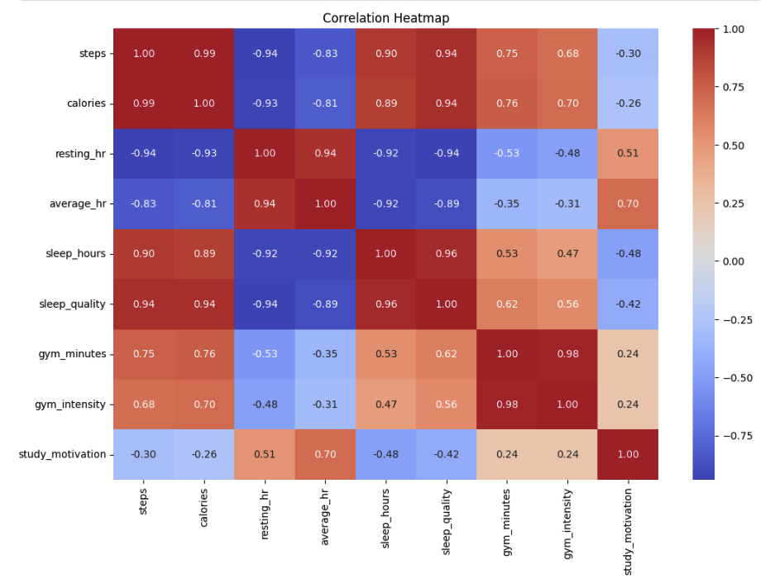
Correlation analysis revealed several notable patterns:
- Sleep duration and sleep quality showed positive correlations with study motivation.
- Average heart rate also exhibited a moderate positive correlation with motivation.
- Steps and calories had weaker or slightly negative correlations with motivation.
- Gym-related variables showed weak positive correlations but were not strongly predictive.
The correlation heatmap suggested that recovery-related variables (sleep and heart rate) were more closely associated with motivation than raw activity volume. This implies that physical recovery and stress levels may be more relevant to academic motivation than how active a person is during the day.
However, correlation alone does not imply causation, and many variables were also correlated with each other, indicating possible multicollinearity.

TREND ANALYSIS
Time-series plots were used to examine how lifestyle variables and study motivation changed over time.
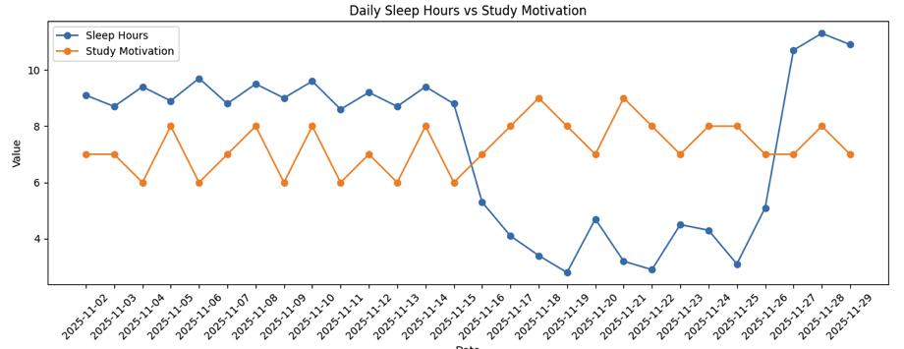
Key observations from the plots include:
- Motivation levels remained relatively stable but increased during the exam period.
- Sleep duration decreased significantly during the stress period.
- Resting heart rate increased during the same time interval, indicating higher stress.
- Gym activity became more irregular during exam weeks.
Interestingly, motivation increased during periods when physiological indicators suggested poorer health, suggesting that external academic pressure may override physical fatigue and drive short-term motivation.

REGRESSION MODELING
A multiple linear regression model was trained using the following features:
- Steps
- Calories
- Resting heart rate
- Average heart rate
- Sleep duration
- Sleep quality
- Gym minutes
- Gym intensity
Study motivation was used as the target variable.
The dataset was split into training and testing sets. Model performance was evaluated using R² and RMSE metrics.
Results showed that:
- Overall R² values were low, indicating limited predictive power.
- No single variable dominated prediction strongly in the linear model.
- This suggests that study motivation is influenced by multiple interacting factors rather than a single lifestyle metric.
To address multicollinearity and perform feature selection, Lasso and Ridge regression were also applied. Lasso regression selected average heart rate and gym minutes as the most relevant predictors, while shrinking most other coefficients to zero.
This indicates that among the recorded variables, physiological stress and structured exercise may contain the most signal related to motivation.

MACHINE LEARNING MODEL COMPARISON
To explore whether non-linear models could improve performance, several models were tested using time-series cross-validation:
- Linear Regression
- Ridge Regression
- Lasso Regression
- Random Forest Regressor
- Gradient Boosting Regressor
A Dummy Regressor using the mean as baseline was also evaluated.
Key findings:
- None of the advanced models significantly outperformed the baseline predictor.
- Random Forest and Gradient Boosting did not provide meaningful performance gains.
- This indicates that the dataset may be too small and noisy for complex models to generalize well.
Thus, machine learning did not offer substantial predictive advantage over simple regression in this case.

HYPOTHESIS TESTING

Gym vs Non-Gym Days
A two-sample t-test was performed comparing study motivation on gym days versus non-gym days.
- p-value ≈ 0.20
- Result: Fail to reject the null hypothesis
This suggests that gym attendance did not produce a statistically significant difference in daily study motivation for this dataset.

Stress Period vs Normal Period
A second t-test compared motivation levels during the exam stress period versus normal days.
- p-value ≈ 0.008
- Result: Reject the null hypothesis
This indicates that motivation levels were significantly higher during the exam period despite worse sleep and higher resting heart rates.
This supports the idea that external academic pressure can temporarily increase motivation even when physical well-being declines.

INTERPRETATION OF RESULTS
The results suggest that study motivation is not solely driven by physical health metrics. While sleep quality and recovery appear related to stable motivation levels, short-term increases in motivation are strongly influenced by external deadlines and academic stress.
This implies a distinction between:
- Intrinsic motivation driven by well-being
- Extrinsic motivation driven by deadlines and performance pressure
During high-pressure periods, extrinsic motivation may dominate, leading to increased effort even under physical fatigue.

LIMITATIONS
This study has several limitations:
- The dataset covers only 28 days, limiting statistical power.
- Motivation and sleep quality were self-reported and may contain subjective bias.
- External factors such as exam difficulty, emotional state, caffeine intake, and workload were not directly measured.
- Linear models may not capture time-lagged or cumulative effects of sleep and fatigue.
Due to these limitations, the results should be interpreted as exploratory rather than conclusive.

CAN IT BE BETTER?
Future work could improve this project by:
- Collecting data over several months instead of weeks
- Including psychological variables such as stress scores or workload
- Measuring caffeine intake and screen time
- Studying lag effects (e.g., yesterday’s sleep vs today’s motivation)
- Including data from multiple participants for better generalization
These additions could allow stronger conclusions and more reliable predictive modeling.

CONCLUSION
This project investigated how daily lifestyle and physiological metrics relate to study motivation using statistical and machine learning techniques. While recovery-related variables such as sleep and heart rate showed meaningful associations with motivation, physical activity volume alone did not strongly predict academic drive.
The most striking result was the increase in motivation during exam periods despite worse health indicators, highlighting the dominant role of external academic pressure in shaping short-term motivation.
Overall, the findings suggest that motivation is a multi-dimensional phenomenon influenced by both physiological state and contextual academic demands. Lifestyle metrics can provide useful insight, but they do not fully explain motivational behavior on their own.

