QuickStop Essentials
CPAN-228 Web Application Development
Assignment 0: Project Planning & GitHub Setup

Assessment Details | Information
Assignment Type | Group Assignment
Group | New Group 8
Course | CPAN-228 Web Application Development
Professor | Ly-Christin Mugisha
Project Category | Category 1: E-Commerce Platform
Project Name | QuickStop Essentials

Group Members (3) | One-line Developer Intro
Amber Forrest | I enjoy problem solving and applying logical thinking when building software solutions.
Garv Dugh | I will help with UI design, wireframes, and testing the project features.
Murat Sasmaz | I will help with project planning, domain model design, and backend development using Spring Boot.

Group Name: QuickStop Devs

Assignment 0 Deliverable | Included in this document
Group name and developer introductions | Yes
Chosen category and reason | Yes
Domain model with 6-8 entities | Yes - 8 entities
Attributes for each entity | Yes
ER diagram | Yes
UI wireframes/layout design | Yes - required screens plus extra order screens
GitHub repository and README information | Repository link placeholder included; paste the final GitHub link before submission
Initial Spring Boot project structure | Planned setup and dependencies included

1. Chosen Category

Category 1: E-Commerce Platform
Our group chose Category 1: E-Commerce Platform for the semester project. The project is called QuickStop Essentials. It is a mobile-friendly e-commerce application for people who are on the go and need urgent daily products quickly.
The users can be drivers, students, commuters, travellers, or anyone who needs quick products during the day. For example, if a person suddenly needs motor oil, a phone charger, windshield washer fluid, deodorant, shampoo, toothpaste, socks, or a hoodie, they can open the app, check nearby stock, place an order, and pick it up quickly from a selected pickup location.
This is not just a normal online store. It is more like a quick pickup app for urgent daily needs.

Why We Chose This Category
We chose this idea because it fits the assignment requirements including CRUD operations and real-world complexity. It gives us a practical system where we can manage products, brands, categories, inventory, pickup locations, users, orders, and order items.
This project can also grow through the next assignments. In Assignment 1, we can create Spring Web and Thymeleaf pages. In Assignment 2, we can connect the entities using JPA and a database. In Assignment 3, we can add login/security and user management.

Product Categories
Category | Example Products
Auto Essentials | Motor oil, oil filter, air filter, wiper blades, windshield washer fluid, phone charger
Personal Care | Shampoo, deodorant, perfume, toothpaste, hand sanitizer, wet wipes
Tech Essentials | USB-C cable, iPhone cable, power bank, phone holder, earbuds
Basic Clothing | Socks, t-shirt, hoodie, gloves, winter hat

Main User Flow
- The user opens the QuickStop Essentials application.
- The user chooses a nearby pickup location.
- The user browses categories or searches for a product.
- The app shows products that are in stock at the selected pickup location.
- The user adds products to the cart and places an order.
- The order status becomes ready for pickup, and the user picks up the order quickly.

2. Domain Model

Main Entities
The QuickStop Essentials domain model uses 8 main entities. This matches the Assignment 0 requirement to identify 6-8 main entities for the selected category.
Entity | Main Purpose in the System
USER | Stores customer login/contact information and connects users to their orders.
PRODUCT | Stores the products that can be purchased by users.
BRAND | Stores product brand information.
CATEGORY | Groups products into categories such as Auto Essentials and Tech Essentials.
INVENTORY | Tracks product quantity at each pickup location.
PICKUP_LOCATION | Stores locations where users can pick up orders.
ORDER | Stores the main order information for each user purchase.
ORDER_ITEM | Stores the individual products inside each order.

Entity Attributes
Entity | Attributes
USER | user_id (PK), full_name, email, password, phone
BRAND | brand_id (PK), brand_name
CATEGORY | category_id (PK), category_name
PICKUP_LOCATION | location_id (PK), location_name, address, city
PRODUCT | product_id (PK), product_name, price, description, brand_id (FK), category_id (FK)
INVENTORY | inventory_id (PK), product_id (FK), location_id (FK), quantity
ORDER | order_id (PK), user_id (FK), location_id (FK), order_date, status, total_price
ORDER_ITEM | order_item_id (PK), order_id (FK), product_id (FK), quantity, item_price

Relationship Summary
- One USER can place many ORDER records.
- One ORDER can contain many ORDER_ITEM records.
- One PRODUCT can appear in many ORDER_ITEM records.
- One BRAND can have many PRODUCT records.
- One CATEGORY can have many PRODUCT records.
- One PICKUP_LOCATION can have many INVENTORY records.
- One PRODUCT can have many INVENTORY records at different pickup locations.
- One PICKUP_LOCATION can be connected to many ORDER records.

Simple Relationship Flow
USER places ORDER(s)
ORDER contains ORDER_ITEM(s)
ORDER_ITEM connects ORDER and PRODUCT
PRODUCT belongs to BRAND
PRODUCT belongs to CATEGORY
INVENTORY connects PRODUCT and PICKUP_LOCATION
PICKUP_LOCATION is used for orders and inventory

3. ER Diagram
The ER diagram below shows the main database structure for QuickStop Essentials. It includes users, products, brands, categories, inventory, pickup locations, orders, and order items.
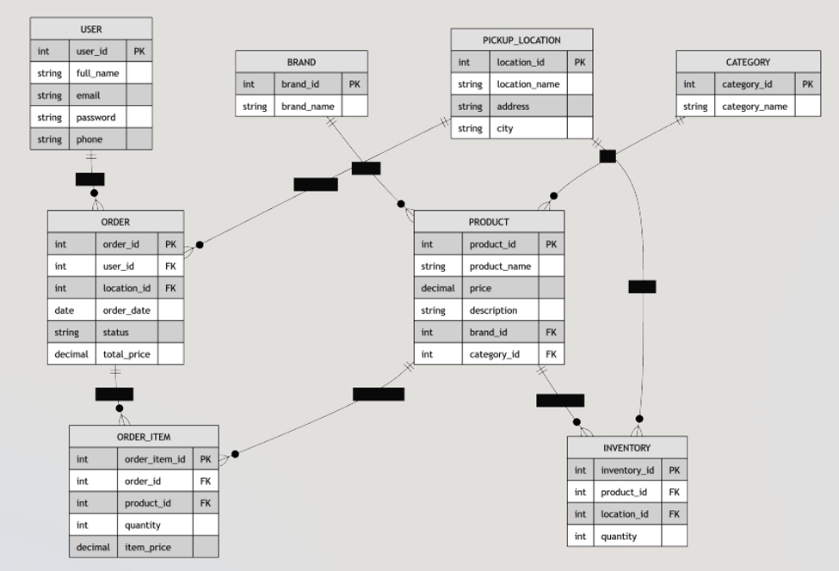
Figure 1. ER Diagram - QuickStop Essentials

Implementation Note
For the planning document, the ER diagram uses USER and ORDER as entity names. During Spring Boot/JPA implementation, the team may use safer class names such as AppUser and CustomerOrder to avoid confusion with reserved database terms or framework classes.

4. UI Layout / Wireframes
The application will include the main pages required by the assignment: Home/Dashboard, List View, Create Form, and Login. The group also planned extra screens for product details, shopping cart, and order confirmation because they fit the e-commerce flow.

1. Home / Dashboard Screen
------------------------------------------------
QuickStop Essentials
------------------------------------------------
Need something fast today?
Select Pickup Location:
( ) Downtown Toronto QuickStop
( ) North York QuickStop
( ) Scarborough QuickStop
Categories
[ Auto Essentials ]
[ Personal Care ]
[ Tech Essentials ]
[ Basic Clothing ]
[ View Products ]
------------------------------------------------

2. Product List View
------------------------------------------------
Products Available
------------------------------------------------
Location:
Downtown Toronto QuickStop
[ Search Products ]
Auto Essentials
Motor Oil
$12.99
In Stock: 8
[ Add to Cart ]
USB-C Car Charger
$14.99
In Stock: 12
[ Add to Cart ]
Phone Holder
$19.99
In Stock: 5
[ Add to Cart ]
[ View Cart ]
------------------------------------------------

3. Product Details Screen
------------------------------------------------
Product Details
------------------------------------------------
Product:
Motor Oil
Brand:
Castrol
Category:
Auto Essentials
Price:
$12.99
Available Stock:
8 Units
Description:
High-quality motor oil for quick vehicle maintenance.
Quantity:
[-] 1 [+]
[ Add to Cart ]
------------------------------------------------

4. Create Product Form
------------------------------------------------
Create New Product
------------------------------------------------
Product Name:
[ ]
Brand:
[ Select Brand ]
Category:
[ Select Category ]
Price:
[ ]
Description:
[ ]
Initial Stock Quantity:
[ ]
Pickup Location:
[ Select Location ]
[ Save Product ] [ Cancel ]
------------------------------------------------

5. Login Screen
------------------------------------------------
Login - QuickStop Essentials
------------------------------------------------
Email:
[ ]
Password:
[ ]
[ Login ]
Do not have an account?
[ Register ]
------------------------------------------------

6. Shopping Cart Screen
------------------------------------------------
Your Cart
------------------------------------------------
Pickup Location:
Downtown Toronto QuickStop
Motor Oil x1 $12.99
USB-C Charger x1 $14.99
--------------------------------
Total: $27.98
--------------------------------
[ Place Order ]
------------------------------------------------

7. Order Confirmation Screen
------------------------------------------------
Order Confirmed
------------------------------------------------
Thank You!
Order Number:
1001
Status:
Ready for Pickup
Pickup Location:
Downtown Toronto QuickStop
100 King St W
Toronto, ON
Items:
- Motor Oil
- USB-C Charger
[ Return Home ]
------------------------------------------------

5. GitHub Repository and Initial Project Setup

GitHub Repository Link
[Paste the final GitHub repository link here before submission]

Repository Content
- README.md with project description, team roster, features, and run instructions.
- ER diagram image for the domain model.
- Wireframe images or wireframe document for UI planning.
- Initial Spring Boot project structure.
- Source folders for controllers, models, repositories, services, and templates.

Planned Spring Boot Dependencies
Dependency | Purpose
Spring Web | Build web controllers and routes.
Thymeleaf | Create server-side HTML pages.
Spring Data JPA | Connect Java entities to the database.
Spring Security | Support login and user management.
Spring Data REST | Expose repository data as REST endpoints if needed.
H2 Database or MySQL Driver | Store project data during development and testing.

Suggested Project Folder Structure
quickstop-essentials/
|-- README.md
|-- docs/
| |-- er-diagram.png
| |-- wireframes.docx
|-- src/
| |-- main/
| | |-- java/com/quickstop/essentials/
| | | |-- controller/
| | | |-- model/
| | | |-- repository/
| | | |-- service/
| | |-- resources/
| | | |-- templates/
| | | |-- static/
| | | |-- application.properties
|-- pom.xml

How to Run the Project
- Clone the GitHub repository.
- Open the project in IntelliJ IDEA or Visual Studio Code.
- Make sure Java and Maven are installed.
- Run the Spring Boot application.
- Open the browser and go to http://localhost:8080.

6. README.md Draft
The following text can be used as the starting README.md content inside the GitHub repository.
# QuickStop Essentials
## Project Description
QuickStop Essentials is a mobile-friendly e-commerce platform for urgent daily products. Users can choose a nearby pickup location, view available products, place an order, and pick it up quickly.
## Course Information
Course: CPAN-228 Web Application Development
Assignment: Assignment 0 - Project Planning & GitHub Setup
Group: New Group 8
## Team Members
- Amber Forrest
- Garv Dugh
- Murat Sasmaz
## Chosen Category
Category 1: E-Commerce Platform
## Main Entities
- User
- Product
- Brand
- Category
- Inventory
- Pickup Location
- Order
- Order Item
## Main Features
- Select pickup location
- Browse product categories
- View product list
- View product details
- Add items to cart
- Place pickup order
- Create product records
- Login and user management
## Planned Technologies
- Spring Boot
- Spring Web
- Thymeleaf
- Spring Data JPA
- Spring Security
- Spring Data REST
- H2 Database or MySQL
## How to Run
1. Clone the repository.
2. Open the project in IntelliJ IDEA or Visual Studio Code.
3. Run the Spring Boot application.
4. Open http://localhost:8080 in the browser.

7. Conclusion
QuickStop Essentials is a practical e-commerce platform that focuses on urgent daily products and quick pickup locations. The idea is different from a basic warehouse project, but it still stays simple enough to build step by step during the semester.
The project supports the main CPAN-228 learning goals because it includes CRUD operations, domain relationships, Thymeleaf pages, database integration with JPA, and future login/security features.

