01- Basic ECG Analysis
Create a PQRST block detector for the smoothed ECG signal.
1- Create a moving smoothing function. Please smooth the signal to an extent where it does not lose its characteristics.
2- Determine PQRST keypoint on the smoothed signal.
3- Calculate the time intervals of the following intervals
In the same block: PQ, QR, RS, ST, PT
In sequential blocks: PP, QQ, TP
4- Submit python script about above instructions
5- Submit a report containing images showing that the specified operations have been carried out. Your report must be in PDF format.

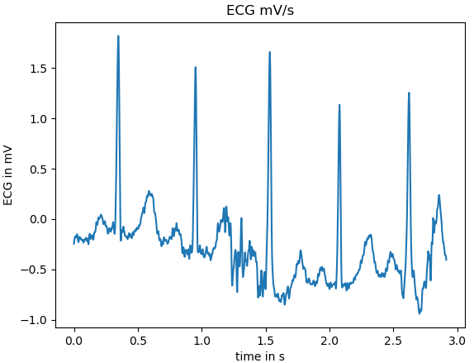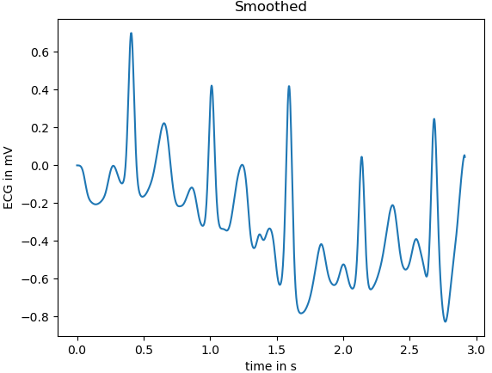
I have used a general use moving average function with width, iteration and not shortening with added zeros as buffer. I have used width of 5 to make sure the signal is not smoothing over the signal. Then I used the iteration to smoothen the signal for PQRST detection.
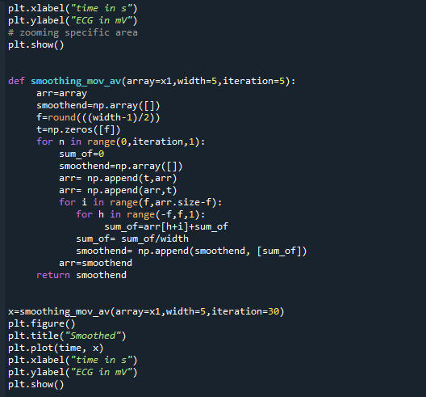

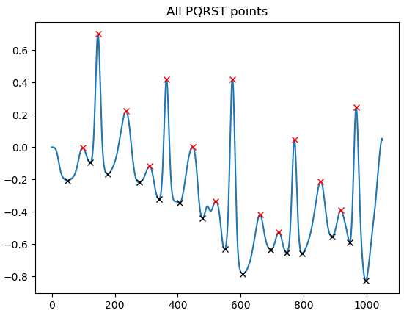
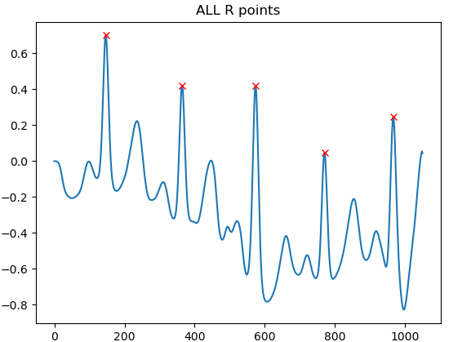
I have then used higher distance “peak_find” to find the R points and used a lesser distance “peak_find” to find P, R , T waves then used “peak_find” function to find Q and S waves.
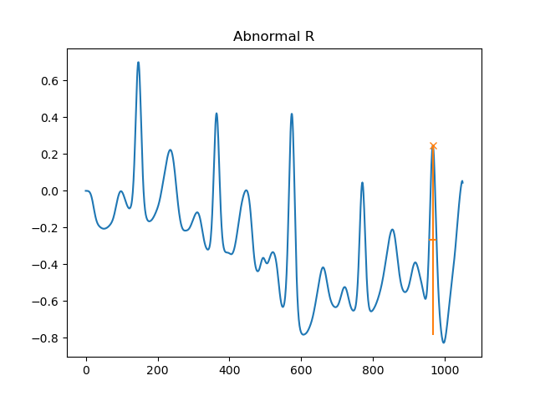
I have used peak_find to abnormal R peaks and Abnormal S peaks which I have eliminated them for accurate readings.
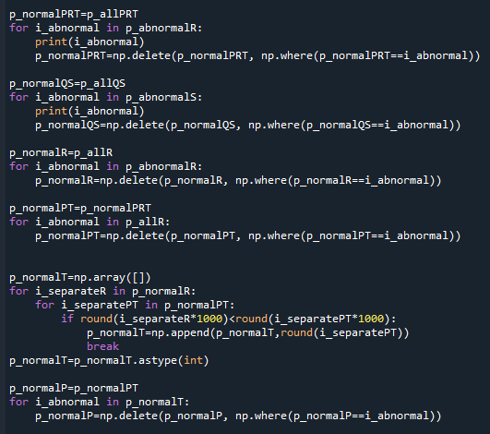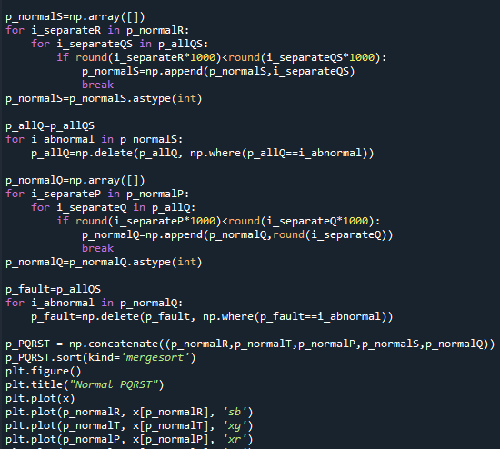
First separating PRT and abnormal R to test then splitting them all each elements by using R as a guide. I have then used merge sort to show each point highlighted right below. 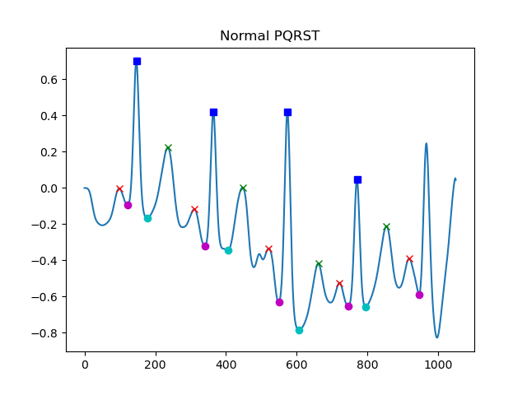
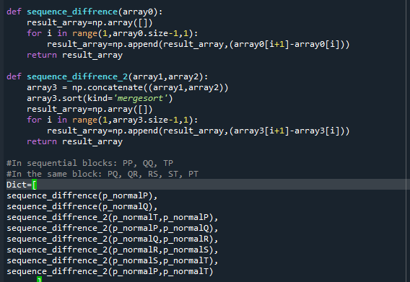
Writing two functions to handle each requested time intervals, I used concatenate to make an array and take differences of time between them. Using Spyder development tool as I have shown below, taken time intervals are in 360Hz, Sampling size of 0 to are as follows.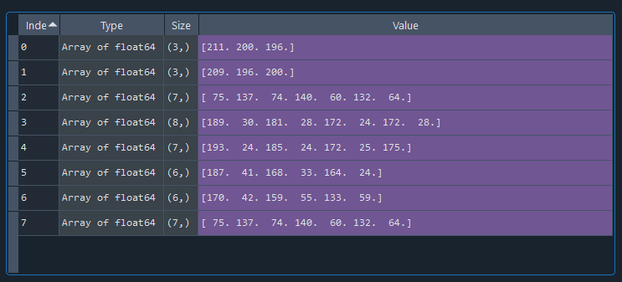
P to P ,Q to Q ,T to P ,P to Q ,Q to R ,R to S ,S to T
Right Below are in 360Hz, Sampling size of 0 to 20000
