CSE102-156-22325-1399932-Final Assignment-201805044-Murat Tan

Instructions

(5 pts) Define a product struct as in Figure 1.

The content of “products.txt” is shown in Figure 2. Each line contains product id, product name product unit and product quantity properties separated by commas.

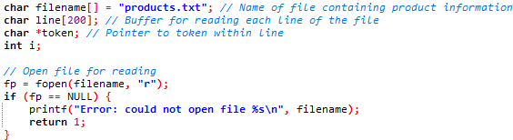(10 pts) Read the product information from “product.txt” file and add each item to struct product array

(10 pts) The program provides a command-line menu as in Figure 3, which prompts the user for input and displays output. The menu must be printed again and again after each operation. The user can select from the following options:

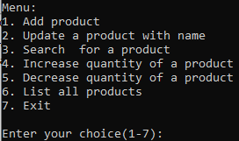1. Add a new product

2. Update a product

3. Search for product with name

4. Increase quantity of a product

5. Decrease quantity of a product

6. List all products

7. Exit / Quit the program

(20 pts) If user select adding a new product. This function prompts the user for information about a new product and adds it to the product array as in Figure 4.

(20 pts) If the user selects updating a product, option 2 prompts the user for the product numbers to update, and then prompts the user for the new product information. The product with the specified product number is then updated in the product array. Update operation sample screenshot is in Figure 5 and the updated list may be seen in Figure 6.

(10 pts) If the user selects searching the products by the name. This option prompts the user for a name and searches the product array for the matching ones. The matching products are then displayed to the user (Figure 7).

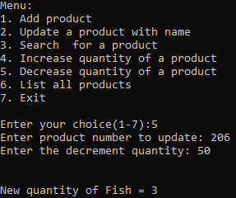(5+5 pts) If the user select increasing/decreasing the quantity of a product. The user is prompted to enter product id to increase/decrease quantity. Sample screenshots may be seen in Figure 8 and Figure 9 respectively.

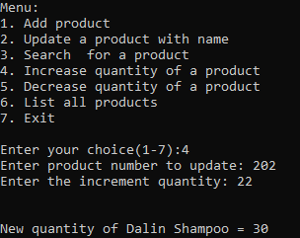

(10 pts) If the user selects listing all the products, products must be listed as in Figure 10.

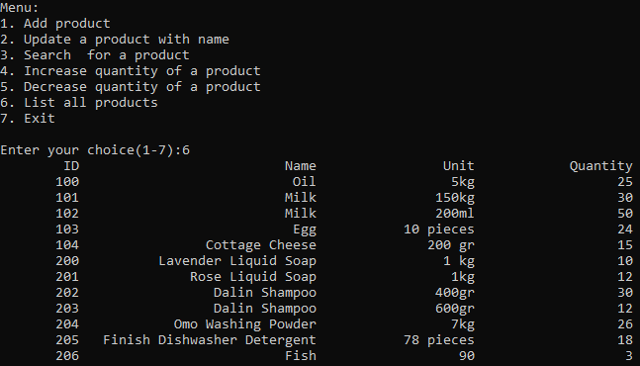

(5 pts) If the user selects “Exit” option the program must end.

For any case add the screenshot of your running program outputs , in case that I could not run your code in my computer i can check the correctness.

