Node.js Developer
Technical Assessment Documentation



Murat TUNÇ
Senior Back-End & Cloud Software Development Engineer
Golang -NodeJS-Java & React-NextJS with Linux Based Microservices
📍 Istanbul, Turkey – Kadıkoy | 📧 murat.tunc8558@gmail.com | 📞 +90 (531) 731-58-54
🔗 GitHub | LinkedIn | 🌐 Dev.to | Medium

📘 Documentation Index

1. Introduction .......................................................... 3

2. System Overview .................................................. 4

3. Architecture Diagram ........................................... 5

4. Building Tools……….. ...........................................6

5. API Gateway .......................................................... 4

6. Microservices Description
6.1. Order Service .....................................................5
6.2. Inventory Service ...............................................6
6.3. Notification Service .......................................…7

7. Order Service Database ............................……... 17

8. RabbitMQ UI………………............................…..19

9. Logging............................…………………………21

10. Environment Configuration………………........22

11. GitHub Repository ..............................................22

12. Integration Tests……………...............................25

INTRODUCTION

In this study, I will try to briefly explain the micro service architecture that I designed in the Node.js environment using RabbitMQ and Redis storage methods. I will definitely have some shortcomings, please send your feedback to my contact information, I would be very happy. Good readers in advance.



SYSTEM OVERVIEW

I divided the system into 2 parts to make it easier to understand, you can think of it as the door and the inside of the room.The part on the left side performs the necessary checks on the http requests coming from the user and forwards them to the RabbitMQ queue structures. On the right side, there are micro services. Each micro service can work independently. This is also event-driven microservices architecture powered by RabbitMQ for asynchronous communication between decoupled services.

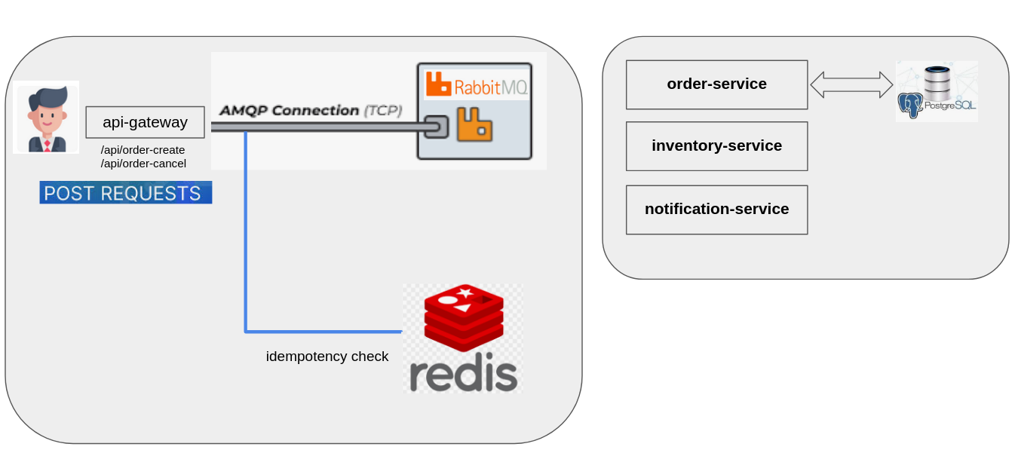

From the API Gateway, the order information is published into four distinct RabbitMQ channels: one for new orders, one for cancellations, and their respective Dead Letter Queues (DLQs). These channels are consumed by the Order Service, which handles storing the order in its database and emits an order.created event to the order-events exchange. It also listens for cancellations via a separate queue and emits an order.cancelled event when needed.

ARCHITECTURE DIAGRAM

When we look at the system architecture, a flow occurs in the following structure.

First Part
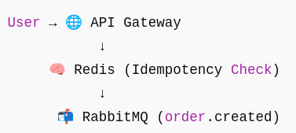

Second Part
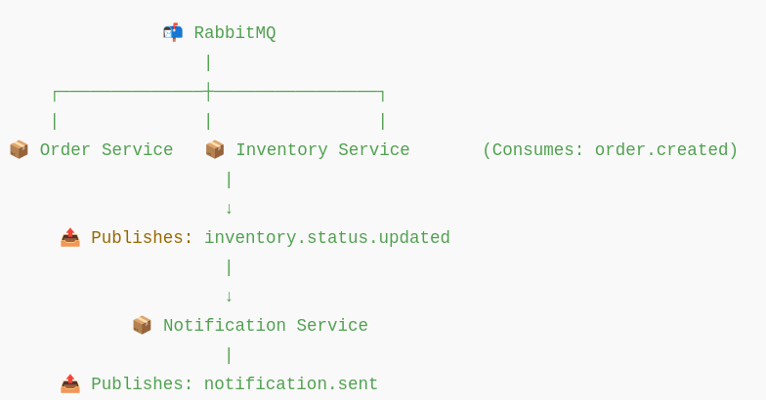

BUILDING TOOLS

All services rabbtimq and redis services, all settings of the postgres database are in the .env file. docker-compose.yaml, Makefile and Project Typescript files also read variable values ​​in the .env file.In order to prepare the runtime environment (for Makefile and compose.yaml file), the prepare_development_pc.sh script must be run.

📁 build-tools
├── 📄 .env
├── 📄 docker-compose.yaml
├── 📄 init-order-db.sql
├── 📄 integration-test.sh
├── 📄 Makefile
├── 📄 prepare_development_pc.sh

Project compilation diagram
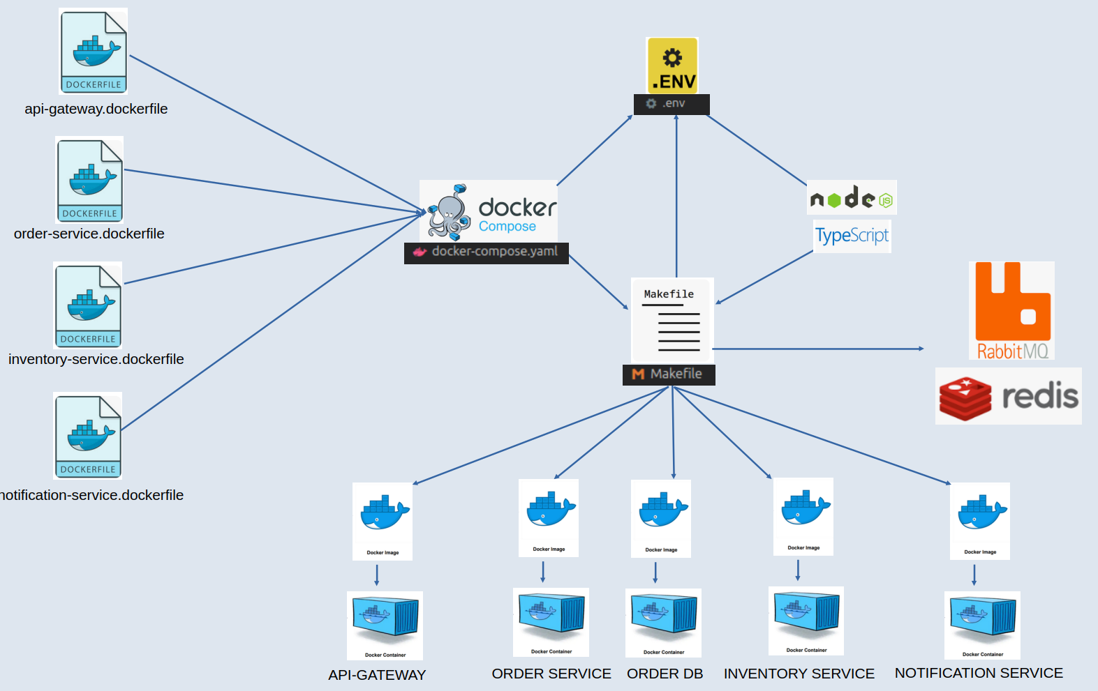

MICROSERVICE DESCRIPTION

There are 3 micro services operating on the backend side. These are order-service, inventory-service and notification-service.

API-GATEWAY
The api-gateway service receives http requests coming from outside the application, uses the redis service for idempotency compliance, stores the "idempotency_key" value coming with the post request in redis, and prevents the same request from being processed repeatedly.

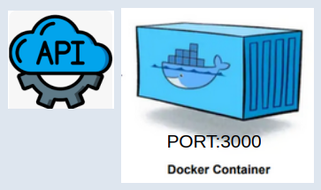
📁 api-gateway
├── 📄 api-gateway.dockerfile
├── 📁 node_modules
├── 📄 package.json
├── 📄 package-lock.json
├── 📁 src
│ ├── 📁 config
│ ├── 📁 handlers
│ │ ├── 📄 order-cancel.ts
│ │ └── 📄 order-create.ts
│ ├── 📄 index.ts
│ ├── 📁 middleware
│ │ ├── 📄 errorHandler.ts
│ │ ├── 📄 idempotencyMiddleware.ts
│ │ ├── 📄 loggingMiddleware.ts
│ │ └── 📄 requestLogger.ts
│ ├── 📁 models
│ ├── 📁 queues
│ ├── 📁 routes
│ │ └── 📄 routes.ts
│ ├── 📁 services
│ │ └── 📄 rabbitmqService.ts
│ └── 📁 utils
│ ├── 📄 custom-error.ts
│ ├── 📄 gracefulShutdown.ts
│ └── 📄 logger.ts
├── 📄 tsconfig.json

API Gateway architecture

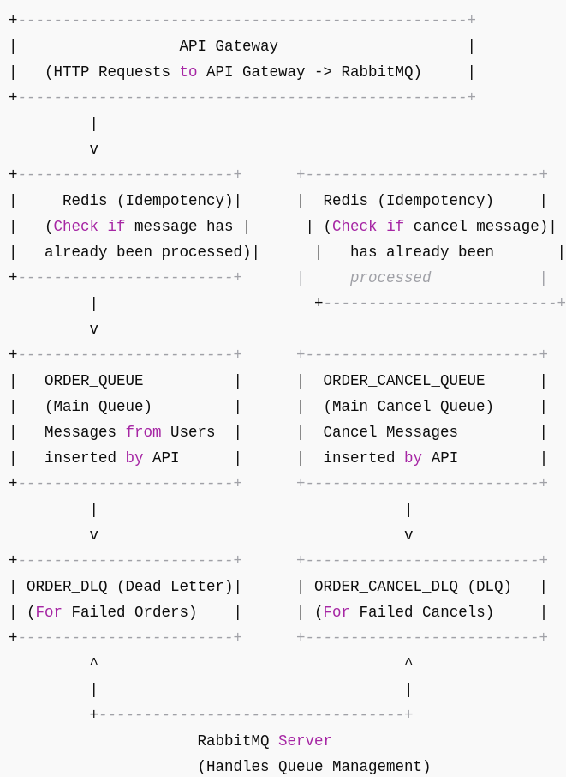

Gracefulshutdown handler:

App listens for OS signals (SIGINT, SIGTERM)
- When received, it:
- Closes the RabbitMQ channel
- Closes the HTTP server
- Logs cleanup results
- Exits the process
- If cleanup takes more than 10 seconds → force shutdown

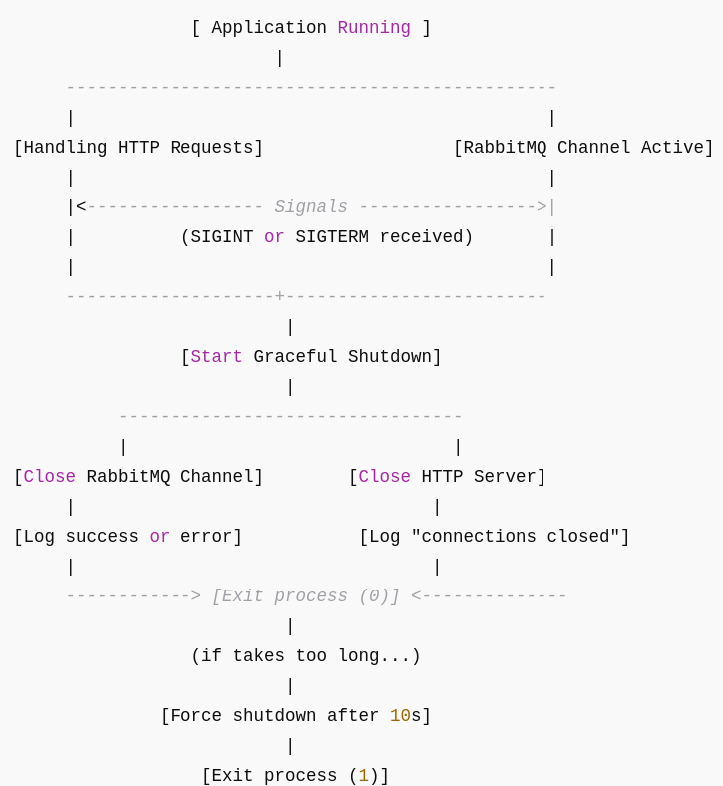

REDIS
The idempotency check happens here. If the request has been processed already (i.e., exists in Redis with a specific key), it prevents further processing. If not, it allows the request to proceed and stores the ID for future checks.

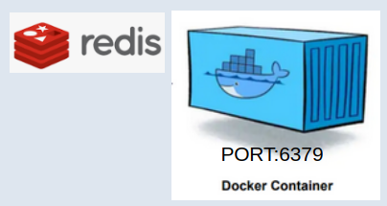

ORDER-SERVICE
Order-service receives data from 4 queues in rabbitmq. Requests coming from the user with api-gateway service are stored in 4 queues by api gateway service, and this stored information is absorbed by order-service.
Responsible for handling all aspects of order processing within the system. It listens to RabbitMQ queues for incoming order messages, including newly created orders and order cancellations. When a new order message is received from the orderQueue, it parses the data, saves the order to the database, and then emits an order.created event to notify other services—such as the Inventory or Notification services—about the new order. Similarly, it handles cancellation requests by consuming messages from the orderCancelQueue, processing the cancel data, and publishing an order.cancelled event.

This service also incorporates Dead Letter Queue (DLQ) consumers (orderQueue_DLQ and orderCancelQueue_DLQ) to ensure failed messages are not lost; it retries or logs them for further investigation. The event messages it emits are versioned (starting with v1) to support future evolution without breaking consumers. Overall, the Order Service acts as the entry point for order-related events in the system’s event-driven architecture, providing a clean and reliable interface for order lifecycle management.

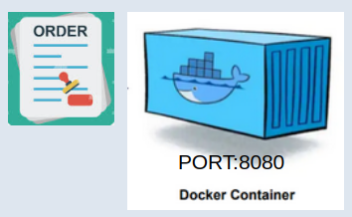
📁 order-service
├── 📄 order-service.dockerfile
├── 📁 node_modules
├── 📄 package.json
├── 📄 package-lock.json
├── 📄 tsconfig.json
└── 📁 src
├── 📁 config
│ ├── 📄 appconfig.ts
│ └── 📄 database.ts
├── 📁 handlers
├── 📄 index.ts
├── 📁 middleware
│ └── 📄 errorHandler.ts
├── 📁 models
│ └── 📄 order.ts
├── 📁 queues
│ └── 📄 orderConsumer.ts
├── 📁 routes
├── 📁 services
│ └── 📄 rabbitmqService.ts
└── 📁 utils
├── 📄 custom-error.ts
└── 📄 logger.ts

Event versioning:
├── 📁 queues
│ └── 📄 orderConsumer.ts

In this file, event versioning is handled by attaching a version field to every outgoing event message. The constant EVENT_VERSION is set to 'v1', and this value is used whenever an event is published to RabbitMQ. For example, when an order is successfully saved to the database, an order.created event is published with both the event name and version ({ event: ORDER_CREATED_EVENT, version: EVENT_VERSION, data: savedOrder.toJSON() }).
order-service architecture

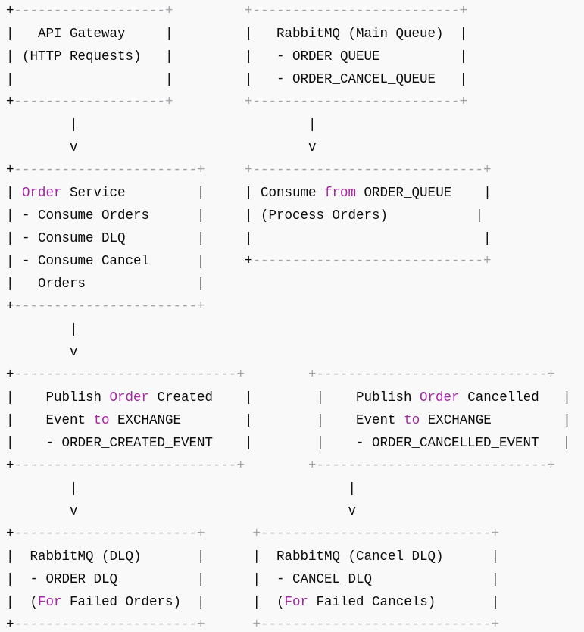

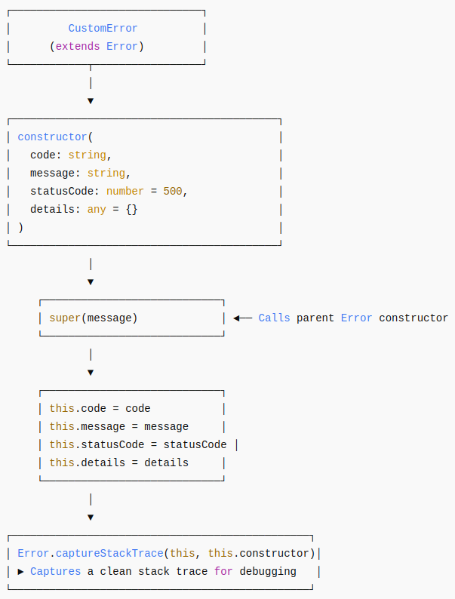
error handling:
└── 📁 utils
├── 📄 custom-error.ts

The CustomError class extends the built-in JavaScript Error class to create a more structured and informative error object tailored for our application's needs.

INVENTORY-SERVICE

The inventory-service is responsible for reacting to new orders placed in the system. When the order-service publishes an order.created event, the Inventory Service consumes this message through RabbitMQ. It processes the order data—typically checking whether the required items are in stock or simply simulating that action—and then generates a new event, inventory.status.updated, to communicate the outcome.
This event is published back to the message broker, specifically to the inventory-events exchange, where other services like the Notification Service can consume it.

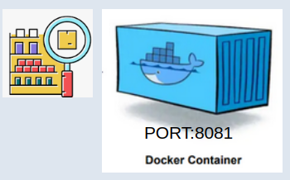
📁 inventory-service
├── 📄 inventory-service.dockerfile
├── 📁 node_modules
├── 📄 package.json
├── 📄 package-lock.json
├── 📄 tsconfig.json
└── 📁 src
├── 📁 config
│ └── 📄 appconfig.ts
├── 📁 handlers
├── 📄 index.ts
├── 📁 middleware
│ └── 📄 errorHandler.ts
├── 📁 models
├── 📁 queues
│ └── 📄 inventoryConsumer.ts
├── 📁 routes
├── 📁 services
│ └── 📄 rabbitmqService.ts
└── 📁 utils
├── 📄 custom-error.ts
└── 📄 logger.ts

inventory-service architecture

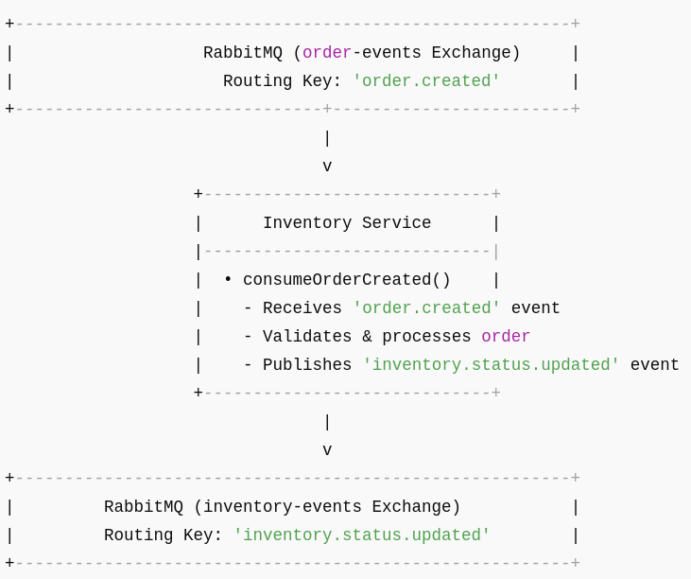

NOTIFICATION-SERVICE

The notification-service is designed to handle communication with users based on important system events. It listens for the inventory.status.updated event, which is published by the Inventory Service once it processes an order. When this event is received, the Notification Service interprets it—typically confirming that the inventory has been updated for a specific order—and then generates a follow-up event, notification.sent. This event indicates that a notification has been triggered, which could be used for logging, alerting users via email/SMS, or updating UI dashboards.

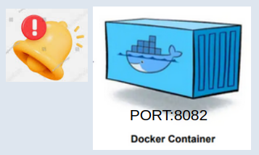
📁 notification-service
├── 📄 notification-service.dockerfile
├── 📁 node_modules
├── 📄 package.json
├── 📄 package-lock.json
├── 📄 tsconfig.json
└── 📁 src
├── 📁 config
│ └── 📄 appconfig.ts
├── 📁 handlers
├── 📄 index.ts
├── 📁 middleware
│ └── 📄 errorHandler.ts
├── 📁 models
├── 📁 queues
│ └── 📄 notificationConsumer.ts
├── 📁 routes
├── 📁 services
│ └── 📄 rabbitmqService.ts
└── 📁 utils
├── 📄 custom-error.ts
└── 📄 logger.ts

notification-service architecture

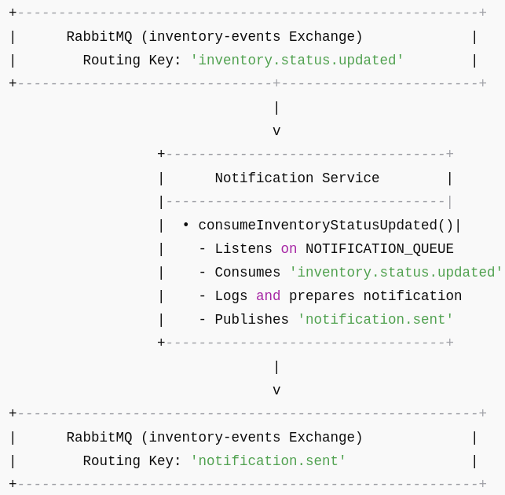

ORDER-SERVICE DATABASE

Schema:
📁 build-tools
├── 📄 init-order-db.sql

This SQL file is used to initialize the orders table in database. By using this script in the docker-compose.yaml file, a database volume is created while starting the order-db service.

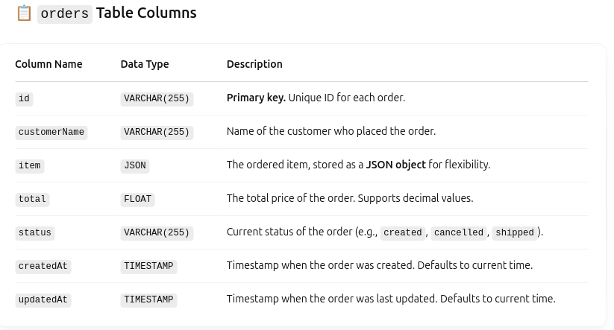

TypeScript:
📁 order-service
└── 📁 src
├── 📁 config
│ ├── 📄 appconfig.ts
│ └── 📄 database.ts

├── 📁 models
│ └── 📄 order.ts

order.ts:

This file defines the Order model using Sequelize, which is an ORM (Object-Relational Mapping) for Node.js and TypeScript.

Fields:
- id: Primary key, required
- customerName: String, required
- item: Changed from an array (items) to a single string field (item)
- total: A float (e.g., 99.99), required
- status: E.g., "created", "cancelled", etc., required

Options:
- sequelize: links to the DB connection
- modelName: internal name Sequelize uses
- tableName: actual name in DB
- timestamps: true: adds createdAt and updatedAt fields automatically
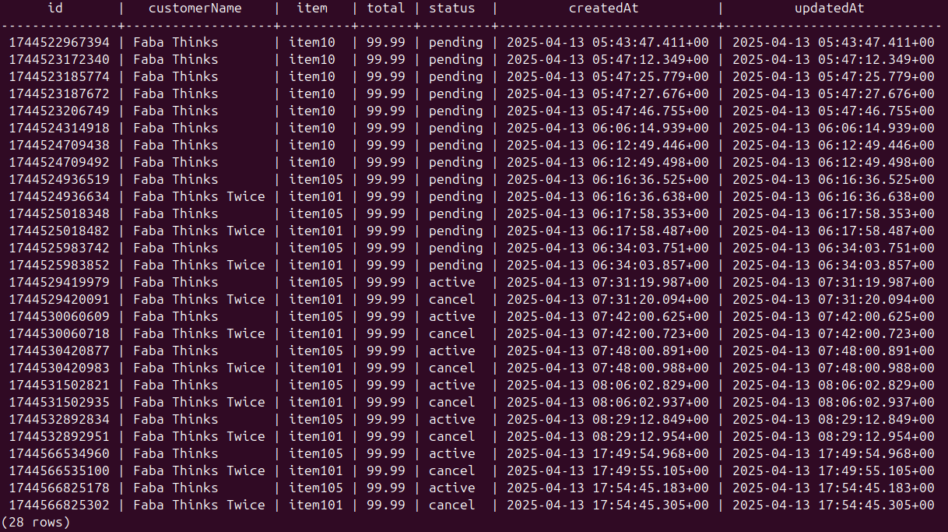

RABBITMQ UI

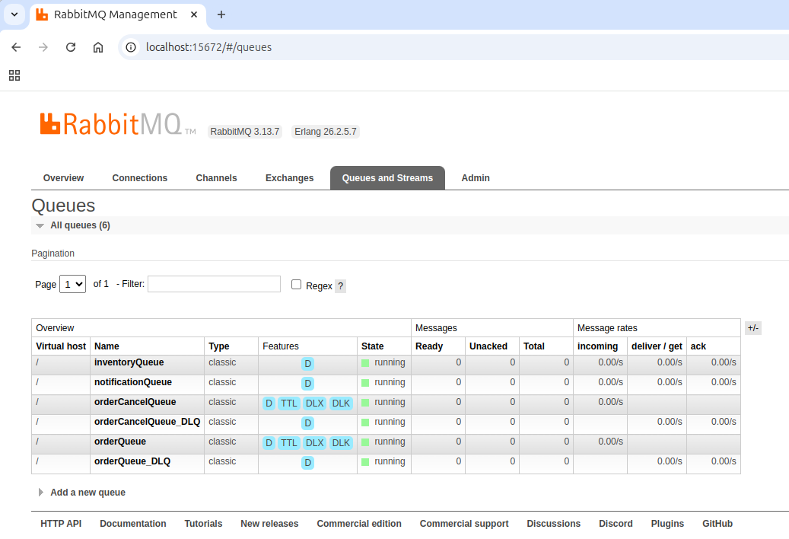

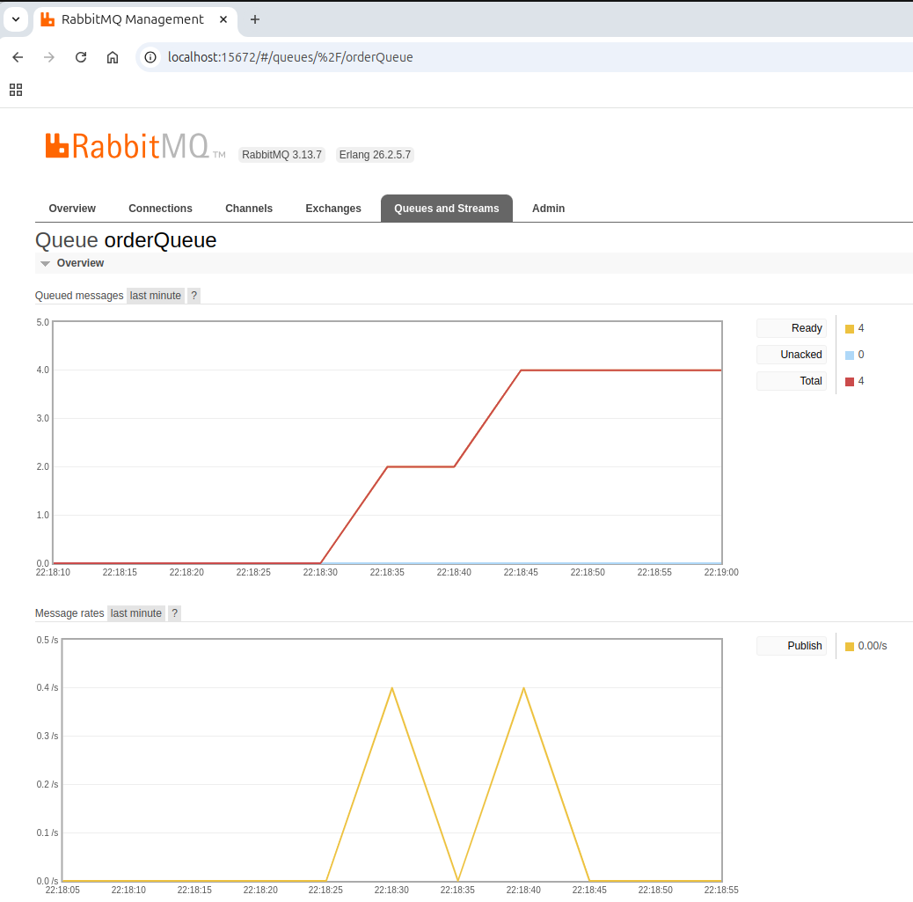
Run integration-test.sh:
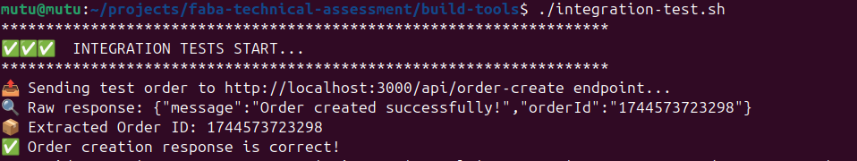
Get Messege(s):
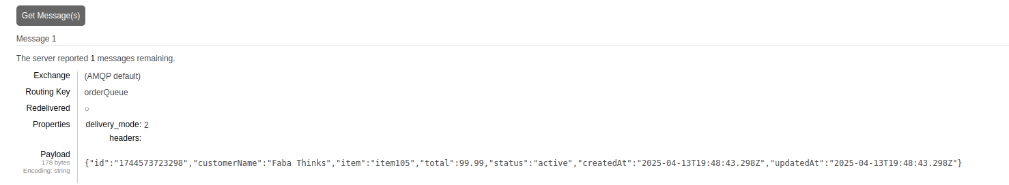

LOGGING

logger:
│ └── 📁 utils
│ └── 📄 logger.ts

The logger.ts file sets up a centralized logging system using the Winston library, which is a popular and flexible logging tool for Node.js applications. It begins by importing Winston, then creates a logger instance using winston.createLogger. This logger is configured to capture all log messages at the info level or higher (such as warn and error). For formatting, it combines a timestamp (formatted as YYYY-MM-DD HH:mm:ss) with a custom printf function that structures the log output to include the timestamp, log level, and the actual message.

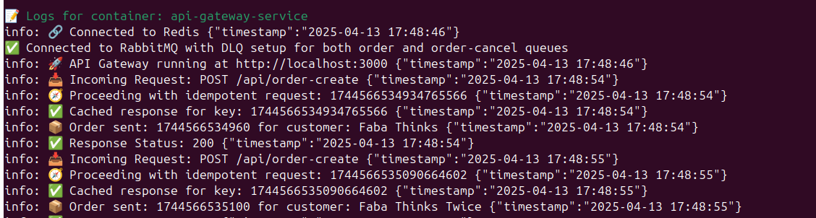

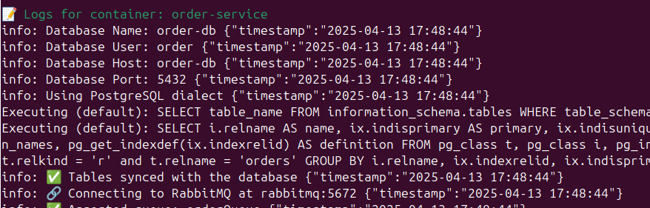

ENVIRONMENT CONFIGURATION
All service information is set permanently in this file.
📁 build-tools
├── 📄 .env

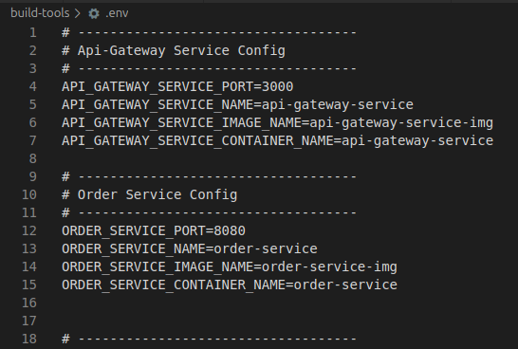

GIT HUB REPOSITORY

Follow the steps below to clone and run the project locally.

Clone the Repository:
You can use HTTPS or SSH to clone:

🔹 Using HTTPS:
git clone https://github.com/MuratTunc/faba-technical-assessment.git
🔹 Using SSH:
git clone git@github.com:MuratTunc/faba-technical-assessment.git

Install Dependencies:
Navigate to the project directory and install dependencies:
cd faba-technical-assessment
cd build-tools
sudo make -s build
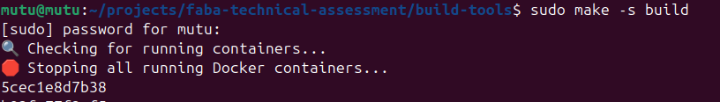
All services started to be compiled in order.
Like these:
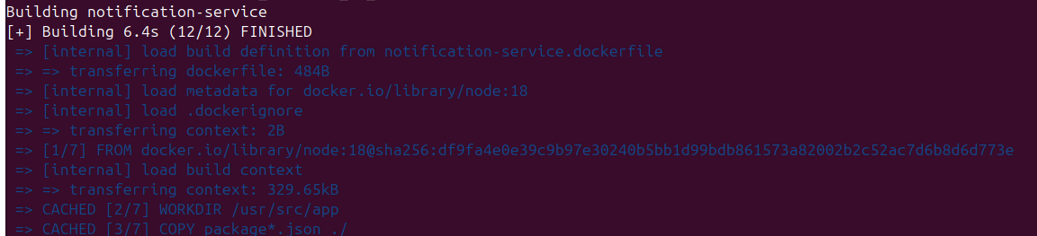

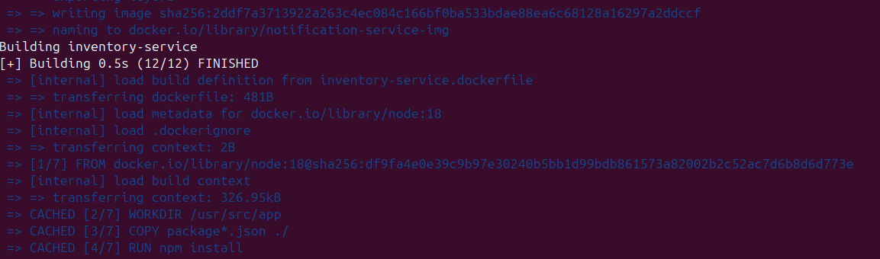

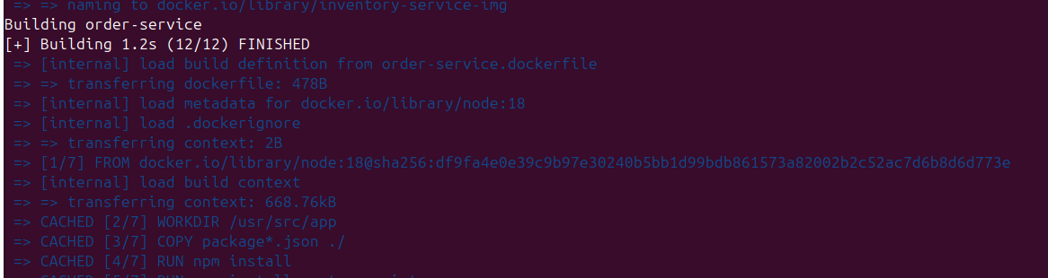
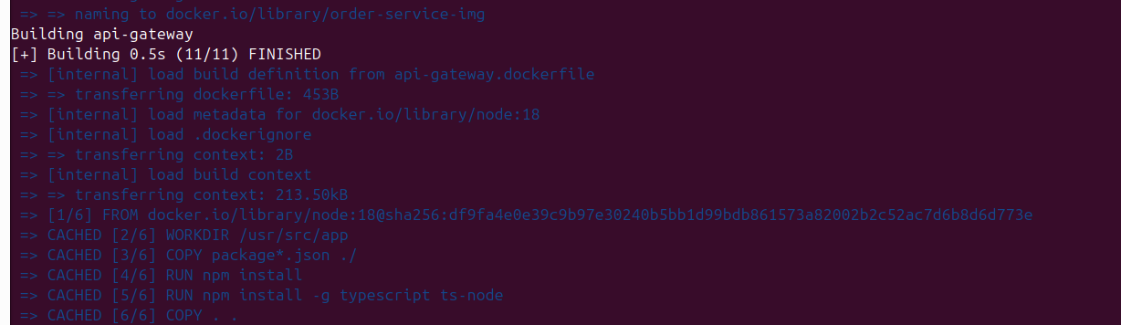

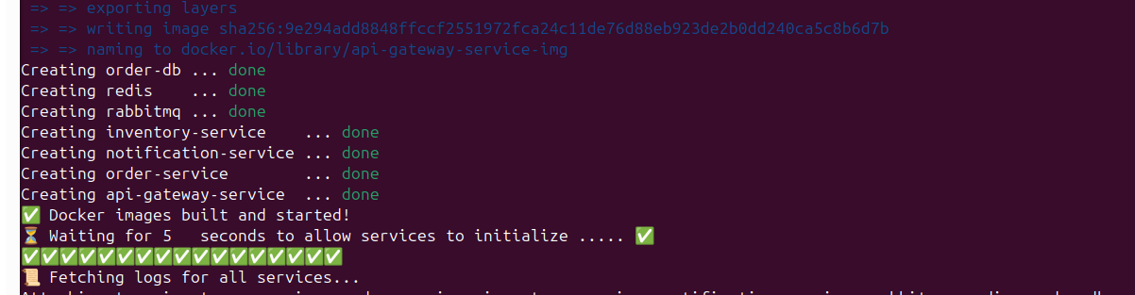
All services are ready.
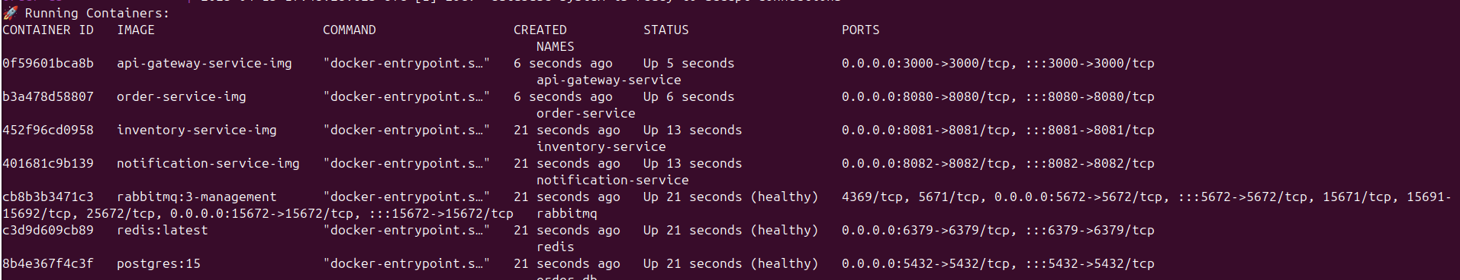

INTEGRATION TESTS
📁 build-tools
├── 📄 integration-test.sh

Sending Post Request to api-gateway service:
