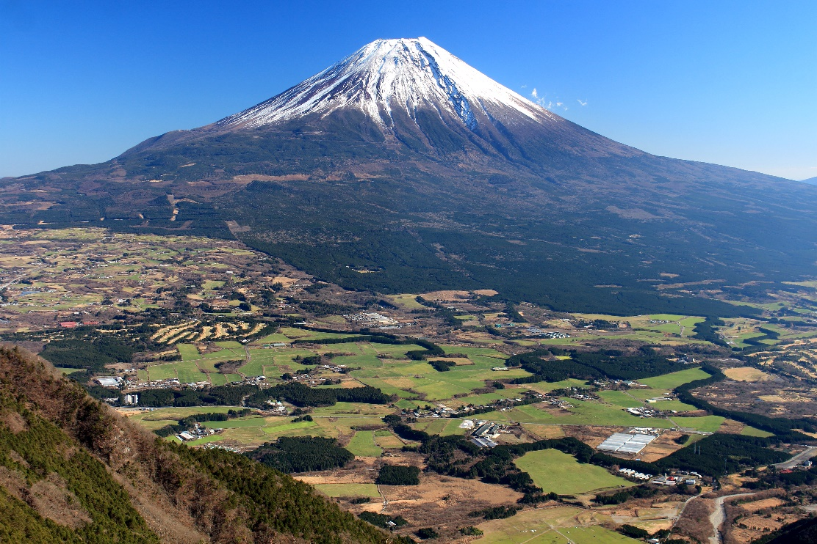CAB230 Assignment one­­

Mitchell Robert Benjamin

N11099887

CAB230 Assignment one

VolcanoNerd.com

Contents

Introduction 3

Purpose & description 3

Completeness and Limitations 3

Use of End Points 3

/countries 3

/volcanoes 3

/volcano/{id} 3

/user/register 3

/user/login 3

Modules Used 3

Application Design 3

Navigation and Layout 3

Usability and Quality of Design 3

Accessibility 3

Technical Description 3

Architecture 3

Test plan 3

Difficulties / Exclusions / unresolved & persistent errors / 3

Extensions (Optional) 3

User guide 3

References 3

# Introduction

## Purpose & description

VolcanoNerd.com is a website designed to simplify accessing volcanic data for people who love volcanoes! You can search by country as well as population radius.

In my implementation of this assignment, I focused on design using the MUI framework to work with material design in react, using coolors.co for assistance with color selection.

For my CSS I elected to make use of CSS modules to make styles easier to deal with.

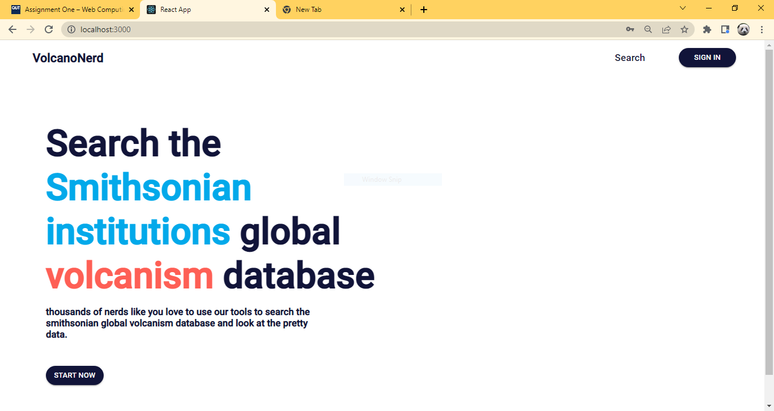

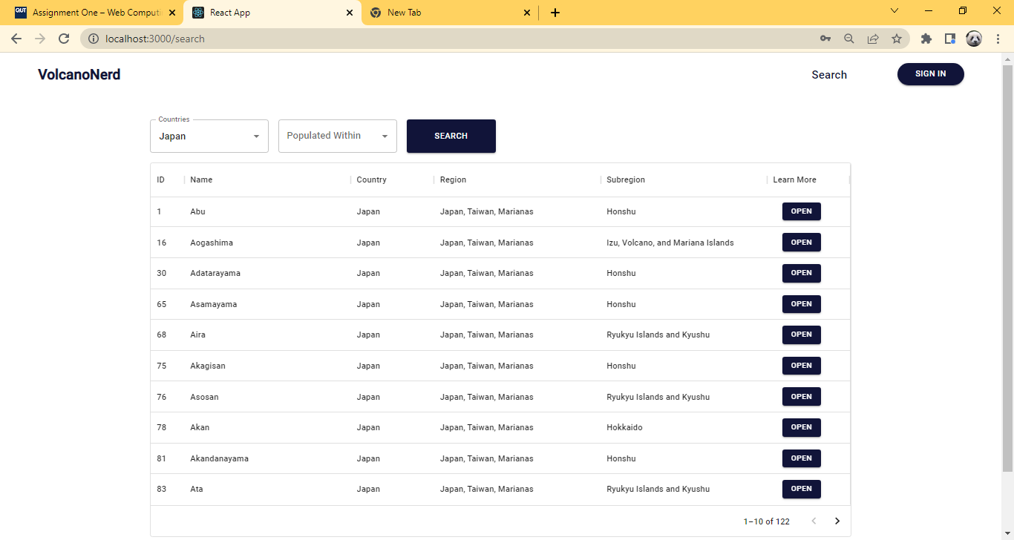

## Completeness and Limitations

During this assignment I implemented all the endpoints, utilised react router for navigation, made use of controlled inputs in my login and register form as well as implementing map and graphing components in my volcano page, one item which I failed to implement was I originally wished to have a hero element like the one on stripe.com with a tilt spanning the header and a moving colour background.

I was unable to implement this not due to lack of time but lack of skill or understanding.

# Use of End Points

### /countries

### /volcanoes

### /volcano/{id}

### /user/register

### /user/login

# Modules Used

# Application Design

## Navigation and Layout

## Usability and Quality of Design

## Accessibility

# Technical Description

## Architecture

## Test plan

## Difficulties / Exclusions / unresolved & persistent errors /

# Extensions (Optional)

# User guide

# References