# General

## 3D Secure Failed:

Sorry for replying in English. Since we cater to so many countries and strive to offer lowest prices available we only offer support in English.

Your order was automatically cancelled because payment was not completed.

You need to enable 3D Secure to make safe purchases online. Your payment was declined because you did not pass 3D Secure.

To enable 3D Secure for your card you must contact your bank and ask them to enable it. This protection is for your own safety when you make purchases online.

Once enabled, please place a new order and complete the payment.

​

No payment has gone through, if your bank shows that it's attempted it may be in Pending state only. But it has not been approved.

## Why price different from the manufacturer

The reason is we buy in larger quantities and therefore receive discounts from manufacturers. These discounts we pass on to customers.

We are proud authorized distributors for Storz-Bickel since 2013. You can always send an email to info@storz-bickel.com and they will also confirm it:)

## Bank payment IBAN:

Sorry for replying in English. Since we cater to so many countries and strive to offer lowest prices and fastest support available we only offer support in English.

We do offer payment by bank transfer.

Add the products you want to order to your cart and proceed to the checkout to see the final amount. Enter your name and address details. Select payment method Trustly. Note down the amount you have to pay and proceed to place your order.

It will redirect you to a payment page. Just close this page.

Make the payment to below account:

Receiver: Anything Worldwide AB

Iban: SE6450000000054238206096

Bic-code: ESSESESS

Bank: Skandinaviska Enskilda Banken

Write a message with your name also.

​Send me a picture of your bank transfer receipt once payment has been done so we can process it faster. We will ship your order the same day the payment arrives and tracking will follow at 19:00.

## Edit address - Changed - Corrected:

Sorry for replying in English. Since we cater to so many countries and strive to offer lowest prices and fastest support available we only offer support in English.

We have corrected the address in the system but unsure if UPS manages to update it before attempted delivery. However it should be fine anyway we believe, just keep an extra eye on your tracking link so if any issues arise you can contact UPS directly to resolve it later.

## Hides wrapping paper cardboard:

The batteries usually hide inside the layer of the wrapping paper or behind the sidewalls of the box we shipped with. Can you please confirm the wrapping has been taken out and looked for carefully between each layer?

## Thanks and Trustpilot review:

We are glad everything is clear and confirmed now.

Please enjoy your time using your device and If there's anything else we can help you with please do not hesitate to ask!

If you are satisfied with our level of service, please find some time to write a review here: <https://www.trustpilot.com/review/magicvaporizers.com>

It would really mean a lot for us as a store. :)

Have a great day=)

## Jersey VAT Costs why:

The price to Jersey is £235 including 0% VAT. When you enter your postal code you will see the VAT valued at 0.

The reason for the more expensive price excl VAT is because the paperwork and shipping costs for us to Jersey are high and therefore the price ex vat is different there to cover that part or otherwise we would not be able to ship to Jersey at all.

While within the UK it is £235 including 20% VAT instead.

## Looking for Dry herb vaporizer:

Let me assist you here :)

Please share the following information with me so that I can provide some good units for you:

- Budget? How much are you willing to invest in one

- How many times per day do you plan to use it?

- Do you want to control the vaporizer from the unit or do you want to have bluetooth connection and an app on your phone to control it?

- Are you experienced since before or will this be your first vaporizer?

- Do you plan to vape oils/waxes also or just dry herbs?

## We recommend vape:

Hash or concentrates/waxes needs higher temperatures which only 2 brands can offer. Also they become sticky and messy when vaping. I would advise you to check out the following two.

1. Hydrology 9NX which is designed for it and includes a special chamber. <https://magicvaporizers.co.uk/hydrology-9-nx>

or

2. DynaVaps which use a torch and you can control the temperatures here. <https://magicvaporizers.co.uk/dynavap-vaporizers>

​

Otherwise most other vaporizers (such as Mighty) can vape both with concentrate pads or packing them in special way but you will have limitation of temperature reaching to about 230C maximum​ but also they can mess up the chamber if not used correctly. You need to use concentrate pads, or sandwish packs, or hemp fibre to put the hash on because so when it melts it can be easily removed and your chamber will be kept clean.

## Newest version date:

We mention the date the product arrives at our warehouse from the manufacturer and not when it was released to the market.

This is a requested feature from our visitors because it also tells that the device has a fresh battery inside and fresh seal rings.

If a device has been sitting on a shelf for months/years the seal rings can dry out but also the battery can lose its capacity and not perform as it should be doing. By making sure you buy something with a newer date you can also rest assured that you have a fresh product in your hand that will last longer :)

## No PayPal:

​There are some issues with PayPal at the moment.

They sent us a letter asking us to define if our products can be used with tobacco or not since tobacco related products are banned with PayPal.

We have therefore temporarily halted this payment option until the matter is cleared as we can't risk accepting meanwhile. Please place your order by card payment instead for the time being.

## No Promo or Discount code

We do not work with any promo codes and instead provide the best prices possible all the time. If we were able to offer a better price we would do it for all customers at the same time without using any promo codes, force users to sign up to newsletters or other traditional methods :)

Keep in mind, accessories receive a 25% discount automatically when purchased together with a vaporizer.

## No visible vapor

Most likely you are using it wrong. Visible vapor is also never a guarantee when using a vaporizer as it depends on many factors such as grinding, packing method, inhalation technique, quality of herbs, temp used and so on. It is not a method of deciding if a product is working well or not. The color of your herbs after your session decides that. A vaporizer is meant to extract the active ingredients of your material as efficiently as possible with the best possible flavors, not just to produce the thickest vapor possible.

You mention that there is no visible vapor at 170C, that is completely normal. Visible vapor needs 190C or more. As an example, one of the best stationary vaporizers – the Volcano Classic – which concentrates all the vapor to a balloon, can produce balloons with vapour you can’t even see at 180°C, but it can also produce balloons with vapour as white as milk at the higher temperatures (215°C+).

I will give you some advices on usage and perhaps you can get better results:

If you are using it the first time, you need to do a burnoff. Burn off means, you need to set the vaporizer to maximum temperature and run it a full session without any herbs inside.

You make a complete clean

Set temperature again to maximum temperature and run it again for a full session.

Make a complete cleaning again where you clean the chamber also. Make sure you blow in the mouthpiece as well to clear the path completely.

The reason is, when it comes from the manufacturer they protect the chamber with a coating, this coating is burned when you use the vape the first time which can make the effect less.

Regarding the packing:

You need to fine grind your herbs first.

Pack the oven full and tight meaning use your finger to press down the herbs in the pod . Most likely you are loosely packing it.

Set temperature to 193C

Once it reaches temperature let it sit for another 20-30 seconds. Most likely you started vaping when it reached the temperature directly.

Do slow inhales for about 10-15 seconds, think of it as you are sipping coffee. At this speed. :)

You can increase the temperature by +5C after some inhales to get the most out of your herbs.

Let me know how that went now.

## Out of stock - Sign up for stock alert

Our next delivery will be in about 6 weeks from now :(

You could enter your email in the product page of what you are interested in and you will be notified by mail when it's back in stock again.

## Please contact our wholesale department

This is the consumer side of MagicVaporizers. Please contact our business wholesale department directly on wholesale@magicvaporizers.com

Ask for Peter, and he will assist you further regarding any questions or account issues you may have :)

## Sorry about your experience - While we try to do everything on time

Sorry about your experience. While we try to do everything on time from our side we can only have fingers crossed for the delivery companies to do theirs. However it is pretty much out of our control and it does not matter which courier company we use. DHL, Fedex, UPS, Schenker they are pretty much all the same with UPS least worst of them all.

## Replacement Granted

Thanks for reaching back!

I've arranged a replacement order to be shipped out to you ASAP.

You will get your tracking information by email as soon as it gets shipped.

If you are satisfied with our level of service, please find some time to write a review here: <https://www.trustpilot.com/review/magicvaporizers.com>

It would really mean a lot for us as a store. :)

## Support in English only

Sorry for replying in English. Since we cater to so many countries and strive to offer lowest prices and fastest support available we only offer support in English.

## Bank transfer option

Thanks for reaching out and for your inquiry!

We apologize for any misunderstanding caused by our web page. It serves all of the EU at the same time, but payment options differ for some countries.

You can pay via bank transfer by purchasing through our international version of the website.

​

Please visit <https://magicvaporizers.com/> and order from there.

​

I hope that was helpful. Looking forward to your order.

Have a great day =)

## Switzerland why VAT

The price to Switzerland is including 0% VAT. When you enter your postal code you will see the VAT valued at 0.

The reason for the more expensive price excluding VAT is because of the export paperwork and shipping costs for us to islands are high and therefore the price ex vat is different there to cover that part or otherwise we would not be able to ship to Switzerland at all.

## Too expensive

We would be glad to make a free shipment for you or throw some complimentary items, but unfortunately the situation is not in our favor from the beginning.

You see, we actually make a loss shipping accessories. We do it from company goodwill only to cater our customers.

Because we provide a door to door UPS service together with all shipments. The shipment is more expensive than we actually charge in reality.

I hope that was helpful. If there's anything else I can help you with please do not hesitate to ask!

Have a great day =)

## While we try to do - UPS are bad

Sorry about your experience. While we try to do everything on time from our side we can only have fingers crossed for the delivery companies to do theirs. However it is pretty much out of our control and it does not matter which courier company we use. DHL, Fedex, UPS, Schenker they are pretty much all the same with UPS least worst of them all.

It is anyway available for pickup at:

Hope you'll enjoy your order when you have it in hands after all

## Discounts:

Thank you for contacting us and for your interest in our products.

Unfortunately, we do not offer discounts. We are very proud of our low prices and our policy is not to give discount codes, unless they are available to everyone.

We are sure that our prices are among the best and almost always the best, that is why we also have a Price Match Guarantee

<https://magicvaporizers.com/price-match-guarantee>

I hope our efforts find your satisfaction. We assure you that you can buy with total confidence.

UPD: The store has a version for each country, so the URL must be modified every time until we have template versions in all languages

## Dead on Arrival item

If the device is dead on arrival it will be replaced to a brand new or refunded, no questions asked.

If the device develops a fault it will need to be sent back depending on the issue to be checked. Since you mentioned you wanted a Mighty Plus, this device provides error codes on display that shows if there is an issue with it or not. If there is an error code on display it means the device will need service or replacement. Since we are authorized distributors for Storz-Bickel we have partnered with them regarding service of their units. Any Storz-Bickel product will be sent to Storz-Bickel to confirm there is an issue and then replaced to a new one for future warranties to be valid. Return labels are issued for you to send it back in. For all other brands we sell, we service them ourselves but Storz-Bickel are special as they are used in hospital environments also and therefore they do have higher standards.

The extremely few customers who have complained about our service level have not told the full truth. They have either used it wrong, or connected it to a water attachment where water has come inside the unit and that caused damage and started to spread bad words. They correspond to less than 4% of all our reviews, and 96% have had a 5-star experience even in terms of warranty replacements. Some people expect large clouds of visible vapor and if they don't receive it they think the device is faulty when in fact the issue is how the device is used, how herbs are grinded and inhalation technique used. Such cases are not a matter of the device being faulty and for such cases we will decline replacement as the devices are behaving exactly as they should be behaving from the manufacturer. A replacement of the device will have the exact same experience.

## Can VAT be deducted if I buy as a business?

We want you to know that we would not be able to sell it to you without VAT anyway, even if you would order it to your company address.

The reason is we cater private consumers only and not businesses and therefor it would be sold to you as a private consumer still with VAT charged.

The only way for you to order as business from us is by registering an account for B2B trading, but then minimum quantities and minimum values would apply to your orders and also your company would have to be a registered vape-store.

We also don't try to hide our origin, and it is in fact written in all 3 pages in the footer.

<https://magicvaporizers.pt/sobre-nos>

<https://magicvaporizers.pt/informacao-de-envio>

<https://magicvaporizers.pt/informacao-da-empresa>

I hope this clarifies the issue for you. Thank you again for your purchase.

## No vapour - ask what type of herbs customer is using

Always check what type of herbs customers are using.

Customers complaining about newly delivered vaporizers that does not work or emmit any vapor it usually means they are using herbs that are not meant for creating vapor. and instead only for aromatherapeutical purposes and other state of mind effects. i think 9 out of 10 times it's usually this and this can only be found after gathering all details. Therefor it is in our interest to initially and directly ask for this type of information including maybe picture of the packaging of their herbs without sounding to accusatory intiailly. this is just so we can have all important information possible in case customers change story etc so we can refer back to it.

## Plastic taste

Foremost, it is crucial to do multiple burnoff sessions.

​Set the direct on the highest temperature and let it run for 5 minutes approximately, then clean the device with a q-tip dipped in alcohol, and make a complete clean. Repeat the procedure 2-3 times.

Also, we would recommend landing the ginger in the chamber and run for 5 min at the highest temperature. That helps to remove any smell. Please see below video and follow the guide here:

https://www.youtube.com/watch?v=1douUFXxefg

Let us know how it goes.

# Abstract UK

## Abstract return address UK:

To make a return:

Please return the items you wish to send back to:

Anything Worldwide

c/o Cloud

Unit 620 Fareham Reach,

Fareham Rd,

Gosport, PO13 0FW

Once you've shipped it you need to notify us so we can process the return.

Once received a full refund will be made per our return policy. We do not refund your own personal shipping costs to us.

## Saturday Delivery:

Thanks for your recent order with us and for your inquiry!

Unfortunately, we can not promise Saturday deliveries, only Mon-Fri. However DPD does sometimes deliver on Saturdays about 30% of our orders. It depends on your zip code and has been very random. I can't find that out beforehand but if you contact DPD with your tracking number they will be able to advise that to you. Either way you will see it on your tracking page later when the estimated delivery is, if it would be Saturday or Monday.

We are in discussion with DPD regarding the price for guaranteed Saturday deliveries but at this moment it's not ready yet therefore we can't as much as you are willing to pay for it to arrange that guaranteed delivery.

# 

# AirVape

## AirVape Reseller number:

Please register your device here to activate your lifetime warranty: <https://airvapeusa.com/pages/warranty-registration>

Our reseller number is 77652.

## AirVape X - Scratched display:

We only sell new products that come directly from Airvape. What you see is unfortunately common and we often hear this from customers.

Almost all Airvapes come like this and on the display you have a plastic film that you need to remove.

For example, check out this unboxing video <https://youtu.be/nAVbkMfsqyE> and you will see how the display is on when it comes from the factory and how the plastic film is removed.

That flip flop, on the other hand, which helps with the reduction, is not available on all units, but it depends on which batch they come from.

## AirVape XS GO- mouthpiece cracked

it's the magnets inside it that causes this, if clean with alcohol need to rinse with water after also to make sure no alcohol is left on it.

then check this ticket <https://magicvaporizers.freshdesk.com/a/tickets/9774> use same resolution, we offer new one from goodwill. but only this time.

## AirVape XS GO - missing screens The screens comes taped on the plastic wrapping of the vaporizer box. Please check your plastic wrapping and you should see them there.

***\*\*\*for Germany (GSL)***, all screens comes taped on the vaporizer box. add this to SOP so you advice customer to always check the plastic wrapping.

## AirVape Legacy Pro - door protrudes from the left side

No worry, this is normal and common situation. The reason why it does not close flush like the upper part is because of the micro-dosing disc gasket. We can assure you however that there is nothing to worry about because that same gasket will make sure that the unit is airtight.

# Arizer

## AIR/SOLO/ArGO - Can not Power up:

To power it up without the cable you need to press and hold M button and + or - at the same time :)

## Arizer filters/Stem recommendation

Arizer does not recommend using filters with their stems because they already have built in ones. Therefore per recommendation from Arizer we do not sell them and do not recommend using them. You can order them from their own website only.

​

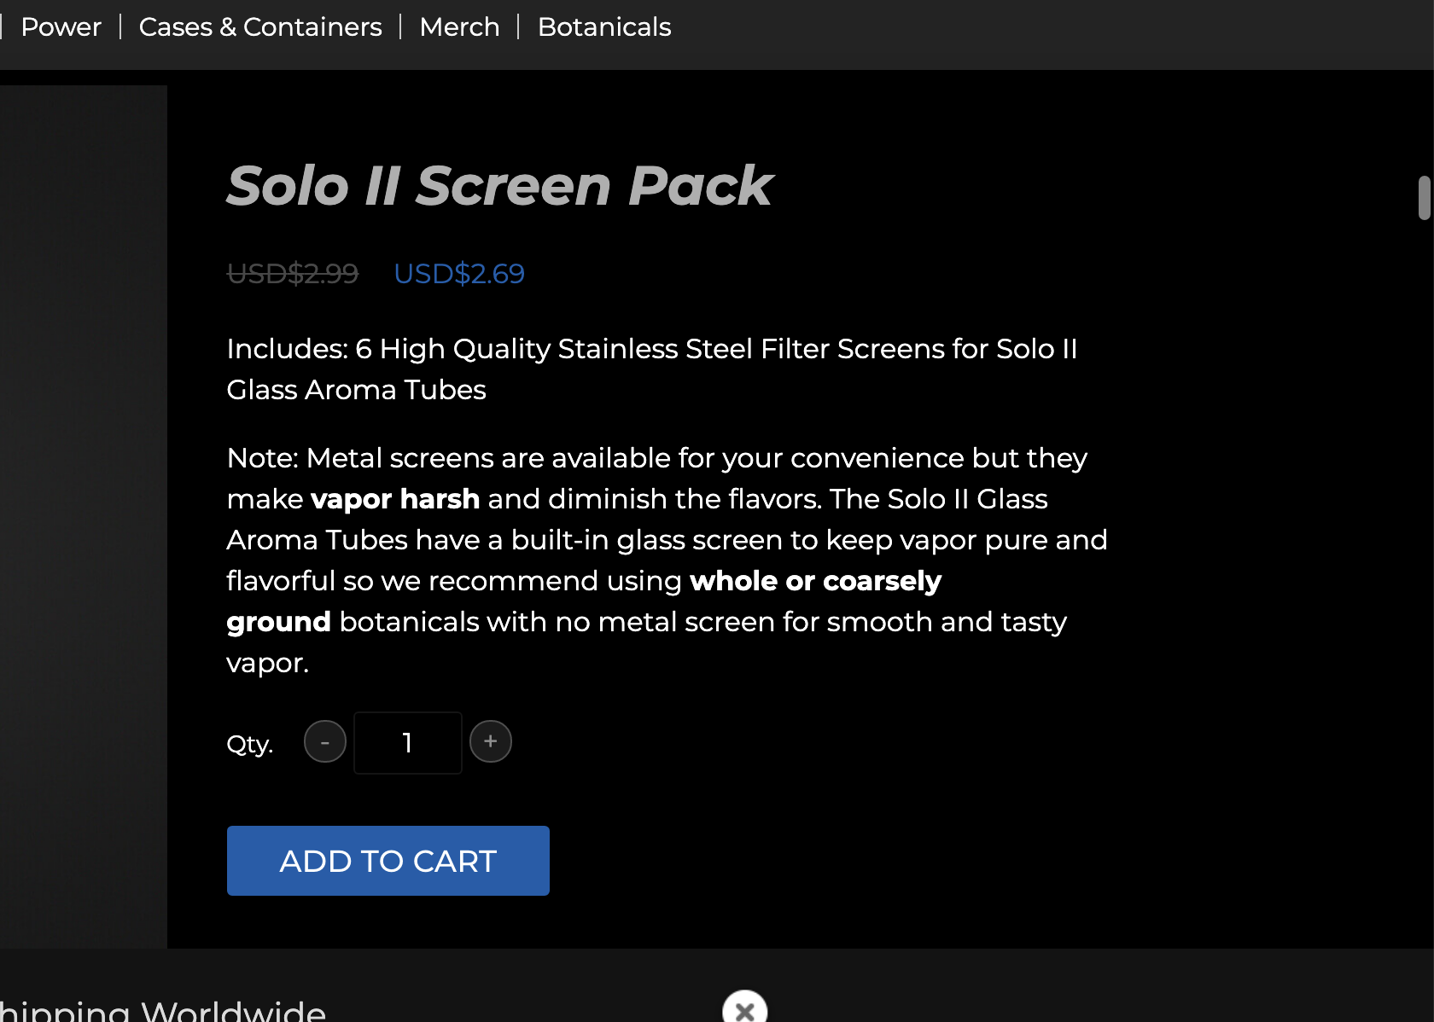

Regards

## Arizer - Does not charge to 100%:

This is common actually. Regarding the battery, the Arizers (Air/Solo/ArGo) can reach 94-99% normally. To reach 100% it takes many hours more. A trick some users found to reach the 100%, is to have it charge to 94-99 and when it does not raise more then then unplug the charger and plug it back again. It will then reach the last 100%.

For best lifetime of the battery it is recommended to unplug it when reach 90% and not charge to 100%. You will double your cycles this way.

Here are topics about the battery and you can see many others ask same question and behaves the same:

<https://www.reddit.com/r/vaporents/comments/az60hm/solo_ii_problems/>

<https://fuckcombustion.com/threads/arizer-solo-ii.23703/post-1340818>

<https://fuckcombustion.com/threads/arizer-solo-ii.23703/post-1340840>

## Arizer EU - Requesting Warranty:

Sorry to hear you are having issues.

Since we are Authorized distributors for Arizer in Europe we have partnered up with them regarding service and warranty repairs in Europe.

This means, they will honor any warranty issue with you directly from their European center so you can be sure it's serviced by the manufacturer directly and not any unauthorized service center for future warranties to still be valid.

To request warranty. Please send an email to: service@arizer.com

Subject: Requesting warranty

Message:

Purchased from: MagicVaporizers

Purchase date:

Your Full name:

Your Full address:

Serial number:

Description of your issue:

I have also attached your invoice here for reference so you can find your purchase date.

Your serial number is located underneath your unit.

## Arizer Solo / Air recommend no screen:

Sorry for replying in English. Since we cater so many countries and strive to offer lowest prices and fastest support available we only offer support in English.

Arizer does not recommend using screens as the mouthpieces already have built in ones. For that reason we do not sell screens for the Solo and Air.

​

Below picture is from Arizers own website, <https://arizer.com/solo2-part-accessories/>

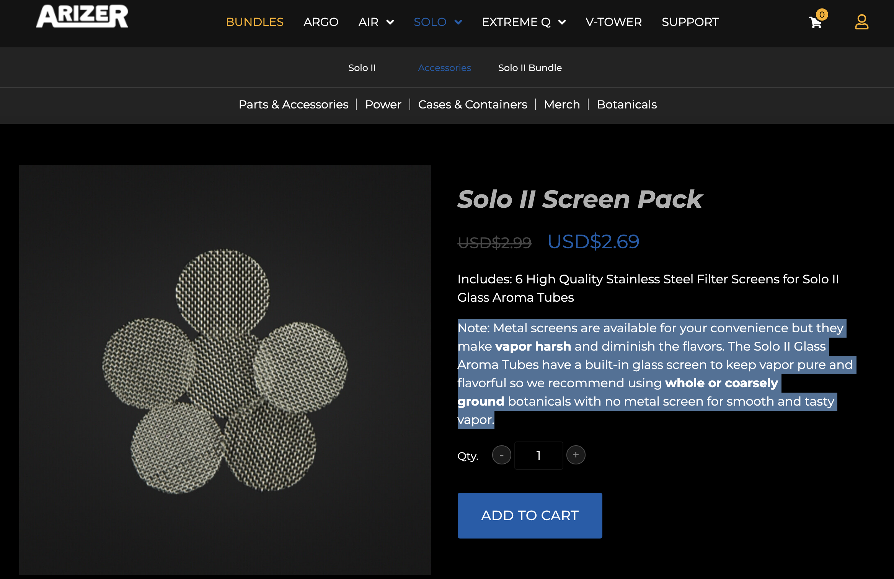

## Arizer Tube is loose:

This is fully normal. You can always send an email to service@arizer.com and ask also if you want an official reply also for confirmation and send your video to them.

​

Below is official response from Arizer regarding this topic.

​

"Hi Sam,

There's an objective behind the dish design and the mouthpieces; easy to draw on, smooth, not too hot vapor. At first, some Glass Aroma Tubes may fit snugly, and after a few uses the fit will loosen up a bit in every Solo unit. The glass pieces will all fit differently into each unit because the glass parts are hand-made. The difference in fit is very slight - some a bit looser and some a bit tighter.

The unit is designed for optimum performance and efficiency with loose fitting Glass Aroma Tubes which is why the ring above the heater bowl expands slightly, to allow for a looser fit and optimized air flow. There is nothing wrong with them if they fit loosely or tightly, but a loose fit is ideal. For example, if you turn it upside down the mouthpiece should fall right out.

I hope this helps. If you have any further questions please feel free to ask."

## Extreme Q / V-Tower - Broken glass bowl:

Sad to hear that. Can you provide us a picture of the damage? And we will have a new one shipped to you.

We need to send it to Arizer so they can compensate us back also. :)

​

Also please visit <https://magicvaporizers.co.uk/arizer-parts> and select Extreme Q to filter out compatible products. We need you to identify the broken part ​for no misunderstanding to happen so we can have the correct one shipped also.

Regards

Arizer Extreme Q - Glass Aroma Dish

SKU: SKU179

## V-Tower no visible vapor:

When you start the first vaping session after unboxing the V-Tower, set the temperature at 260 degrees Celsius and let your V-Tower Vaporizer work for about 30 minutes. This way, you’ll get rid of all the remains of substances from the manufacturing process and you’ll be sure that the vapor flavor will be unspoiled from the very first inhalation. Dont forget to do this first!

Don’t start vaping straight away when the display shows the required temperature. It’s the temperature of the heater but for optimum results, all the elements need to heat up properly and that applies to the Cyclone Bowl heating chamber, too. The device needs extra 10-15 minutes to heat up all the elements. Wait and you will be able to enjoy the inhalation to the maximum.

The herbs should be ground as finely as possible so that it comes in better contact with the hot air and the inhalation will be more intense. V-Tower works well with medium-ground herbs, too, but if you grind them well, the quality of inhalation will definitely be higher.

For optimum results, you should load at least half of the chamber, which translates into c.a. 0,4 ground herbs. If you use a smaller amount of material, you might not be happy with the effectiveness of the vaporization**. This means, you start the device FIRST and let it run for 10-15 minutes at around 200C with no herbs inside and after 10-15 minutes you add your herbs to the bowl.** You can go up to 220C but we don't recommend higher than 220C.

If you don’t want to use this amount of herbs in one inhalation (e.g. during solo sessions), load the herbs in a different way to the one recommended by the manufacturer and use the so-called elbow-pack method. You simply put the herbs into the sieve located in the glass elbow at the end of the tube, rather than into the Cyclone Bowl chamber.

The V-tower is not aimed to give big cloud of vapes. Also it must be on for 10-15 minutes before you put the herbs inside this is how the device works optimally.

**You can see video here when he blows out his mouth how much visible vapor is expected:** [**https://youtu.be/X78fdjab0DY?t=1024**](https://youtu.be/X78fdjab0DY?t=1024) **and this is with cannabis for this small amount of visible vapor. You need to inhale deeply for long period and blow out quickly to see. When you inhale, you need to think of it as sipping coffee at this speed. So you don't do quick and large inhales.**

We understand some customers prefer big clouds as it looks cooler but don't let your eyes decide if the vaporizer is working well, instead go after what you feel. If your material looks brown after being vaped, it usually means the vaporizer is working well. Remember the vaporizers we sell are meant to extract the active ingredients of your material as efficiently as possible with the best possible flavours, not just to produce the thickest vapor possible.

## Extreme Q version 6.0 - 7.0

Arizer stopped putting versions on the Extreme Q some years ago. if we would follow that version then this would be the 7.0 and not 6.0. But officially there are no versions.

We received goods from Arizer last month, meaning he can rest assure it's the absolute latest version available

# Boundless

## Boundless CFX - No adapter included:

The CFX is supposed to be charged by USB in Europe. We ship them straight as they come from the manufacturer. We used to import them with the AC adapter (this one has USA plug) before, but people got confused as it was not able to use the adapter in Europe anyway without any sort of converter. Therefor, we asked the manufacturer to remove the AC adapter before shipping. As you can see on our website, we don't even mention the DC charger there, only the USB.

## Boundless CFX - No adapter/Angry customer

We provide the goods straight as they come from manufacturer. As you saw when you received it the product came fully sealed and nobody except the manufacturer had access to the content.

We don't mention the charger nor we have pictures on our product page showing there is a charger nor the "In the Box" section it mentions a charger, only an USB cable. We never advertised any charger here when we sold the product to you. In 2019 they used to offer one but lately they don't.

What other unboxing videos are showing (most likely they are non UK OR they are older than 2019) we can not be liable for. We are authorized distributors for Boundless for years now and goods are moved to customers as they come in.

I do know that some other customers in forums could successfully source a charger from Boundless by contacting them through <https://support.bndlstech.com/support/tickets/new>

If that would be something they still do or do out of goodwill or if you would be successful in that we can not promise you. It's worth a shot but when it comes to how products are sold from us, they are sold as advertised on our website.

# Da Vinci

## Ask DaVinci for support:

Since we are resellers only, we don't have that deep knowledge this specific question.

​

For such a specific question, I really recommend you to contact DaVinci support directly instead as they would be better fitted for this question. They do have a great support and customer service. I say it for your own benefit, so you don't spend/waste time testing and searching for info. They know their units inside and out and I am sure you will receive a greater response there.

​

They can be reached through: <https://www.davincivaporizer.com/support/>

Sorry for not being more of help here, just want the best for you.

## Battery will not connect - We contacted DaVinci for you:

We contacted DaVinci for you and they asked if you could try the following to see if it works better as it could be resolved by yourself.

And if not, we will proceed with the warranty case for you to send back your unit. I will quote them below. Are you willing to try their solution first and see if it works for you so you won't be without an unit for unnecessary time?

"

Please ask your customer to check the metal clamp/spring at the bottom of the battery compartment. Sometimes it gets compressed causing the battery to not connect. Ask your customer to get something long, thin and hooked and reach in there to lift that spring back up so it can connect properly to the battery and he/she should be good.

Also make a full reset once that's done. A guide to make reset can be viewed here: <https://www.youtube.com/watch?v=-W9_ThO2YfM>

"

## Broken Pearl:

The pearl is very sensitive and can break during cleaning or if too much herb was pressed inside the chamber. This is a wear and tear part and is not covered by warranty according to DaVinci and customer is recommended to purchase a new pearl. We do sell them here: [https://magicvaporizers.com/davinci-iq2-pearl](https://magicvaporizers.hu/davinci-iq2-gyongy)

​

You can try to contact their support directly on: <https://www.davincivaporizer.com/support/> and maybe they could offer you a free one under goodwill but don't count on it. I have also attached a copy of your invoice if you would need it.

## DaVinci does not charge - Battery not connect:

I think it sounds like the usual issue with the DaVincis's. That happens to almost every DaVinci product (IQ/IQ2/MIQRO) after 2-4 months of usage and unfortunately no replacement will resolve it since it is from factory.

It is the spring at the bottom of the battery compartment that is compressed causing the battery to not connect. Get something long thin and hooked that you can reach in there with and lift that spring back up so it can connect to the battery and you'll be good.

I do know it sounds like a 'hack' but it is the only way you will be able to enjoy the device. The repair process for it is very simple and can be done by yourself as well as this is the first thing that DaVinci will do.

I would suggest you to test this first so you don't have to be without your device for unnecessary time. If it does not work or you still want to send it so they can lift the spring themselves then let me know please. Most customers do resolve this themselves though.

## DaVinci IQ2 - No visible vapor:

Most likely you are using it wrong. Visible vapor is also never a guarantee when using a vaporizer as it depends on many factors such as grinding, packing method, inhalation technique, quality of herbs, temp used and so on. It is not a method of deciding if a product is working well or not. The color of your herbs after your session decides that. A vaporizer is meant to extract the active ingredients of your material as efficiently as possible with the best possible flavours, not just to produce the thickest vapour possible.

I will give you some advises on usage and perhaps you can get better results but to do that I need to know what temperature are you setting it to, how long you are inhaling and what type of herbs you are using?

What temperature are you setting it to and what herbs are you using?

The issue sounds to me a mix between how you are packing and how long you are inhaling.

Let's start with a reset first as the following guide explains to make sure no custom settings are conflicting: <https://www.youtube.com/watch?v=-W9_ThO2YfM>

If you are using it the first time, you need to do a burnoff. Burn off means, you need to set the vaporizer to maximum temperature and run it a full session without any herbs inside.

You make a complete clean

Set temperature again to maximum temperature and run it again a full session.

Make a complete cleaning again where you clean the chamber also. Make sure you blow in the mouthpiece as well to clear the path completely.

The reason is, when it comes from manufacturer they protect the chamber with a coating, this coating is burned when you use the vape the first time which can make the effect less.

Regarding the packing:

You need to fine grind your herbs first.

Pack the oven full and tight meaning use your finger to press down the herbs in the pod . Most likely you are loosely packing it.

Check this video otherwise, <https://vimeo.com/392846480> from about 9:20 to see how he packs it and how he inhales.

Set temperature to 193C or smart path 3.

Once it reaches temperature let it sit for another 20-30 seconds. This is very important. Most likely you started vaping when it reached the temperature directly.

Do slow inhales for about 10-15 seconds, think of it as you are sipping coffee. At this speed. :) I do think this is the part where you did strong inhales. Any vaporizer will be very hot if you do strong inhales and vapor production will be very low.

You can increase the temperature by +5C after some inhales to get the most out of your herbs or once you familiarise yourself with it better, or smart path 4.

So:

- Do not make strong pulls or inhale more than 15 seconds. And do not chain-vape. You need to have the vaporizer rest a bit between each pull.

Hot mouthpiece or device issue occurs to many vaporizers if you do chain-vaping. Any vaporizer that is chain-vaped will heat up rapidly and never have the chance to cool down. The heat has to go out somewhere causing either the unit itself to become very hot to touch (specially metal cased ones) or the mouthpiece to become very hot. Also vapor production will be very limited.

It takes about a week of learning curve to get used to it and experiment with different techniques.

Try everything above and let me know how it goes, I'm sure it will be better now.

Bonus: This youtube link is from DaVinci which also explains how to get most dense vapor out of your unit: [https://www.youtube.com/watch?v=II2gb_pUx2M](https://www.youtube.com/watch?v=II2gb_pUx2M%C2%A0)

## DaVinci IQC - When will it arrive:

DaVinci will start shipping them to Europe on 28th August. Then it will take the shipment time plus the time in customs process for them to arrive to us. That usually takes about 2 weeks to clear and receive the goods.

We should probably have them ready for sale around mid September. :)

## DaVinci Miqro not happy:

Since we are resellers only, we don't have that deep knowledge these specific questions. My personal experience with MIQRO is also rather limited but I have not had the issues you've mentioned from what I recall.

I usually follow this guys videos: <https://vimeo.com/280162117> I would suggest you to do the same when it comes to fine grinding, packing, adjusting the pearl, inhaling technique and so on. The flat mouthpiece do help improve air resistance.

I also found this topic where he explains his steps to using the MIQRO and it seems other guys commenting are doing the same with great results: <https://www.reddit.com/r/vaporents/comments/m9l127/questions_regarding_the_typical_davinci_miqro/>

Besides that I would recommend you to contact DaVinci support directly instead as they would be better fitted for this question. They do have a great support and customer service. I say it for your own sake so you don't spend/waste time and bud by testing and searching for info. They know their units inside and out and I am sure you will receive a greater response there.

They can be reached through: <https://www.davincivaporizer.com/support/>

Sorry for not being more of help here, just want the best, fastest and most efficient help for you.

Btw did you make a full burnoff prior to using it? To burnoff, Run it without any herbs inside on maximum temperature for a session and then clean it properly.

Also try to make a full reset if some settings are screwed. To reset the miqro check this vid: <https://www.youtube.com/watch?v=3euzZ05_zFQ>

## Request warranty DaVinci support:

Since we are Authorized distributors for DaVinci in Europe we have partnered up with them regarding service and warranty repairs in Europe. This means, they will honor any warranty issue with you directly from their center so you can be sure it's serviced by the manufacturer directly and not any unauthorized service center for future warranties to still be valid.

To initiate an RMA and return your product, visit: <https://www.davincivaporizer.com/support/>

and fill out the form.

A DaVinci technician will return to you shortly after with instructions.

I have also attached your invoice here for reference.

## We have opened a warranty claim for you with DaVinci now:

We have opened a warranty claim for you with DaVinci now. A DaVinci technician will return back to you directly to offer a replacement. Usually what they need will just be video evidence that it's not working properly to send you a replacement. It's a simple procedure.​

Please wait for their email to you, don't forget to check spam folders as sometimes their reply can appear there.

​I have attached a copy of your invoice here also if you would need it.

## Message to the manufacturer:

DaVinci RMA's for our internal use only, never share email address or conversation with customers.

Send email to: mdejnozka@greenlane.com

First and Last Name:

Full Physical Address:

Contact Number:

Email:

Description of Issue:

Product Name:

Device Color:

Unit serial number:

Purchase date:

Include copy of invoice as well as any links to videos. All emails to be sent from Freshdesk.

As subject in email enter product name and serial number and some short word about describing issue

## **Miqro - It no longer charges/Works/Turns on/Heats up”**

Rationale (1): This can happens due to a build up of residue on the battery lid hinges, which doesn’t allow it to close properly. This prevents the battery from conducting energy?

Troubleshooting:

1)

Take battery out and clean the negative side of battery and battery lid hinges with 91% Isopropyl Alcohol, making sure to work it in to the door hinges by repeatedly opening and closing the lid. Dry the device well and try again.

2)

Ask them how many batteries they have for the MIQRO. If it’s only 1, ask them to buy more on our website. $10.95

https://www.davincivaporizer.com/18350-battery/ If they give you a hard time, promo it out.

3)

Rationale: “Keep in mind that the MIQRO is a Micro-dosing unit. They use an 18350 battery with 900mAh capacity. This makes it good for quick discreet sessions but not very good for longer, shared sessions. If you are unhappy with the MIQRO’s performance, perhaps this may not be the correct Vape for you”

Troubleshooting: “If you’re unhappy with the MIQRO’s performance, we do have an upgrade performance in place. For this, we will ask you to return the unit to us *except EU orders*, and we will credit your account with 30-50% of the MIQRO’s original purchase price to go towards our latest and greatest IQ2”

## 

## Buttons stop working

Rationale (1): This can happen due to a build up of residue around the button, which causes it to stick

Troubleshooting: “Clean the buttons with 91% Isopropryl Alcohol, making sure to work it into the buttons by repeatedly pushing them down over the course of 15-20 seconds. Dry the device well and try again.

If this doesn’t work, begin RMA process.

## **My device gets TOO hot**

1) “This is an issue our technicians have been looking into for months. After several experiments they’ve found that clients usually let their devices heat up on a flat surface. Our natural body temperature is 98.6F while the units exterior can be slightly more than this due to the interior being ~430F. When you pick up your unit, your autonomic nervous system sets off the ‘TOO HOT!’ alarm even though the device is only ~2-5F degrees hotter. After holding it for a moment, the heat should dissipate and it will no longer feel warm to the touch.”

2) “If you check on our website, you’ll see that we do sell sleeves for the device. I believe this will eliminate the issue of having it heat up in your hand.”

## **Can’t connect to the App**

We are aware that there are issues connecting to the App as of late. Because Apple has suspended all APPS that have to do with vaporizers, we are unable to update the application that already exists, resulting in a loss of APP support. This causes the app to crash when people login. Our tech team is currently working on a way around this issue to get the app up and running. We do apologize for the inconvenience this issue has caused you

## **Davinci OQC: “The lid of my device won’t stay open while it’s in use”**

This can happen due to something called an expanding flavor chamber gasket. When the unit heats up, the silicone around the flavor chamber expands and causes the chamber to rise, pushing against the units lid.

Troubleshooting: “This issue is something that falls under warranty. At this point, I would like to submit a claim for you.” *Send RMA Information Request Macro*

## **LED lights Stopped Working**

Rationale (1): Their device may be dirty (Said Hector)

Troubleshooting: “Please turn off your device and wipe the LED lights down with 91% Isopropyl Alcohol wipes”

Common Issue: LED lights STILL won’t work

Rationale (2): The LED diode inside of the device may have failed.

Troubleshooting: “This issue is something that falls under warranty. At this point, I would like to submit a claim for you.” *Send RMA Information Request Macro*

## 

## **I can’t connect to the App**

Rationale: “We are aware that there are issues connecting to the App as of late. Because Apple has suspended all APPS that have to do with vaporizers, we are unable to update the application that already exists, resulting in a loss of APP support. This causes the app to crash when people login. Our tech team is currently working on a way around this issue to get the app up and running. We do apologize for the inconvenience this issue has caused you.”

## 

## **IQ2 The rubber piece that holds the pearl fell off”**

Troubleshoot: “This is something that falls under warranty. However, to submit a claim for repair/exchange, this would require you to send in the device, have our technicians repair it for you, and send the device back. Another option you have is to purchase the pearl on our website. You can use code ‘rosie5ACC’ at checkout for a discount. This comes with the pearl post for replacement. It is an easy fix. If you don’t feel comfortable changing the piece yourself, we can definitely fix it for you. We wanted to let you know your options because we would hate for you to go without your device for an easy fix. I will attach the link down below.

## Instructions to replace IQ2 Pearl

Hello,You are able to purchase the IQ2 Pearl on our website. That accessory will come with all of the attachments that you need to replace it.<https://www.davincivaporizer.com/iq2-pearl/>

The instructions on how to replace will be down below as well.Pearl Post Replacement:1. With a flat tool or pick, pry out the circle gasket, lightly pulling upward making your way up around the gasket.  
2. Once that is off, remove the broken pearl post stem using a pick and/or tweezers. Sometimes a safety pin or needle will help to pick out the post by poking and pulling out the silicone.  
3. Once the broken pearl post is removed, replace the pearl post. Use a small flathead screwdriver to push the pearl post under the silver plate.  
4. Once the pearl post is installed, install back the circle gasket by aligning the square side of the gasket to the square hole of the silver plate. Gently pressing down on the gasket to ensure it is seated flush to the silver plate. A small flathead screwdriver can help  
    push the square side into place.  
5. Screw the pearl on the pearl post threads by turning the pearl Clockwise.You are able to use the code rosie5ACC for accessories only, at check out.Thank you and have a great day!

## 

## **DaVinci All Leds Flashing**

With the device showing All Leds Flashing can draw to the following conclusions

All LED Flashing 2X - Could be an issue with the battery and/or connection to the battery. If the customer can test the battery and when fully charged the voltage capacity is 3.9V to 4.2V with an Internal resistance under 200mOhm is good. Values outside these numbers, the battery is still considered good, but it is best to replace the battery. A battery replacement could resolve this issue.

All LED Flashing 3X - There is an issue with heating. There could be a crack in the oven bowl and/or the heat sensor is faulty. Cracking the bowl is a bit difficult and should not happen. When a crack does appear, the material was high in moisture or it was physically damaged while cleaning or using improper cleaning tools and/or solvents.

# DynaVap

## Cap loose or used:

Just some general info first. We have only brand new units and don't even accept used units back in return. There is no possibility for any units we sell that they have been used before. Also we are official distributors for whole Europe and provide other stores with their stock as well, there is no need to worry regarding this point.

Now for the DynaVap specific information. What you see is common for every unit sold and we receive emails like yours often as well. You are not the first

One of your questions is already covered on DynaVap own FAQ page and Blog.

<https://www.dynavap.com/about/dynablog/why-doesnt-my-cap-fit/>

or

<https://www.dynavap.com/about/faq/>

Please check topics: HOW TO TIGHTEN OR LOOSEN THE CAP?

and regarding the second question check out these topics

<https://www.reddit.com/r/Dynavap/comments/cbg8ba/has_my_vapcap_been_used_already_arrived_as_brand/>

<https://www.reddit.com/r/Dynavap/comments/jdqwmb/dynavap_just_arrived_havent_used_it_yet_cap_looks/>

<https://www.reddit.com/r/Dynavap/comments/a9xx5y/question_i_think_i_got_ripped_off/>

<https://www.reddit.com/r/Dynavap/comments/lxwwkq/did_i_just_get_a_used_dynavap_brand_new_from/>

there are maybe 50 more topics like that in different forums.

If you still don't want to take our word for it, just send DynaVap an email here: <https://www.dynavap.com/contact-us/product-issues/> and they will respond the same

## DynaVap do not click:

We have after almost 2000 sold DynaVaps never had any device with issue not clicking. It's usually related to how it has been used or the torch used is not producing enough heat. If you can please assist in answering below first?

Are you using a triple jet torch lighter with it and spinning while heating up? Click should happen at about 6 seconds. A normal lighter will not work and will take forever if ever to click, also a single jet torch will take much longer.

Do you hear any cool down click after you stopped heating? If so there is a chance you did not hear the initial click as sometimes it can be vague in case your torch has higher audible sound.

​

Check these two videos:

<https://www.youtube.com/watch?v=N-Gxyki0_DM>

and

<https://www.youtube.com/watch?v=ZSvIzwSa65M>

For best results continue to heat 2-3 seconds after the click also.

## Torch de-clog:

Can you show me what type of Butane you are using?

Also try to de-clog it.

It sounds to me that your torch is clogged as sometimes very small particles/dust or air can come inside and block the path when attempting to fill it. You need to clear the path where the butane goes, it's a common thing with torches. Please try to de-clog following instructions below and let me know how it goes.

To de-clog:

Try to turn the torch so that the refill hole is facing upwards and leave it for one minute for all butane to go down.

Then take something sharp and push down the tube so that oxygen can go out from the unit.

DynaVap recommends emptying all fuel (purge it), and refill it 3 times with one of the recommended fuels, This should remove any remaining residues and provide a clean path.

Let me know if it starts to work after this.

## Version 2021 or THE M(2022)?

The 2022 and 2021 is the exact same version. DynaVap changed the name from DynaVap 2021M to "DynaVap - The M" this year. But in reality it was just a name change but the product is exactly 100% the same therefor you can read 2021 there. All DynaVap's will always show as 2021 and not 2022.

## ORION heater troubleshooting

The Orion V2 should last about 40 clicks on a full battery and not less. If the performance is not there it can be that the battery may be faulty yes. Can you help us troubleshoot it please

It should give about 25 clicks until blue. There is more information here: <https://www.youtube.com/watch?v=rHBHCvcPHVQ>

It has multiple built in protectors. Those shows green/blue/red and then turns off. **Please confirm this is not the light sequence you see?**

See illustration below from video. Please test and confirm if this is not the performance you are receiving.

Can you confirm how you are charging it. **Please share the specifications of the plug you are using?**

It needs to be running 2Ampere at 5V and needs to charge for 3 hours even if LED is green at this power output. **Please confirm that you did charge it for full 3 hours at this power output?**

# Flowermate

Email

frank@flowermate.com

Not to be shared with customer.

Please send all Flowermate request to this email here when seeking assistance or advise with rma. If not its possible to determine from video only.

Including for this ticket also.

# GSL

## GSL Return address EU:

To make a return:

Please return the items you wish to send back to:

Anything Worldwide AB / GSL

Am Weimarer Berg 6

99510 Apolda

Germany

Once you've shipped it you need to notify us so we can process the return.

Once received a full refund will be made. We do not refund your own personal shipping costs to us.

# IOLITE

## De-clog IOLITE:

You could try to de-clog it and see if it helps your usage a bit as sometimes very small particles/dust can come inside and block the path when attempting to fill it. You need to clear the path where the butane goes, it's a common thing to do with IOLITE's and is good to do every 3-6months as well.

To de-clog:

Try to turn the Iolite so that the refill hole is facing upwards and leave it for one minute for all butane to go down.

Then take something sharp and push down the tube so that oxygen can go out from the unit.

Iolite recommends emptying all fuel (purge it), and refill it 3 times with one of the recommended fuels, This should remove any remaining residues and provide a clean path.

Let me know if it starts to work better after this.

# Maintenance/Cleaning

# 

## How to clean chamber with alcohol:

First do a session on lowest temp to warm up the bowl while having the vaporizer is upside down.

Take then a qtip (the ones you clean your ears with) in 99+% isopropyl alcohol and swab the chamber clean still keeping it upside down.

Change qtip and do it again, then third time just put the qtip in hot water and clean the last.

Run then 2 burnoff sessions upside down again for the smell or alcohol to burnoff. A burnoff session is when you run the vaporizer on hottest temperature for a few minutes without any herbs inside.

The reason for upside-down is because you are using liquid (alcohol/water) then you are safe that that everything goes out and not deeper inside the chamber.

# PAX

## PAX Warranty EU:

Sorry to hear you are having issues.

Since we are Authorized distributors for PAX in Europe we have partnered up with them regarding service and warranty repairs in Europe.

This means, they will honor any warranty issue with you directly from their center so you can be sure it's serviced by the manufacturer directly and not any unauthorized service center.

To request warranty. Please visit: <https://eu.pax.com/account/register>

and follow all instructions.

1. Choose your Country <- IMPORTANT. If Country is not found here select OTHER.

2. Create a Customer Account

3. Go to the section “My Devices” within your Customer Account and register your device

Your device will now have 10 Year warranty instead :)

Now go inside your account and open a warranty case / contact PAX Support.

PAX will return to you shortly after with instructions on how to send it back for repair.

I have also attached your invoice here for reference.

## Gets too hot:

Thank you for getting in contact. I'm sorry to hear you are experiencing an overheating issue with your new Pax 3.

​

Fortunately, this is a quite common issue that most of the time is only due to an incorrect usage of the Pax 3 and has an easy solution.

Most likely, you are using it wrong. I will give you some advices on usage and perhaps you can get better results, but to do that I need to know: what temperature are you setting it to, how long you are inhaling and what type of herbs you are using?

We can make a step-by-step guide first. If you are using cannabis, continue to read below.

Also if you are using it the first time, you need to do a burnoff. Burn off means, you need to set the vaporizer to maximum temperature and run it a full session without any herbs inside.

You make a complete clean

Set temperature again to maximum temperature. Make a complete cleaning again where you clean the chamber also. Make sure you blow in the mouthpiece as well to clear the path completely.

After that you can use your vaporizer as normal.

Then:

1. Please charge it fully

2. Grind as fine as possible. If you have a 3-4 piece grinder then move the grinder upside-down and continue to grind also. Pack the oven tight meaning use your finger to press down the herbs but not too hard. Most likely you were loosely packing it.

3. Download the app to your PAX. Set it to 'efficiency' setting. Once it reaches the temperature let it stay there for another 20-30 seconds. Most likely you started vaping when it reached the temperature directly.

4. Do slow inhales for about 10-15 seconds, think of it as you are sipping hot coffee. At same speed. keep the vapor in your lungs if possible and then blow out, wait 15-30 seconds between next pull and then inhale again the same way.

Keep in mind:

- Hard pulls = HOT Mouthpiece and Hot device

- Chain vaping = HOT Mouthpiece and Hot device

In the vape-world they usually say "Sip it - Don't Rip it" this is specially important for metal cased vaporizers.

You can continue to increase the temperature by +5C after some inhales each time to get the most out of your herbs.

It takes about a week of learning curve to get used to it and experiment with different techniques.

If the mouthpiece becomes hot then you can try use the flat one instead. The volcano shaped mouthpiece has a metal piece inside which causes the mouthpiece to become hot for sensitive users. If you feel it becomes you then you need to use the flat one here, it's cooler.

I hope the instructions will be useful to solve any issue you are experiencing. If that is not the case, please reply by answering the questions I asked above too: what temperature are you setting it to, how long you are inhaling and what type of herbs you are using?

So that I will be able to assist you properly.

## PAX 3 / 3.5

3.5 is PAX 3.

Original pax 3 came in glossy color first. Then they released pax 3.5 with matte color since about 18 months ago. We have since then sold 3.5 version.

All our pax are 3.5 with matte finish and not glossy.

## PAX Screens

No worries, you received all screens. They are sticked together, please use your fingers to separate them :)

# Refunds and Returns

## Confirm the return is still sealed and brand new:

Vaporizers are considered as hygienic goods since they are meant to be used orally. Therefore, for health reasons, we can only accept returns for products that are unopened with sealing intact as per our return policy. Please confirm that your product has not been opened, is still in brand new condition as received and the package still has sealing intact so we can provide you with return instructions.

## Refund not arrived yet:

It has been confirmed refunded from our side. Check the picture below from the bank.

Can you see the original transfer to us in your bank? Sometimes the bank removes the original transfer instead of making a withdrawal and deposit. I guess yours might be this case.

## Return can not accept used products back:

Vaporizers are meant to be used orally which means they classify as hygienic goods and are exempted from the right of withdrawal. Vaporizers are not returnable due to health regulations if the seal has been broken or product has been opened regardless if it has been used or not.

We are really sorry but we can't accept it back as we have no use of it and can not resell it even.

We recommend you to sell it on a second hand marketplace or similar.

## RMA to GSL:

I have attached a RMA form to this email if you like to take advantage of your warranty and have your unit replaced. Please follow all instructions inside.

If you want to be reimbursed for your shipping costs, please include a letter that you would like to be refunded your shipping costs together with your banking information and as well as the receipt of the payment of the shipping inside the box. Shipping standard should normally cost around 10-15€ approx with UPS/DHL.

## RMA to Reinhart:

I have attached a RMA form to this email if you like to take advantage of your warranty and have your unit replaced. Please follow all instructions inside.

If you want to be reimbursed for your shipping costs, please include a letter that you would like to be refunded your shipping costs together with your banking information and as well as the receipt of the payment of the shipping inside the box. Shipping standard should normally cost around 10-15€ approx with UPS/DHL.

## We have cancelled and refunded your order:

We have cancelled and refunded your order now :)

Refunds for payments by card or bank may take up to 2 banking days to reach your account again.

# Sales Tips

## DynaVap Wax:

So the thing with waxes is they get messy and sticky easily. You do need something that is easy to clean. Therefore I would recommend the DynaVap 2021M.

<https://magicvaporizers.dk/dynavap-m-2021> it has no electronics and you use it with a torch lighter. The plus is, since there is no electronics, nothing can break. If it gets messy its simple to clean as it's made of stainless steel.

When you use waxes sometimes you need to reach higher temps, since you are using a torch to light it with you control that temp yourself. The DynaVap has built in 'click' sounds which says when it's ready to use. I would recommend you to watch some YouTube videos and get a picture of it. Such as <https://www.youtube.com/watch?v=wUjYfO_dytE>

​

It is made for herbs initially so you will have a very good herbal experience also.

​

To have a better concentrate experience add a Dynacoil to your purchase, here is a demonstration <https://www.youtube.com/watch?v=Ql_tf50t8x8>

Enjoy :)

# SMONO

## Smono 5 Mouthpiece assembly:

The Smono support wrote the following to us:

"You can remove the glass tube by pulling and twisting.

If you un-thread the collar attaching the glass tube to the mouthpiece, you can then use the screwdriver to push through the hole and separate the mouthpiece for cleaning. There is a screw to be removed once inside."

Hope it helps :)

## Smono Questions - Ask support:

Very good questions. While we are resellers only we have no deep knowledge of the exact questions you ask for unfortunately :)

I can either contact the Smono support for you and forward their reply or you can also contact them yourselves through <https://en.smono.shop/pages/kontakt> and communicate any follow up questions you may have the same time.

Let me know if you want us to do the contact

## Smono Questions - email to manufacturer - request for credit note

neeed to add template here

# Storz-Bickel

S&B website have great advises also FYI, to give alongside our first tips. If still not working could be RMA case.

https://www.storz-bickel.com/en/support/crafty/troubleshooting

## Ask S&B for help:

Hold the “HEAT” button for 10 seconds (your device must be on for this to work), this will reset your device. Sometimes this resolves most issues.

​

​Otherwise I would recommend you to contact Storz-Bickel directly, they have a dedicated and awesome customer service for these types of questions and they know their units inside and out, while we are resellers only. You can contact them on info@storz-bickel.com

​

Sorry for not being able to assist more in your topic, we never heard of this issue before but I do believe S&B own customer service will be able to give proper response to you.

## Crafty+ Can not connect Bluetooth:

There are some troubleshooting tips with Storz-Bickel below. If below does not work please email them on info@storz-bickel.com and they can assist further. There is also another email for app related issues app@storz-bickel.com

<https://www.storz-bickel.com/en/support/crafty/troubleshooting>

First of all please reset the CRAFTY by pressing the button for 10 seconds.

Switch off CRAFTY for 5 minutes or more.

Switch off Wi-Fi on your smartphone.

Switch off Bluetooth on your smartphone.

Kill the browser

Switch off smartphone and restart.

Switch on Bluetooth with Wi-Fi still switched off.

**​Please assure that no other Bluetooth device is connected to your smartphone.**

Start the browser now and visit <https://app.storz-bickel.com/> and press connect.

Make sure that permissions are also given to the browser to connect.

It should work now. And if you still can not make it work, please send Storz-Bickel an email and one of their technician will be able to assist you in case there is some more settings on your phone that needs to be enabled.

## Mighty - Recommended Addons:

Most of the accessories you can select are extras of what is already included in the Mighty.

What we usually recommend is:

Magazine with 8 dosage capsules. To allow you to use dosage pods for quick loading/unloading and keeping your chamber fresh and clean.

TightVac. To always store your herbs as fresh as possible

Wear and tear set is also good to have since you get it discounted the same price. But if you use the dosage capsules all the time you might not need this set actually. This is if you wish to change the parts on your Mighty in say after one year and restore it back to it's new shape again.

## Mighty missing 20% Sticker:

It is the latest which can also be confirmed by registering your device or email Storz-Bickel on info@storz-bickel.com and have it confirmed through your serial.

You have received one of the freshest delivery available and we also write the date on our website when we receive the stock from SB. So you know you have fresh batteries inside that has not been resting on a shelf for many months.

Storz-Bickel stopped putting stickers on since April, 2020 actually so any unit that has left their factory since then has all not had any sticker on. If you find a box with the sticker on it means its older than that.

## Mighty Plus EU - When in stock:

Storz-Bickel will start fulfilling orders in about a week for distributors. We have a very early position in the queue.

I would guess we will have it ready for sale in about 2 weeks from now.

## Mighty Plus UK - When in stock:

Storz-Bickel will start fulfilling orders end of September/Early October. We have a very early position in the queue.

Once they've shipped there is an obligatory customs procedure for importing goods to UK which takes about 10 days to have them released and received.

Meaning around second half of October is a realistic target for us in UK.

## Storz & Bickel warranty request UK:

Your unit will be replaced by Storz-Bickel directly to a brand new one and not repaired. Please follow below to generate a return label and have it shipped back to S&B. Once S&B receives it they will send you a new one the next day.

To initiate an RMA and return your product, visit: [https://www.storz-bickel.com/en/initiate-rma](https://www.storz-bickel.com/en/rma)

and follow all instructions.

1. Choose your Country <- SELECT UK HERE, IMPORTANT!

2. Create a Customer Account. You have to do this since we can not share your customer data with third party.

3. Go then to the section “My Devices” within your Customer Account

4. Register your device by filling in your device serial number.

5. Your device will now appear in your devices list. Click on "Initiate RMA"

There is also a step for step process here: <https://drive.google.com/file/d/1vCG5NhyecSKwW_YaGc07yyQxYRMixYk9/view?usp=sharing>

A Storz-Bickel technician will return to you shortly after with instructions and a return label.

I have also attached your invoice here for reference.

## Storz-Bickel Warranty Request EU:

Since we are Authorized distributors for Storz-Bickel in Europe we have partnered up with them regarding service and warranty repairs in Europe. This means, they will honor any warranty issue with you directly from their center so you can be sure it's serviced by the manufacturer directly and not any unauthorized service center for future warranties to still be valid.

To initiate an RMA and return your product, visit: [https://www.storz-bickel.com/en/initiate-rma](https://www.storz-bickel.com/en/rma)

and follow all instructions.

1. Choose your Country <- IMPORTANT

2. Create a Customer Account. You have to do this since we can not share your customer data with third party.

3. Go then to the section “My Devices” within your Customer Account

4. Register your device by filling in all required product information

5. Your device will now appear in your devices list. Click on "Initiate RMA"

There is also a step for step process here: <https://drive.google.com/file/d/1vCG5NhyecSKwW_YaGc07yyQxYRMixYk9/view?usp=sharing>

A Storz-Bickel technician will return to you shortly after with instructions.

I have also attached your invoice here for reference.

## We contacted Storz-Bickel:

We contacted Storz-Bickel for you now.

Their technician will contact you directly to offer you a replacement once you submit the form they will guide you with. Please allow 24 hours for their response back.

I have also attached a copy of your invoice if you would need it.

<https://www.storz-bickel.com/en/contact>

## Plug adapter info - S&B

*Can I get the volcano classic with an EU outlet?*

→ no, we only ship UK outlets from UK warehouse

And we ship EU outlets if customer order from our .COM website

**BUT .COM does not deliver to UK, only rest of EU since Brexit.**

Customer can always buy the UK version and use a UK>EU adapter which he can buy at any electronic store or Amazon UK because the base unit is identical for UK and EU version only the plug differs.

TICKET EXAMPLE: https://magicvaporizers.freshdesk.com/a/tickets/36181

# Xmax / XVape

## New Xmax V3 Pro doesn’t charge - weak plug

Please note that the Xmax V3 Pro has an automatic charging protection once charger exceeding 5V/2A.

Normally, the manufacturer suggests using the charger plug with the capacity 5V/1A.

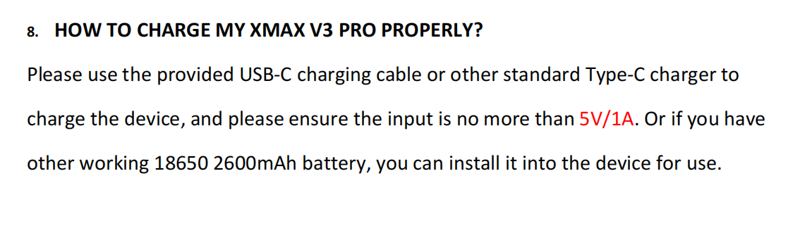

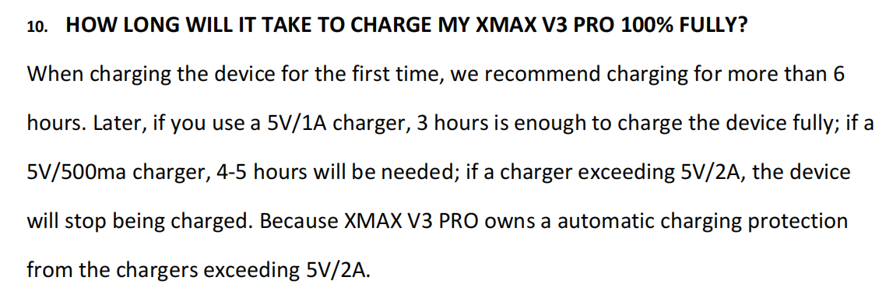

## WHY CAN’T MY XVAPE STARRY 3.0 START PROPERLY?

1. , Please confirm whether the power button is stuck, so that it cannot be turned on normally.
2. , Please make sure that the battery lid has been closed properly, and then press the battery lid tightly to try again whether it can be turned on properly.
3. , Please check whether there is any foreign matter or dirt in the part where battery contacts the device. If so, please clean them up and try to start the device again.
4. , If possible, please install another working 18650 2600mAh battery to see if it is the battery problem.

# Warranty

## Arizer Warranty Video:

Sorry to hear you are having issues. It sounds according to your explanation that the device does not behave as it's supposed to.

For us to open a warranty claim for you, we would need you to record a short video where we can see the described behaviour so we can provide it to the manufacturer. This way we can process the warranty case much faster and send out a replacement asap!

​

The video needs to show the error you are experiencing as well as your device serial number which is located on the bottom of your device, all in the same video sequence.

If file is too large to attach here you can upload it using [https://wetransfer.com](https://wetransfer.com/)

​

You also need to open a warranty claim here:

<https://magicvaporizers.co.uk/warranty-claim>

## Please use following code in checkout:

Thank you,

Please use following code in checkout: **UK9784089**

It will deduct £XX from your future purchase.

​

Let me know once you've placed the new order so I approve it for you :)

## Warranty - Pay shipping postage back - Two options:

Yes, you have two options. You can select between both :)

​

Option A) You send it back as return meaning you pay for shipping back to us. This option will be considered as a return and allow you to receive a brand new package back instead (we also pay for shipping back to you). This is a much faster resolution for you and most customers prefer this.

or

Option B) You send it back as warranty repair. This option will also cover your shipping costs and your vaporizer will be serviced instead by the manufacturer and they will post it back to you once it's repaired.

Please let me know if you wish to have it serviced instead of option A.

## Warranty - Video request:

Sorry to hear you are having issues. It sounds according to your explanation that the device does not behave as it's supposed to do.

For us to open a warranty claim for you, we would need you to record a short video where we can see the described behaviour so we can provide it to the manufacturer. This way we can process the warranty case much faster and on distance without unnecessary shipping back and forth.

If file is too large to attach here you can upload it using wetransfer.com

# We will send you a new device with DPD today:

We will send you a new device with DPD today. You can keep/throw the old one!

If you are satisfied with our level of service, please find some time to write a review here: <https://www.trustpilot.com/review/magicvaporizers.com>

It would really mean a lot for us as a store. :)

# Not willing to record a video

Unfortunately, we did not have a possibility to test the device ourselves, because we sell them sealed as they come from the factory.

​

The procedure is not made up. To confirm all our warranties on distance we (actually manufacturers) require video proof of the fault.

​

This is much faster and save time for back and forth shipping. In case you would ship device to the manufacturer or us and it works - it would be send back as it is and you would have to cover all shipping costs.

Therefore, to prevent all that - we (manufacturer) ask for a simple video of the fault - showing how you insert the battery, how device behaves when connected to the charger and when turned on.

Unfortunately, without proof warranty cannot be approved.

Please record a video showing the things described below and upload the video using this link: <https://magicvaporizers.com/rma-upload>

Your RMA number is

# Difficult customers, Not willing to comply, follow test procedures and insisting on return no matter what.

## #1

f a device is getting too hot to hold it means you are overheating it yourself. It is not a matter of faulty device that you claim. All units are passing quality control from factory and you received a brand new and sealed unit that passed it. Since you are unwilling to follow our advises given we are also unable to assist you further. Since you are not using the device as instructed the result will also be thereafter.

All vaporizers become warm as you are heating a unit up to 200C in a pocket size vaporizer. If you keep ripping it or make repetitive and short puffs the device will overheat. This is unrelated to brand and model used, device will overheat if you keep "ripping" it.

If you rip it, no vapor will come out even.

You need to make long and slow draws for 10-15 secs as if you are sipping hot coffee and wait 30 secs between each inhale.

Your herbs also need to be grinded well and packed well. You have failed on the inhalation and probably packing also if you consider that the device is overheating as you are deliberately making it overheat by not following the way it needs to be inhaled or packed.

If you consider it to be still faulty even though you followed correct instructions , we can offer you to send it back under warranty and we will send it to manufacturer for checking. In case no fault has been found with the device it will be sent back to you as it is and at your own cost. In case a fault is to be found it will be fully refunded then.

We are very sure that the device you received is fully working and fit for purpose as it passed QC prior to shipping. We have never experienced brand new devices sold as faulty and we have sold vaporizers for almost 10 years soon. Vaporizers have built in sensors and if the sensor registers a different temperature it will show on display "SENSOR ERROR" or give an error code. Since your device does not give any error code it also means it is fully functional as designed by the manufacturer.

Feel free to make proper testing with the device according as we assisted you with or if you wish to not comply then you are also free to contact trading standards and explore your alternatives should you not want to accept the above. We follow all UK laws and regulations set and have no problem in accepting any outcome from them.

Our terms for your reference can be found here: https://magicvaporizers.co.uk/terms-and-conditions and return policy here: https://magicvaporizers.co.uk/return-policy

## Picking error - scammer response

Our warehouse concluded the investigation as well as followed the CCTV camera.

All orders are shipped insured by UPS. For insurance to be covered we also have our packages scanned for weight and recorded them with UPS. UPS also charges us based on how much the package weight and they make the weight records themselves also.

UPS investigation shows that their scan had the correct weight all the time and the weight matches a box with both vaporizer and grinder. If it was not included it also means the weight would have been much lesser.

We are very sure that the parcel was shipped fully intact and delivered completed as the last scan recorded was just before the driver collected it and delivered himself.

If you still have doubts here we ask you to file a police report so that we can provide it to UPS and they can then make a further investigation by interviewing the driver also.

We will cooperate and provide all of our logs to law enforcement authorities as needed.

## 

## How to fill waterbubblers (Xmax etc) with the water - Video

<https://player.vimeo.com/video/629209004?h=f80b09a9c9>

how to use waterbubblers and how to fill them to perfect level

# MW Stashbox how to open and how to change the code

https://magicvaporizers.freshdesk.com/a/tickets/33082

The box is closed at 000 and will open on 001, please set this code and press this button to the left.

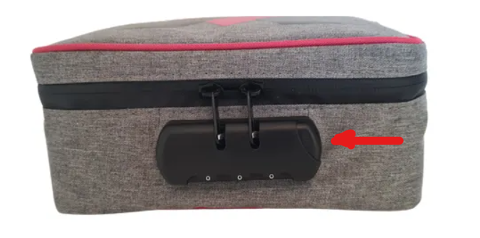

Regarding the changing of the code, please try to push this button to the left when the box is opened and press it during this to set your own code. When the code is set to unhold the button and close the box.

​

Please let me know how it goes.