Zachary M. Wing

Visualization

Assignment 2

I first started with a data set foreign currency exchange rates compared to the US dollar beginning 1/3/2000 and ending 12/31/2019 (<https://www.kaggle.com/brunotly/foreign-exchange-rates-per-dollar-20002019/data>). My initial questions are which had the best return over the last 2 decades, which one was the best return for each year. I then wanted to see if December or January had any influence on rates, as it is the holiday season. There we some days that did not have data which were holidays, but had to be cleaned out of the dataset.

The format of the data is Time Series Date, Australian Dollar/USD, EURO/USD, New Zealand Dollar/USD, UK Pound/USD, Brazil Real/USD, Canadian Dollar/USD, Chinese Yuan/USD, Hong Kong Dollar/USD, Indian Rupee/USD, Korea Won/USD, Mexican Peso/USD, South Africa Rand/USD, Singapore Dollar/USD, Danish Krone/USD, Japanese Yen/USD, Malaysia Ringgit/USD, Norwegian Krone/USD, Sweden Krona/USD, Sir Lankan Rupee/USD, Swiss Franc/USD, New Taiwan Dollar, Thailand Baht/USD.

The transformation that was needed was to remove the days that had missing data, but were still an observation in the dataset. I also had to correct a spelling error in the New Zealand Column name. See attached excel file of the observations that were removed as there was no data for any of the exchange rates for the day. Most of these were probably holidays due to data being missing for all rates.

I Pivoted the Currency Columns to the data so that I could graph them in tableau. I would not be able the graph them the way I wanted as columns. Pivoting allows me to get the overall average, but allows to graph to be detailed out to each of the currencies. Doing this also allows me to add more information to the data. I then used Tableau prep builder to add a group column grouping by location (Continent). I also then added another column to group them by NASDAQ market (Major market, Minor Market, Other Market). This will allow me to not only look at the Currency, but also look as them as a continent as a whole, or as the Major/Minor/Other market as a whole, and possibly see trends that I might not be able to see with just currencies.

I realized that Korea Won was extremely higher exchange than the others, also the exchange is based on their comparison to the dollar. This is just nominal unless you want to look at strengths of the currencies compared to others using USD as landmark. to get to my end goal I want to look at what would be the best return on investment. I calculated the daily returns of each day using excel, then calculated the percent daily return. This then normalizes the data so they are on an even playing filed, and I can truly see which historically has been the best investment (over the last 20 years). In tableau I had to group by month and grouped by year.

I had to manually fill in 4 errors with correct data from an exchange history website listed in references. I also made the 1/3/2000 (the first record for each currency) set to 0 for return and return percent as it is the first record in this set so there is not a return yet.

Tableau

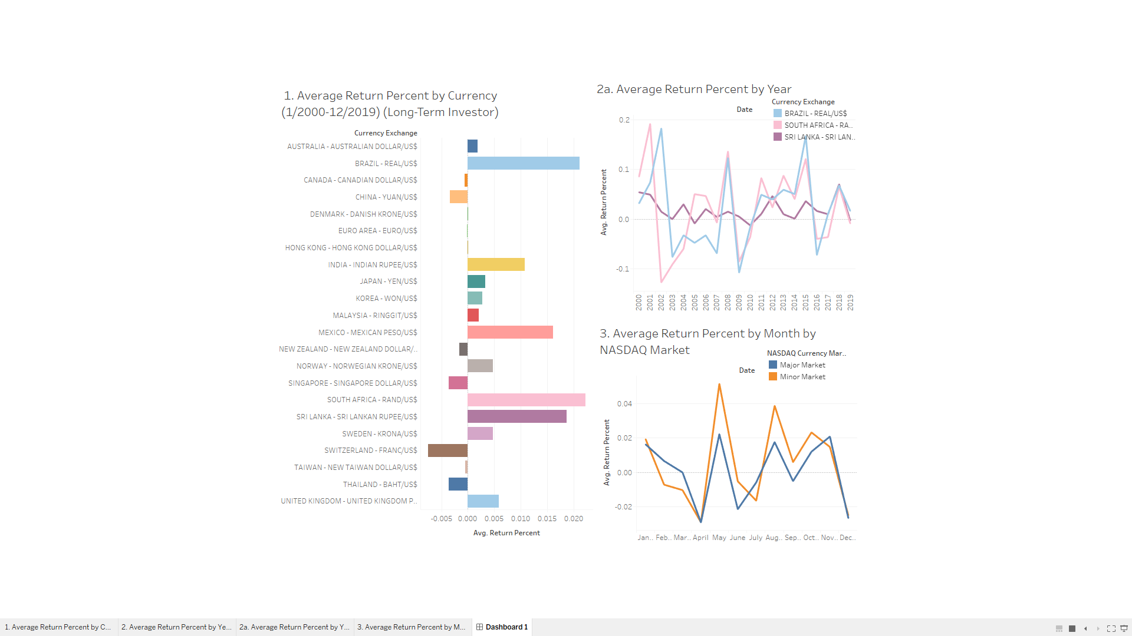

Power BI

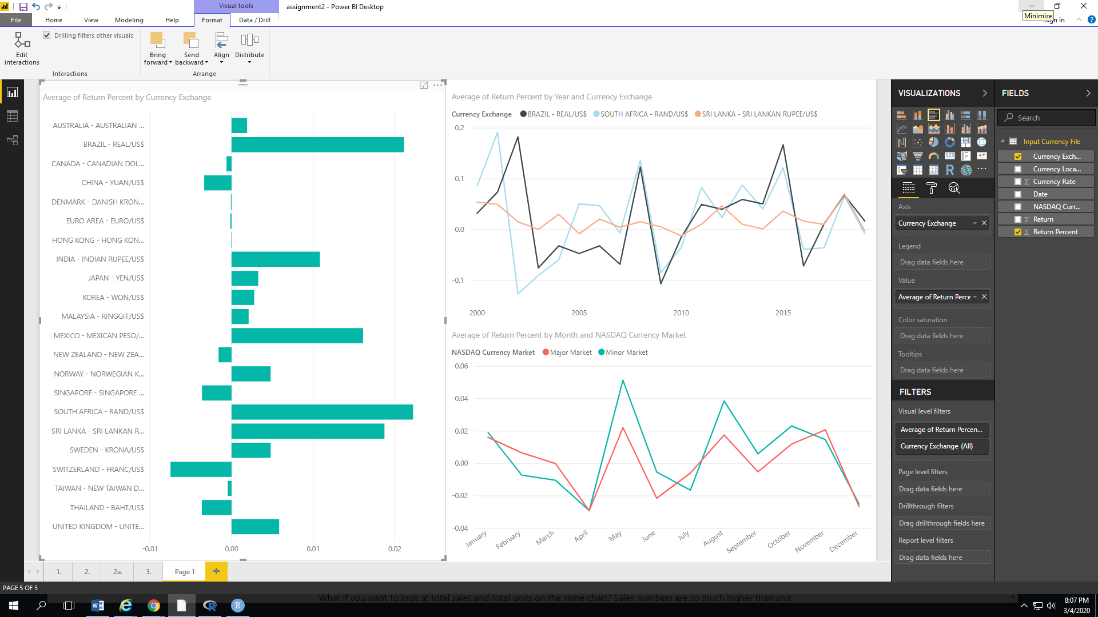

Analysis:

1. Looking at the first chart (Average Return Percent by Currency) the best 3 long term investments over 20 years (1/2000-12/2019) was the South African rand, the Brazil Real, and the Sri Lankan Rupee.
2. Looking the second chart (Average return Percent by Year), you can see the currency with the best return for each year. This is not seen the final but saved for future reference
3. Specifically chart 2a. It is the same as chart 2 but only those 3 Currencies with the best returns (the ones from chart 1). Seen on this graph the most stable return of those 3 is the Sri Lankan Rupee.
4. Looking at the previous 2 graphs, if I would to invest in Foreign Currency, it would be the Sri Lankan Rupee, as it has the best tradeoff between high return and low volatility.
5. Looking at the third Graph which is Average Return by Month by NASDAQ Market, The Major and Minor Markets do see a downward trend Nov to Dec, and Jan to Mar. This could be caused by many people liquefying foreign currency investments back to the USD for the holiday, and it takes until about April for people to start investing and that is the huge jump from April to May.

Final Input

I did achieve my final outcome of finding out which had the best return of the last 20 Years, which was the South African Rand. However, on second thought while I was doing this was if I was looking at his as an investor which would I invest in, going forward, solely based on the past 20 years. This ended up being Sir Lankan Rupee as it was the best between high return and low volatility. I did include this in my analysis. I did end up making a graph of which had the highest return every year, but it was very overcrowded and going off of the investor idea I only showed those 3 in the final graph, but I do have the graph with all of them shown below. Finally, I also was trying to analyze if the holidays had an impact in the exchange rate. I did not see it at first, as I was looking at each individually, but if you look at it as a market as a whole only broken down by NASDAQ classification of Major or Minor Market you can see that it does decrease in the holiday months, as explained in the analysis. For this I first looked at all of the currencies, then looking at the markets I took out the “Other Markets’ as it is not the significant currency people trade in. I do not have actual trading volume numbers, only what NASDAQ declarers as Major or Minor, and the rest are Other. These also can be seen below. The pivoting of currencies and adding of the markets and continents seem to come in handy as I found connections that I would not have otherwise.

Steps

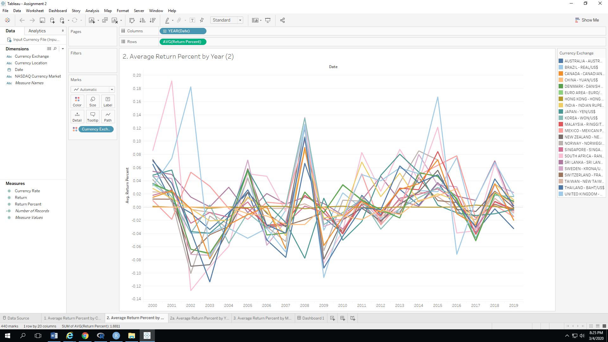

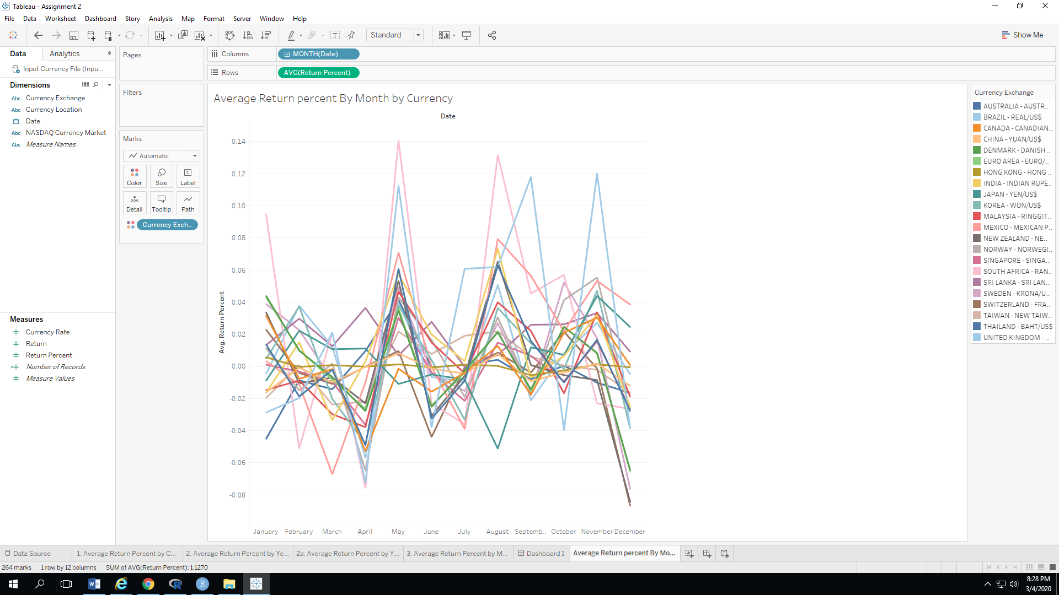

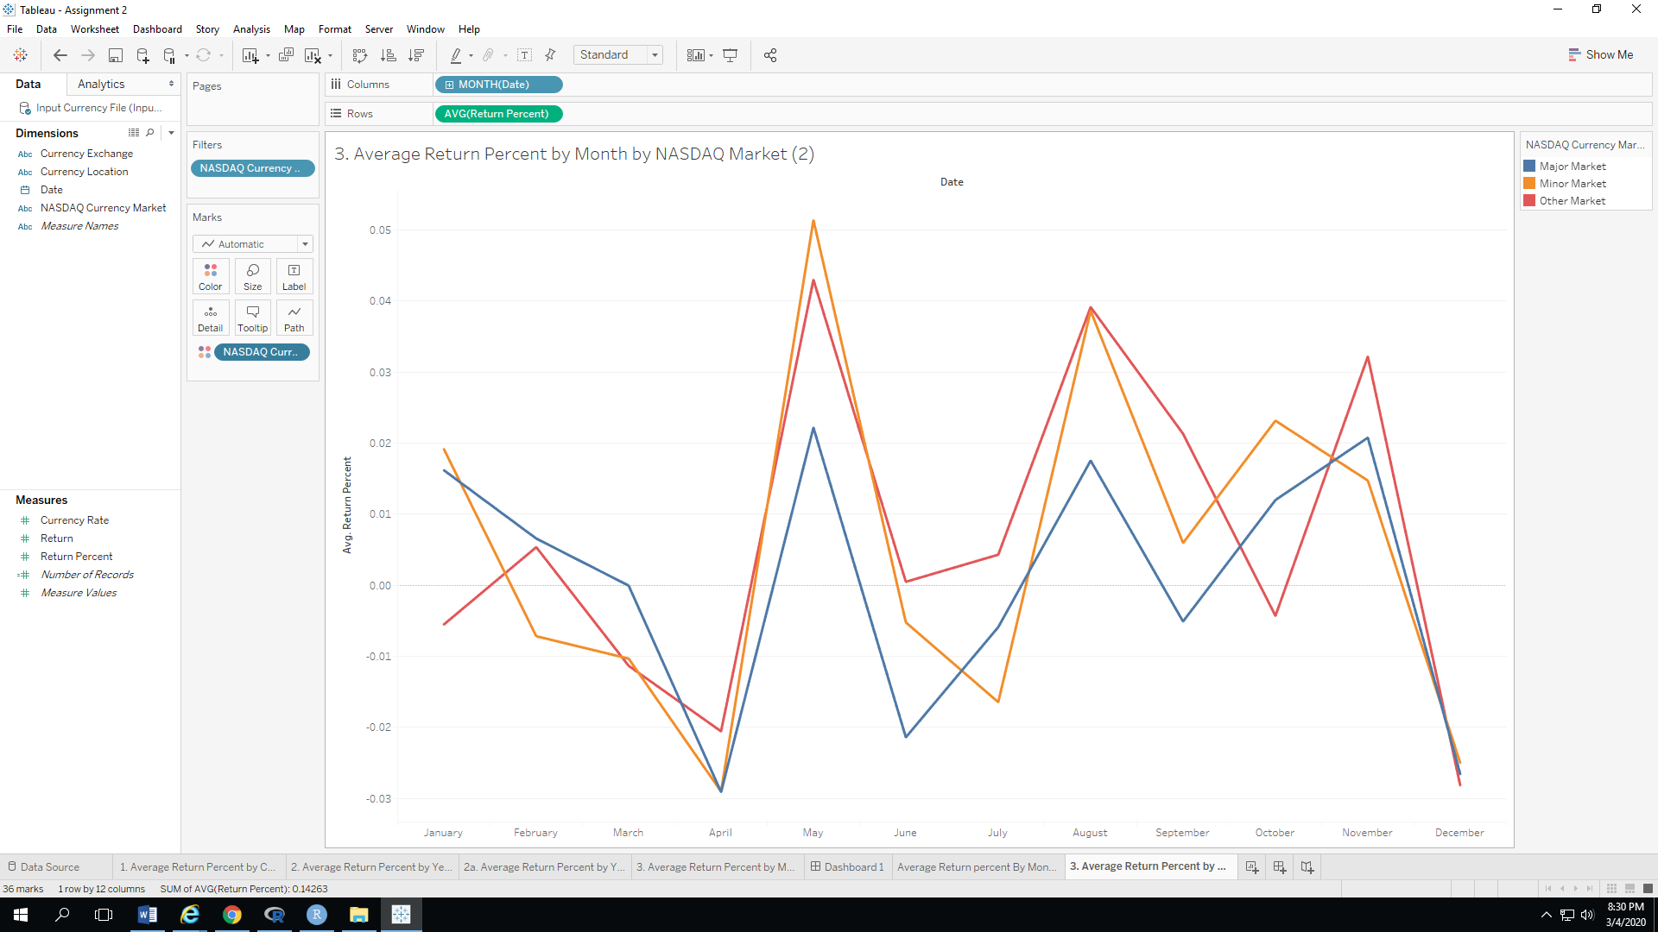

REFERENCES:

<https://www.kaggle.com/brunotly/foreign-exchange-rates-per-dollar-20002019/data>

<https://en.wikipedia.org/wiki/Asia-Pacific>

<https://www.nasdaq.com/articles/forex-market-overview-2019-06-07>

<https://www.exchangerates.org.uk/USD-INR-spot-exchange-rates-history-2010.html>

<https://www.poundsterlinglive.com/bank-of-england-spot/historical-spot-exchange-rates/usd/USD-to-TWD-2007>