Project Report

Sentiment Analysis using Naive Bayes

Submitted to: Submitted by:
Prof. Mithun Balakrishnan Aditya Mahajan(AXM156630)
Harshil Shah (HXS155030)

Problem description:
The problem is to detect whether a given sentence indicates happiness or sadness.

Proposed Solution:

We trained a naïve bayes model using different attributes to indicate the sentiment of a sentence.

Full Implementation Details:

The formula for naïve bayes is
P(y∣x1,…,xn)=P(y)∏^{n}i=1 P(xi∣y)/P(x1,…,xn).

Here y is sentiment of the sentence and x_{i}'s are the attributes of the given sentence. So P(x₁x₂.....x_{n}) is the probability of all the attributes for a given type of a sentence.
P(x_{i}|y) is the probability of the word occurring given the sentiment was y and P(y) is the probability of the sentiment which is simply the ratio of the count of the sentences with a given sentiment and the total number of sentences.

Now for a given sentence we calculate the probability of the sentence being positive given the words and also calculate the probability of the sentence being negative given the words, whichever probability is higher we assign that tag to the sentence.

If P(Positive| words)>P(Negative| words):
Sentence will be classified as positive
else:
Sentence will be classified as negative

1. Baseline Strategy:
Steps followed:
a) Created attributes of each sentence by treating each word in a sentence as a separate
attribute.
b) Converted those attributes into lowercase form.
c) Trained a naïve bayes model on the resulting dataset.

Using this baseline strategy we got an accuracy of 43% on the testing database

2. Improvement Strategy:

Strategy 1:
Steps followed:
a) There are words in a sentence that generally donot hold much information about that sentence. So we removed the stopwords in order to remove those attributes
b) Converted those attributes into lowercase form
c) Trained a naïve bayes model on the resulting dataset.

Using this strategy the accuracy improved to 44% on the testing dataset.
Strategy 2:
Steps followed:
a)After removing the stopwords we used bigrams in a sentence to form the features of the model
b) Converted all the bigram features of the sentence into attributes of the model
c) Trained the naïve bayes model on the resulting dataset

Using this strategy the accuracy improved to 59% on the testing dataset

Examples:

Baseline Strategy:
Consider a sentence like: I am so happy.
The above sentence

After passing through step1 of the baseline strategy, the attributes created for the sentence will be:

1. I
2. am
3. so
4. happy

Now when we pass these attributes to the step2 of the baseline strategy,the attributes modified will be:

1. i
2. am
3. so
4. happy

So if the P(Positive| ( i,am, so, happy))>P(Negative| ( i,am,so,happy))
The sentence will be classified as positive
else:
will be classsified as negative

Strategy 2:
In this strategy we convert the tokens in to bigrams, so the new attributes generated will be:
1. i,so
2. so,happy

The hypothesis that we were testing was if there are two antonyms or words which have a completely opposite meaning are used together, their effect cannot be counted individually. For example, 'not great': here not is contradicting the fact that it is great, therefore the sentence has a negative sentiment.

Using the bigram model actually improved the accuracy to 59%.

Programming tools (including third party software tools used):

Language used: Python
External API and libraries used:
1. NLTK module
2. CMU's syntactic parsing api

Architectural Diagram:

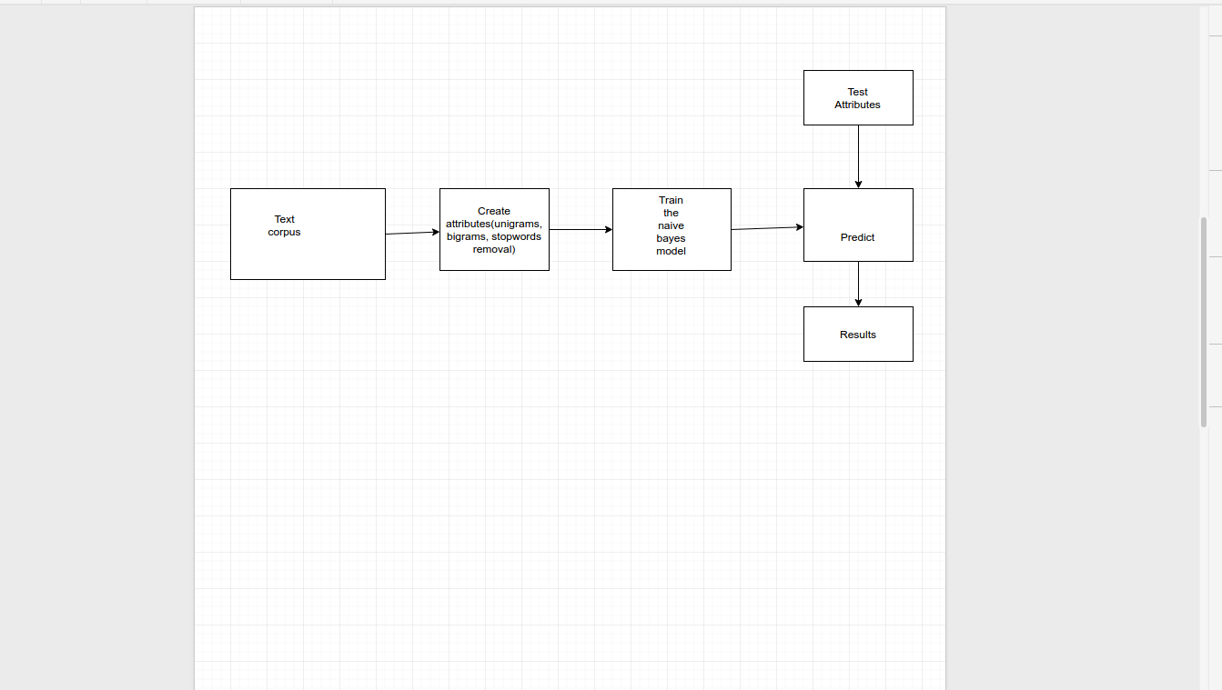

Results:

1. By using unigram model, we get an accuracy of about 44%
2. By incorporating the bigrams, the accuracy increased to 59%

