**Lab results KW13**

IHSAN AHMAD SIDDIQUEE

KIE170706 / 17155732

TEST 1: ADDING A TIMER

Continued from KW12 , after step 1 to 7 :

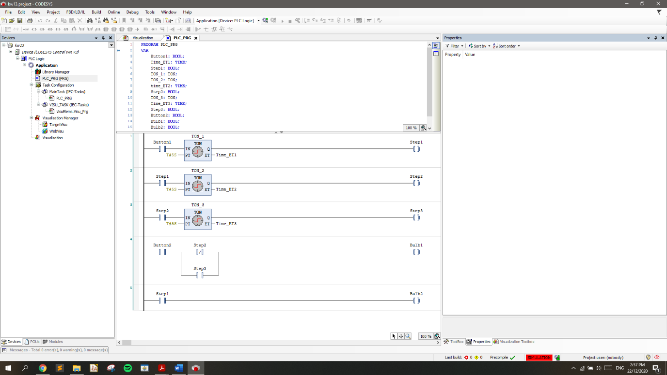

Figure : Constructed the program using ladder diagram

**Q. Capture the output at time intervals of 0s, 5s, 10s, and 15s.**

**Output At 0s :**

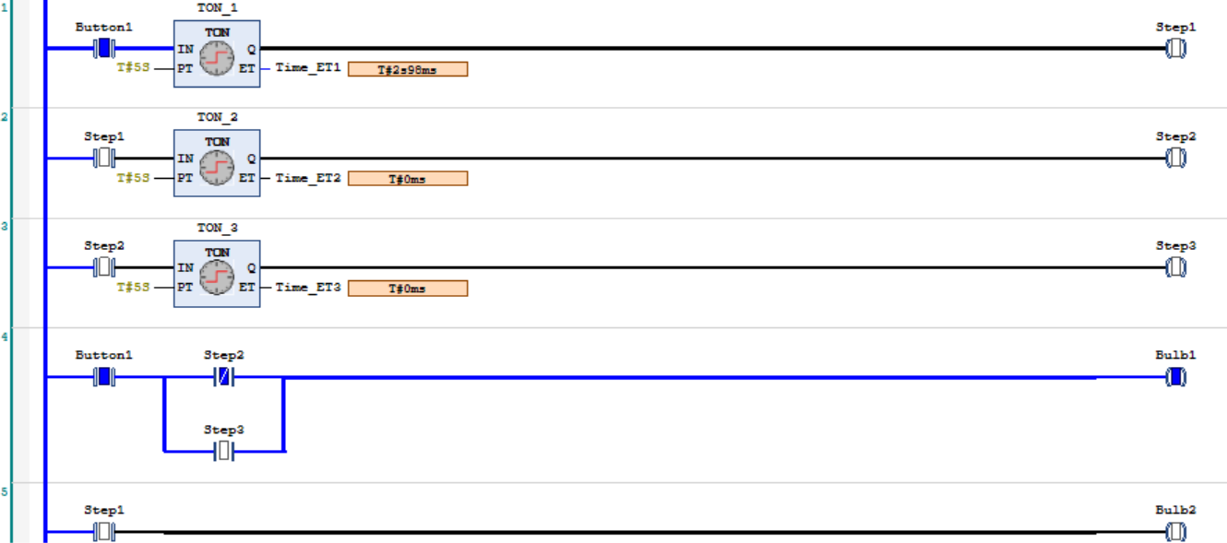

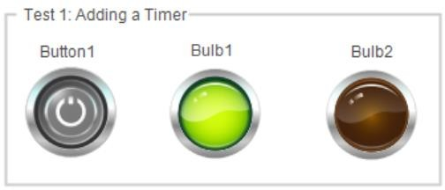

Figure : at 0s , Button1 is on , Bulb1 is on while bulb2 is off.

**Output At 5s :**

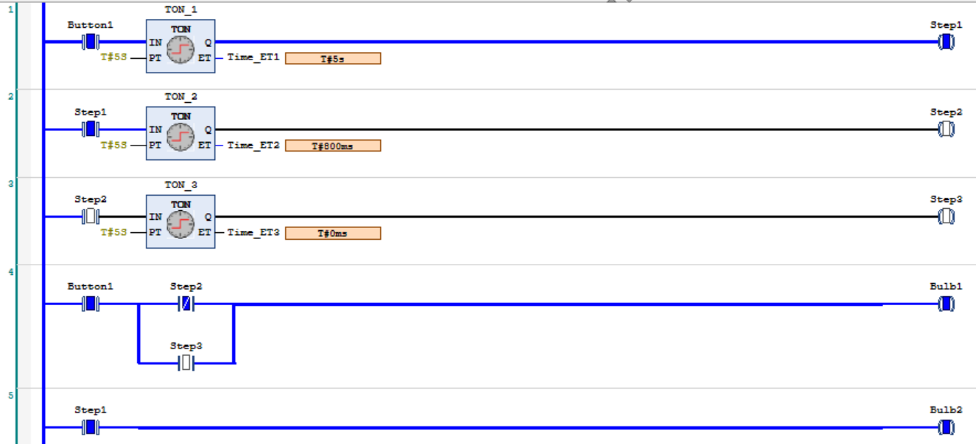

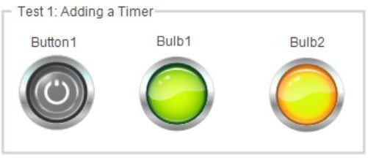

Figure : Bulb1 is true which makes Bulb1 and Bulb2 to be true.

When button1 is true which makes step1 true , when step1 is true bulb2 is on. That’s why from the ladder diagram , button1 makes two bulbs to trun ON.

**Output At 10s :**

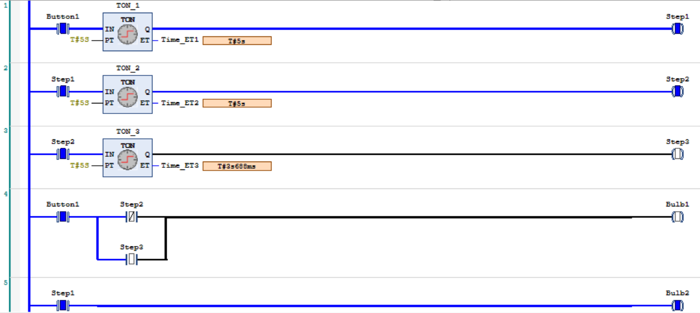

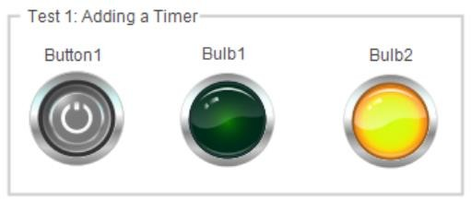

Figure : At 10s , only bulb2 is ON.

**Output At 15s :**

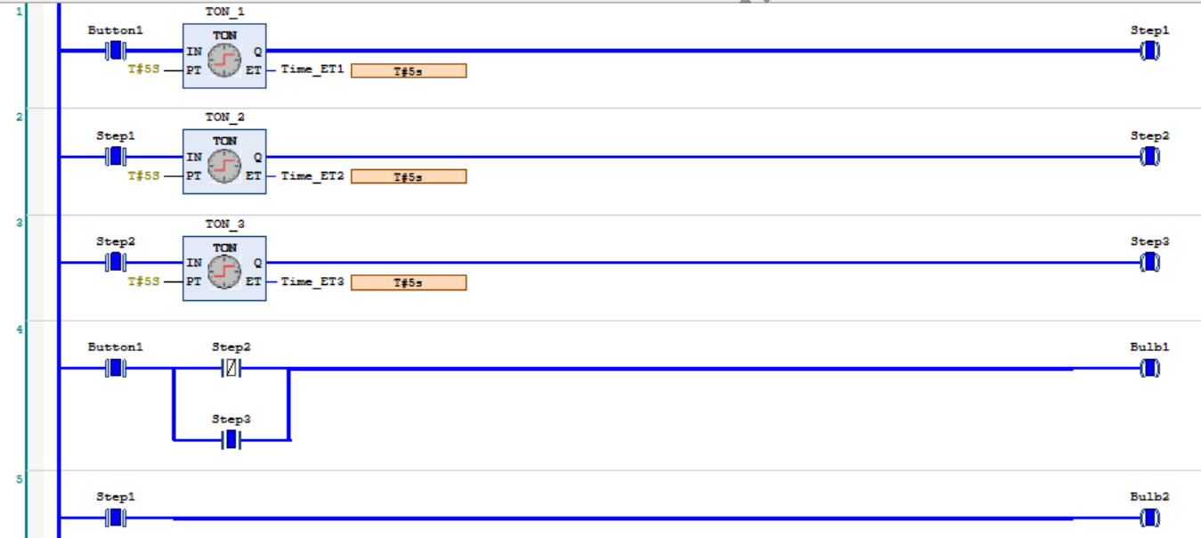

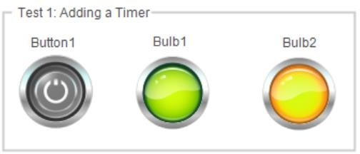

Figure : At 15s , both bulbs are ON

TEST 2: ADDING A UP/DOWN COUNTER

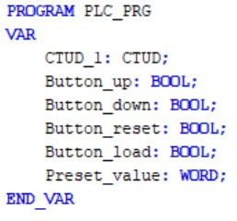

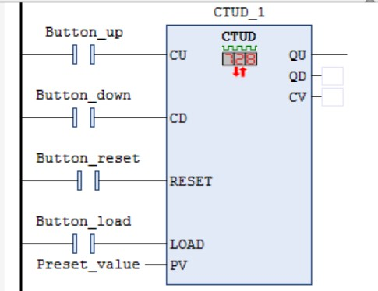

Figure : Connection to the UP/DOWN counter

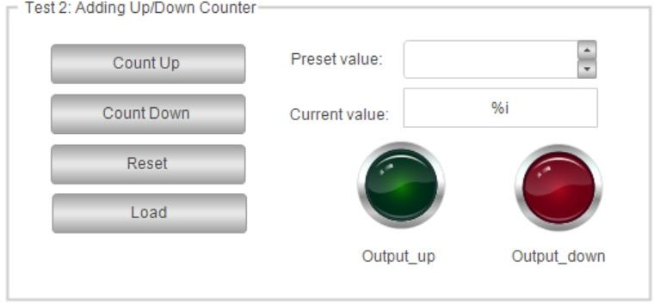

Figure : UI of the Counter application in Visualization

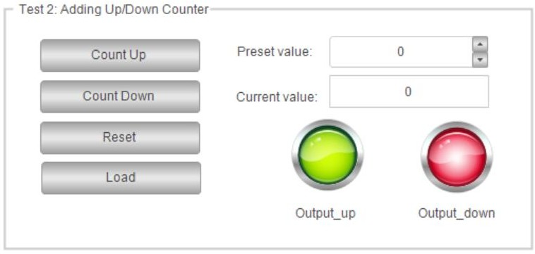

Figure : output up and down is on

Here output up and down is both on because of the pre-set value is 0 and current value matched the pre-set value.

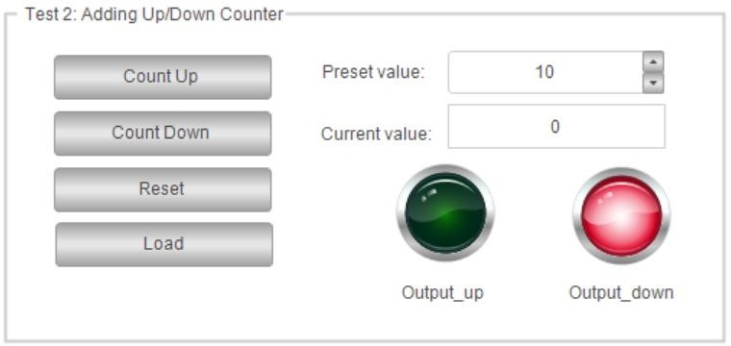

Figure : preset value is set to 10 which makes the output down button ON.

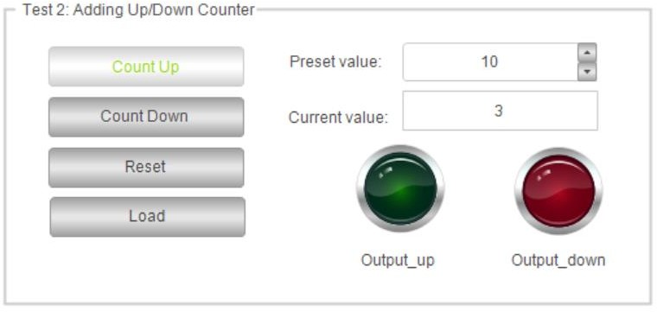

Figure : pressing the count up button makes current value to go upto preset value. Which makes output up and down both to be turned off. Because the value isn’t yet reached preset value.

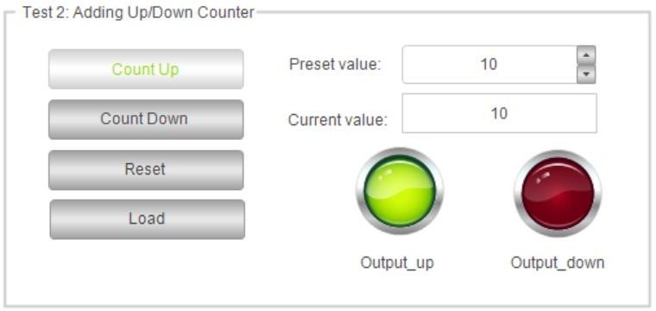

Figure : current value reached preset value which makes ouput up bulb to be ON.

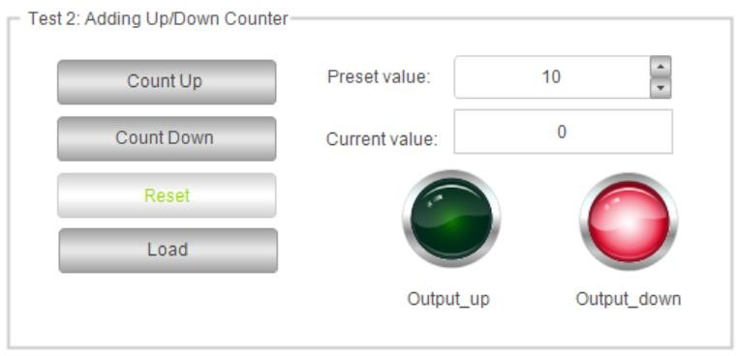

Figure : Pressing reset makes the output down button in OFF state.

**Exercise**

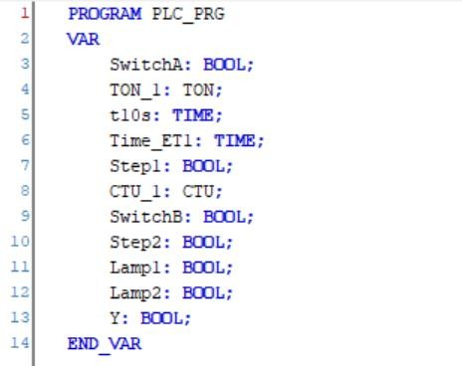

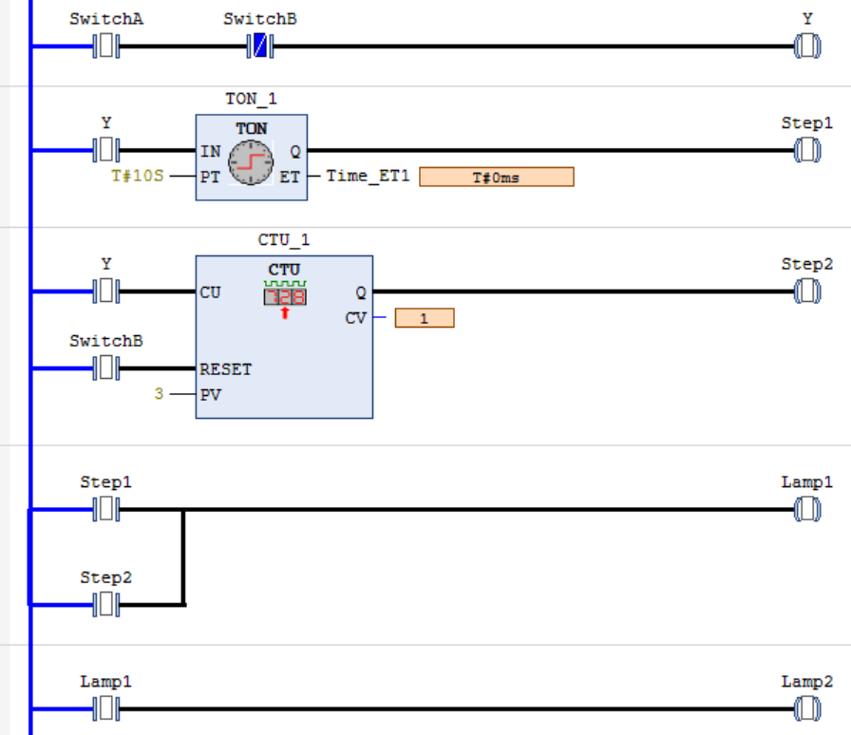

Figure : Ladder diagram for the exercise application

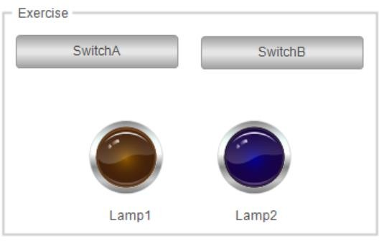

Figure : Visualization of the application

Condition 1 : Switch A is switched on for 10 seconds

Output : Both the bulbs will be ON.

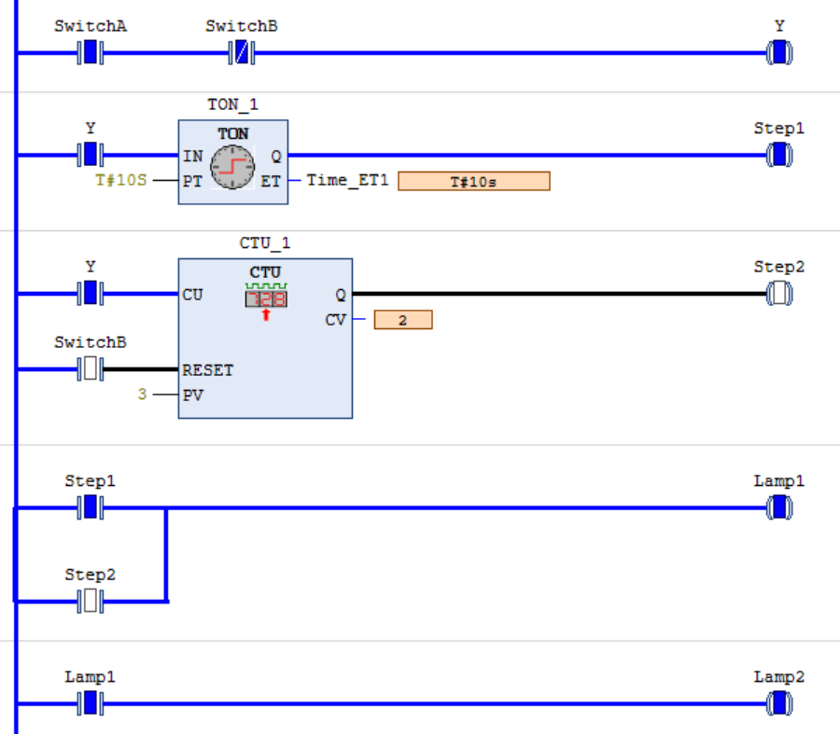

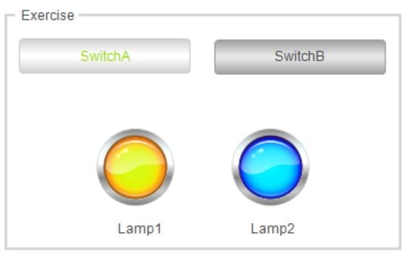

Condition 2 : A is closed three times.

Output : the lamps will be activated

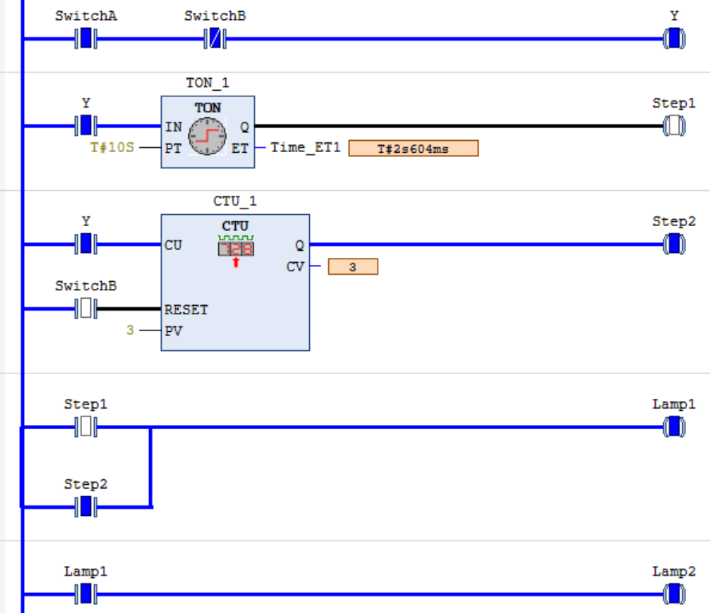

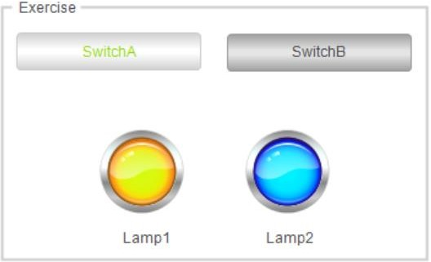

Condition 3 : Switch B is closed or pressed

Output : the lamps will be deactivated

