Lab results P11

IHSAN AHMAD SIDDIQUEE

KIE170706 / 17155732

TEST 1: AVR without feedback controller

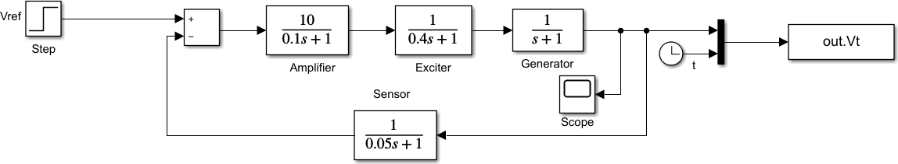

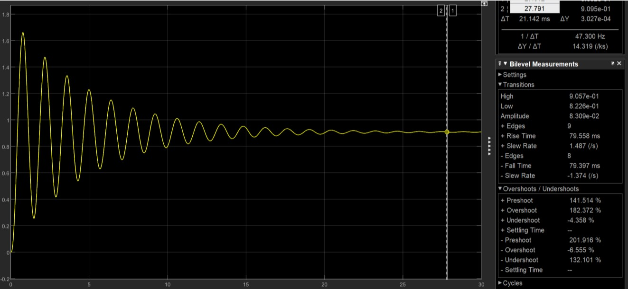Figure : AVR block diagram using SIMULINK

Figure : AVR simulation without feedback controller.

Q. Obtain the step response of the system (rise time, overshoot, settling time and steady-state error).

Rise time = 79.558ms

Overshoot = 182.372%, -6.555%

Settling time = 25.169s

SS error = 1-0.911=0.089

TEST 2: AVR with stabilizer.

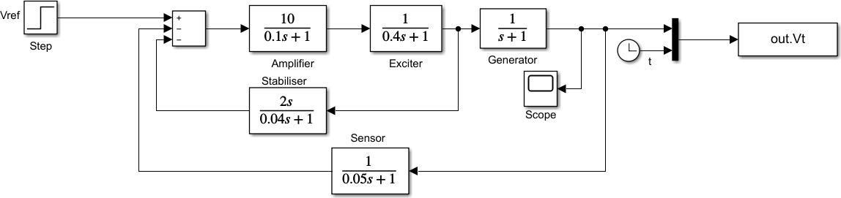

Figure : AVR diagram with stabilizer in Simulink

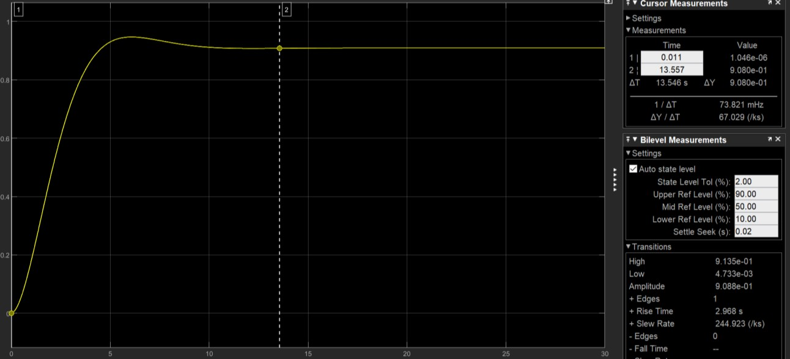

Figure : AVR simulation with stabilizer

Rise Time = 2.968s

Overshoot = 3.646%

Settling Time = 10.060s

Steady State Error = 1-0.9091=0.0909

TEST 3: AVR with PID controller



Figure : AVR with PID controller in Simulink

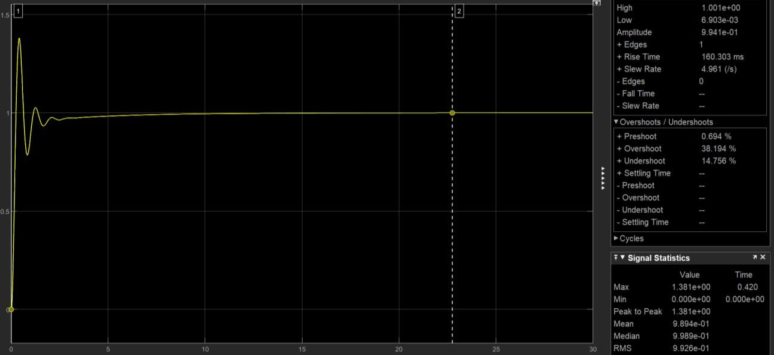

Figure : Simulation of AVR with PID controller.

Rise Time = 160.303ms

Overshoot = 38.194%

Settling Time = 14.379s

Steady State Error = 1-0.9998= 0.0002