Lab result P12

IHSAN AHMAD SIDDIQUEE

KIE170706 / 17155732

1.     The electric field magnitude at point X located at the middle of silicon rubber is obtained as below

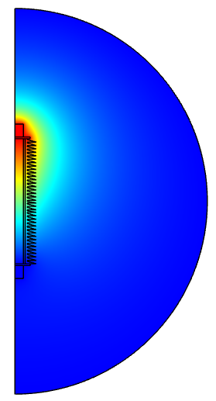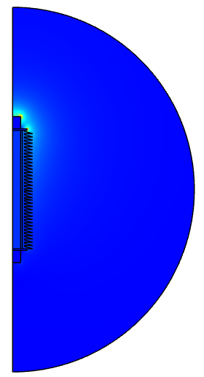

Figure 1: Electric potential distribution      Figure 2: Normal electric field distribution

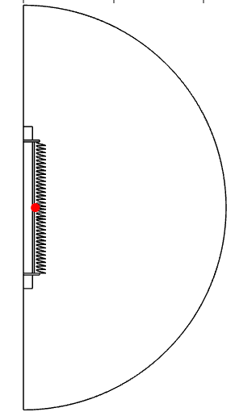

Figure 5: Point X located in the middle of silicon rubber

At point X, the coordinate is r = 13.2 cm and z = 0 cm. The electric field magnitude at point X is 94295.41 V/m.

2.     The value of the relative permittivity is chosen by varying the silicon rubber permittivity by ±25%. Five different values are used. For each of the values, the electric field magnitude at point X is obtained and recorded in a table.

3.6(original) X 0.25 = 0.9, the allowable range for varying is from 2.7 to 4.5.

|  |  |
| --- | --- |
| Varying the relative permittivity of silicon rubber | Electric field magnitude at point X (V/m) |
| 2.7 | 104500.2 |
| 3.2 | 97933.82 |
| 3.7 | 93546.69 |
| 4.0 | 91591.86 |
| 4.5 | 89099.78 |

Table 2: The magnitude of the electric field by varying silicon rubber permittivity

3.     The original permittivity of the silicone rubber is set to the original value. Next, the value of the relative permittivity is chosen by varying the value of permittivity of the fiberglass by ±25%. Five different values have been chosen. For each of the values, the electric field magnitude at point X is obtained and recorded in a table.

4.2(original) X 0.25 = 1.05, the allowable range for varying is from 3.15 until 5.25.

|  |  |
| --- | --- |
| Varying the relative permittivity of fiberglass | Electric field magnitude at point X (V/m) |
| 3.2 | 93651.61 |
| 3.6 | 93953.15 |
| 4.0 | 94194.04 |
| 4.5 | 94434.37 |
| 5.2 | 94692.22 |

Table 3: The magnitude of the electric field by varying fiberglass permittivity

4.     The original permittivity of the fiberglass is set to the original value. The radius R of the silicon rubber is varying by ±25%. Five different values are used. For each of the values, the electric field magnitude at point X is obtained and recorded in a table.

14.4(original) X 0.25 = 3.6, the allowable range for varying is from 10.8 to 18.

|  |  |  |
| --- | --- | --- |
| Varying the radius R of the silicone rubber (cm) |  | Electric field magnitude at point X (V/m) |
| 15.4 |  | 95405.28 |
| 15.8 |  | 94819.2 |
| 16.4 |  | 93818 |
| 17.6 |  | 92322.98 |
| 18.0 |  | 91865.32 |

Table 4: The magnitude of the electric field by varying the radius of silicon rubber

5.     The original thickness, th of the fiberglass is set to the original value. The thickness of the fiberglass is varying by ±25%. Five different values are used. For each of the values, the electric field magnitude at point X is obtained and recorded in a table.

All the components are maintained as an original value without changing any width of zinc or silicone rubber. 2(original) X 0.25 = 0.5, the allowable range for varying is from 1.5 to 2.5.

|  |  |  |  |
| --- | --- | --- | --- |
| Varying the thickness, th of fiberglass (cm) | All points for silicone |  | Electric field magnitude at point X (V/m) |
| 1.5 | minus 0.5 |  | 94714.26 |
| 1.8 | minus 0.3 |  | 99076.66 |
| 2.1 | add 0.1 |  | 94027.74 |
| 2.3 | add 0.3 |  | 94155.2 |
| 2.5 | add 0.5 |  | 93332.11 |

Table 5: The magnitude of the electric field by varying the thickness of fiberglass