***Lab P4 RESULTS***

IHSAN AHMAD SIDDIQUEE

KIE170706 / 17155732

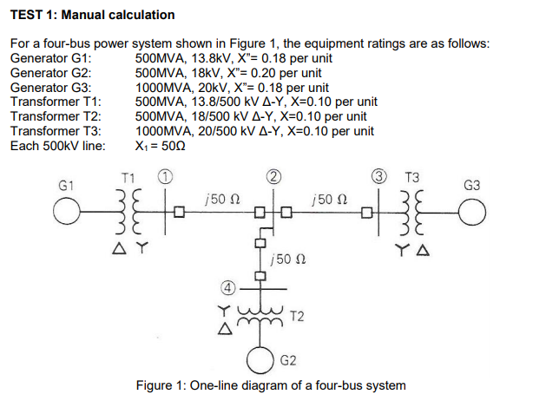

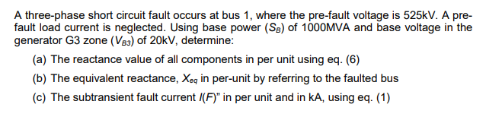

***Simulation calculation results***

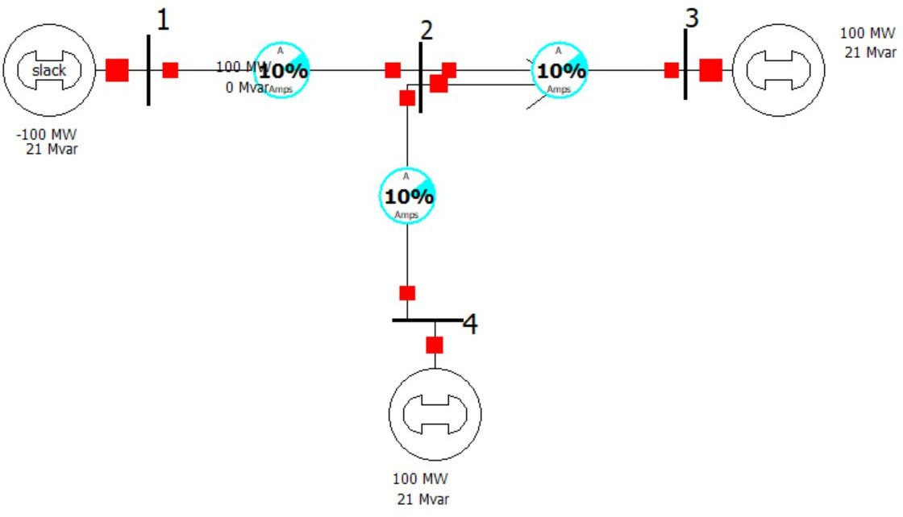1. A three-phase fault occurs at bus 1. Determine the subtransient fault current in per unit. Then, compare this value with your manual calculation in TEST 1(c).

Figure : Before fault analysis

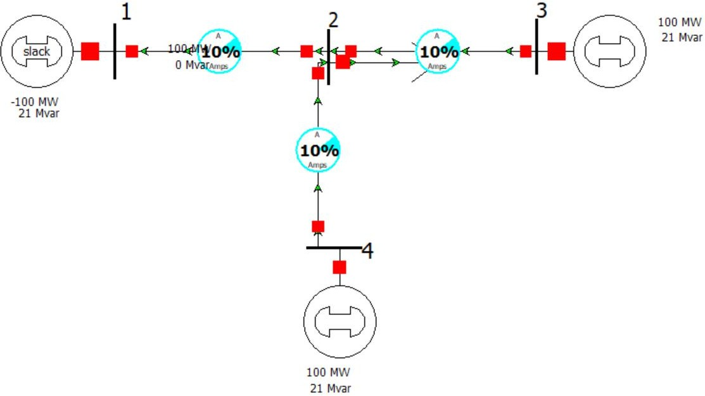

Figure : Load flow analysis

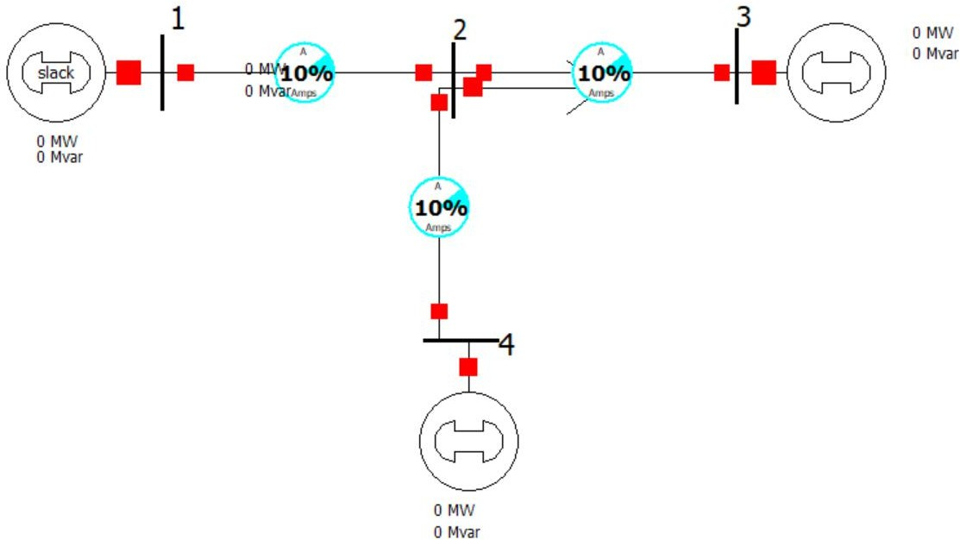

Figure : all sources has been short circuited, and all loads has been open circuited. MW and MVar for generator and load set to zero.

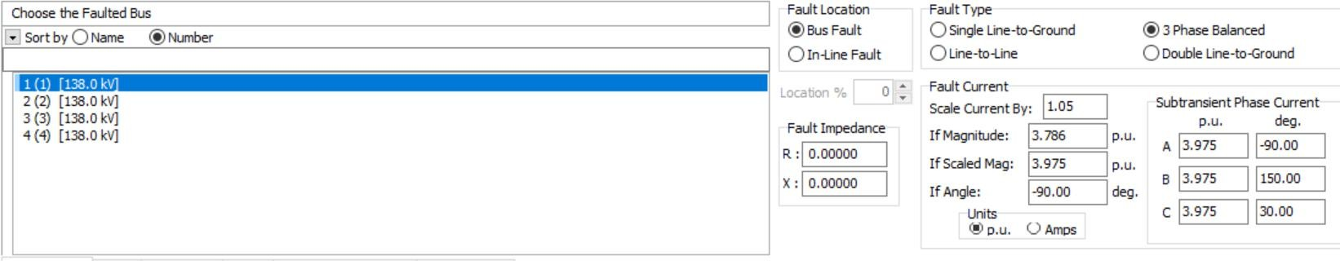

Figure : Faulted bus is selected which is no 1



Figure : Fault current is 3.875 p.u. which is exactly same as manual calculated value

2. Determine the per-unit bus voltage magnitude at each bus when a three-phase short circuit fault occurs at bus 1.

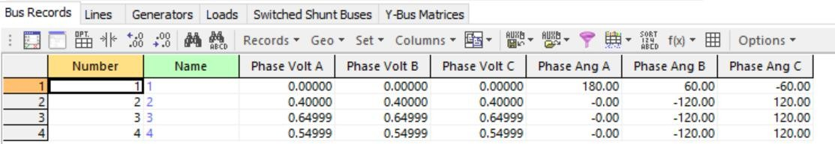

Bus voltage magnitude at bus 1: 0.0000 p.u.

Bus voltage magnitude at bus 2: 0.4000 p.u.

Bus voltage magnitude at bus 3: 0.6499 p.u.

Bus voltage magnitude at bus 4: 0.4999 p.u.

3. A three-phase fault occurs at bus 3. Determine the subtransient fault current in per unit. Compare this fault current value with the fault current found in TEST 2(a). Explain why there is a difference or no difference between the two fault current values.

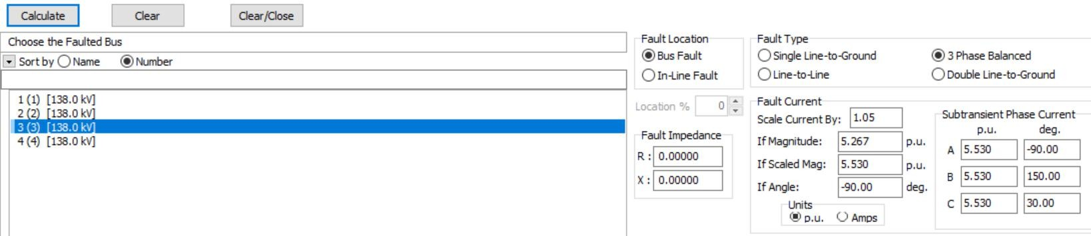

Figure : Fault at the bus 3 is 5.530 p.u.

Fault at the bus 3 is different than the fault in bus 1 because the difference in equivalent impedance.

Manually calculating the Xeq

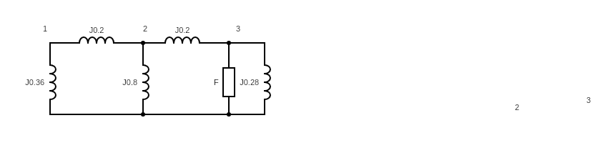

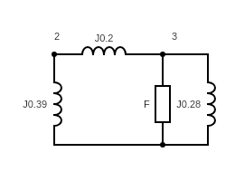

TEST 1 : Manual calculation

