27386_Murenzi Charles_Assignment1

1. The P3 Directory, Go to Your Home
a) Relative path:
cd ../../../.. (from P3 → winner)
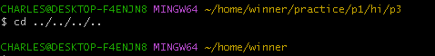
b) Absolute path:
cd ~/home/winner
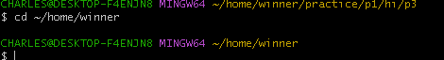

2. Show Long Listing of Here
I have first created here directory.
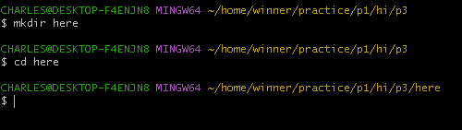
a) Relative path:
ls -l ../../P3/Here
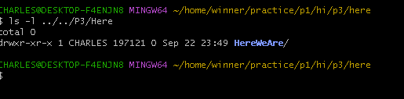
b) Absolute path:
ls -l /c/Users/CHARLES/home/winner/practice/p1/hi/p3/here
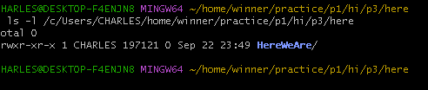

3. Copy the Directory P3 to the Command Directory
a) Relative path (in P3 directory):
cp -r ../p3 ../../command
b) Absolute path:
cp -r /c/users/charles/home/winner/practice/p1/hi/p3 /c/users/charles/home/winner/practice/command
c) Relative path (in Command directory):

d) Absolute path:
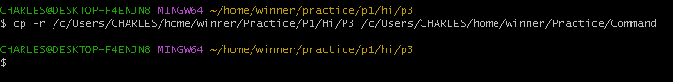

4. Copy the Files in P3 to the Command Directory
a) Relative path (in P2 directory):
cp ../P3/* ../Command/
b) Relative path (in P3 directory):
cp -r * ../command/
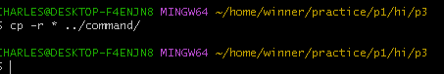
c) Relative path (in Command directory):
cp -r ../P3/*
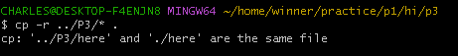
d) Absolute path:
cp /c/Users/Charles/home/winner/practice/p1/hi/P3/* /c/Users/Charles/home/winner/practice/p1/hi/Command/

5. Difference Between Q3 and Q4
• Q3: Copies the directory P3 itself into Command.
• Q4: Copies only the contents of P3 (files/subfolders), not the directory itself.

6. Meaning of Colors
• Yellow: Executable file (program or script with execute permission).
• Blue: Directory.
• hereWeAre: Should be green (regular file), unless it is executable (then yellow) or a directory (then blue).

