***Lab 01***

# Quadratic equation Solver

**Lab objectives:**

* Editing and running a python application using an IDE (**IDLE**)
* Introducing the steps of designing a solution and testing
* Download and install Python and IDLE on your Machine: <https://www.python.org/downloads/>

A quadratic equation is can be represented as follows:

y = ax2 + bx + c

Our Quadratic equation solver will find the Reel values of x (roots) that make y = 0.

* Manually fill in the following Table:
  + You may use a calculator not a program.

|  |  |  |  |  |
| --- | --- | --- | --- | --- |
|  |  |  | Expected | Expected |
| a | b | c | delta | Roots |
| -1 | 1 | -1 |  |  |
| 1 | 2 | 1 |  |  |
| 2 | -10 | 12 |  |  |
| 0 | 3 | -2 |  |  |
| 1 | -6 | 9 |  |  |
| 1 | 4 | 3 |  |  |
| 3 | 0 | 0 |  |  |

* In Idle type, save and run a file containing the exactly the following program:
  + Type it yourself. Do not copy and paste.

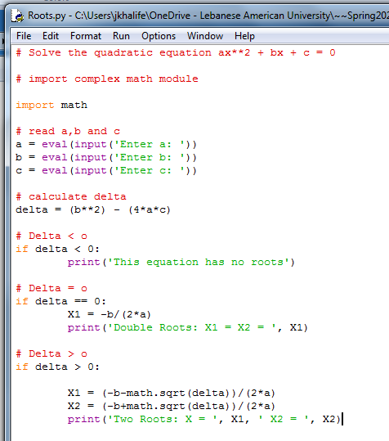

* List any error and corrections that you made before being able to run the program
* For each of the seven input values run the program. Complete the table below showing, in addition to the expected results already calculated, the observed results.

|  |  |  |  |  |  |
| --- | --- | --- | --- | --- | --- |
|  |  |  | Expected | Expected Results | Observed Results |
| a | b | c | delta | Roots |  |
| -1 | 1 | -1 |  |  |  |
| 1 | 2 | 1 |  |  |  |
| 2 | -10 | 12 |  |  |  |
| 0 | 3 | -2 |  |  |  |
| 1 | -6 | 9 |  |  |  |
| 1 | 4 | 3 |  |  |  |
| 3 | 0 | 0 |  |  |  |

* Analyze by comparing the expected to the observed results and write your observations.

**Deliverables**:

A Lab **report** including the following:

1. A list of errors that you encountered before being able to run the program.
2. The table showing the expected results and the observed results.
3. Analysis and observations when comparing the expected and the observed results
4. Write your Recommendations to improve the program and do a design (flowchart or pseudocode, not a program), that includes your recommendations.

To Be Submitted on Blackboard before due Date.

**Attention!**

**Policy on Cheating and Plagiarism:**

**Plagiarism on assignments and project work is a serious offense. If plagiarism is detected, a student will be subject to penalty, which ranges from receiving a zero on the assignment concerned to an “F” in the course.**