*Spring 2021*

**CSC/BIF 243**

**Introduction to Object Oriented Programming**

*Course Instructor: Joe Khalife*

Lab02

**Problem 1**

Write a program that prints the text below to the screen.

**Output:**

Hello World!

Using Python is so easy

I am the ‘King‘ of Python

Save and Run your program.

1. **Delivery 1**: Document and explain your observations.

**Problem 2**

In a program put the following expressions in print statements. Use two statements for each expression:

5+3 (Try once with double quotations and once without)

5-3 (Try once with double quotations and once without)

5/2 (Try once with double quotations and once without)

5//2 (Try once with double quotations and once without)

5*2 (Try once with double quotations and once without)

Save and Run your program.

1. **Delivery 2**: Document your run and explain your observations.

**Problem 3**

**Try these print functions below:**

**print(“Hello”, “World!”)**

**print(“Hello “,”World!”)**

**print(“Hello “, “ World!”)**

**print(“Hello”, “World!”, sep=”----“)**

**s=”Hello World!”**

**print(s)**

**Comment at the end if you notice any difference concerning the first 3 functions, if you do not recognize any difference, type N/A.**

1. **Delivery 3: Your Comments**

**Problem 4**

The following program finds Minimum Number of Coins:

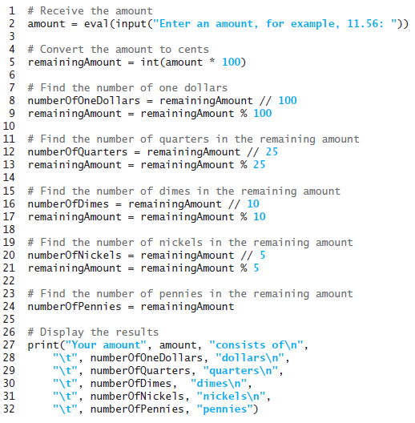

Write it and run it 5 times for 5 different input values. Complete the Table below

|  |  |  |
| --- | --- | --- |
| **Run** | **Input:** | **Outuput** |
| **1** |  |  |
| **2** |  |  |
| **3** |  |  |
| **4** |  |  |
| **5** |  |  |

1. **Delivery 4**: Table

**Problem 5**

Write a program that reads an integer *N* and prints the 2 rightmost digits of *N*.

**Input**

328

**Output**

28

**Problem 6**

The following program finds Minutes and seconds from seconds.

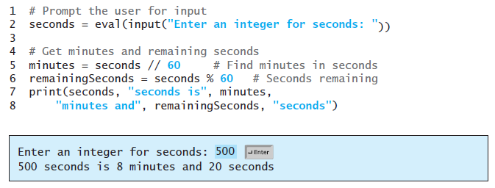

Write a program to find Hours, Minutes and seconds from seconds. Include comments in your program. Run it 5 times for 5 different input values and complete the following table.

|  |  |  |
| --- | --- | --- |
| **Run** | **Input:** | **Outuput** |
| **1** |  |  |
| **2** |  |  |
| **3** |  |  |
| **4** |  |  |
| **5** |  |  |

1. **Delivery 6:** Your program and the table.

**Deliverables**:

A Lab **report** containing the six delivery items described to be submitted on Blackboard before due Date.

**Attention!**

**Policy on Cheating and Plagiarism:**

**Plagiarism on assignments and project work is a serious offense. If plagiarism is detected, a student will be subject to penalty, which ranges from receiving a zero on the assignment concerned to an “F” in the course.**