*Fall 2021*

**CSC/BIF 243**

**Introduction to Object Oriented Programming**

*Course Instructor: Joe Khalife*

**Lab4**

**Problem 1**

Given three points of a triangle, you can compute the angles using the following formula:



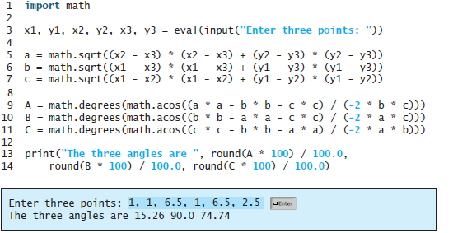

Rewrite the above program by defining and calling the following two functions:

* **Distance:** that takes four numbers representing two points and returns the distance between them.
* **Angle:** that takes as arguments three sides of a triangle and returns an angle,

**Problem 2**

Write a program that generate a random uppercase alphabetic character and asks the user to guess on the generated character by entering an uppercase alphabetic character.

The program should check if the entered character is the same as the generated one, if they are equal print the *Good Guess* else print *Wrong Guess*.

Sample Runs:

Enter an uppercase alphabetic character: ***A***

*Wrong Guess*

The Random character is: B

Enter an uppercase alphabetic character: ***C***

*Good Guess*

The Random character is: C

**Problem 3**

A triangle is considered valid if the sum of each 2 sides is greater than the remaining third side. Also, triangles can be classified as follows:

* Equilateral: If all sides are equal
* Isosceles: If 2 sides are equal
* Scalene: If all sides are not equal

Write a program that takes the length of three sides and print “equilateral”, “isosceles”, or “scalene”. If the input does not create a valid triangle print “invalid”.

|  |  |
| --- | --- |
| Sample Input | Sample Output |
| 3 2 3  2 5 1 | isosceles  invalid |

**Problem 4**

**Design** and **write** a Python program that will from Keyboard read four inputs, named **test1**, **test2**, **test3**, and **final**. The application will then determine the best 2 (Btest1, and Btest2) out of the 3 grades of tests 1, 2 and 3. Then, it will compute the final average and the letter grade.

Use the following grading policy:

BTest1: 30% BTest2: 30% Final: 40%

And then display the corresponding letter-grade based on the following scheme:

90-100: A 80-89: B 70-79: C 60-69: D 59 and below: F

Define and use functions in your implementation.

The following shows a **sample run**. Your application should be able to generate a similar output:

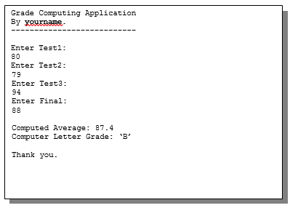

Use functions in your program.

**Attention!**

**Policy on Cheating and Plagiarism:**

**Plagiarism on assignments and project work is a serious offense. If plagiarism is detected, a student will be subject to penalty, which ranges from receiving a zero on the assignment concerned to an “F” in the course.**