*Fall 2021*

**CSC/BIF 243**

**Introduction to Object Oriented Programming**

*Course Instructor: Joe Khalife*

LAB05

**Problem 1**

**Study this code:**

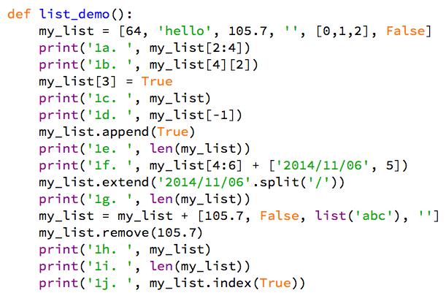

**Step 1**.

Predict the output of this code.

**Step 2**.

Type the code into a file named **Prob03.py**. Run the code.

**Step 3**.

Understand any discrepancies between your predictions and the actual output.

**Note: Nothing to deliver for this problem.**

**Problem 2**

**Write a program that reads a line of text and an integer and outputs the first and last word of the line each n times.**

**Hint: You may want to use the split method.**

**The split() method splits the string into a list of substrings**

**Input**

Enter a line of text: Hi how are you all in the class

Enter an integer: 3

**Output**

HiHiHi

classclassclass

**Problem 3**

**Ask the user to enter his/her first name, Last name and ID number and then print 3 lines as follows:**

**Input**

Enter your first name, last name and ID (seperated by a space): Joe Khalife 12345

**Output**

Hi, my name is first name is Joe

My last name is Khalife

My ID is 12345

**Problem 4**

**Ask the user to enter as many integers as he/she like, separated by spaces, store the numbers in a list. Use list functions and methods to print the list, the number of integers, entered, the sum, the largest, the smallest and how many zeros the list contain.**

**Input:**

Enter as many numbers as you like, separated by spaces: **42 34 0 56 1 3 0**

**Output:**

Your entered: [42, 34, 0, 56, 1, 3, 0]

Your list contains 7 numbers

Sum:136

Smallest:0

Largest: 56

Your List contains 2 zeros

**Policy on Cheating and Plagiarism:**

**Plagiarism on assignments and project work is a serious offense. If plagiarism is detected, a student will be subject to penalty, which ranges from receiving a zero on the assignment concerned to an “F” in the course.**