*Spring 2021*

**CSC/BIF 243**

**Introduction to Object Oriented Programming**

*Course Instructor: Joe Khalife*

**Lab 09**

**Problem 1**

1. **Create a text file (Notepad) containing the below and name it flanders.txt.**

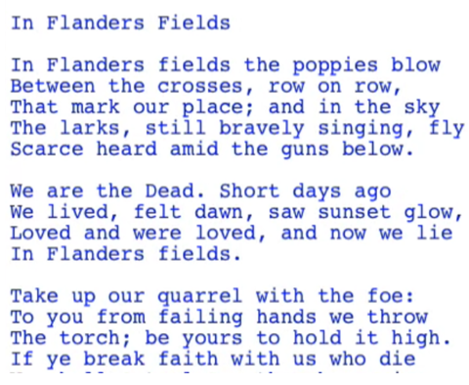

1. **Write a python program that reads flanders.txt and creates a text file containing in addition to what is written in the file, a report on the file.**

**The report should include the following:**

* **Number of lines**
* **Number of words**
* **Number of characters**
* **Number of occurrences of every alphabetic character in the file**

**Problem 2**

Design and write a complete **Application program** that ask the user to enter an integer N and simulates the **roll** two dies ***N*** **times (**N being a large number such 10000 times). Your program should count and output the number and percentage of occurrences of each

* Implement and use a function roll that simulate the rolling of a Die:

*Def roll():*

*# () -> int*

*# returns a random number between 1 and 6*

* Include in the application a prompt for re-running the simulation.

**Problem 3**

*Hangman Game:* Write a program that prompts the user to guess a word. The program starts by displaying dashes for each character in the word. Then, the user starts by inputting characters. If the character is in the word, it replaces the dash and the program proceeds. The user is allowed a number of attempts equal to double the length of the word.

Hint: Store the words in a list and then have the program pick one randomly.

**Deliverable: ?**

* **Your programs in a python file.**
* **Sample Runs.**

**Attention!**

**Policy on Cheating and Plagiarism:**

**Plagiarism on assignments and project work is a serious offense. If plagiarism is detected, a student will be subject to penalty, which ranges from receiving a zero on the assignment concerned to an “F” in the course.**