Midterm Exam - Comp 251
Murhej Hantoush
301-325-314

PySpark SQL — Flight Data (2010–2015)
Environment: PySpark shell (Python).
Dataset location: /home/centos/data/flight-data/csv/*.csv
Columns: DEST_COUNTRY_NAME, ORIGIN_COUNTRY_NAME, count
Run this setup once:
flightDF = (spark.read.format('csv')
.option('header','true')
.option('inferSchema','true')
.load('/home/centos/data/flight-data/csv/*.csv'))
flightDF.createOrReplaceTempView('flights')

Section A — Data Exploration (5 Questions)
Q1. Show 5 sample rows from flights.
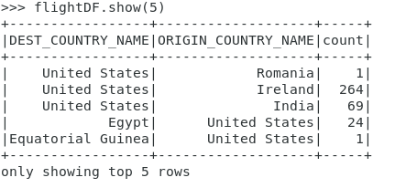
Q2. Display the schema using DataFrame API.
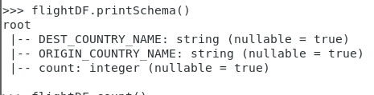
Q3. Count total rows in flights.
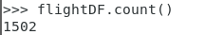
Q4. List 10 distinct origin countries.
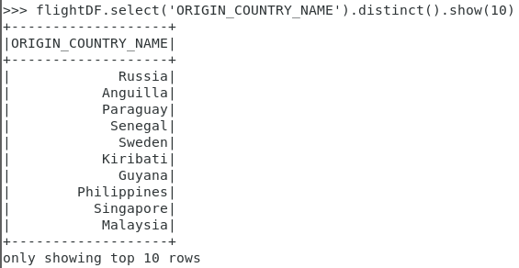
Q5. List 10 distinct destination countries.
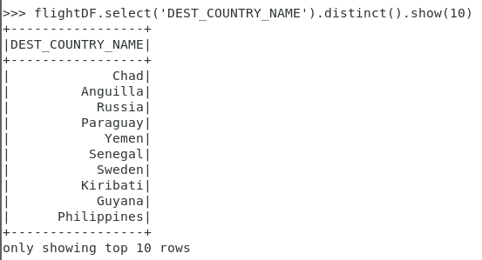

Section B — Filters & Sorting (5 Questions)
Q6. Show all rows where ORIGIN_COUNTRY_NAME = 'United States'. Limit 10.
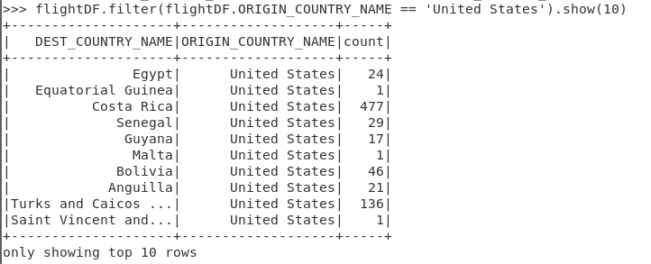
Q7. Show rows where count >= 1000, ordered by count descending.
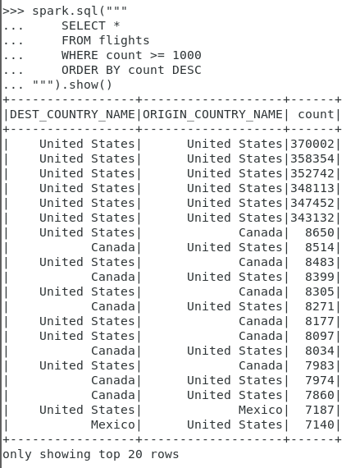
Q8. Find routes where origin equals destination (domestic). Show 10.
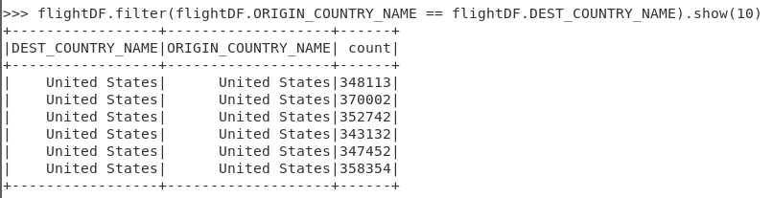
Q9. Show rows where DEST_COUNTRY_NAME starts with 'U' (use LIKE). Show 10.
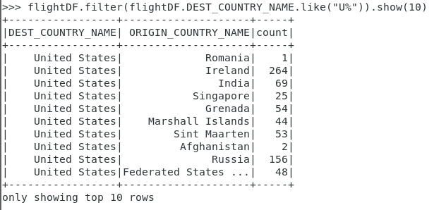
Q10. Show rows where count is between 100 and 500 inclusive. Show 10.
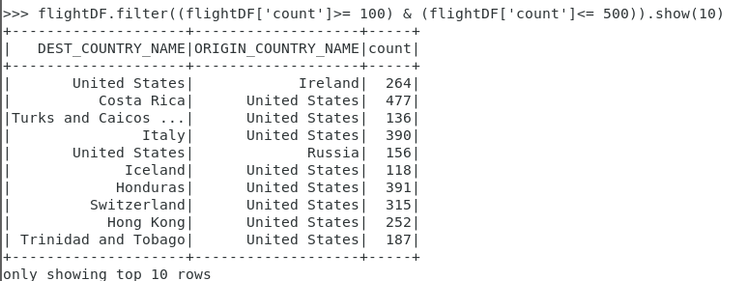

Section C — Aggregations (6 Questions)
Q11. Total flights (SUM(count)) overall.
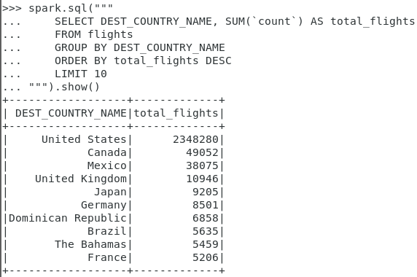Q12. Total flights per DEST_COUNTRY_NAME (sort by total desc). Show top 10.
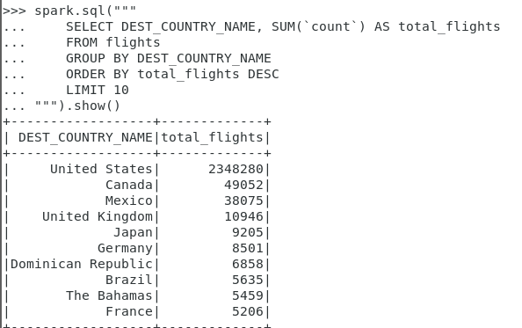
Q13. Total flights per ORIGIN_COUNTRY_NAME (sort by total desc). Show top 10.
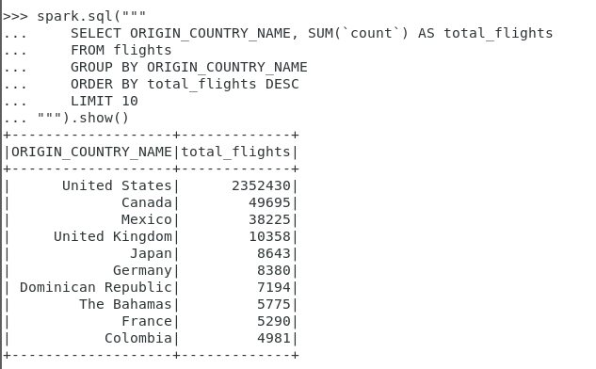
Q14. Top 10 routes by total flights (group by origin, dest).
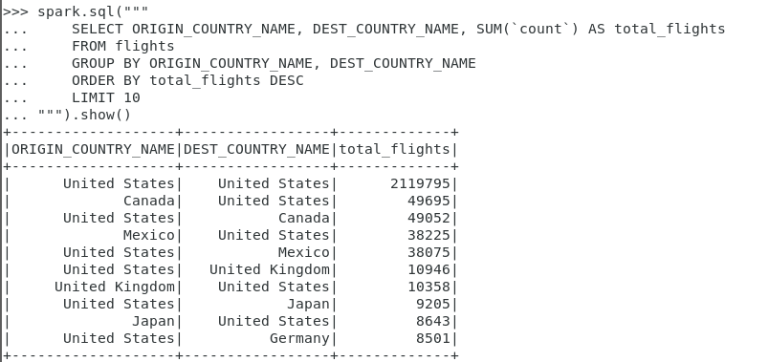
Q15. For United States as ORIGIN, compute total flights per destination. Show top 10.
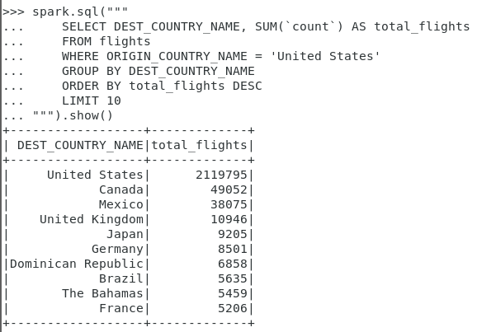
Q16. For United States as DEST, compute total flights per origin. Show top 10.

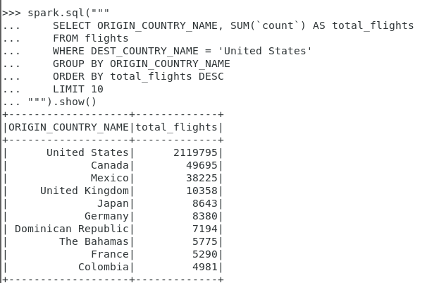Section D — Analytical Exploration (2Questions)
Q17. Find the top 10 busiest routes (origin–destination pairs) by total flights, and describe whether the majority are domestic or international routes.
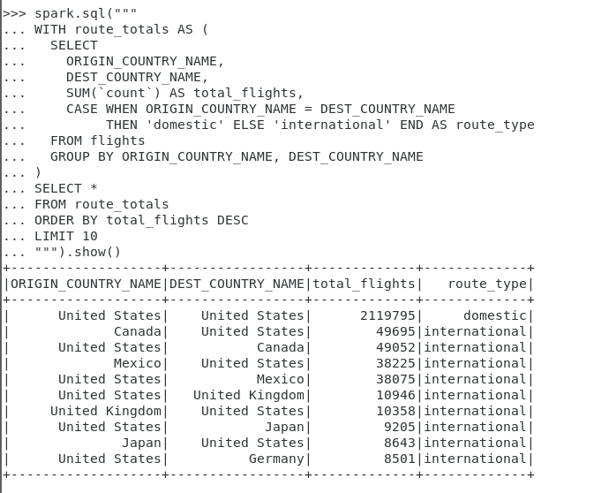
Q18. Using window functions, rank all destinations by total inbound flights and find which rank belongs to ‘Canada’ and ‘India’.
