**Introduction**

Past studies that explored the relationship between complexity and robustness of ecological networks have often been criticized for their simplistic representation. In “Stage structure alters how complexity affects stability of ecological networks”, V.H.W. Rudolf and Kevin D. Lafferty state that most species often change diets as they develop. They had further proposed that the study of these ontogenetic niche shifts could be key to predicting which species could be at risk of extinction in real ecological networks. Adding stage structure to models can more precisely replicate the working of real ecological networks. This paper examines the relationship between the complexity of a stage-structured ecological network and its effect on the robustness and diversity during community assembly.

**Methods**

**Food Web Matrices:**

The Stage Structured Ecological model is built off of Richard Williams and Neo Martinez’ “Simple Rules Yield Complex food webs” (citation). This model extends the previous Cascade model’ fit by compelling species to consume a coterminous grouping of prey in a one-dimensional trophic specialty, or niche. The Niche model function takes in three inputs – richness (S), links (L), and replicates (N), and outputs a two dimensional matrix that represents a Niche food web. The S parameter directly translates to the total population of the ecosystem, and the L parameter represents the total number of predator-prey relations between species. Connectance, represented by C, is a parameter derived from the total number of links. Connectance is the number of links expressed as a proportion of the total possible number of links (citation, foraging biology). Species that do not consume any other species for survival are flagged as self-sustaining species.

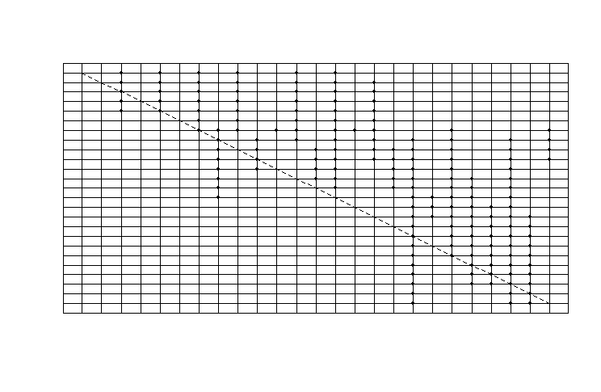

^Sample Niche model with 25 species and Connectance = 0.3^

**Adding stages:**

Stage-structure is introduced to the ecosystem by assigning a random integer with a minimum value of 1 and a maximum value of 10 to each species. This integer represents the total number of stages for each species. In addition to the number of stages, each species is also assigned a reproductive index that is equal to at least half of the total number of species present in the ecosystem. The reproductive index represents the minimum stage requirement for a species to be able to reproduce and not go extinct.

**Stage Matrices:**

A Niche model is two dimensional and is only capable of representing species to species interactions. In order to represent interactions between various stages of these species, stage matrices are introduced, which are then assigned to every species. Unlike the food web matrix, stage matrices aren’t necessarily symmetrical, and the dimensions vary based on predator stages and prey interactions. A stage matrix of a species represents predator-prey relations between the stages of the said predator species, and prey species. Prey are not stage dependent, and the predator stages will be able to consume all of the stages of the prey species. The probability of each stage in the stage matrix consuming a resource is determined by probability p where 0<=p<=1. The p value is assigned during the instantiation of the ecosystem and is immutable. All the stage matrices in an ecosystem are built using the same p value. It is also ensured that each predator stage in the stage matrix consumes at least one prey, and also that each prey is able to get consumed by at least one predator stage (citation Rudolf Lafferty). Due to this condition, the row-sums and column-sums of any stage matrix is always greater than or equal to 1.

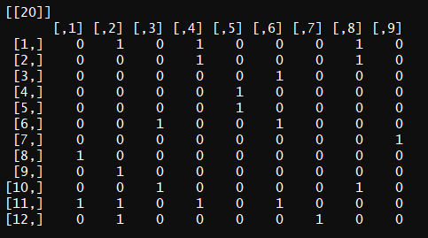

^Example stage matrix of species 20^

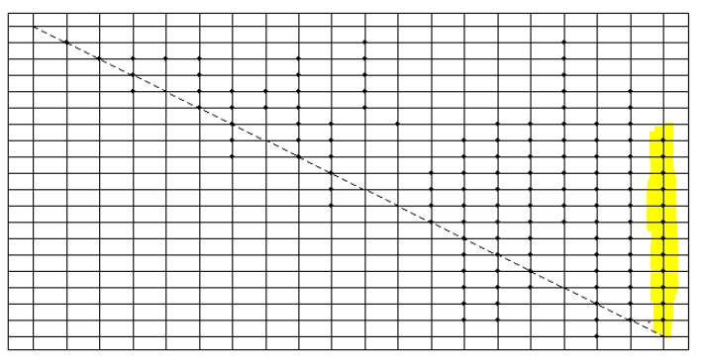

^ Ecosystem from which the stage matrix was extracted

There are 9 predator stages and 12 prey species in the provided example. The 12 prey species refer to the 12 interactions occurring on column 20.

**Mainland and Island:**

An ecosystem is represented as a record that contains the food matrix, the stage matrices, and the food habit information associated with them. It also keeps track of the species and their corresponding stages that are actively present in the ecosystem. A species is considered to be active if its reproductive stage is able to survive off the resources available in the ecosystem. Mainlands and Islands are ecosystems that contain the same food network information, and the only difference between them is that the former always has all of the species present, while the latter is void of any active species.

**Reproduction and Extinctions:**

After every migratory event that occurs in an ecosystem, primary and secondary extinctions are computed. Primary extinctions consist of all the stages of species that aren’t capable of surviving in the new ecosystem due to a lack of resources. After eliminating all the stages that cannot survive, stage lists are checked for any gaps. For example, if stages 1, 2, and 4 of a species X are active, but stage 3 is inactive, stage 4 will be made extinct as an older stage cannot exist without transitioning through a younger one. After getting rid of all the gaps in stages, the remaining species are checked for capabilities of reproduction. In the example of species X, if the reproductive threshold were to be stage 2, then the species would survive as stage 2 can be attained in its current environment. However, if the minimum reproductive threshold were to be greater than 2, the entire species would be made extinct as it will not be able to reproduce. Secondary extinctions consist of all the species that die out due to the loss of resources after primary extinctions. Out of all the species that survive after the wave of primary extinctions, the same check is run through the ecosystem again to simulate secondary extinctions. Considering the possibility that there could be a third wave of extinctions, an iteration function has been added to the ecosystem model that can simulate multiple iterations of secondary extinctions, and the default value has been set to 1.

**Migration:**

At every constant time t, a constant number n species are randomly picked from the Mainland and placed in the Island. After the migration, primary extinctions, and a constant m number of secondary extinctions are calculated, and the resulting population data is logged into the Island’s ecosystem. This can be repeated multiple times until the demographics of the Island become identical to that of the Mainland.

**Results**

A niche model was used as the food web model for this simulation. As the Niche model is an extension of the cascading model, the limit for the Connectance value was based upon it. A cascading model has a theoretical maximum Connectance of C = 0.5. All the communities that were examined had their species richness, N, set to 100, and the number of stages were limited to at most 10. 30 replicates of migration had been run for every permutation of parameters, and the below plots represent a mean of those 30 replicates.

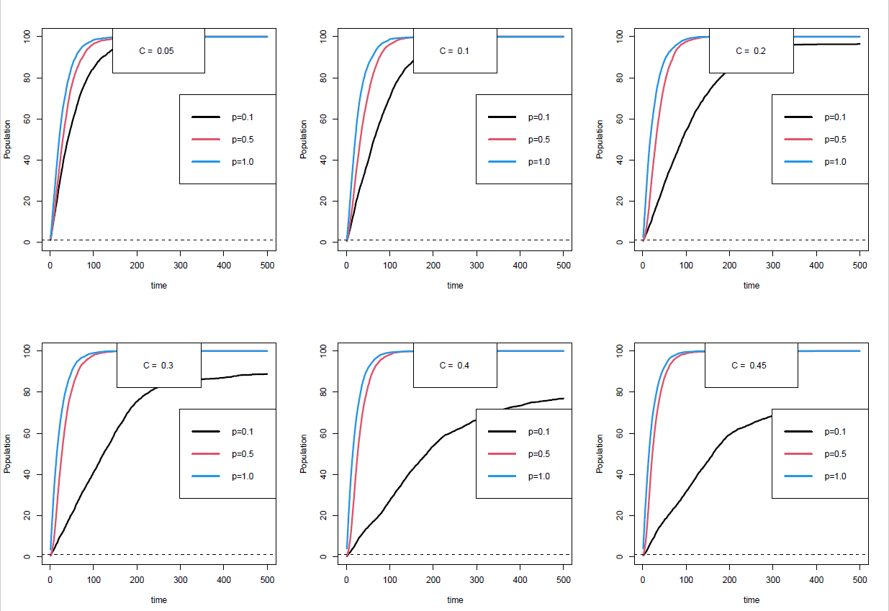Figure X.1: Population Assembly Plots

Figure X.1 shows a very clear correlation between the complexity of the ecosystem and the time taken to assemble. Lower p values tend to take the longest time to assemble, and the higher p values tend to assemble much faster. Interestingly, as the Connectance of the ecosystems increases, the speed at which the lower p values assemble also steadily decreases. As we can infer from figure X.1, assembly not only slows down drastically for ecosystems with p=0.1 at C=0.2 and above, but the island also stabilizes at a population that is lower than that of the mainland.

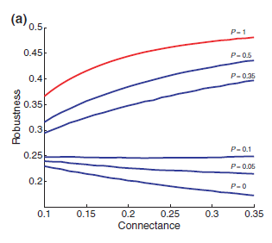

Figure X.2: Rudolf and Lafferty’s Robustness Analysis

These results are consistent with that of the study of Rudolf and Lafferty’s robustness analysis (citation). Figure X.2 showcases how robustness of ecosystems with p values greater than 0.3 increases with an increase in Connectance, but has an opposite effect for ecosystems with a lower p value. The substitution hypothesis can explain the results of the migration as well. Generalist species, which have a greater p value, can often substitute their primary resources with other resources and can thrive by feeding on them. Meanwhile, specialist species, which form in ecosystems with a lower p value cannot substitute their primary resources. Even in the case of ecosystems with higher Connectance, these species might appear to be generalists on a species level, but their individual stages are all specialized on unique resources. This causes them to face a higher risk of secondary extinction (citation).

To generate the diversity data for the ecosystems, three mainlands were generated for every permutation of the Connectance and p values. Each of these 3 mainlands had a corresponding empty island to which there were 10 independent runs of migrations conducted and recorded. The alpha diversity, a variable that measures the diversity within a particular area within an ecosystem was calculated by measuring the number of unique species in each of the 10 islands at every time period of migration. Gamma diversity, a measure of the overall diversity within a large geographical region was calculated by recording the total number of unique species across all 10 islands at every time period of migration. Beta diversity, a comparison of diversity between ecosystems was calculating by dividing the gamma value by the alpha value (diversity citation, 2021).

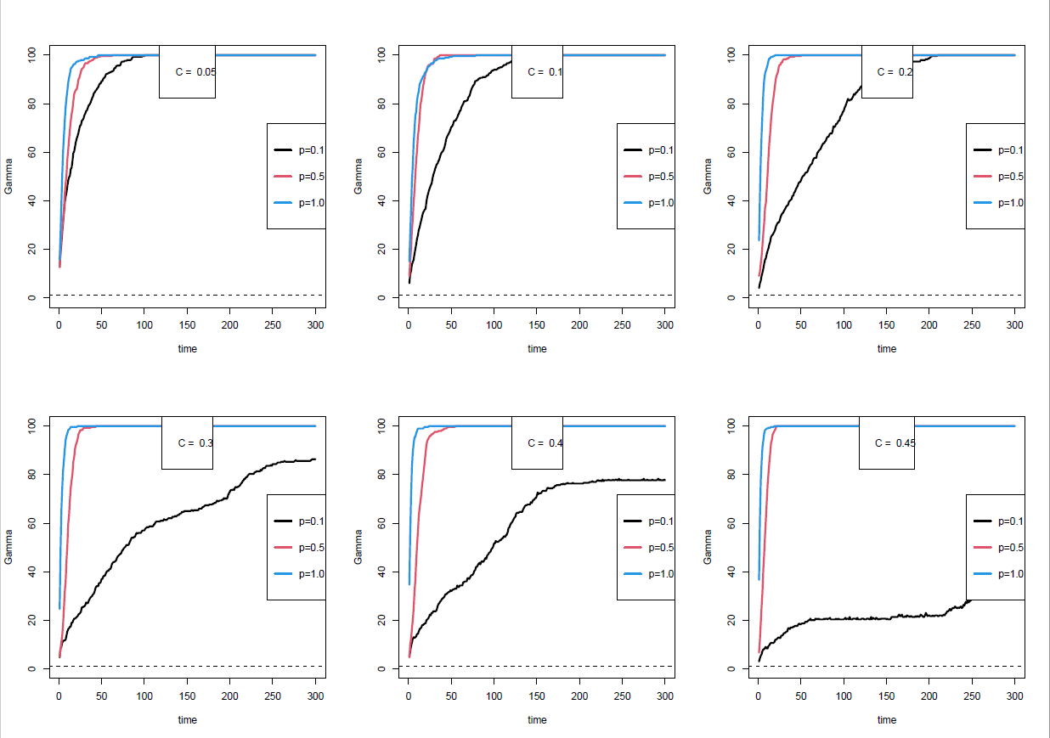

Figure X.3: Gamma diversity plots

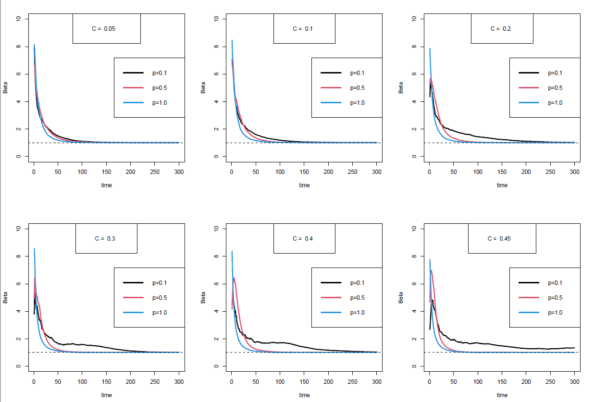

Figure X.4: Beta Diversity Plots

Similar to the population assembly plots, there is a very clear correlation between the complexity of ecosystems and the time to reach maximum diversity as shown in figures X.3 and X.4. The aforementioned substitution hypothesis can also explain the results of the diversity data. Ontogenetic generalists that are specialists on the stage level are more likely to undergo secondary extinctions which thereby affects the overall diversity of the ecosystems.