WORKING TITLE FOR THESIS

by

Nayan Chawla and Akhil Alasandagutti

A thesis submitted to the faculty of the University of Mississippi in partial fulfilment of the requirements of the Sally McDonnell Barksdale Honors College.

Oxford

March 2021

Approved By:

______________________

Advisor: Dr. Peter Zee

______________________

Reader: Dr. Jason Hoeksema

_______________________

Reader: Dr. Ana Pavel

_______________________

©2021

Nayan Chawla and Akhil Alasandagutti

ALL RIGHTS RESERVED

ACKNOWLEDGEMENTS

We would like to thank Dr. Zee, the Sally McBarksdale Honors College, Dr. Hoeksema, and Dr. Pavel for their contribution to this process.

ABSTRACT

AKHIL ALASANDAGUTTI AND NAYAN CHAWLA: WORKING TITLE FOR THESIS

(Under the direction of Dr. Peter Zee)

This is our abstract.

TABLE OF CONTENTS

LIST OF FIGURES X

1. INTRODUCTION 1
2. METHODS X
3. RESULTS X
4. DISCUSSION X

LIST OF REFERENCES X

LIST OF FIGURES

Figure 1 Simulation timeline X

Figure 2 Shift of interactions throughout simulation for a community of richness 200 and 100 percent connectance X

Figure 3 Shift of interactions from start to end of simulation for communities of connectance 10, 50, and 100 percent X

Figure 4 Heatmaps of maximum persistence reached for island communities at 10, 50, and 100 percent connectance X

Figure 5 Heatmaps of the proportion of species on mainland communities after equilibrating, relative to before equilibration, for 10, 50, and 100 percent connectance X

Figure 6 Heatmaps of the logarithm of time to maximum persistence for island communities at 10, 50, and 100 percent connectance X

**1. INTRODUCTION**

Theoretical studies of ecological food webs has allowed ecologists to remove the constraints of location and time from their observations, and provides a tool unique in its ability to represent all possible food web structures. However, these simulated communities are only as useful as the model from which they were constructed. Modifying existing considerations in these models, and generating new ones, are the jobs of theoretical ecologists that seek to achieve the shared goal of a majority of simulations: realism. However, there are many different models that have been developed, all by individuals with varying approaches to achieving biologically realistic results. The difficulty of comparing and combining every single model is not a feat any one study or model can be expected to accomplish. Instead, the paired studies presented here seek to examine two ubiquitous features of ecological communities that are often omitted from food web models: stage-structured interactions, and networks of varied ecological interaction types. By generating the results of these differing models, the effects of combining approaches on the assembly and stability of communities can be examined.

* 1. **STAGE STRUCTURED INTERACTIONS**

Past studies that explored the relationship between community complexity and robustness of ecological networks have often been criticized for their overly simplistic representation. One simplification of the majority of models is to ignore the demographic structure of species in the community. V.H.W. Rudolf and Kevin D. Lafferty (2011) state that most species often change diets as they develop from juveniles to adults. They further propose that the study of these ontogenetic niche shifts could be key to predicting which species could be at risk of extinction in real ecological networks. Adding demographic stage structure to models can more realistically replicate the working of real ecological networks (Rudolf & Lafferty, 2011). This study examines the relationship between the complexity of a stage-structured ecological network and its effect on the robustness and diversity during community assembly.

* 1. **VARIED INTERACTION ECOSYSTEMS**

The relationship between the diversity of a community and its stability, and their joint effect on its assembly has been debated since the early days of ecology. Elton is often credited as having popularized the idea of a direct, positive correlation between community diversity and stability. Elton believed that the more diverse a community grew, the less likely it was that the community would be invaded (Elton, 1958). This idea was challenged by Robert May, a physicist turned ecologist who approached the question using graphical analysis paired with dynamic mathematical modeling. May defined stability as whether networks perturbed at equilibrium would return to their previous state (May, 1972). May’s work found that as the structure of the networks he created grew more complex in both size and interconnectivity, the resulting community became less stable. This directly challenged the prevailing theory in the field, and thus sparked an ongoing debate on the underlying relationships between the properties of complex food webs.

The properties this paper seeks to examine include the relationship between the stability, complexity, diversity, and interaction types of model communities. Until recent years, most literature has focused on the stability of an ecosystem primarily considering antagonistic relationships in communities where the connectivity of a network and its size were varied. The effects of varied interaction types on the properties of a community have been largely unconsidered. This was a result of the wide-spread belief that mutualistic interactions only served to destabilize communities (Allesina & Tang, 2012). However, this was due to the misrepresentation of mutualistic interactions. In most studies, antagonistic relationships are modeled using a Holling Type 1 linear functional response. Mutualistic interactions were being modeled using this approach as well, resulting in a biologically unrealistic scenario where the interacting parties would realize unending positive benefits from their relationship. In order to more accurately portray these interactions, researchers began to employ the use of a Holling Type 2 nonlinear response (Tolcha, et. al). This model allows mutualistic interactions to eventually saturate, so that the interacting parties stop receiving benefits once their population sizes pass a certain threshold. With the issue of representing these interactions solved, contemporary literature has begun to debate the importance and effect of them in a new light.

Previous papers have found that varied amounts of mutualistic, exploitative, and competitive interaction types result in stability that consistently scales with varied complexity and diversity in model communities (Mougi & Kondoh, 2012). This paper seeks to examine the effects of these properties with respect to the rate and manner in which a community is constructed, by simulating a series of communities with varied properties and reassembling them on islands. Through analysis of the procedure in which these islands grow to resemble the communities from which they were assembled, this paper seeks to determine the existence and significance of any relationships between the varying of a community’s properties, and the manner in which it is constructed.

1. **METHODS**
   1. **STAGE STRUCTURED COMMUNITIES**
      1. **FOOD WEB MATRICES**

The Stage Structured Ecological model is modified from Richard Williams and Neo Martinez’ seminal paper “Simple Rules Yield Complex Food Webs” (Williams & Martinez, 2000). This model extends the previous ‘Cascade model’ fit by forcing species to consume a grouping of prey in a one-dimensional trophic specialty, or niche. Effectively, this forces predator species to consume similar prey. This Niche model function takes in two key inputs – species richness (S), and links among species (L), and outputs a two dimensional matrix that represents a Niche food web. The S parameter directly translates to the total number of species in the community, and the L parameter represents the total number of predator-prey interactions between species. Connectance, represented by C, is a parameter derived from the total number of links. Connectance is the number of links expressed as a proportion of the total possible number of links (Beckerman et. al, 2006). Species that do not consume any other species for survival are flagged as self-sustaining species.

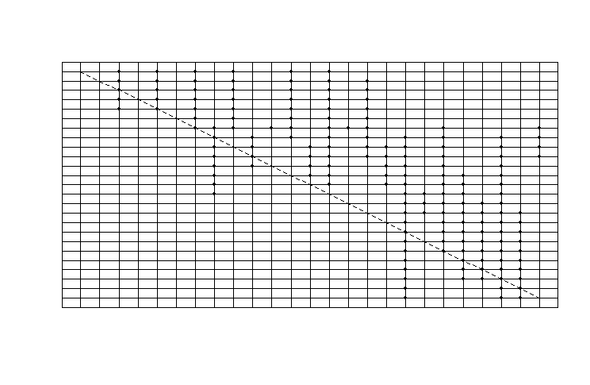

Figure 2.1.1: Sample Niche model with 25 species and C=0.3, where points represent interactions and rows and columns are species in the community.

* + 1. **ADDING STAGE STRUCTURE**

We introduce demographic stage-structure to the community matrix by assigning a random integer with a minimum value of 1 and a maximum value of 10 to each species. This integer represents the total number of possible life history stages for each species. These stages can be thought of as ages, sizes, or life-history stages (eg. juveniles, adults). In addition to the number of stages, each species is also assigned a reproductive index that is equal to at least half of the total number of stages present in that particular species. The reproductive index represents the minimum stage requirement for a species to be able to reproduce and not go extinct.

* + 1. **STAGE MATRICES**

A Niche model community in the absence of stage structure is represented as a two dimensional matrix, and is only capable of representing species-to-species interactions. In order to represent interactions between various stages of these species, stage matrices are introduced, which are then assigned to every species in the community. As a result, each species has its own unique stage matrix. Unlike the food web matrix, stage matrices aren’t necessarily symmetrical, and the dimensions vary based on predator stages and prey interactions. A stage matrix of a species represents predator-prey relations between the stages of the focal predator species, and the possible prey species. Prey are not stage dependent, and the predator stages will be able to consume all of the stages of the prey species. The probability of each stage in the stage matrix consuming a resource is determined by probability p where 0<=p<=1. The p value is assigned as a state variable of the community and is immutable. All the stage matrices in an ecosystem are built using the same p value. It is also ensured that each predator stage in the stage matrix consumes at least one prey, and also that each prey is able to get consumed by at least one predator stage (Rudolf & Lafferty, 2011). Due to this condition, the row-sums and column-sums of any stage matrix is always greater than or equal to 1.

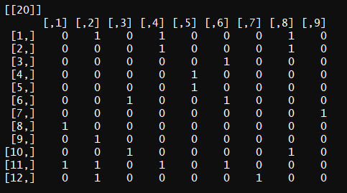

Figure 2.1.2: Example stage matrix of stage-structured species showing links between different stages of a predator species and prey species.

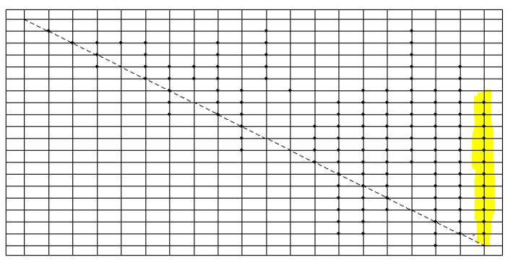

Figure 2.1.3: Community matrix corresponding to Figure 2.1.2. Species 20 is able to use Species 8 – 19 as prey, but different stages are each only able to use certain prey (determined by Figure 2.1.2).

There are 9 predator stages and 12 prey species in the provided example. The 12 prey species refer to the 12 interactions occurring on column 20.

* + 1. **MAINLAND AND ISLAND**

A community is represented as a record that contains the predator-prey community matrix, the stage matrices of each species, and the food habit information associated with them. It also keeps track of the species and their corresponding stages that are actively present in the community. A species is considered to be active if its reproductive stage is able to survive off the resources available in the ecosystem. Mainlands and Islands are different community types that contain the same food network information, and the only difference between them is that the former always has all of the species present, while the latter is initially void of any active species. We simulate community assembly from the mainland community onto island communities as a stochastic process.

* + 1. **MIGRATION**

At every constant time t, *n* species are randomly picked from the Mainland and placed in the Island. After the migration, primary extinctions, and a constant m number of secondary extinctions are calculated, and the resulting population data is logged into the Island’s ecosystem. This can be repeated multiple times until the demographics of the Island become identical to that of the Mainland.

* + 1. **REPRODUCTION AND EXTINCTIONS**

After every migration event, primary and secondary extinctions are computed. Primary extinctions are calculated as species that aren’t capable of surviving in the new ecosystem due to a lack of resources. After eliminating all the stages that cannot survive, stage lists are checked for any gaps in life history stages. For example, if stages 1, 2, and 4 of a species X are active, but stage 3 is inactive, stage 4 will be made extinct as an older stage cannot exist without transitioning through a younger one. After getting rid of all the gaps in stages, the remaining species are checked for capabilities of reproduction. In the example of species X, if the reproductive threshold were to be stage 2, then the species would survive as stage 2 can be attained in its current environment. However, if the minimum reproductive threshold were to be greater than 2, the entire species would be made extinct as it will not be able to reproduce. Secondary extinctions are calculated as all the species that die out due to the loss of resources after primary extinctions. Out of all the species that survive after the wave of primary extinctions, the same check is run through the ecosystem again to simulate secondary extinctions. Considering the possibility that there could be a third wave of extinctions, an iteration function has been added to the ecosystem model that can simulate multiple iterations of secondary extinctions between discrete migration events. The default number of iterations has been set to 1.

* 1. **VARIED INTERACTION ECOSYSTEMS**

The model constructed closely follows that used in the Qian (2019) paper on community assembly. Consider a community of *N* species. The interactions of this community are represented as an *N* x *N* matrix *A*. The diagonals of *A* are set to zero, to signify self-regulation. Each cell in the lower triangle is populated with a true or false value based on probability *C*, the connectance of the community. The lower triangle is then duplicated into the upper triangle, creating symmetrical intersections. Each of the intersections with true as their value become interactions between species *i* and *j*. The type of each of these interactions is then determined based on probability *p.e*, *p.m*, and *p.c*: mutualism, exploitation, and competition respectively, where the sum of these probabilities is equivalent to 1. The weights of these interactions are then randomly drawn from a normal distribution of mean 1 and standard deviation 0.5. The signs of each side of the interaction are determined by the type. Competition results in negative weights for both parties, exploitation results in a positive weight for one randomly selected party and a negative for the other, and mutualism results in positive weights for both parties. This yields a random model community, similar to that use in May’s (1972) approach.

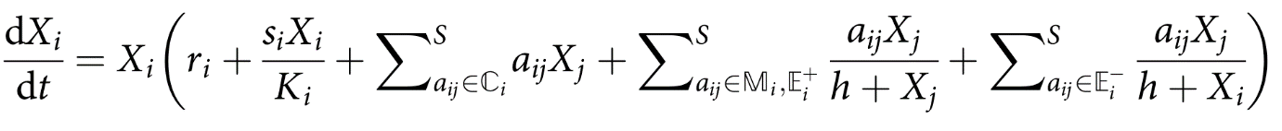 Once *A* is constructed, the population dynamics of the community are simulated. We utilized Qian’s (2019) model equation, which employs a Holling Type 2 functional response:

in which the variables included are as follows: *Xi* is population of species *i*, *ri­* is the intrinsic growth rate, *aij* is the interaction weight in matrix *A* between species *i* and *j*, *h* is the half saturation constant of the functional response, *si* is the negative self-regulation term, and *Ki* is the carrying capacity of the community. *C*, *M*, *E+*, and *E-* are simply subset matrices of *A*, separating the interaction types. The default values for these variables were kept constant with those used in Qian (2019) across their simulations.

Each of the species in the community are given initial populations equal to a pre-set value *xo* multiplied by a randomly selected value from a uniform distribution of 0 to 1. All other variables are kept constant for all species. Once the requisite data for equation 1 are set and the community is populated, the simulation of the community’s population dynamics begins. The model equation is integrated using the R package *deSolve*’s built in function *lsodar*. This function integrates the model equation while searching for a root; once a root is reached, the integration is ceased. If a root is not reached by a predetermined time limit *tl*, the integration automatically ceases, and the state of the community at the end of integration is returned. The root function the integrator uses simply determines whether the populations of every species in the community have fluctuated less than a pre-set threshold, *δ*. This is the condition for equilibrium that our model sets, following May’s (1972) original approach towards modeling the internal stability of a community. Once equilibrium is achieved or the simulation reaches the time limit, the populations for each species in the community are returned at the new levels they settled upon. Those species whose populations fell below a specific threshold *e* are considered extinct, and are removed from the community. Accordingly, the altered community experiences a shift in the balance of interaction types, which is calculated and recorded.

The aforementioned procedure is the process by which a single “mainland” is constructed. In order to analyze the effects of varied interaction types, connectance, and richness, a mainland is generated for every possible combination. Probability of mutualism, competition, and exploitation were varied from 0 to 1 by increments 0.1, with the combined sum of the being equivalent to 1. To ensure biological realism, a minimum of 10 percent chance of competition was maintained. This resulted in 55 possible combinations of interaction types for each mainland. Connectance was also varied from 0 to 1 by 0.1 increments, while species richness was varied from 20 to 200 species by 20 species increments. This generates 5,500 possible combinations; for each combination, 5 replicate mainlands are constructed, yielding a total of 27,500.

Once the mainlands are constructed, the assembly process begins. Typical approaches select species from a randomly generated pool to invade an established community, to examine the community’s resistance to invasion. In order to study the manner by which pre-established communities reconstruct themselves, the invaders are selected from the equilibrated mainlands. For each of the 5,500 combinations, 1 of the replicate mainlands is randomly selected. If the surviving community maintained its richness above a sampling size *nI*, the simulation continues; for the main text, *nI* was held at a constant size of 5. If the community’s richness is less than *nI*, the mainland is considered extinct and the next combination is selected. If the simulation continues, 5 replicate islands are generated. For each island, *nI* species are selected to form a community. This is done through random sampling of the mainland community, without replacement. The selected species are introduced to the island at *xz* percent of their population on the mainland; for our purposes, *xz* was held constant at 10 percent. The selected species are not removed from the mainland, nor are their population sizes affected. For the duration of each island community’s assembly, the mainland community remains at equilibrium.

Once the *nI* immigrant species are selected, their population dynamics are simulated using the same interactions from the mainland’s matrix *A*. When the community achieves equilibrium below δ or reaches the time limit *tl*, the simulation ceases. The species whose population’s fall below the extinction threshold *e* are removed from the island, and the selection step is repeated. Another set of *nI* species are chosen to immigrate from the mainland, including those species previously selected. If a previously selected species immigrates, the population on the island simply increases by *xz* percent of the mainland’s population. Otherwise, the new immigrants are introduced to the island community, and the population dynamics of the community are simulated using *A* once more. This assembly process repeats itself until the richness of an island community is equivalent to that of the mainland, or until a set number *kl* of equilibriums is reached. Upon satisfying either of these conditions, the simulation of the island community’s assembly ceases. Each island’s assembly process is simulated independently of the others, so different species immigrate at each time step, and different approaches are realized towards achieving the same richness of the mainland.

Due to the significant time complexity of the algorithms implemented, the island’s assembly is simulated using parallel processing on the High-Performance Cluster (HPC) Supercomputer. This reduces the runtime of the simulation from over a week to 2 days. To work with the large amounts of information generated, big data management techniques such as the Map – Reduce model are implemented. This allows the quick expansion and summarization of the data, and the production of figures descriptive of the entire dataset. Descriptive statistics were generated for each mainland and island as well. These include: the Whittaker Beta Diversity over time, the balance of interaction types over time, the maximum persistence reached, and the time taken to reach maximum persistence, among other measures.

1. **RESULTS**
   1. **STAGE STRUCUTED ECOSYSTEMS**

A niche model was used as the food web model for this simulation. As the Niche model is an extension of the cascade model, the limit for the Connectance value was based upon it. A cascade model has a theoretical maximum Connectance of C = 0.5. All the communities that were examined had their species richness, N, set to 100, and the number of stages were limited to a maximum of 10. 30 replicates of migration had been run for every combination of parameters. Figure 1 summarizes the mean accumulation of species in island communities.

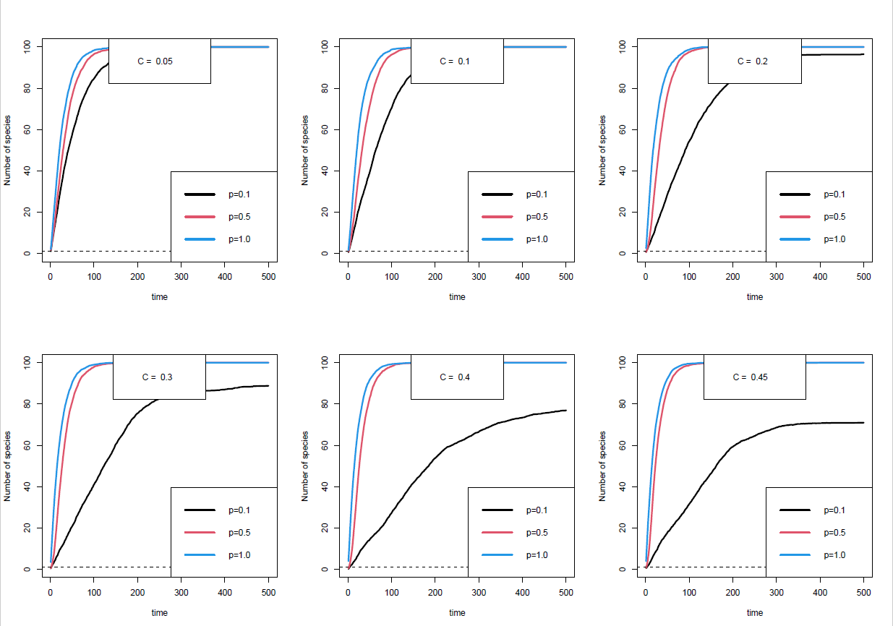

Figure 3.1.1: Population Assembly Plots

Figure 3.1.1 shows a very clear correlation between the complexity of the stage structured interactions (represented by the variable p) of the ecosystem and the time taken to assemble. Lower p values tend to take the longest time to assemble, and the higher p values tend to assemble much faster. Interestingly, as the Connectance of the ecosystems increases, the speed at which the lower p values assemble also steadily decreases. Connectance does impact the speed of community assembly for higher values of p. As we can infer from figure 3.1.1, assembly not only slows down drastically for ecosystems with p=0.1 at C=0.2 and above, but the island also stabilizes at a population that is lower than that of the mainland.

These results are consistent with that of the study of Rudolf and Lafferty’s robustness analysis (Rudolf & Lafferty, 2011). They showed how robustness of ecosystems with p values greater than 0.3 increases with an increase in Connectance, but has an opposite effect for ecosystems with a lower p value. The substitution hypothesis can explain the results of the community assembly simulationns as well. Generalist species, which have a greater p value, can often substitute their primary resources with other resources and can thrive by feeding on them. Meanwhile, specialist species, which form in ecosystems with a lower p value cannot substitute their primary resources. Even in the case of ecosystems with higher Connectance, these species might appear to be generalists on a species level, but their individual stages are all specialized on unique resources. This causes them to face a higher risk of secondary extinction (Rudolf & Lafferty, 2011).

To generate the diversity data for the ecosystems, three mainlands were generated for every permutation of the Connectance and p values. Each of these 3 mainlands had a corresponding empty island to which there were 10 independent runs of migrations conducted and recorded. The alpha diversity, a variable that measures the diversity within a particular local community was calculated by measuring the number of unique species in each of the 10 islands at every time period of migration. Gamma diversity, a measure of the overall diversity within a large regional community was calculated by recording the total number of unique species across all 10 islands at every time period of migration. Beta diversity, a comparison of diversity between ecosystems was calculating by dividing the gamma value by the alpha value (Bynum, 2021).

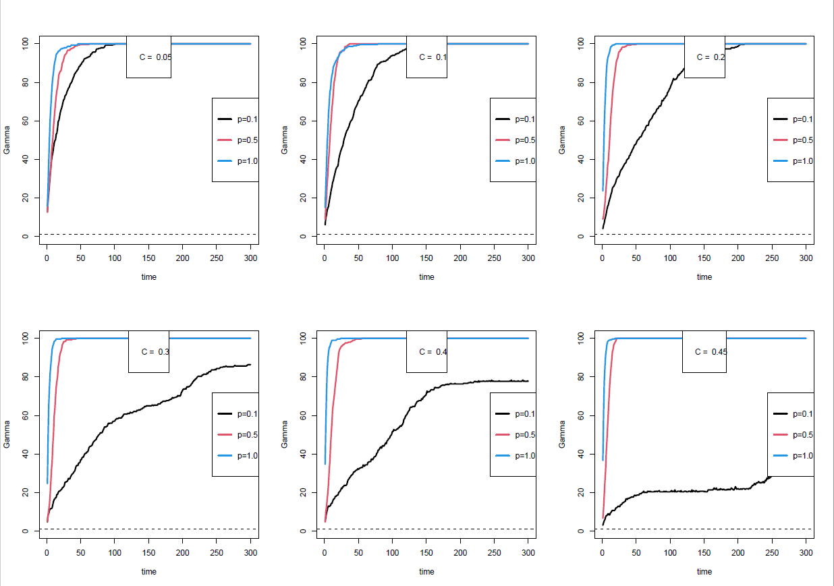

Figure 3.1.2: Gamma diversity plots

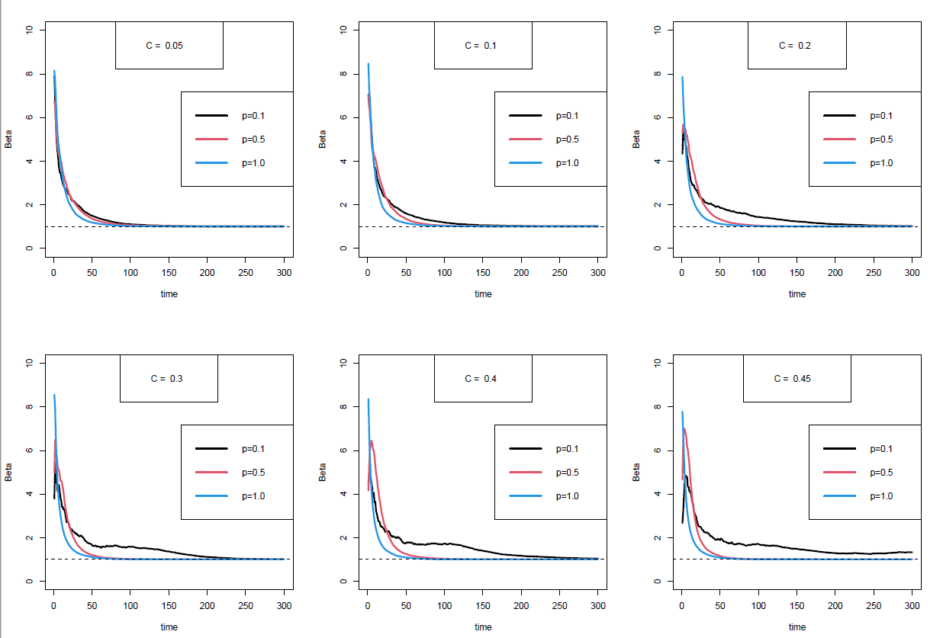

Figure 3.1.3: Beta Diversity Plots

Similar to the population assembly plots, there is a very clear correlation between the complexity of ecosystems and the time to reach maximum diversity as shown in figures 3.1.2 (gamma diversity) and 3.1.3 (beta diversity). In Figure 3.1.3, the elevated beta diversity for low p simulations suggests that there is more variability on which species effectively can colonize and persist on a given island community. This variability is consistent with the reduced speed off community assembly shown above (Figure 3.1.1). The aforementioned substitution hypothesis can also explain the results of the diversity data. Ontogenetic generalists that are specialists on the stage level are more likely to undergo secondary extinctions which thereby affects the overall diversity of the ecosystems.

* 1. **VARIED INTERACTION ECOSYSTEMS**

For the purpose of this paper, the communities examined in these results and the figures generated by them all had species richness of 200. These were selected in order to best represent the effects of the various interaction types on a community’s time to assembly. At lower levels of initial richness, communities were too small to study after equilibrating, given the considerations of the model.

The figures generated in this section display data relative to the persistence of the mainland and island at specific timepoints throughout the simulation. Figure 1 provides a visual aid in order to interpret these results, and determine what point each graph is referring to. It is also a representative of the general trend in mainland and island persistence reflected in the majority of communities throughout the duration of their assembly. Except in certain conditions, a majority of mainland communities experienced a significant decrease in persistence upon reaching equilibrium, and many of the island communities were able to achieve a similar level of persistence to the equilibrated mainland, within the time constraints of the simulation.

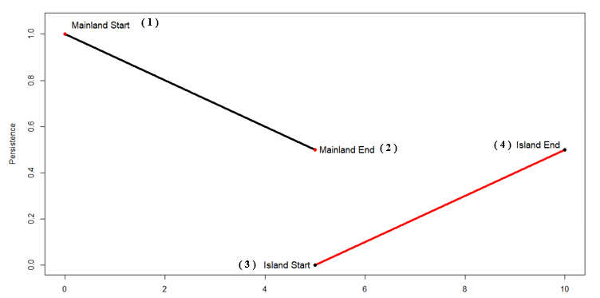Figure 2 shows the shift in the balance of interaction types over the simulation’s runtime for a mainland of 100 percent connectance. Plot 1 shows the shift in the balance of interaction types between the beginning and end of the mainland’s path to equilibrium. Plots 2, 3, and 4 show the balance of interaction types at 33, 66, and 99 percent respectively, with respect to the island’s assembly. Plot 5 shows the shift in the balance of interaction types between the mainland’s start and the island’s end, or points 1 and 4 on Figure 1.

Figure 1. An example of the decreasing persistence of a mainland and the assembly of its island community over the simulation’s run time.

Plot 1 shows that, upon equilibrating, the mainland experiences a major shift in the balance towards mutualistic interactions. Plots 2, 3, and 4 show that the community on the island rapidly reaches a similar balance of interactions to the mainland at point 2 on Figure 1, and then remains there until the simulation ends. This suggests that species participating in largely mutualistic interactions provided stability to the community, while species primarily participating in competitive and exploitative interactions were eliminated.

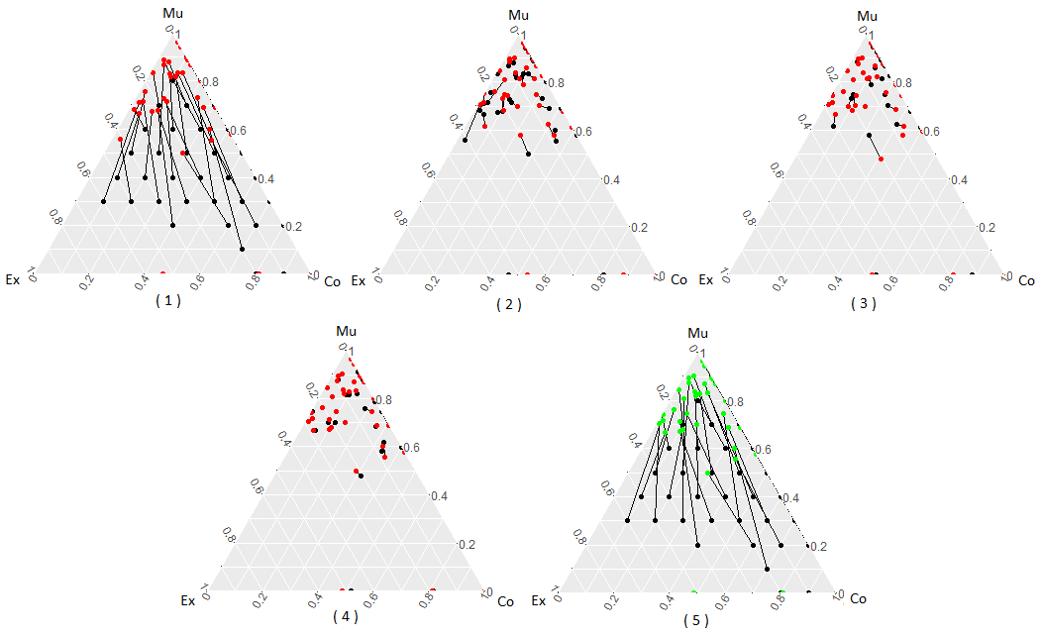Figure 3 expands upon this data, showing the shift between points 1 and 2 on Figure 1 for 10, 50, and 100 percent connectance. As connectance increases, the shift towards mutualistic interactions increases, as seen in plot 1 of Figure 2. However, communities at lower levels of connectance shift less, resulting in more even balances of interaction types. A majority of communities starting at 100 percent connectance with high proportions of exploitative interactions go extinct, as can be seen by the lack of their starting points in the bottom left of the third plot in Figure 3. Without at least 20 to 30 percent of interactions being mutualistic, antagonistic interactions in a highly connected community are likely to push it to extinction, as the individual benefits from predation do not outweigh the overarching consequences towards internal stability of a community.

Figure 2. The shift in the balance of interaction types between Fig. 1’s points 1 – 2, 2 – 3, 3 – 4, 4 – 2, and 4 – 1 respectively, for a community at 100% connectance.

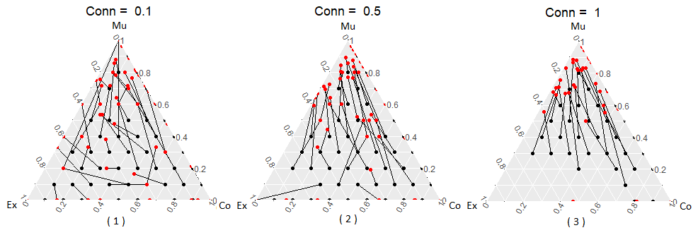Figure 4 shows the blanket destabilizing effect that increased connectance had on the assembled island communities. This is done through plotting the maximum persistence of the island communities, or the number of species present on the island upon the simulation’s end, relative to the number of species on the equilibrated mainland. At low levels of connectance, such as 10 percent, a majority of communities are able to reach a maximum persistence of 1, regardless of the balance of interaction types. However, as the connectance of the communities increases, the shift in the balance of interaction types begins to have a more meaningful impact.

Figure 3. The shift in the balance of interaction types of communities between points 1 and 2 in Fig. 1, for selected percentages of connectance.

At 50 percent connectance, their effects are apparent. The communities that originally started with high proportions of exploitative interactions destabilize more than the others, as they retain less species despite starting with the same amount as the other communities. At 100 percent connectance, a majority of the communities starting with high proportions of exploitative interactions are extinct, as well as many of those with high levels of competitive interactions. The mainland communities that avoided extinction clustered at much higher levels of mutualistic interactions than before, but produced islands whose maximum persistence were highly similar to those assembled at 50 percent connectance. The communities that began with pronounced levels of exploitative interactions continued to retain less species regardless of a significant shift in the balance of interactions towards mutualism.

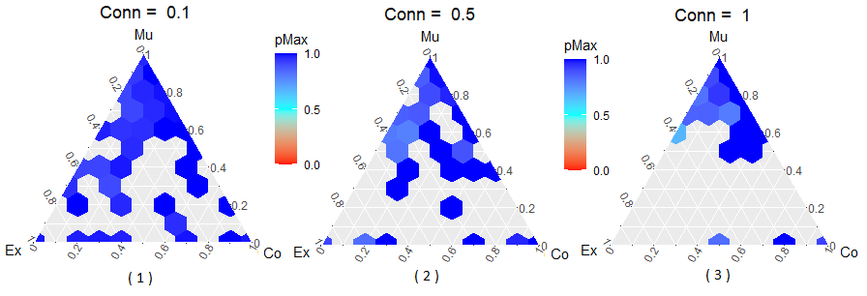The decreased stability of communities is explored by Figure 5. The graph shows the significant decrease in species surviving on mainlands through equilibrium, when connectance is increased. At 10 percent connectance, the importance of mutualistic interactions in stability is readily apparent, with the internal stability of the mainlands visibly decreasing as the proportion of mutualistic interactions in communities decrease. At 50 percent connectance, these effects are still visible, but are much less significant, and this downward trend continues at 100 percent connectance. The data clearly suggests that, while the balance of interaction types has an important and meaningful impact on the internal stability of a community, the destabilizing effect of increasing levels of connectance is greater.

Figure 4. The maximum persistence reached at point 4 relative to point 2 in Fig. 1, by communities of varying interaction types, at selected percentages of connectance. Blank spaces represent communities which went extinct.

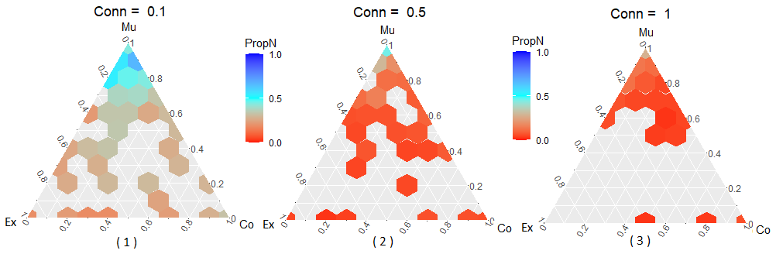Figure 6 examines the effects of varied interaction types and connectance on the time of assembly for island communities. The ternary heatmaps display the logarithm of the time of assembly, where each timestep represents an equilibrium on the island community at which new migrants were introduced from the mainland. The intuitive expectation would be that a smaller surviving community on the mainland would result in decreased time of assembly for the island community. The data in Figure 5 shows that this is the case, but in communities of similar richness, the effects of the differing balance of interaction types clearly contribute to the time of assembly.

Figure 5. The proportion of the mainland’s persistence at point 2 in Fig. 1, relative to point 1, for communities of varying interaction types at selected percentages of connectance.

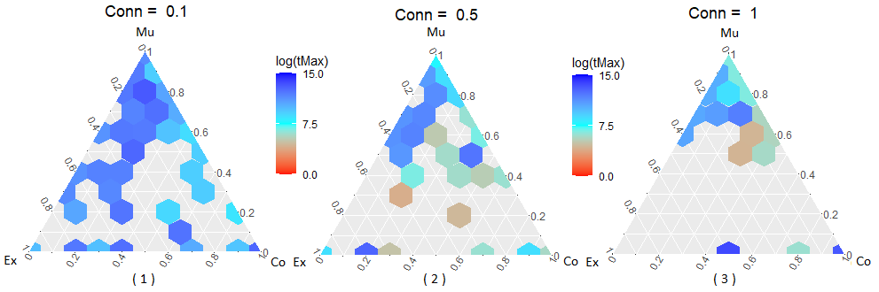At 10 percent connectance, island communities formed from mainlands with originally higher proportions of competitive interactions are clearly assembling at a faster pace than the rest. At 50 percent connectance, the time to assembly decreases across all communities. The trend concerning competitive interactions continues, as is apparent from Plot 2 in Figure 6 when compared with plot 2 in Figure 4. The communities starting at higher levels of competition cluster after equilibrating, and the communities within this cluster have a visibly lower time to assembly than the rest of communities in the heatmap. At 100 percent connectance, the time to assembly decreases further across the board, with communities with high levels of exploitative interactions going extinct as previously discussed. The effects of competitive interactions on time to assembly are most easily visible here. With all of the mainlands clustered at the top of the heatmap, the gradient showing a decreasing time to assembly as the initial levels of competitive interactions increase is unmistakable.

Figure 6. The logarithm of the time to max persistence for communities of varying interaction types, for selected percentages of connectance.

1. **DISCUSSION**

Here, we present two models of community assembly with different ecological complexities incorporated: demographically structured species interactions and the proportion of ecological interaction types. These are ubiquitous realities of real ecological communities, but are understudied in literature. The complexity of the stage structured model challenges the findings of older unstructured models. Greater complexity of interaction does not necessarily mean greater stability of the ecosystem. Communities with greater niche overlap are able to migrate to newer ecosystems significantly quicker than those with lower niche overlaps. Increasing connectances only seemed to amplify this instability in communities with lower niche overlaps. Ontogenetic specialists are more robust at a lower p value than generalists are at higher p value. These findings seem to be consistent with the findings of Rudolf & Lafferty (2011) stage structured model.

The results of the interaction type model suggest that mutualistic interactions guarantee greater internal stability and thus increased time to assembly. Competitive interactions decrease time to assembly, while not severely compromising a community’s internal stability. Varied proportions of both mutualistic and competitive interaction types guarantee the shortest time to assembly while preserving internal stability, in line with the findings of Qian (2019). Exploitative interactions were found to decrease time to assembly, but only as a result of significantly destabilizing communities. Connectance was shown to be a destabilizing force, as increases in connectance were directly linked to large decreases in mainland size and island persistence; this falls in line with findings supported by May (1972) and others thereafter. Varying richness was not shown to have any significant effect on these results.

These models both explore differing aspects of mathematical food web constructs, and measure the resulting communities’ stability in separate ways. However, the combination of these models can contribute to a better understanding of both, along with assisting in the study of similar ones in the future. The study of coextinctions in the stage – structured model could be enhanced by the application of keystone analysis, and determining if individual species are contributing more than others to destabilizing the community. Taken one step further, the interaction types of the species could be varied, and their effects on coextinctions could be examined. A plethora of models exist that yield interesting and meaningful results when combined, and are better examined together than apart. Condensing them and reducing the number of constraints that must be studied separately is work for the future.

**LIST OF REFERENCES**

1. Richardson, David & Pyšek, Petr. (2007). Elton, C.S. 1958: The ecology of invasions by animals and plants. London: Methuen. Progress in Physical Geography - PROG PHYS GEOG. 31. 659-666. 10.1177/0309133307087089.
2. May RM. Will a large complex system be stable? Nature. 1972 Aug 18;238(5364):413-4. doi: 10.1038/238413a0. PMID: 4559589.
3. Allesina, Stefano & Tang, Si. (2012). Stability Criteria for Complex Ecosystems. Nature. 483. 205-8. 10.1038/nature10832.
4. Tolcha, Solomon & N, Phani & Acharyulu, K.V.L.N. & Kumsa, Boka & S, Vishwa. (2017). Stability Analysis in a Mutualism System with Linear, Holling Type-II and Functional Response. International Journal of Advanced Science and Technology. 103. 35-46. 10.14257/ijast.2017.103.04.
5. Mougi, A & Kondoh, Michio. (2012). Diversity of Interaction Types and Ecological Community Stability. Science (New York, N.Y.). 337. 349-51. 10.1126/science.1220529.
6. Qian, Jimmy & Akçay, Erol. (2020). The balance of interaction types determines the assembly and stability of ecological communities. Nature Ecology & Evolution. 4. 10.1038/s41559-020-1121-x.
7. Landi P., Minoarivelo H.O., Brännström Å., Hui C., Dieckmann U. (2018) Complexity and Stability of Adaptive Ecological Networks: A Survey of the Theory in Community Ecology. In: Mensah P., Katerere D., Hachigonta S., Roodt A. (eds) Systems Analysis Approach for Complex Global Challenges. Springer, Cham. <https://doi.org/10.1007/978-3-319-71486-8_12>.
8. Bynum, N. (2021, January 3). Alpha, Beta, and Gamma Diversity. Retrieved March 22, 2021, from <https://chem.libretexts.org/@go/page/17392>.
9. Beckerman, A., Petchey, O., & Warren, P. (2006, September 12). Foraging biology predicts food web complexity. Retrieved March 23, 2021, from https://www.pnas.org/content/103/37/13745.short.
10. Rudolf, V.H.W. and Lafferty, K.D. (2011), Stage structure alters how complexity affects stability of ecological networks. Ecology Letters, 14: 75-79. <https://doi.org/10.1111/j.1461-0248.2010.01558.x>.
11. Williams, Richard & Martinez, Neo. (2000). Simple Rules Yield Complex Food Webs. Nature. 404. 180-3. 10.1038/35004572.