Student:

Akhil Reddy Alasandagutti

[aalasand@go.olemiss.edu](mailto:aalasand@go.olemiss.edu)

Sponsor:

Thomas Andre

Assistant Professor of Exercise Science

tlandre@olemiss.edu

662-915-5521

LoL Tryhard

User Manual

OS Requirements

1. Windows 7 or newer, 32 or 64 bit operating system.

Installation

1. Extract “LoLTryHard-win32-x64.zip” to any desired folder on your machine.



1. Run “LoLTryHard.exe” to launch application.

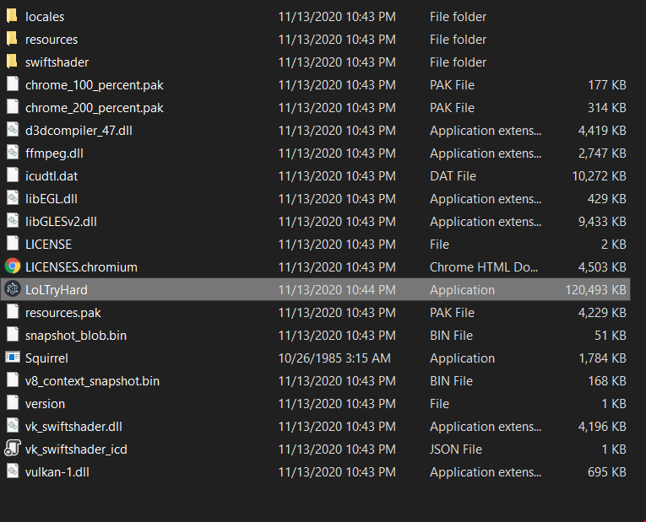

**NOTE:**

LoL TryHard requires Python 3.6+ along with the following python modules to be installed on the host machine in order to function properly – keras, numpy, pandas, requests.

Installing Python

1. Open any browser and head over to <https://www.python.org/downloads/> .
2. Click on “Download Python 3.9.0”.

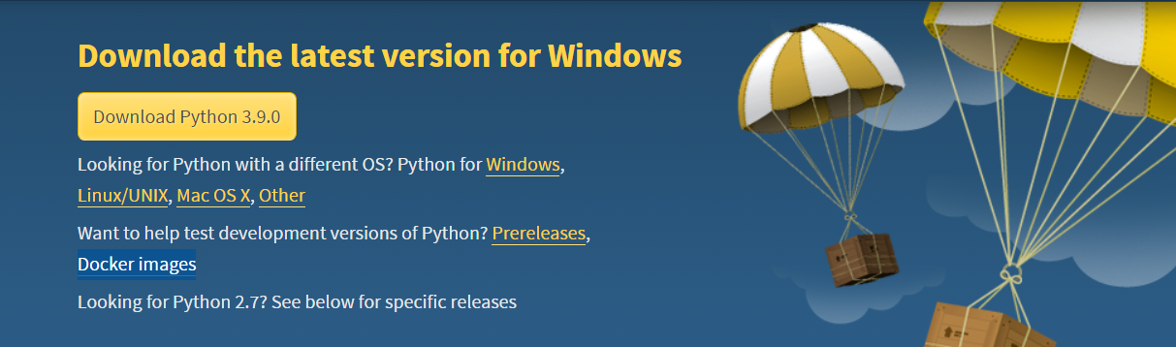

1. Install Python to a directory of your choice and select “add to environment PATH” at the end of installation.
2. Open command prompt (cmd) and run “pip install numpy”.

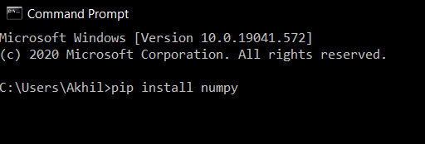

1. After numpy finishes installing, similarly install “keras”, “pandas”, and “requests”.

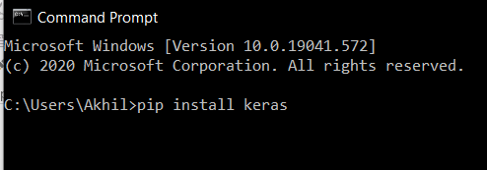

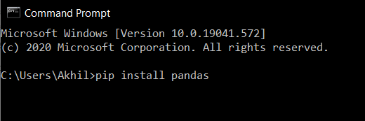

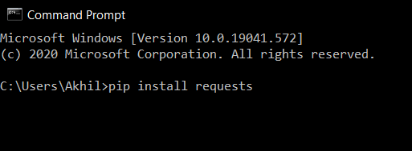

Using LoL Tryhard

1. Run “LoLTryHard.exe” to launch application

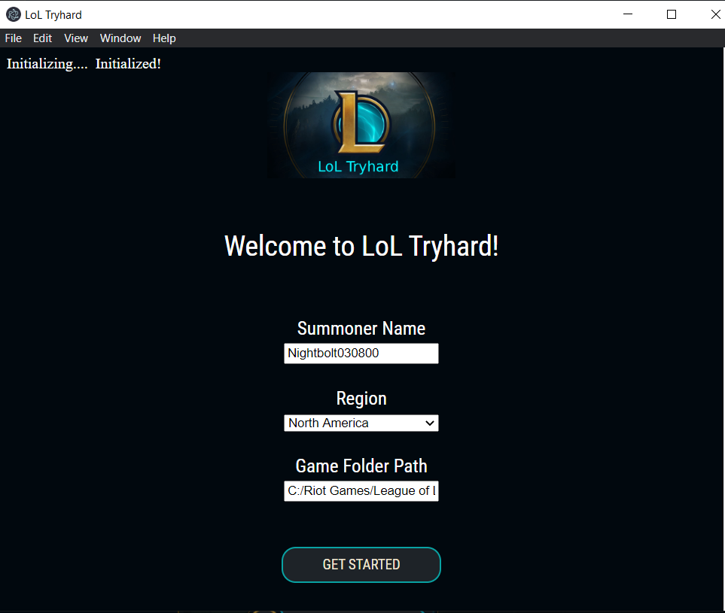

1. Enter prompted details – League of Legends Summoner Name, Account Region, and League of Legends Game Folder Path.
2. Wait for “Initialized!” to appear on top left corner. This takes about 5 – 20 seconds depending on the machine. While the app can be run before the message is displayed, the predictions will not be displayed until initialization is complete.
3. Click on “Get Started” after a match has been found and players are in the ban/pick phase.

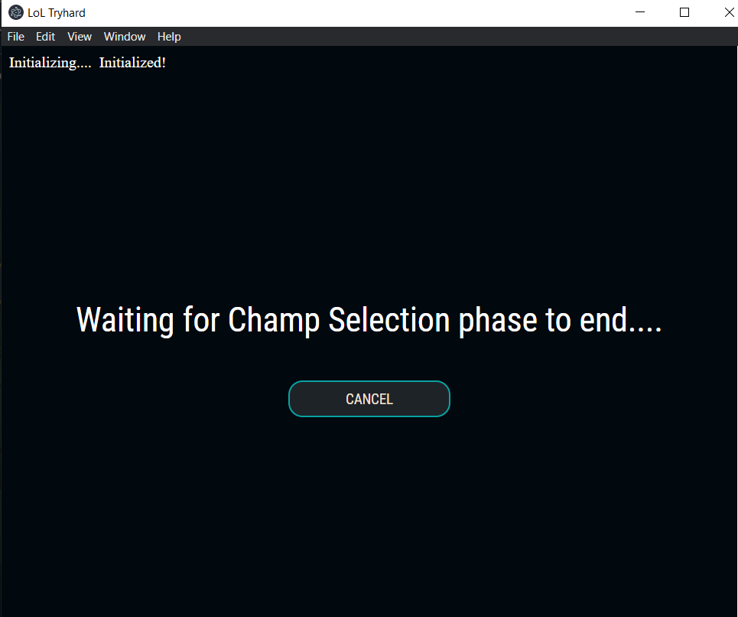

1. Users can click on “Cancel” anytime to go back to homepage.

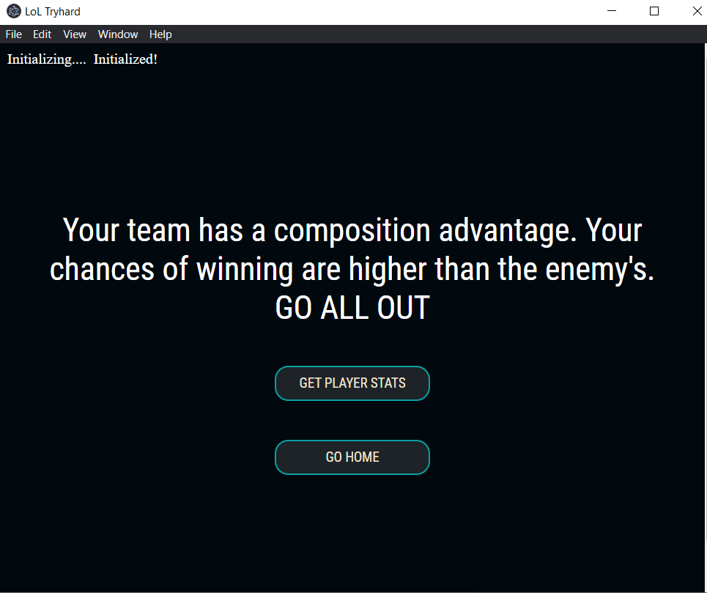

1. After Champion Selection phase has ended, LoLTryhard displays a message stating the likeliness of your team winning. Users can also choose between “Go Home” and “Get Player Stats”.
2. Clicking on “Go Home” takes the user back to the home page.

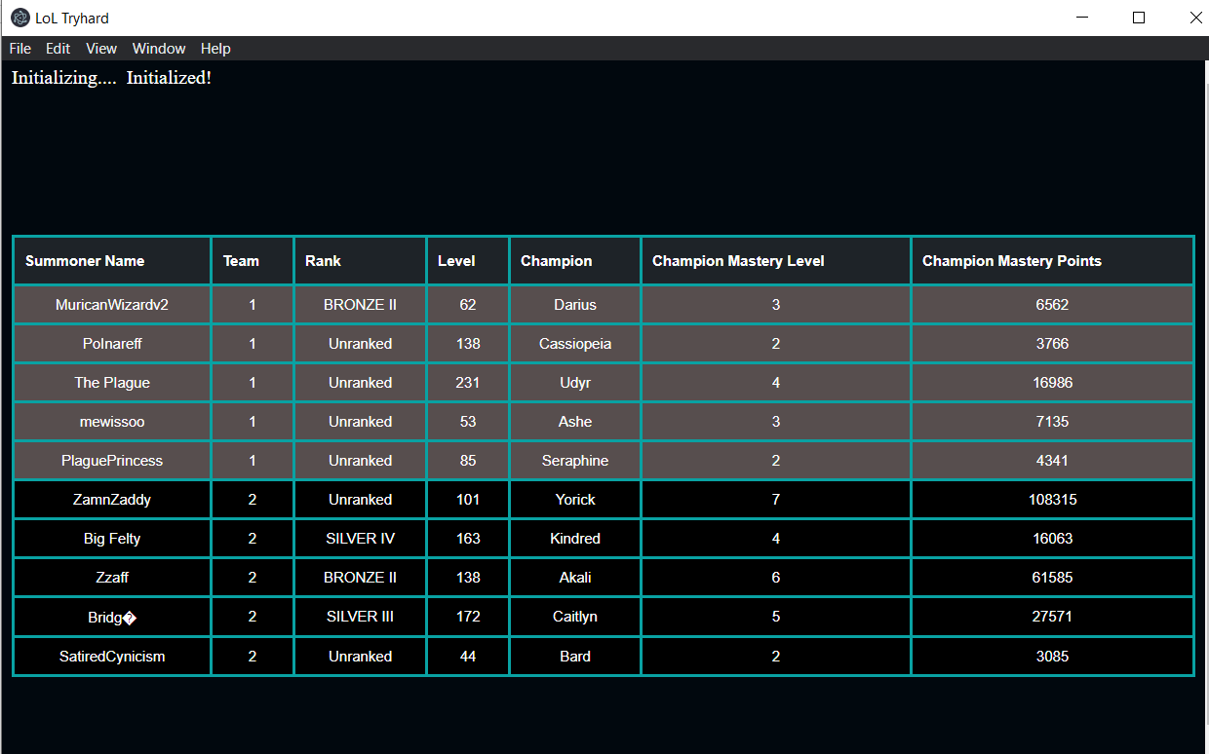

1. Clicking on “Get Player Stats” displays the player stats of all the participants after the game starts to load.
2. Blue Team is highlighted gray, while the Red Team isn’t.

Maintenance and Enhancements

1. The source code will need to be updated every time a new League of Legends patch rolls out, which is on average once every month. Simply replace ’10.23.1’ in test.py in the source code with the latest league of legends patch version.



1. The development API key will need to be reset every day at 9AM in order for the “get player stats” feature to function. An API key can be generated at <developer.riotgames.com>. Simply replace the existing key in “key.txt”. A permanent production key can be used to solve this problem, however, it can only be assigned to a large scale commercial app with a working business model. A request can be filed at developer.riotgames.com.

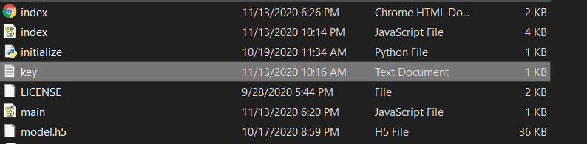

1. The machine learning model can be replaced if a better performing model is engineered. Save keras models in a JSON file, and save the weights in an h5 file. Replace “model.h5” and “model.json” with the new files to update the classifier.