Muriel’s
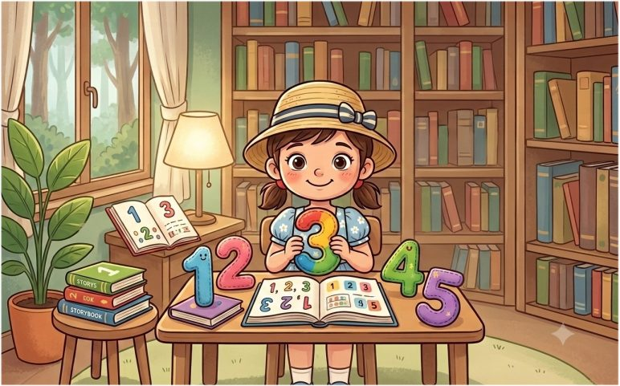
Counting lesson

Muriel was very busy practising counting things.
She counted the birds in the garden.
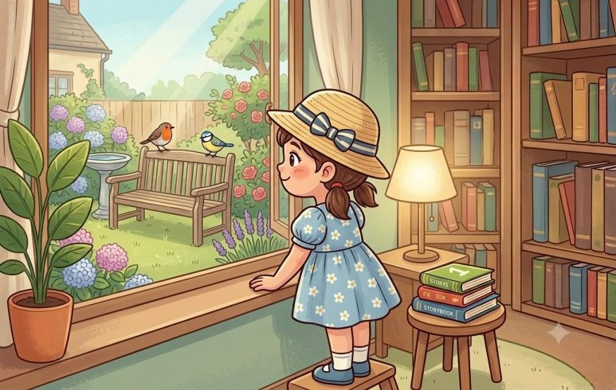
Can you see the birds?
How many can you see?
What colour are they?
While Muriel was counting the birds, she heard Mummy get a phone call.
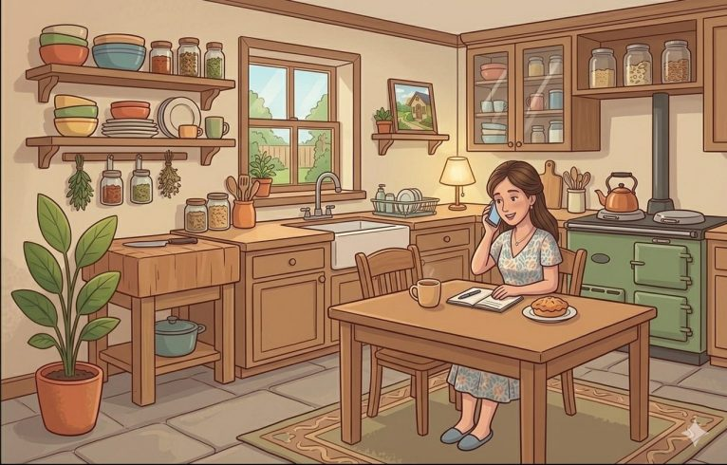
‘Hello?’ said Mummy. ‘Oh, hello Auntie Rachel. What? Well yes of course they can. Yes, I’m sure Muriel will be thrilled. Yes – thank you very much. Bye then.’
She called Muriel.
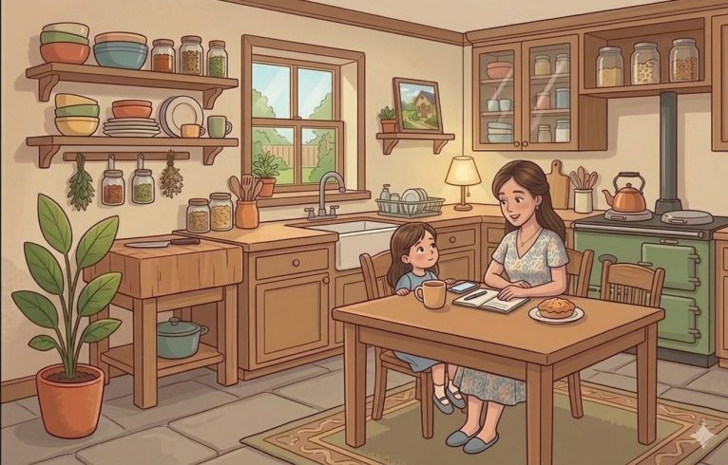
‘That was Auntie Rachel,’ she said. ‘We’re going to have some special visitors this afternoon. I think we had better go to the shops and buy some things for them.’
Muriel was very excited. ‘Who’s coming?’ she asked.
But all Mummy would say was that it was someone very special, and she would find out later on today.
Then she got her shopping bag, and she and Muriel went out to the shops.
On the way they went to the park. So Muriel did some more counting practice. She counted the dogs.
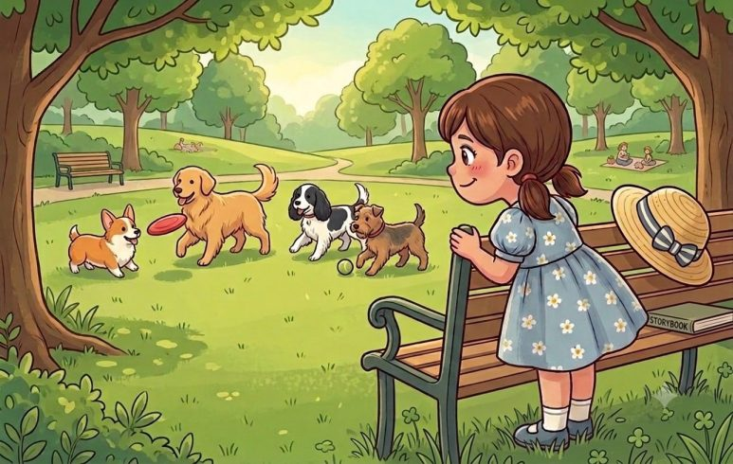
Can you see the dogs?
How many can you see?
What are they doing?
Then they went to the shops and Muriel counted the cars.

How many cars can you see?
What colours are they?

And then they came home to lunch.
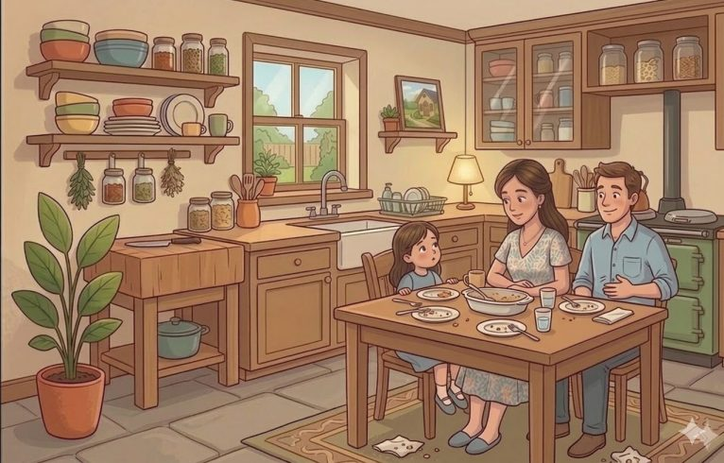
Just as they were finishing lunch, there was a knock at the front door.

Muriel ran to see who was there.
There was a big surprise. Two rag dollies were standing on the step, holding suitcases.
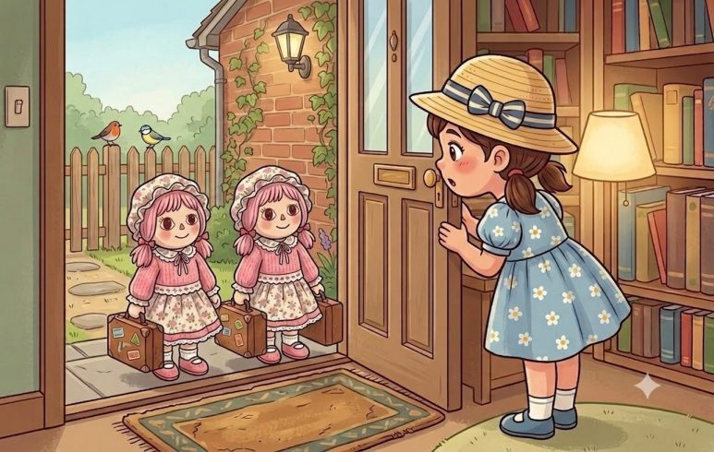
‘Hello!’ they said.
‘Oh, wow!’ said Muriel. ‘Whoever are you? Do come in.’
And she brought them into the living room, where Mummy was smiling.
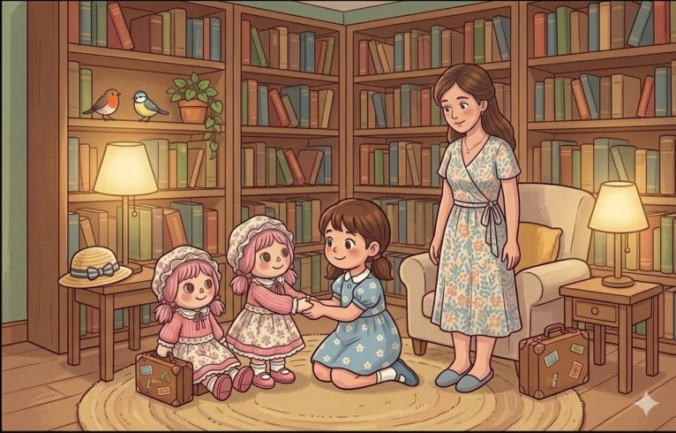
‘These are the Rebeker Zoes,’ she said. ‘They used to be Auntie Rachel’s dollies, and they’ve come to visit us and play with you.’
One of the dollies shook hands with Muriel. ‘Hello,’ she said. ‘We’re twins, so we’re both called Rebeker Zoe. I’m Rebeker Zoe the First, because I came to live with our Mummy first. And my sister is Rebeker Zoe the Second.’
Muriel was very excited and wanted to start playing straight away. But Mummy said that first she should take the Rebeker Zoes up to their bedroom so they could unpack.
‘I thought they should have the pink bedrrom,’ she said.
‘Come with me,’ said Muriel, and she led them upstairs and took them to their room.
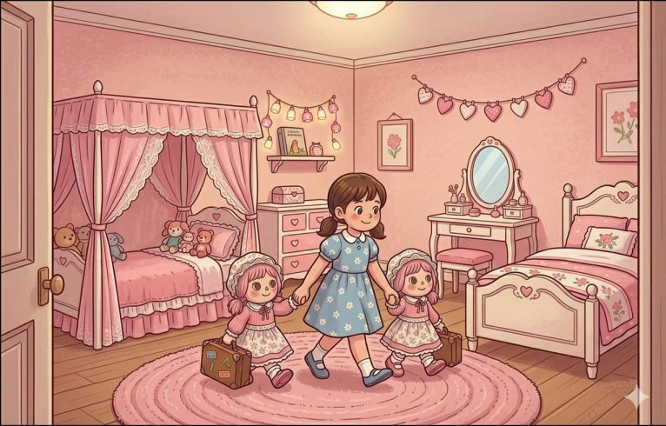
‘Oh, it’s lovely,’ they said, and they unpacked their cases and put their clothes and things in the cupboard.
Ten minutes later they were back downstairs.
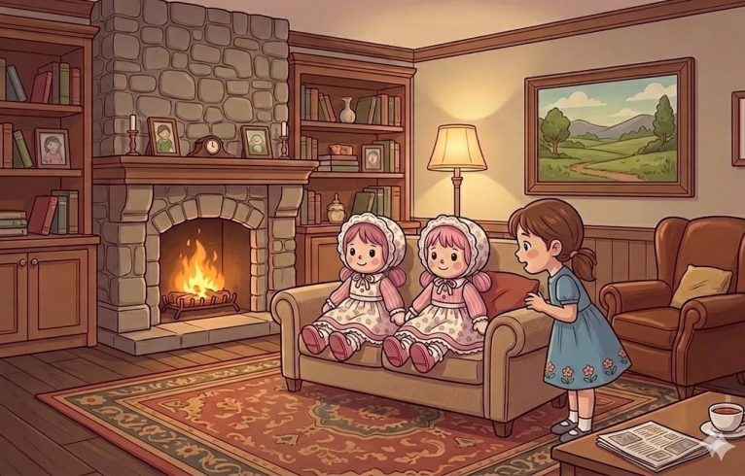
‘We’re ready to play now,’ they said. ‘What shall we do?’
Muriel thought.
‘I know,’ she said, ‘do you know how to count?’
‘Of course we do,’ said the Rebeker Zoes.
‘All right then,’ said Muriel. ‘How many hands have you got?’
Do you know how many hands the Rebeker Zoes have?
Rebeker Zoe the First thought for a very long time.
‘Er … six?’ she said.
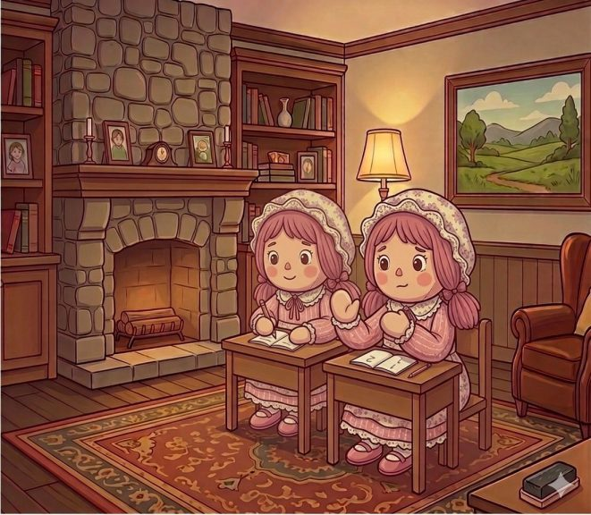
‘No,’ said Muriel. ‘That’s the wrong answer! Let’s play schools and I’ll teach you how to count.’
So that’s what they did.
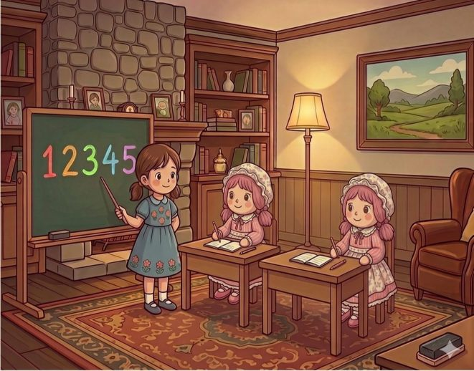
First, Muriel told them what the numbers were called.
And then she showed them how to write them down.
And then she helped them to count things.
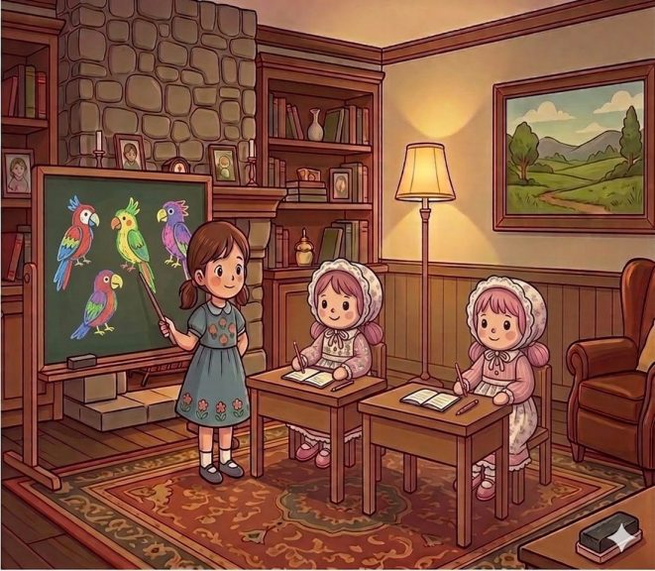
By the time Muriel had finished, the Rebeker Zoes were almost as good at counting as she was.
Mummy came in. ‘Oh my,’ she said, ‘you have done well. I should think you must be hungry.’ And she gave them some tea.
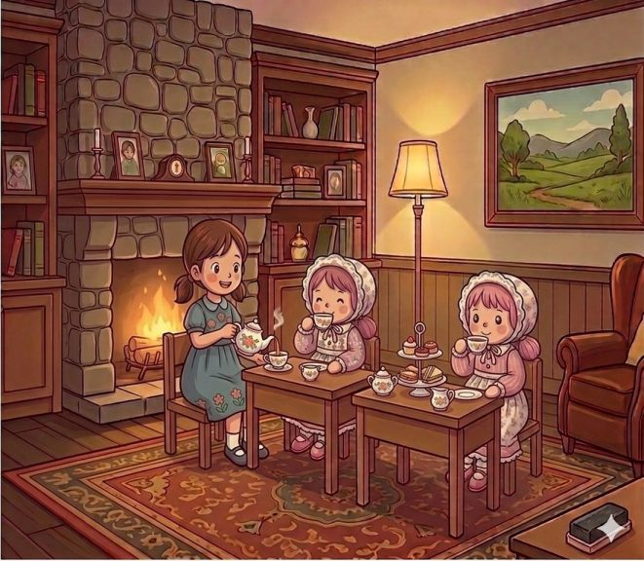
The Rebeker Zoes yawned. ‘That was fun,’ they said. ‘But we had a very long train journey, and now we’re very tired. Would it be all right if we went to bed?’
Muriel went up to the bedroom with them and tucked them up.
Then she sat beside the bed and told them a bedtime story.
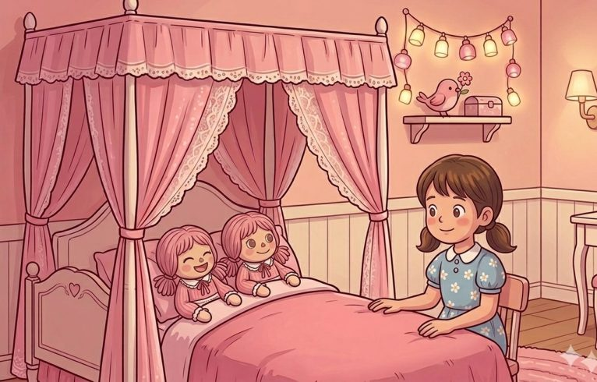
It wasn’t long before the Rebeker Zoes were fast asleep.
Muriel crept very quietly out of the room so she didn’t wake them.
‘That was lovely,’ she said to herself as she went to her own bed room.
‘And the best part is that I’m sure we’re going to have lots of adventures together.’

