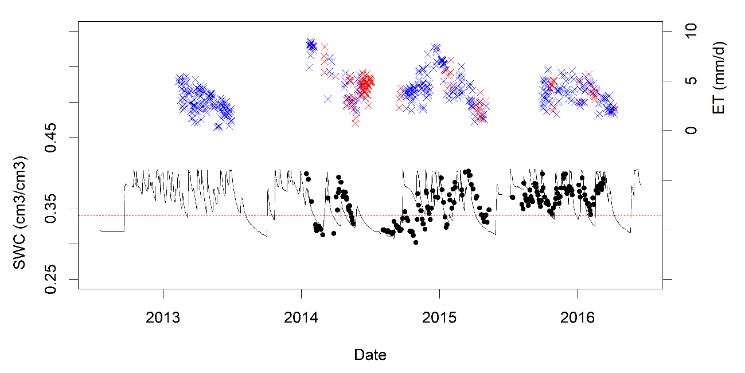

Fig. Soil Water Content (SWC – cm3/cm3) until 60 cm depth and Crop Evapotranspiration (ET – mm/d) during the Piracicaba experiment (4 sugarcane seasons). Filled dots are Frequency Domain Reflectometry (FDR) measurements, dashed red line is the field capacity (0.34 cm3/cm3), solid black line is the “tipping-bucket” soil water balance, blue and red crosses are the crop evapotranspiration (Bowen Ratio) when soil water content was optimum and below field capacity, respectively.

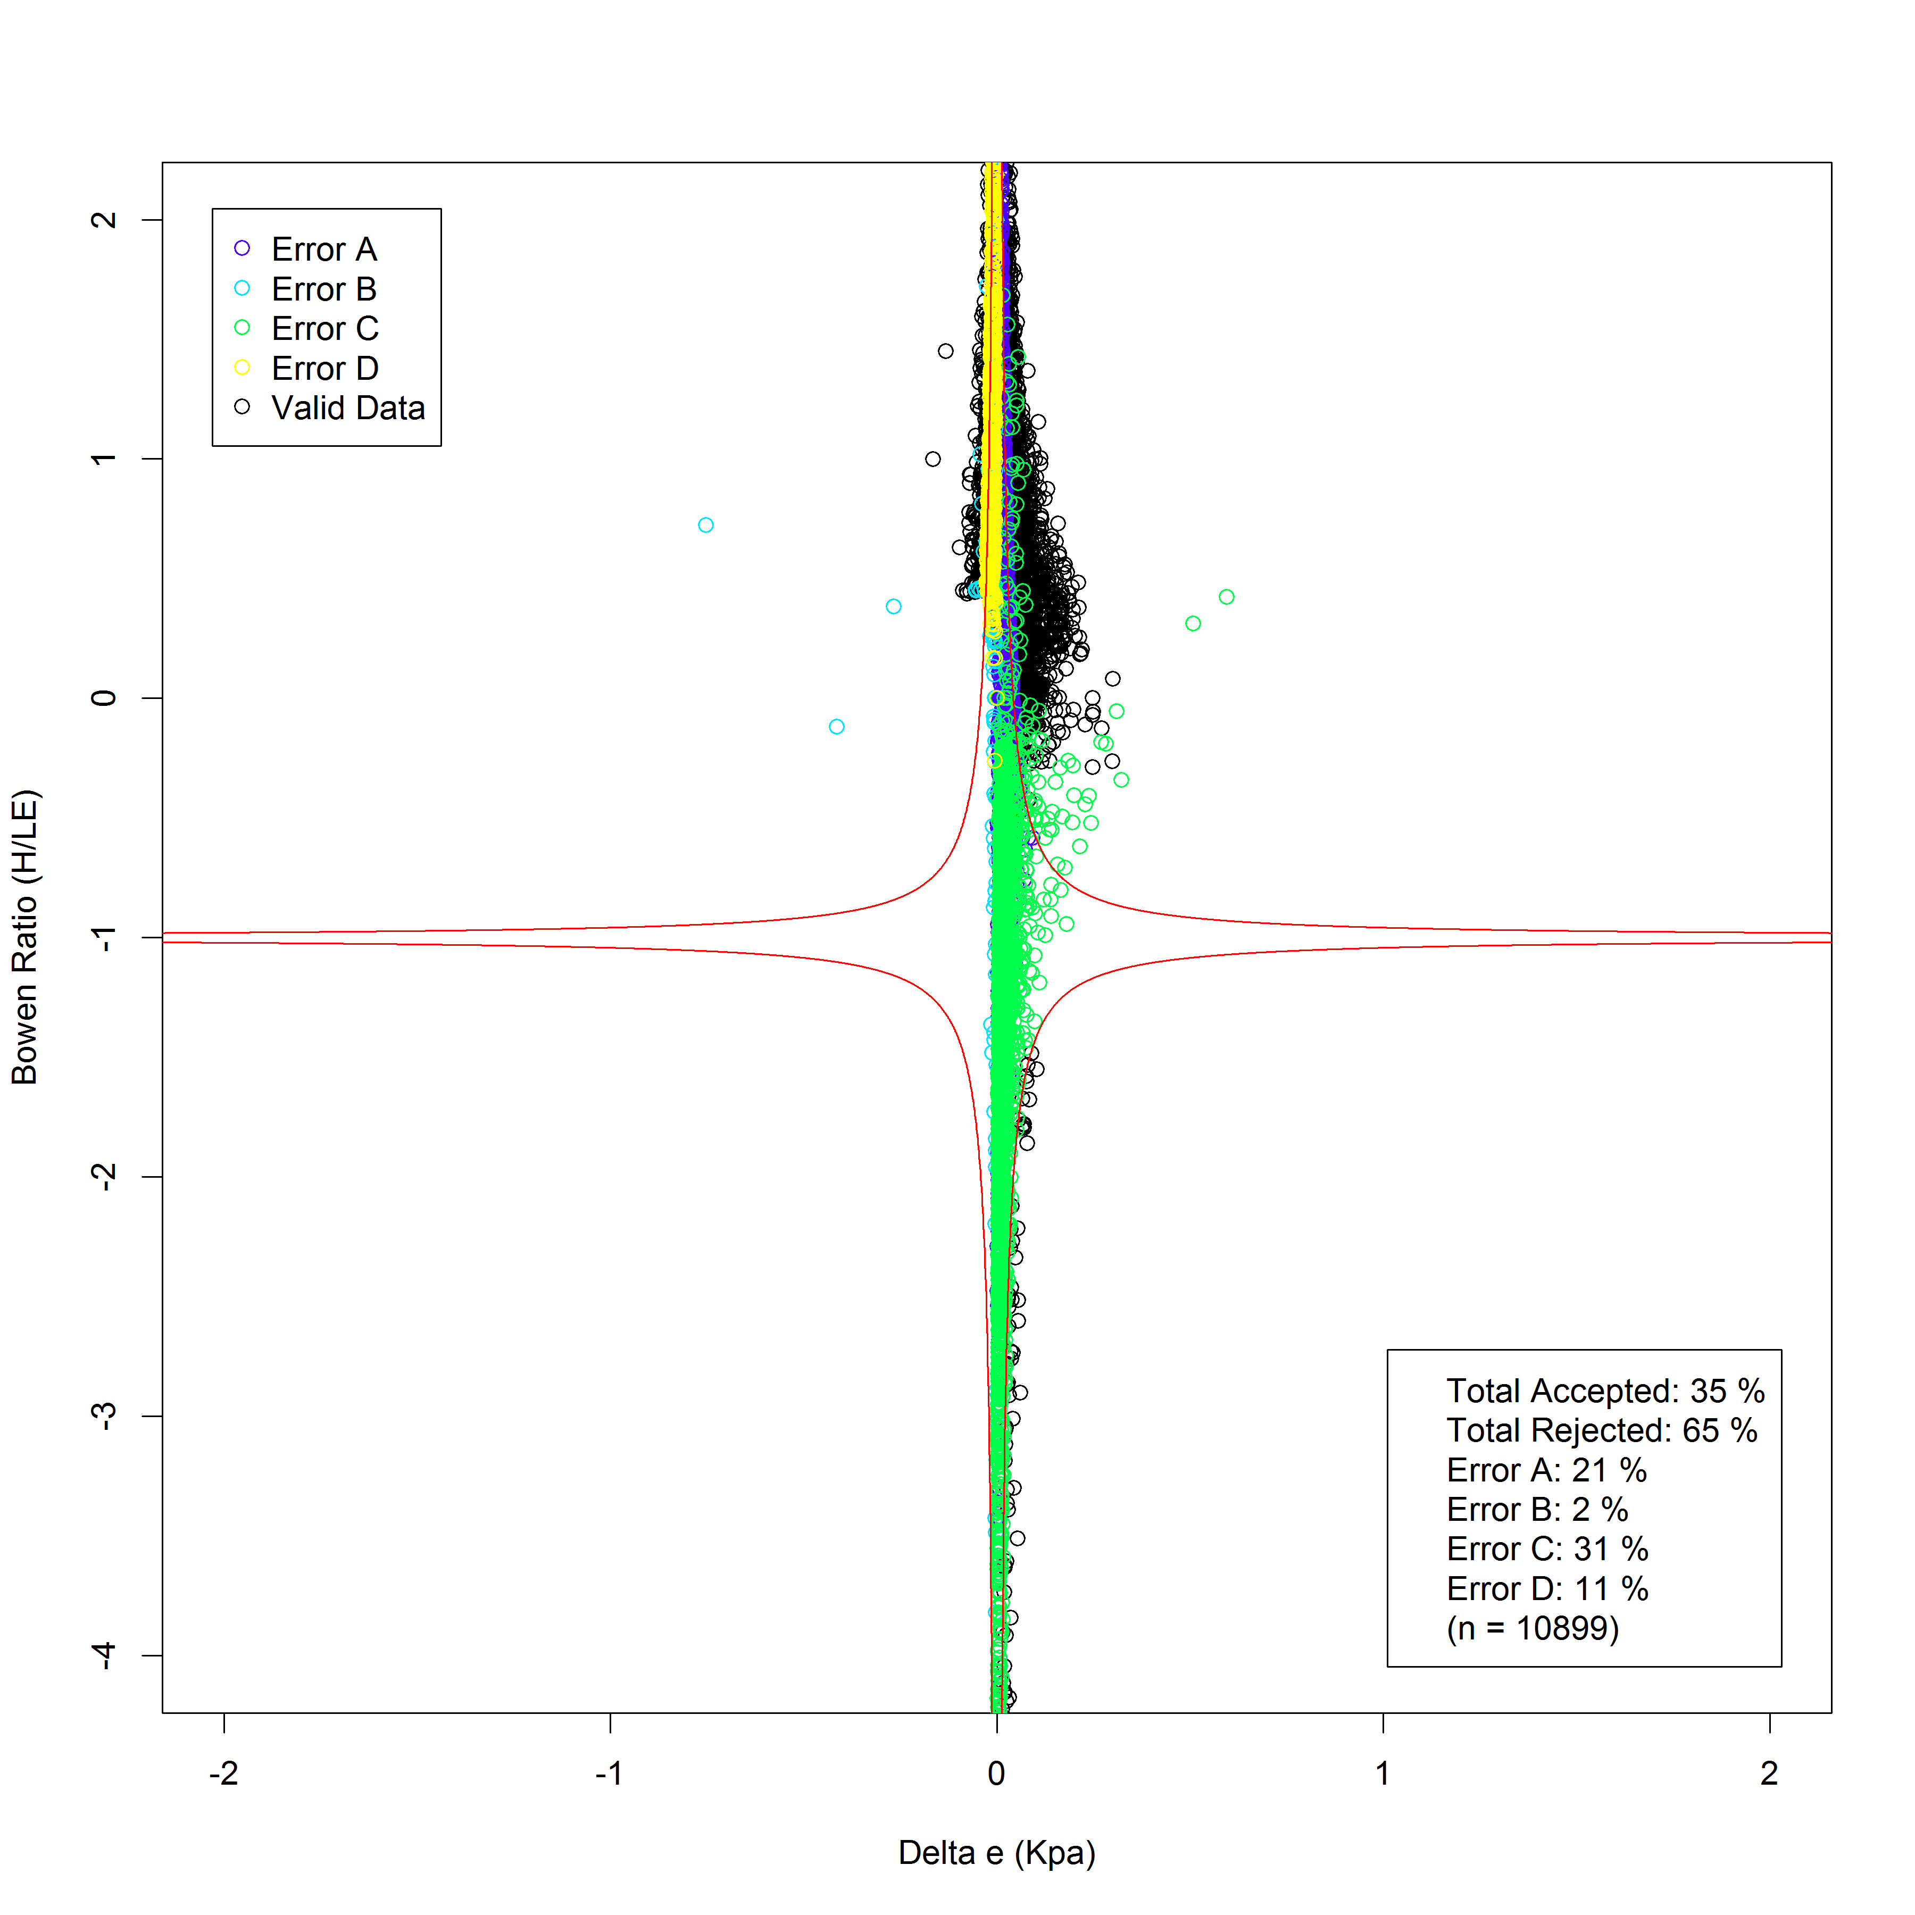

Fig. Bowen Ratio and Delta *e* (Kpa) measurements in Piracicaba experiment for physical consistence analysis proposed by Perez et al. (1999). Red lines are the limits thresholds for the sensor bias, open colored circles are the errors based on Perez et al. (1999) filters, and black open circles are the valid data (35% of acceptance).

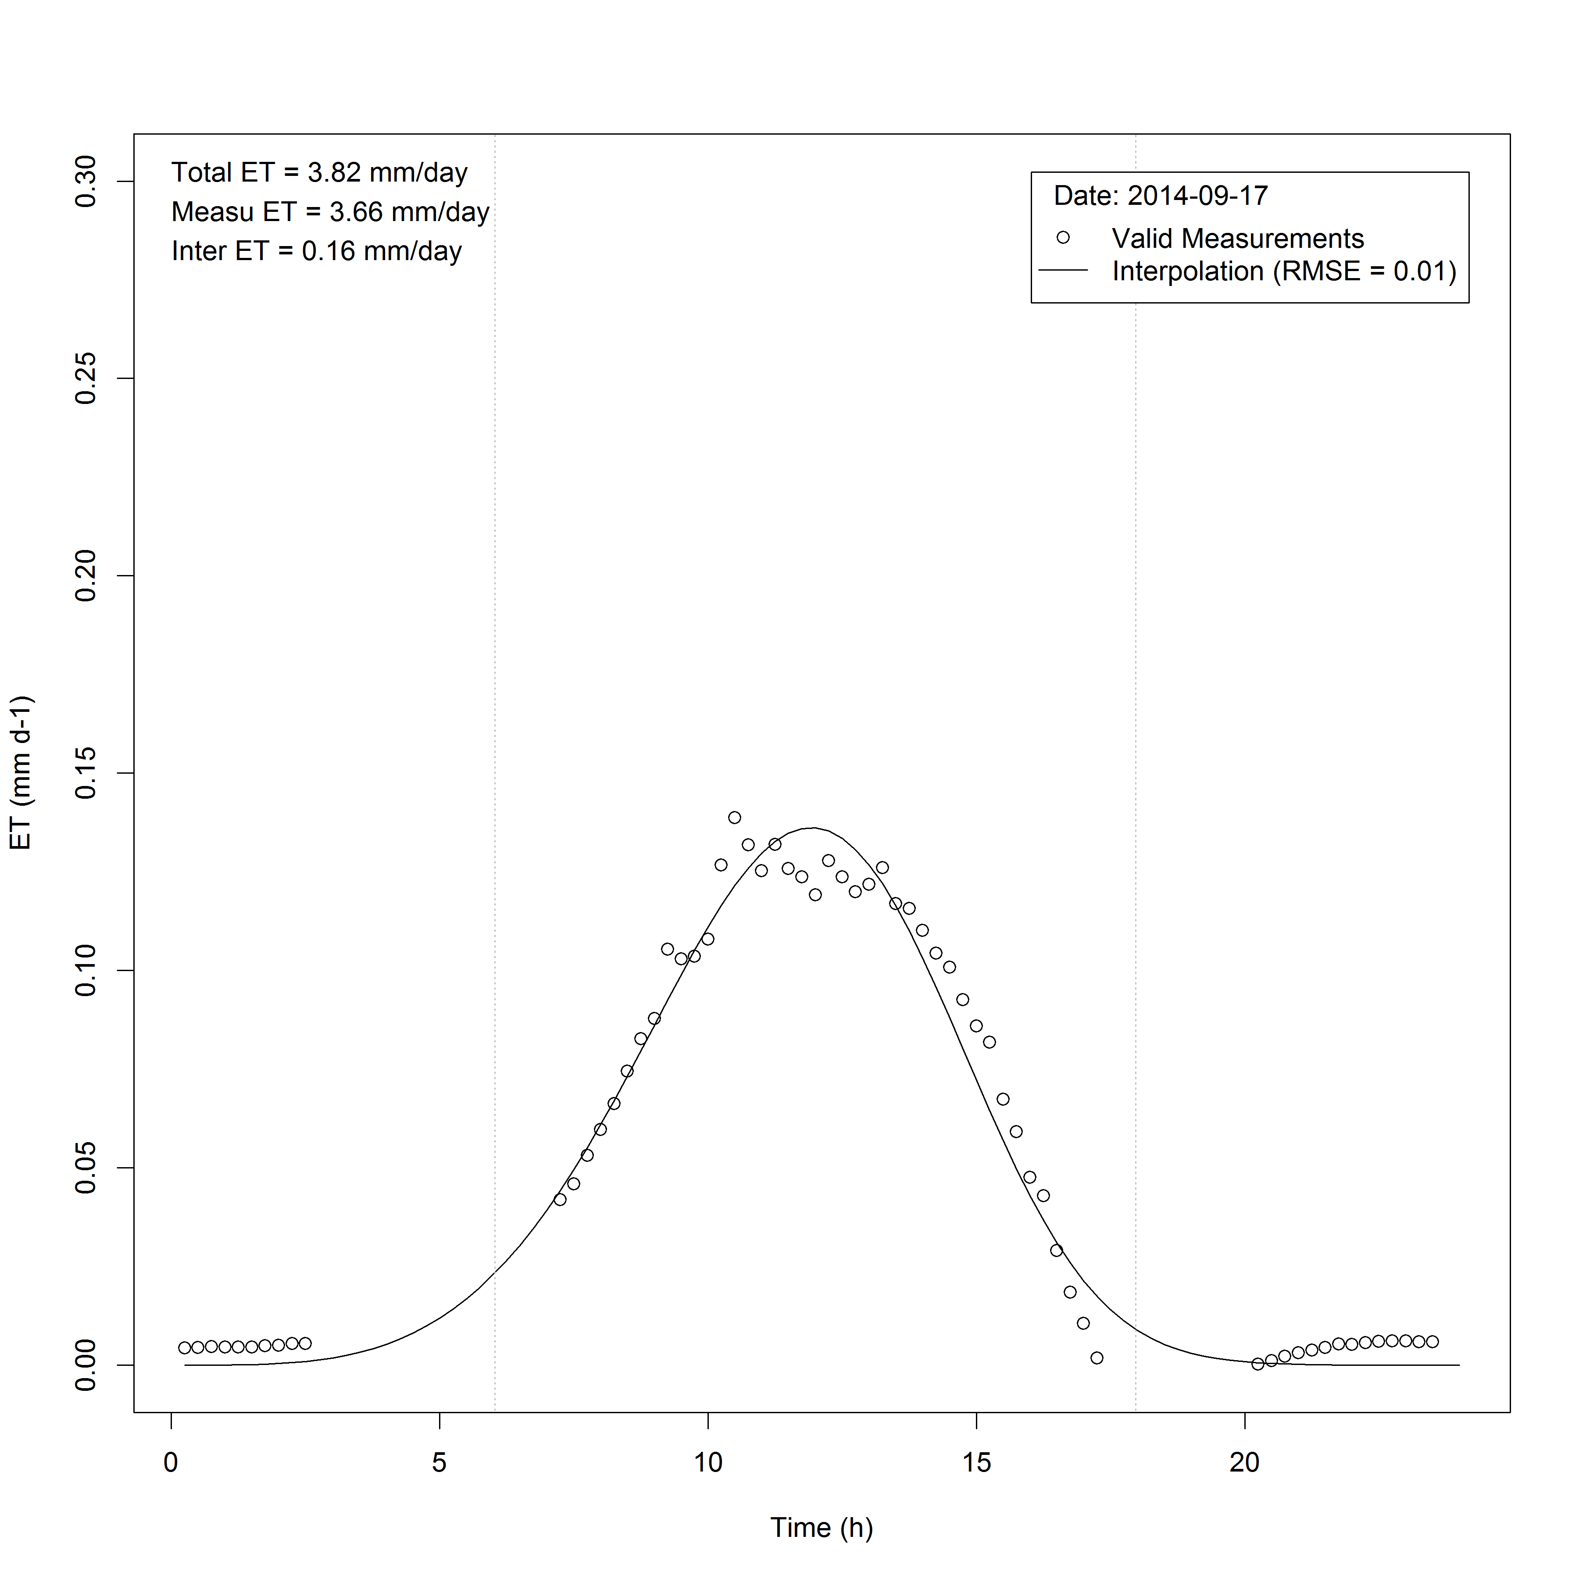

Fig. Time course of water vapor flux (mm 15min) measured by the Bowen Ration (open circles) and estimated (solid line) for 09/14/2014 in Piracicaba experiment. Missing data or invalid data (Perez et al., 1999) was interpolated by sigmoidal function adjusted to the available valid data. This procedure took place for all days that had up to 2 hours of missing data. Days with more than 2 hours were ruled out for daily ET.