**COMBINED AGRO-HYDROLOGICAL MODEL FOR SIMULATING SUGARCANE DEVELOPMENT, GROWTH AND WATER USE**

Murilo dos Santos Vianna 1, Fábio Ricardo Marin 2, Quirijn de Jong van Lier3, Klaas Metselaar 4

1Phd student at ESALQ/USP, Piracicaba (Brazil), murilodsv@gmail.com; 2Associate Prof. at ESALQ/USP, Piracicaba (Brazil), fabio.marin@usp.br; 3 FullProf. at Center for Nuclear Energy in Agriculture, University of Sao Paulo, Piracicaba (Brazil), qdjvlier@usp.br; 4Assist. Prof. at WUR, Wageningen (The Netherlands), klaas.metselaar@wur.nl.

**ABSTRACT:** Sugarcane is the second largest source of biofuel and the main source of sugar in the world. It is a crop of major social, economic and environmental importance in many tropical countries. Brazil is the largest sugarcane producing nation representing half the global production. In the current scenario with yields reaching the plateau of 80 t ha‑1, the crop strongly expanded towards central-western region where irrigation is mandatory to offset water stress risks. The effects of crop management, land use change, climate variability and change and agro-economic factors on crop production and associated quantities can be assessed using process-based crop simulation models (PBM). Despite its great importance and in contrast with other major crops, only two specific sugarcane crop growth models are available for end users worldwide. A new sugarcane PBM developed for Brazilian conditions showed good performance on crop components predictions, however, simplified soil water balance routine may be assessed to reduce uncertainties on crop water use. This paper aimed to couple a newly developed process-based sugarcane model (SAMUCA) to the agrohydrological model SWAP, aiming to reduce this prediction uncertainty and to provide a better tool for crop water consumption and hydrological analysis. The SAMUCA-SWAP model performed slightly better for the prediction of stalk fresh and dry mass (3 and 7% lower RMSE) and notably better for leaf area index prediction (reducing RMSE by 38%) than the standalone version of SAMUCA. Soil water balance simulations were improved (32% lower RMSE) compared to the standalone version (tipping bucket), enabling more robust predictions of crop water use. The extended ability to simulate solute transport and salinity stress by SWAP-SAMUCA can be explored to support sugarcane irrigation strategies, as well as fertigation with sewage or vinasse.

**KEY-WORDS:** crop modeling, agrohydrology, *Saccharum officinarum*

# INTRODUCTION

Sugarcane is the main source of sugar globally and has emerged as the second largest source of biofuel (Scheiterle et al. 2017; Tapia Carpio and Simone de Souza 2017). In many tropical countries, sugarcane is of major social, economic and environmental importance and compared to other crops it is the 6th most economically significant and the 2nd most important C4 species (FAO 2016). On a global scale, more than 70% of sugarcane production comes from Brazil, India, China, Thailand and Pakistan. Brazil alone corresponds to half the global production, and besides sugar as end product, it also provides more than 15% of the country’s energy source (liquid fuel and biomass) providing ethanol and biomass energy mainly for electricity and heating (Walter et al. 2014; EPE 2015; Fortunato et al. 2017).

Traditionally, sugarcane is cultivated under rainfed conditions in Brazil´s southeast and coastal northeast regions. To address the increasing demand for sugar and energy, more recently sugarcane areas strongly expanded towards the central-western region, area of the original Cerrado biome (Adami et al. 2012; F. V. Scarpare, Hernandes, Ruiz-Corrêa, Picoli, et al. 2016). In these newly exploited regions, sugarcane production faces difficulties due to higher water deficits and poor soil conditions, making supplementary irrigation mandatory for crop production (M. Vianna and Sentelhas 2016; F. V. Scarpare, Hernandes, Ruiz-Corrêa, Kolln, et al. 2016). In addition, average sugarcane yield leveled to a maximum of about 75 t ha-1 and irrigation became a successful strategy to increase production in many parts of the country. Nowadays, Brazilian irrigated fields are the greatest water consumers, corresponding to more than 55% of total consumption, sugarcane being responsible for 29% of irrigated fields (ANA 2016). In this context, soil-water and hydrological studies become increasingly useful for planners and policymakers (F. V. Scarpare, Hernandes, Ruiz-Corrêa, Kolln, et al. 2016; Barbosa et al. 2017).

Process based crop models (PBM) integrate soil, plant, atmosphere and managements effects on crop growth and development. Nowadays, more than five generic PBMs (van Diepen et al. 1989; Brisson et al. 1998; J. R. Williams et al. 1989; J. W. Jones et al. 2003; Keating et al. 2003) and around 32 specific crop PBMs are available for end users. Besides, some crops have several specific PBMs, like wheat with 27 available models, representing different modeling approaches or options to include crop and management specificities. It has been shown that PBM ensembles reduce the uncertainty of predictions for many crops (Asseng 2013; Tebaldi et al. 2007; Martre et al. 2015; Battisti, Sentelhas, and Boote 2017; F. R. Marin et al. 2015), although the reason for that is still unclear due to the specificity of each model and complexity of simulated interactions.

Several PBMs for sugarcane were developed and described in literature (Villegas et al. 2005; Singels and Donaldson 2000; J.F. and Todoroff 2002; Liu and Bull 2001; Singels, Jones, and Berg 2008; Keating et al. 1999). However, in contrast to other crops, only two of these are available for end users: DSSAT/CANEGRO model and the APSIM/Sugar model. Both have been extensively used and tested for sugarcane studies worldwide (Everingham et al. 2015; Singels et al. 2014; Knox et al. 2010; Inman-Bamber, Muchow, and Robertson 2002; Inman-Bamber and McGlinchey 2003), including in Brazil (S. Vianna and Sentelhas 2014; M. Vianna and Sentelhas 2016; Costa et al. 2014; F. R. Marin et al. 2011; F. R. Marin et al. 2013; F. R. Marin et al. 2015). Because of the heuristic character of modeling and specific features of sugarcane farming systems in Brazil, Marin & Jones (2014) presented a stand-alone sugarcane PBM (SAMUCA - *Agronomic Modular Simulator for Sugarcane*). Marin et al. (2017) applied SAMUCA for stochastic simulation of sugarcane production and uncertainty analysis. In these publications, authors verified the need for improving soil water balance routines to better represent crop growth and water use under rainfed and irrigated conditions.

The SWAP model (Kroes et al. 2009) is currently one of the most robust and widely used hydrological models available for end users (EITZINGER et al. 2004; Lier et al. 2008; VAZIFEDOUST et al. 2008; Noory et al. 2011; Kumar et al. 2015). The model employs a robust implicit numerical solution scheme to solve the Richards equation and to simulate soil water movement in saturated or unsaturated soils. Soil physics modules are included to simulate solute transport, macropore flow, water repellency and soil heat flow. Three modular routines to simulate crop growth and development are included: a simple module, a detailed module for all kind of crops (WOFOST, WOrld FOod STudies), and a detailed module for grass (re)growth. Water interception by crops and/or forests is included as well as the effects of soil water content, solute concentration and frozen on root water uptake and plant growth (Kroes et al. 2009).

In this paper, we describe the coupling of SAMUCA to the SWAP model, and evaluate the resulting new approach for dynamic simulating sugarcane growth and development under Brazilian conditions, besides consistently considering soil water and irrigation. The coupled model (SWAP-SAMUCA) is expected to reduce prediction uncertainty and to provide a better tool for predicting crop water use and vadose zone hydrology under sugarcane.

# MATERIAL E METHODS

The sugarcane PBM (SAMUCA - Agronomic Modular Simulator for Sugarcane) framework is entirely described by Marin e Jones (2014) and Marin et al. (2017). It simulates sugarcane growth and development based on crop phenology (thermal time), leaf growth (source to sink), biomass accumulation and partitioning, root growth, and water stress (Table 1). Daily time-step integration is performed to simulate biomass accumulation and crop growth and maintenance respiration are discounted from gross photosynthesis and the daily remaining amount of carbohydrates is allocated to roots, leaves, stalks (sucrose and fiber).

Table 1. Sugarcane model’s main state variables, descriptions, units and categories

|  |  |  |  |
| --- | --- | --- | --- |
| **State Variables** | **Description** | **Units** | **Category** |
| NSTK | Number of stalks per area unit | stalks m-2 | Phenology |
| LN | Number of green expanded leaves per stalk | leaves stalk-1 | Canopy Development |
| LNTOTAL | Number of green plus dead leaves per stalk | leaves stalk-1 | Canopy Development |
| LAI | Leaf area index | m2 m-2 | Canopy Development |
| W | Total plant dry biomass | t ha-1 | Biomass Accumulation |
| WA | Aerial dry biomass | t ha-1 | Biomass Accumulation |
| WR | Root dry biomass | t ha-1 | Biomass Accumulation |
| WL | Leaf dry biomass | t ha-1 | Biomass Accumulation |
| WSUC | Sucrose weight | t ha-1 | Biomass Accumulation |
| WSDM | Stalk dry biomass | t ha-1 | Biomass Accumulation |
| WSFM | Stalk fresh biomass | t ha-1 | Biomass Accumulation |
| SLENG | Stalk length | m | Plant extension |
| RLD | Root length density | cm cm-3 | Root and water Stress |

Differently from others sugarcane PBMs, sucrose accumulation is calculated in an internode basis (Uys et al. 2007). The substrates partitioned to stalk dry mass are then partitioned between stalk structure and sucrose based on the sink capacity, the thermal age of the internode, and characteristics of the cultivar. The approach relies on the concept that exceeding substrates are stored as sucrose within the non-structural biomass of mature internodes, thus, is considered the fourth priority after leaves, roots and stalk fiber (storage of energy).

Temperature and water stress effects on sucrose accumulation is indirectly accounted by stalk extension rate because plant extension sensitivity to low temperatures and water stress is considered higher than on substrates production, mimicking the process of sucrose accumulation under conditions of middle water deficits and lower temperatures (F. R. Marin and Jones 2014; Uys et al. 2007; Inman-Bamber 2004).

To simulate soil water balance, the SAMUCA standalone version employs a simple ‘tipping bucket’ routine, distributing downwards the daily amount of rainfall and/or irrigation added to the soil (top layer). Next, water is redistributed based on the potential gradient and the Richards equation (Knight and Raats 2016; Richards 1931). For simplicity, the hydraulic conductivity (K) is assumed to be exponentially related to soil water content, to saturated hydraulic conductivity and to volumetric water content at saturation point enabling a straightforward analytical solution (eq. 1) of Richards equation (Kendy et al. 2003; Teh 2006; F. R. Marin and Jones 2014). Flux from the bottom layer is considered as drained water out to the soil profile, and groundwater is not considered to be part of the soil water balance. Then, the volumetric water content ** (m3 m‑3)

(1)

where θv(i,t) and θv,sat are, respectively, the volumetric water content and saturation point (m3 m-3) for soil layer (i) and time-step (t); Li is the thickness (m) of soil layer (i); Ksat(i) is the saturated hydraulic conductivity in layer (i); Δt is the time-step set equal to 1 (day); and α is an empirical parameter (dimensionless), supposed equal to 13 in a homogeneous soil (Kendy et al. 2003).

When sugarcane starts growing, the root system is simulated by the amount of allocated carbohydrates to roots which is distributed throughout the soil profile and expressed as root length density (RLD, cm cm-3) (F. R. Marin and Jones 2014; Laclau and Laclau 2009). Root water extraction is derived from the theory of radial flow to a single root and assumes that the hydraulic conductivity of all soils is similar when normalized to the wilting point (Ritchie 1998). Thus, a daily potential root water uptake (PRWU, mm d-1) is integrated as function of the underlying layer’s water content (θv) and RLD (F. R. Marin and Jones 2014). Atmospheric demand for water is derived from potential evapotranspiration to potential crop transpiration (PTRANS, mm d-1) as function of leaf area index. Actual root water uptake and crop transpiration are set as the minimum value between potential supply and demand.

Similarly, water stress is computed as the ratio between water supply (PRWU) and demand (PTRANS) following the CERES-Maize model (C. A. Jones, Kiniry, and Dyke 1986). If the crop allocates carbon to roots, the PRWU capacity increases with RLD (Figure 1a). Two water stress factors are used for relative process reduction, one for photosynthesis rate (SWFACP) and the other for the more sensitive physiological process (SWFACE) like plant expansion and tillering (Figure 1b). Any stress due to nutritional restrictions is not simulated in the standalone version.

Figure 1. Potential root water uptake (PRWU) as function of relative soil water depletion (RSWD), defined as the difference between soil field capacity and wilting point, and averaged root length density (RLD) for a soil profile (a). Relative effect of water stress on photosynthesis process and plant expansion/tillering as function of potential water supply and demand ratio (b).

To compute soil water movement, the SWAP model solves the Richards equation with respective sink terms:

whydraulic byaresolve equation 2

A robust numerical scheme combined with an accurate mass balance closure and a dynamic time-step method guarantee accurate results and rapid convergence (van Dam et al. 2008; Kroes et al. 2009). A Newton-Raphson iteration procedure is used to solve a set of discrete form of the Richards equations as function of pressure head (h), converging to mass conservation (Kroes et al. 2009). In addition, a backtrack method on Newton step is performed to ensure the convergence towards water balance closure. Various parameters can be defined to configure the numerical scheme such as a convergence criterium and maximum and minimum time-step (Kroes et al. 2009).

The maximum root water extraction (Sp), integrated over the rooting depth (Droot), is equal to potential transpiration (PTRANS). Relative root length density (RLD) distribution over soil compartments is used to compute the potential water extraction at a certain depth, Sp(z), as follows:

(3)

Stress due to dry or wet conditions may reduce Sp by the function proposed by Feddes et al. (1978). Pressure head (h) thresholds parameters (h1 to h4) define five zones of potential root water extraction reduction (Figure 2). In the range of h2 to h3 no reduction is simulated and root water extraction is at its potential level. When h is in the falling rate phase below h3, root water extraction is linearly reduced until zero at and below h4. Similarly, above h2 actual root water uptake is linearly reduced due to anoxia down to zero at and above h1. The model allows to specify a the value of h3 for a high and low atmospheric demand (h3h and h3l, respectively) (Kroes et al. 2009). Actual root water extraction (Sa) is then integrated over the soil compartments and actual transpiration rate is updated.

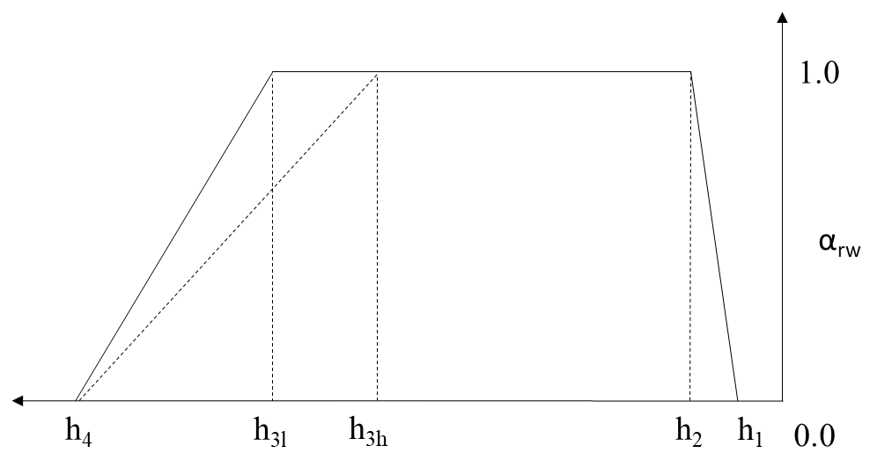

Figure 2. Reduction coefficient for root water uptake (αrw), as function of soil water pressure head (h) and potential transpiration rate (PTRANS) (after Feddes et al. 1978).

Pressure head threshold values h1 to h4 for sugarcane were proposed by Qureshi (1999) and applied to simulate irrigation schemes strategies (Qureshi, Madramootoo, and Dodds 2002) and to evaluate SWAP/WOFOST model performance (F. V. Scarpare 2011). Because potential root water uptake (PRWU) is set equal to potential transpiration (PTRANS), the plant expansion water stress factor (SWFACE) used in SAMUCA would be very restrictive (*Figure 1*b). Thus, PRWU based on Ritchie (1998) was re-computed only to obtain SWFACE and avoid further calibration.

The SWAP model structure is fully described in Kroes et al. (2009) and to merge SAMUCA with SWAP, the sugarcane model was re-structured into initialization (i=1), potential rate/state (i=2) and actual rate/state (3) mode (Figure 1). In this way, all input/output data could be exchanged between the main structure of SWAP and sugarcane PBM during the simulations.

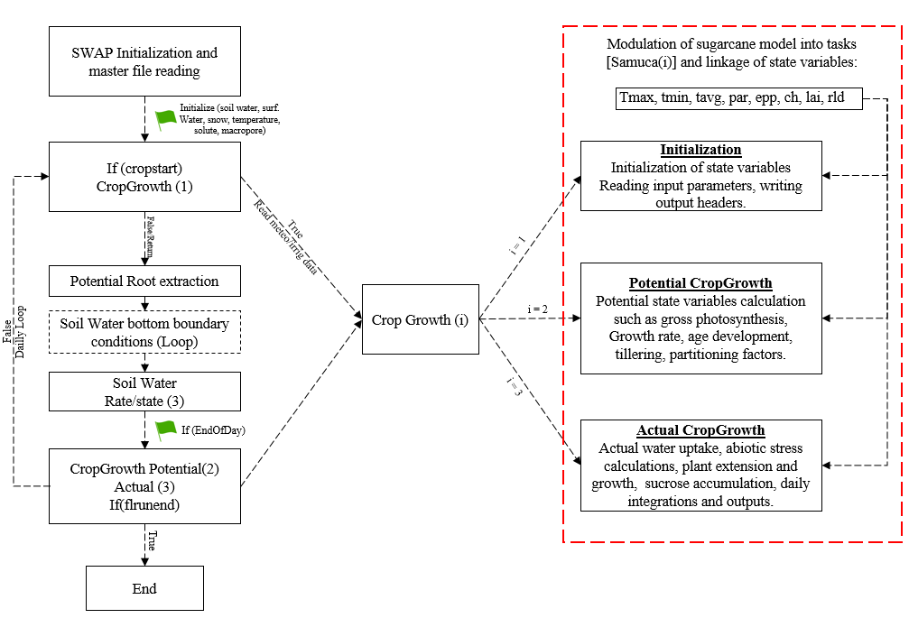

Figure 3. Simplified framework of SWAP model structure and Crop Growth module, including sugarcane restructured PBM and variables at initialization, potential and actual plant growth.

All SWAP plant variables and process routines were compiled together using the TTUTIL library (Kraalingen and Rappoldt 2002) and identified to track model steps and similarity with sugarcane PBM. The sugarcane PBM code was then included in the SWAP routine and compiled in the CropGrowth module. Weather, soil and control variables were identified and modified for sugarcane PBM to be linked to the SWAP main structure (Table 2). In addition, crop parameters and controls were added to simulations in an input file similar to the SWAP crop files (extension “.crp”).

Table 2. State variables linked, its description and modules in which it is used by SWAP main structure

|  |  |  |
| --- | --- | --- |
| **Variable** | **Description** | **Module** |
| Pleng | Plant Height | CropGrowth and ET |
| Llength | Leaf Length | CropGrowth and ET |
| Lai | Leaf Area Index | CropGrowth and ET |
| rld(i) | Root Length Density array(i) | CropGrowth and RootWaterUptake |
| Rdi | Initial Root Depth | CropGrowth and RootWaterUptake |
| Rdm | Maximum Root Depth | CropGrowth and RootWaterUptake |
| Rd | Actual Root Depth | CropGrowth and RootWaterUptake |
| Rdctb | Relative Root Density | CropGrowth and RootWaterUptake |
| Kdif | Extinction coefficient for diffuse visible light | CropGrowth |
| Kdir | Extinction coefficient for direct visible light | CropGrowth |
| Albedo | Crop reflection coefficient | CropGrowth and ET |
| Rsc | Minimum canopy resistance of dry crop | ET |
| Rsw | Canopy resistance of intercepted water | ET |
| Tmx | Maximum Air Temperature | CropGrowth and ET |
| Tmn | Minimum Air Temperature | CropGrowth and ET |
| Tavg | Average Air Temperature | CropGrowth and ET |
| Rad | Solar Radiation | CropGrowth and ET |
| Rh | Relative Humidity | ET |
| Wind | Wind Speed | ET |
| Etref | Reference Evapotranspiration | ET |
| Ptra | Potential evapotranspiration | ET and RootWaterUptake |
| Peva | Potential evaporation | ET and RootWaterUptake |
| Tra | Actual transpiration | ET and RootWaterUptake |
| Evap | Actual soil evaporation | ET and RootWaterUptake |
| h(i) | Soil water pressure head array(i) | CropGrowth and RootWaterUptake |

The ability of the coupled SAMUCA-SWAP model to simulate crop yield and its components and the soil-plant atmosphere dynamics was calibrated, tested and evaluated for a detailed field experiment dataset including soil water content, evapotranspiration measurements and crop growth and development (tillering, fresh and dry biomass, leaf area index, plant height and sucrose content). The experiment was conducted in Piracicaba, Brazil (Lat: 22°41’55”S Lon: 47°38’34”W Alt: 547m) from July 2014 to May 2015 (327 days) under two treatments (with and without trash cover) for a 2nd ratoon, cultivar RB867515 (Figure 2). The Köppen climate type is Cwa, and the soil is a Hapludox according to the USDA classification (Soil Taxonomy, 2004). Soil water content measurements were taken after every rain event and at least 3 times per week by a capacitance probe (FDR, “Diviner 2000®”), Figure 2.

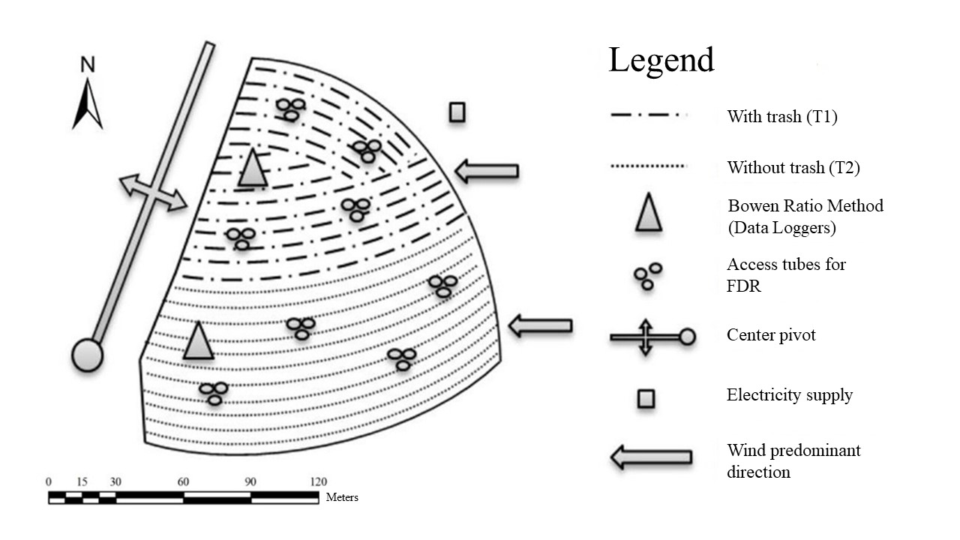

Figure 4. Experimental area showing the center pivot, predominant wind direction, location of evapotranspiration evaluation towers for each treatment (T1) with trash (T2) without trash, and FDR access tubes.

The evapotranspiration was computed by the Bowen Ratio Method (BRM) based on net radiation (Nr), soil heat flux (G), temperature and vapor pressure differences (∆t and ∆e) measurements allowing to establish the energy balance (Perez et al. 1999). Two BRM equipment towers were slightly displaced to the northwest (NW) inside each treatment area, as southwest is the prevailing wind direction (Wiendll and Angelocci, 1995) to assure enough fetch and adequate superficial boundary layer (Heilman, Brittin, and Neale 1989). Mualem-van Genuchten soil parameters and saturated hydraulic conductivity (Ks) were determined in lab using undisturbed soil samples taken at five depths (Table 3). ~~Wilting point (15 MPa) and field capacity (0.33 MPa) were determined for the SAMUCA standalone model, which layers 30-60 and 60-100 were averaged to attend the four-limited layer profile (F. R. Marin and Jones 2014).~~

Table 3. Mualem-van Genuchten soil parameters and saturated hydraulic conductivity (Ks) for the Piracicaba field experiment.

|  |  |  |  |  |  |
| --- | --- | --- | --- | --- | --- |
| Parameter | depth (cm) | | | | |
| 0-5 | 5-15 | 15-30 | 30-60 | 60-100 |
| θr (m3 m-3) | 0.01 | 0.01 | 0.01 | 0.01 | 0.01 |
| θs (m3 m-3) | 0.358 | 0.357 | 0.367 | 0.389 | 0.384 |
| α (cm-1) | 0.011 | 0.019 | 0.005 | 0.004 | 0.002 |
| n (-) | 1.124 | 1.065 | 1.068 | 1.072 | 1.090 |
| Ks (m d-1) | 2.510 | 2.430 | 2.010 | 1.780 | 0.110 |

A simple calibration routine was implemented to optimize crop parameters by minimizing the root mean squared error (RMSE) between simulated and measured data. The SWAP-SAMUCA model was embedded into an R function to compute the RMSE based on the detailed field experiment measurements. This function was then iteratively called by a General-Purpose function (“*optim(crop_array,fun)*”) changing the crop parameters array in order to converge it into the minimum RMSE for each crop component (dry biomass, tillering, LAI) (Figure 3). By default, *optim()* uses an implementation of Nelder and Mead (1965), but it is also possible to use quasi-Newton and conjugate-gradient algorithms with box-constrained optimization (Nelder and Mead 1965; Nash 1990; Byrd et al. 1995; Vanderplaats 1995; R. and Reeves 1964).

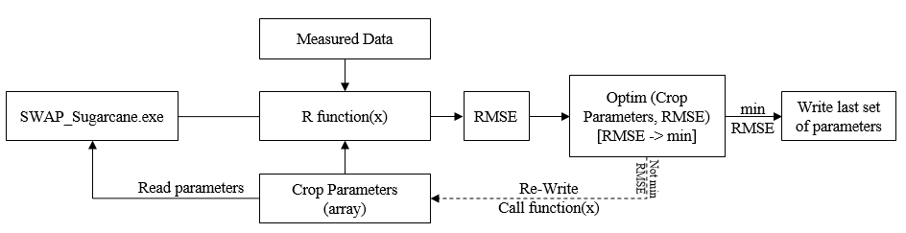

Figure 5. Schematic framework of a general-purpose calibration routine developed in R environment.

The constrained BFGS (Broyden–Fletcher–Goldfarb–Shanno) optimization method (Byrd et al. 1995) was selected to calibrate the SWAP-SAMUCA model focusing only on tillering and canopy parameters (chustk, chupeak, chudec, chumat, popmat, poppeak and maxgl) based on the detailed field experiment dataset for RB857515 cultivar described above. Initial parameters values and constrains were set according to Marin (2014) and Marin & Jones (2014), respectively.

To evaluate the SWAP-SAMUCA model performance in different weather and soil conditions, a field experiment dataset was used (Table 4). All weather input data was formatted according to the SWAP input format. As no relative humidity and wind data were available, reference evapotranspiration (ETref) was estimated according to Priestley-Taylor (1972). The soil parameters were numerically derived from soil saturation curves for each site (M. T. van Genuchten, Leij, and Yates 1991; F. R. Marin and Jones 2014). The cultivar RB857515 was selected because at present it is one of the most cultivated in Brazil (in more than 25% of sugarcane fields) (CTC 2012).

Table 4**.** Locations used in this study: data about geography, climate and sugarcane management.

|  |  |  |  |  |  |  |  |  |
| --- | --- | --- | --- | --- | --- | --- | --- | --- |
| **City/state, latitude, longitude, altidude (m)** | **Average temperature (°C)** | **Yearly rainfall**  **(mm)** | **Köppen climate type** | **USDA Soil Type** | **Soil depth**  **(m)** | **Planting date** | **Harvesting date** | **Water treatment** |
| União/PI, 4°51'S, 42°52‘W, 68 | 27.0 | 1500 | Aw | Oxisol | 1.25 | 29/Sep/2007 | 16/Jun/2008 | Irrigated and Rainfed |
| Coruripe/AL, 10°07'S, 36°10‘W, 16 | 24.4 | 1400 | As’ | Typic Hapludox | 0.40 | 11/Aug/2007 | 15/Nov/2008 | Two irrigation levels |
| Coruripe/AL, 10°07'S, 36°10‘W, 16 | 21.6 | 1400 | As’ | Typic Hapludox | 0.40 | 16/Aug/2005 | 15/Sep/2006 | Rainfed |
| Aparecida do Tab. /MS, 20º05S, 51º18’W, 335 | 23.5 | 1560 | Aw | Typic Hapludox | 4.00 | 1/Jul/2006 | 8/Sep/2007 | Rainfed |
| Colina/SP, 20°25’S, 48°19’W, 590 | 22.8 | 1363 | Cwa | Typic Hapludox | 4.00 | 10/Feb2004 | 1/Dec/2005 | Rainfed |
| Olímpia/SP, 20°26’S, 48°32’W, 500 | 23.3 | 1349 | Cwa | Typic Hapludox | 4.00 | 10/Feb/2004 | 1/Dec/2005 | Rainfed |
| Piracicaba/SP, 22°41’S, 47°38’W, 547 | 21.0 | 1255 | Cwa | Typic Hapludox | 1.00 | 16/Jul/2014 | 8/Jun2015 | Rainfed |

Statistical indexes such as bias, root mean squared error (RMSE), relative root mean squared error (RRMSE), determination index (r2) and the Willmot index (d) were used to evaluate the model performance in simulating plant components and soil water contents for different scenarios (Wallach et al. 2014).

# RESULTS AND DISCUSSION

## Model calibration and performance to simulate crop components and soil water content in southeast Brazil

The values obtained using the calibration routine using a constrained range of parameters (F. R. Marin and Jones 2014) and pre-defined parameters (Fábio Ricardo Marin 2014) are summarized in Table 5. The best values for RMSE for green leaf number, LAI and tillering measurements were 1.82 green leaves tiller-1, 1.36 m2 m-2 and 3.64 tillers m-2, respectively. The parameter values optimized for tillering on maturation and maximum green leaf number were similar to measured values in the field experiment, 10.86 tillers m-2 and 4.74 leaves tiller-1 (average values among treatments). The estimated population peak was also close to measured data (20.77 tillers m-2), however, a significant difference between the peak population of treatment with trash and without trash was observed and might be related to soil temperature and light interception (Bezuidenhout et al. 2003).

Table 5. Parameter description and calibration values for the SWAP-SAMUCA model

|  |  |  |  |
| --- | --- | --- | --- |
| **Parameter** | **Description** | **Value** | **Units** |
| maxgl | Maximum number of green leaves | 5.5* | n° |
| tb | Base temperature | 9.98 | °C |
| rue | Radiation use efficiency | 1.82 | g MJ-1 |
| sla | Specific leaf area | 64.0 | g m-2 |
| extcoef | Light extinction coefficient | 0.59 | - |
| sgpf | Max partitioning fraction to culms | 0.79 | - |
| dpercoeff | Plant extension rate | 0.352 | mm °C-1 d-1 |
| sucmax | Max sucrose fraction of dry biomass | 0.769 | - |
| srl | Specific root length | 17.38 | cm g-1 |
| chustk | Heat units for start culm elongation | 432.1* | °C d |
| chupeak | Heat units for population peak | 1256.5* | °C d |
| chudec | Heat units for start of tiller abortion | 1481.6* | °C d |
| chumat | Heat units for population establishment | 2501.8* | °C d |
| popmat | Number of tillers on maturation | 11.05* | tillers m-2 |
| poppeak | Maximum number of tillers | 20.01* | tillers m-2 |
| phyloc | Phyllochron interval for leaf appearance | 169.7 | °C d |
| mla | Maximum leaf area | 543.2 | cm2 |
| rwep1 | Soil water supply/potential threshold for expansion stress | 2 | - |
| rwep2 | Soil water supply/potential threshold for photosynthesis stress | 1 | - |

* Calibrated parameters

Crop components were well simulated by the model, with focus on green leaf number, stalk dry mass and tillering. The simulated green leaf number started close to emergence observed in the field experiment (34 days after ratooning [DAR]) ranging between 4.5 to 5.5 green leaves per tiller (Figure 4). For LAI, early season values were overestimated (Figure 4), probably because the model ignores the effect of water stress on leaf appearance. In addition, the tillering peak occurred at 113 DAR (Figure 5) which may have contributed to the overestimations resulting from the upscaling approach of LAI based on tillering and leaf area. The water stress effect on leaf appearance was pointed out by Inman-Bamber (1991) and accounted for in DSSAT-CANEGRO model by a thermal time assumed for crop full recovery from water stress. In addition, in both APSIM-Sugar and DSSAT-CANEGRO models, leaf senescence is accelerated by water stress (F. R. Marin et al. 2015).

Figure 6. Number of green leaves per tiller (left) and leaf area index (right) simulated and measured for both treatments in the Piracicaba experiment.

Tillering results were close to measured data, except at the tillering peak when 25.5 and 16.0 tillers m-2 were measured without and with trash cover treatment respectively (Figure 5). Tiller emergence occurs from buds at the base of the plant and soil temperature could be a key factor driving this process (LAUDE 1972). This showed up especially in this case because trash cover significantly affects soil temperature (Donk et al. 2004) but the effect of soil temperature on the sugarcane tillering process is not included in the model (F. R. Marin and Jones 2014). Plant height was underestimated over crop season (Figure 5), possibly due to water relations on plant expansion that is simulated based on a plant expansion parameter (dpercoeff) to account for the entire plant expansion (Singels, Jones, and Berg 2008), and not only the stalks. Moreover, water stress sensitivity on plant expansion (rwep1) is considered to be higher than on photosynthesis (rwep2) (F. R. Marin and Jones 2014), and as the soil water balance routine changed from priory calibration routine this parameterization should be reviewed.

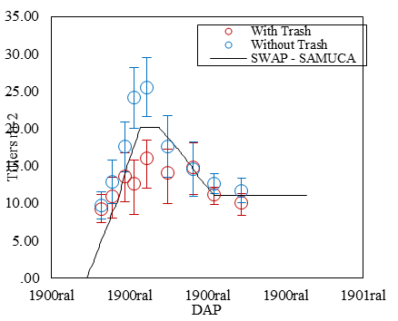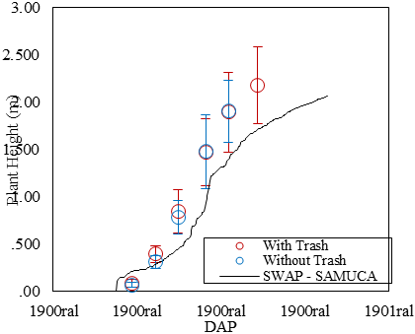

Figure 7. Tillering (left) and stalk height (right) simulated and measured for both treatments in Piracicaba experiment.

Stalk dry mass was simulated by the SWAP-SAMUCA with an RMSE of 5.37 t ha‑1 (Figure 6), similar to previous calibration for different Brazilian regions (F. R. Marin and Jones 2014). Despite the high variability of measured data, simulated stalk dry mass pattern over time was close to the average field measurements. This variable is directly affected by partitioning and radiation use efficiency parameters, and indirectly affected by almost all other parameters due to the model dynamics. Similar observations were made for stalk fresh mass, which was well simulated until the mid-season (200 DAR). An underestimation was observed on final season stalk fresh mass. This crop component, like stalk dry mass, is affected by almost all parameters and a further sensitivity analysis could be performed for a more detailed assessment. In addition, the relation between soil water content and plant fresh mass is quite undetermined, increasing these uncertainties (Martine and Lebret 2001; F. R. Marin et al. 2015).

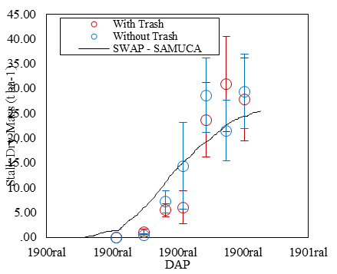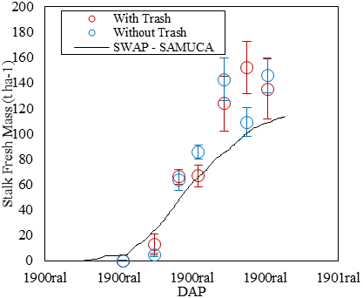

Figure 8. Stalk dry (left) and fresh (right) mass simulated and measured for both treatments in Piracicaba experiment.

Final sucrose content on fresh mass basis (POL %) was simulated well, however, the sucrose accumulation process was anticipated in simulations (Figure 7). The sucrose accumulation within sugarcane stalks is accelerated by low temperature and/or drought stress. In traditional sugarcane areas in Brazil, the humid subtropical climate (Cwa) with a dry winter from May to August favors sucrose accumulation (Alvares et al. 2013). In irrigated fields where no dry winter occurs the “drying off” strategy (irrigation suppression) takes place at the final season to accelerate sucrose accumulation, in addition to saving water and energy (Inman-Bamber 2004). To simulate this effect, the model uses two stress parameters to regulate plant expansion and growth. The expansion parameter is more sensitive mimicking the sucrose accumulation as a passive storage of energy (“sugar leftovers”) by a source-sink approach. Nevertheless, knowledge about the process is still incomplete, mainly because of uncertainties about the partitioning of substrates (sugars) among organs and the key-role of the sucrose fraction stored in the apoplastic tissue (Wang et al. 2013; Moore and Botha 2014).

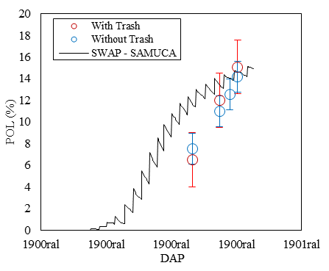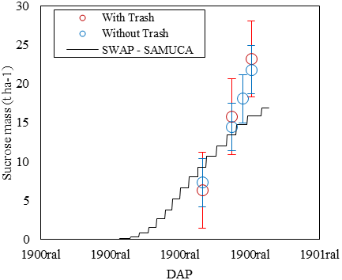

Figure 9. Sucrose content in fresh stalks (POL%) (left) and sucrose mass (right) simulated and measured for both treatments in Piracicaba experiment.

On general, the coupled model resulted in better statistical indexes for crop components than the standalone version of SAMUCA (Table 6). Green leaf number, and stalk dry and fresh mass simulations performance were not much affected by the SWAP coupling. On the other hand, tillering and LAI were the most improved simulations variables 7 and 27% of RMSE decreasing respectively and stalk height showed an increased RMSE compared to the standalone version.

Table 6. Statistical performance indexes for SWAP-SAMUCA and Sugarcane standalone versions compared to the Piracicaba field experiment (averaging with and without trash treatment).

|  |  |  |  |  |  |  |  |  |  |  |
| --- | --- | --- | --- | --- | --- | --- | --- | --- | --- | --- |
| **Variable** | **SWAP - Sugarcane** | | |  | **Sugarcane - PBM** | | | |  | |
| **Bias** | **RMSE** | **r²** | **d** | **Bias** | **RMSE** | **r²** | **d** | |
| Green Leaf Number tiller-1 | 0.09 | 0.58 | 0.83 | 0.95 | 0.08 | 0.59 | 0.84 | 0.96 | |
| Tillers m-2 | -0.86 | 3.34 | 0.67 | 0.90 | -0.09 | 3.21 | 0.73 | 0.89 | |
| LAI | -0.15 | 0.83 | 0.46 | 0.79 | 0.15 | 1.16 | 0.14 | 0.65 | |
| Stalk Height (m) | -0.26 | 0.37 | 0.96 | 0.92 | -0.07 | 0.18 | 0.98 | 0.98 | |
| Stalk dry mass (t ha-1) | 0.23 | 5.37 | 0.87 | 0.93 | 3.15 | 5.98 | 0.82 | 0.90 | |
| Stalk fresh mass (t ha-1) | -15.72 | 27.33 | 0.93 | 0.92 | -5.34 | 28.30 | 0.87 | 0.91 | |
| POL (%) | 7.87 | 2.81 | 0.97 | 0.67 | 9.33 | 3.05 | 0.95 | 0.69 | |

The soil water content in layers down to 60 cm was well simulated by SWAP-SAMUCA throughout the crop’s season (Figure 9), except for the period after 242 DAR when a lodging event occurred in the experimental area (Figure 8). This kind of field perturbation is not included in model predictions leading to a prediction mismatch. Lodging is frequent in “Cwa” climates and has increased over the past years (Silva Dias et al. 2013). After lodging, the soil water content was mostly underestimated by the model. This may also explain the lower predicted yields for stalk fresh mass (Figure 6).

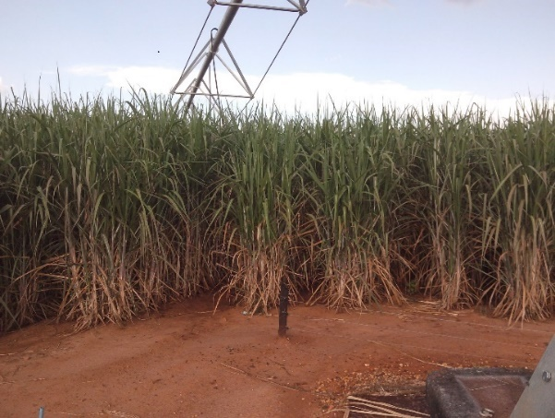

03/04/2015 (DAR=232)

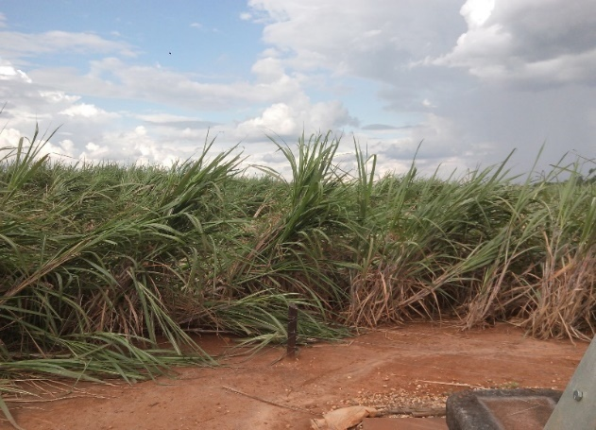

03/16/2015 (DAR=244)

Figure 10. Lodging event occurred on 242 DAR after a storm (10.2 mm in 15 minutes and over 12.6 m s-1 max wind speed).

Lodging

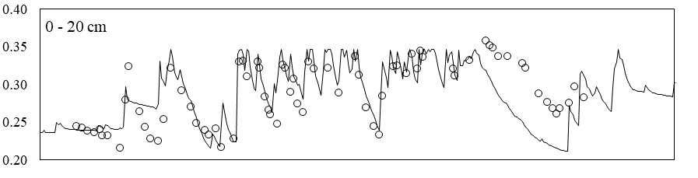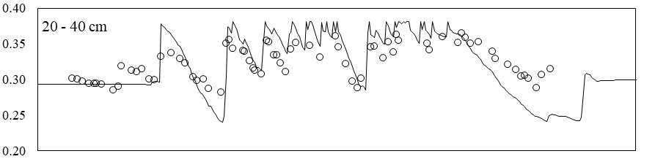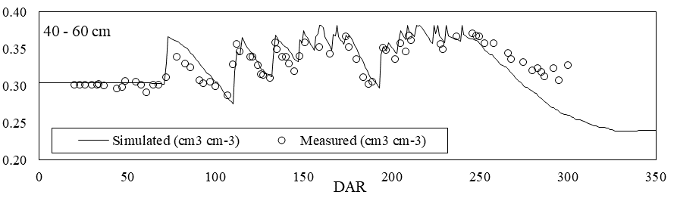

Figure 11. Soil water content (cm3 cm-3) in three soil layers simulated by SWAP-SAMUCA model and measured in Piracicaba experiment (average both experiments). Red-dotted line indicates the lodging event occurred on 242 DAR.

The soil water balance routine used in the standalone sugarcane model also yielded good results over the crop season (Figure 10). Although predicting a higher temporal variability of soil water content in all soil layers, the model simulated the main soil water content ranges and variation. Like the coupled version, soil water contents were underestimated after the lodging event.

CERES-based models have shown to predict a much more abrupt root water uptake reduction than observed, whereas simple models based on soil water content thresholds simulate a more gradual decline that mimics observations more closely (Singels et al. 2010). Under limited water availability this approach may overestimate soil water stress reducing drastically crop yield (López-cedrón et al. 2008; Kendy et al. 2003). Alternatively, root water uptake thresholds limit (e.g. wilting point) can be crop-specific allowing root water extraction below or above -15MPa in the APSIM platform (Keating et al. 1999). Moreover, hydrological models usually do not include compensation mechanisms allowing for reductions in uptake from dry layers to be compensated by an increased uptake from wetter layers, as included in the SWAP platform (De Jong van Lier et al. 2008; Jarvis 1989).

Lodging

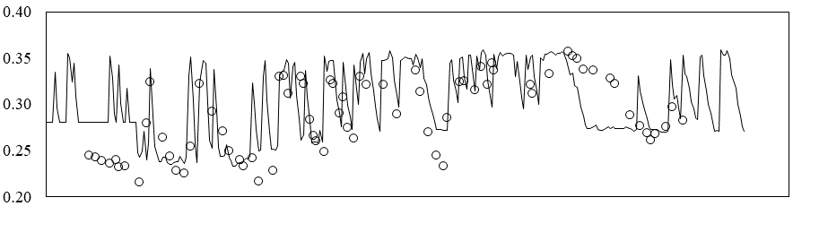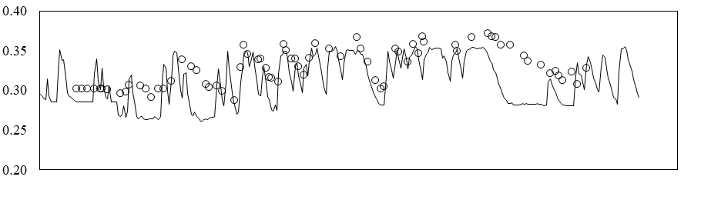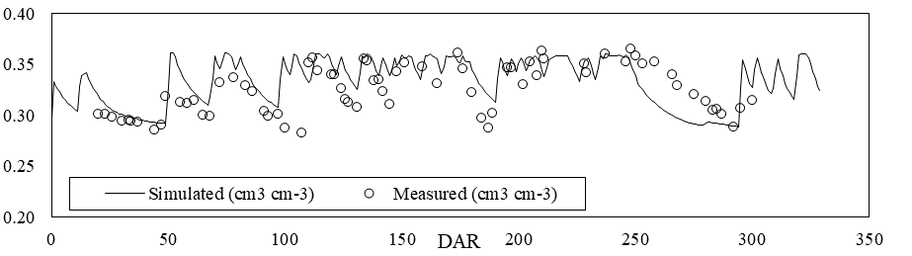

Figure 12. Soil water content (cm3 cm-3) in three soil layers simulated by the Sugarcane standalone water balance routine and measured in Piracicaba experiment (average both experiments). Red-dotted line indicates the lodging event occurred on 242 DAR.

Evapotranspiration can be expected to diminish after lodging due to damaged stems and/or root systems (affecting transpiration) and the increased soil cover by biomass (reducing evaporation). Lodging affects not only the sugarcane crop, but many crops cultivated under irrigated and windy conditions (Baker, Sterling, and Berry 2014). Physiologically, sugarcane lodging results in a reduction of radiation use efficiency and sucrose accumulation due to stalk damage and geotropic expansion. The occurrence can be simulated by empirical relations using plant height and wind speed (van Heerden et al. 2015), or physically through moment forces, soil conditions, and crop canopy and root system characteristics (Baker, Sterling, and Berry 2014).

The SWAP-SAMUCA predictions of soil water content were better than the SAMUCA stand-alone approach (Figure 11). The soil water content values simulated by SWAP-SAMUCA, applying the full Richards equation water balance module of SWAP, showed a higher precision (r2 = 0.82) and accuracy (d = 0.93) with a 32% lower RMSE than the original bucket-type simple water balance routine. Thus, besides the quantitative improvement in simulation performance when using SWAP-SAMUCA, there is a qualitative advantage by enabling the inherent ability of SWAP to simulate process-based soil water dynamics.

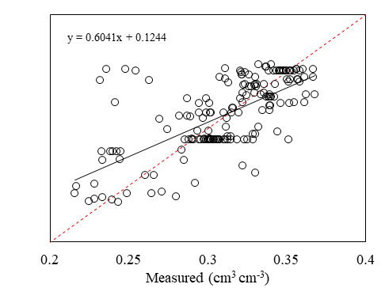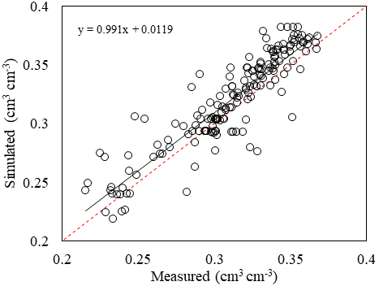

Figure 13. Measured versus simulated water contents over the cropping season and statistical indexes of performance using SWAP-SAMUCA (left) and SAMUCA standalone (right). Red dotted line is the line 1:1.

Actual evapotranspiration simulated by both models accompanied the observed values during the season (Figure 12). A small underestimation in the mid-season (around 150 DAR) occurred for the SWAP-SAMUCA model. This may be due to differences in root water uptake and/or root system growth simulations or by a miscalibration of threshold values of the Feddes et al. (1978) reduction function. The effect of lodging after 242 DAR can be observed in the data, but used models cannot be expected to simulate this.

(b)

(a)

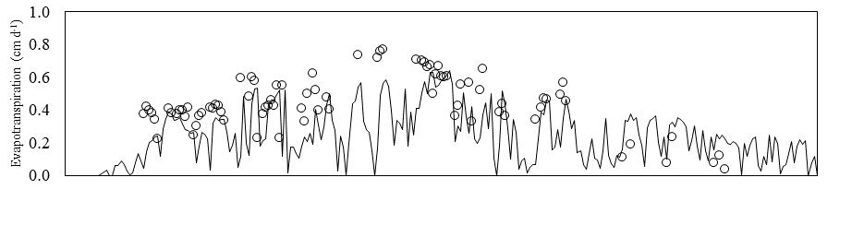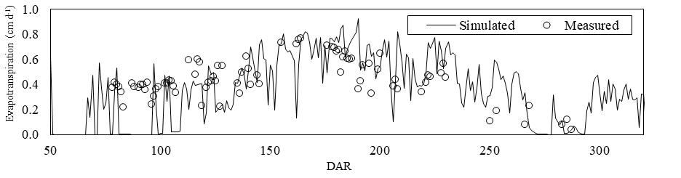

Figure 14. Crop actual evapotranspiration simulated by SWAP-SAMUCA (a) model and sugarcane standalone (b) version.

PBMs for sugarcane have shown satisfactory performance to simulate crop components for Brazilian conditions (M. Vianna and Sentelhas 2016; F. R. Marin et al. 2015). Nevertheless, uncertainty about LAI and, especially, about the tillering process require attention mostly because the canopy and population density are directly affecting the upscaling. In addition, trash cover management techniques are used in many Brazilian sugarcane fields (De Souza et al. 2005; de Aquino and de Conti Medina 2014; Costa et al. 2014) increasing the importance of physiologically accounting for trash cover. Soil temperature is lower under the trash cover, which might be a driving factor for tillering and initial crop development.

## Model performance to simulate crop components for other regions in Brazil

For the other sites, SWAP-SAMUCA showed good performance in stalk dry and fresh mass predictions (Figure 13), with an RMSE of 3.4 and 24.1 t ha-1 among the five different regions. Compared to previous studies with DSSAT-CANEGRO and APSIM-Sugar, the model presented a higher RMSE for stalk fresh and dry mass simulations, earlier reported as 18.2 and 20.9 t ha-1 respectively (F. R. Marin et al. 2015), but improved in relation to the standalone version RMSE, reported as 5.38 t ha-1 (F. R. Marin and Jones 2014). In contrast, for a longer season in Colina, São Paulo State, the model did not satisfactory simulate stalk fresh mass, whereas in Olimpia, São Paulo State, for a longer crop cycle and similar climate, the result was good. In both sites, sugarcane was cultivated under rainfed conditions whereas the production is very dependent on soil hydraulic properties and quick variations in fresh mass increase the uncertainty on fresh biomass simulations.

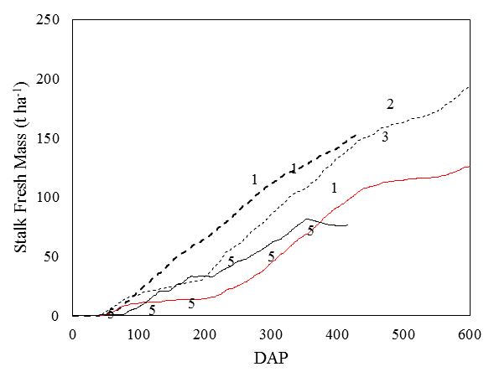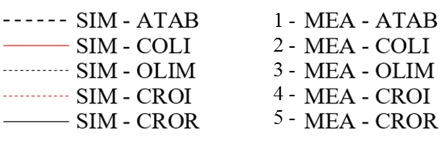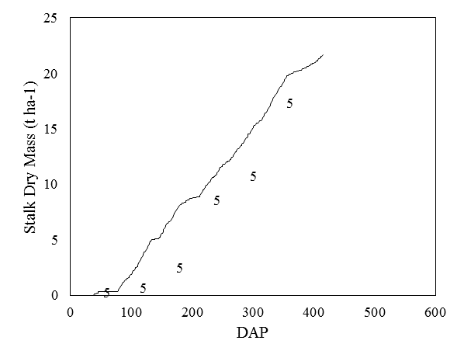

Figure 15. Stalk dry (left) and fresh (right) simulated (SIM) by SWAP-SAMUCA model and measured (MEA) data for several Brazilian conditions.

The model could simulate the tillering pattern over time, such as peak population time and quantities. However, in some regions the tillering peak did not match the simulated pattern. There is lack of data describing the management of each site regarding to soil trash cover (Aparecida do Taboado, MS), which may have great effect on tillering as discussed before (LAUDE 1972). A similar effect was noted for LAI, and the model was able to simulate its pattern over time, although not very accurately.



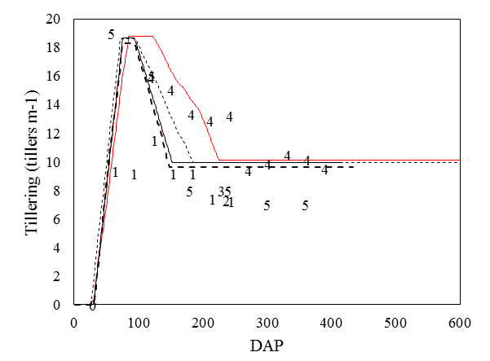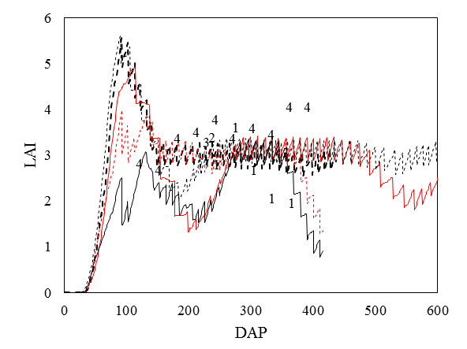

Figure 16. Tillering (left) and leaf area index (right) simulated (SIM) by SWAP-SAMUCA model and measured (MEA) data for several Brazilian conditions.

Excepting Coruripe (AL), where sucrose contents were overestimated for the whole season resulting in an unexpected additional accumulation at the end of the season (320 DAR), sucrose content accumulation on fresh basis was well simulated, better than earlier discussed (Figure 14). Stalk height was evaluated only at one site but under two treatments (irrigated and rainfed) and model predictions were accurate over the season.



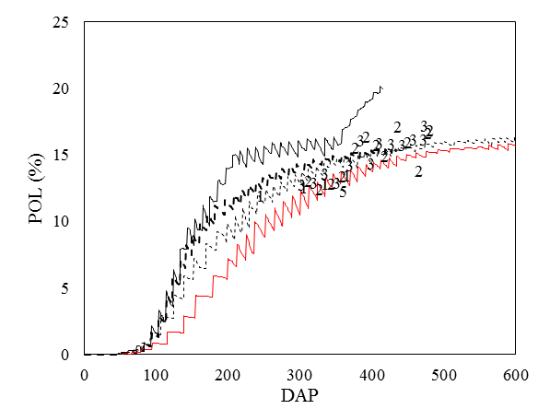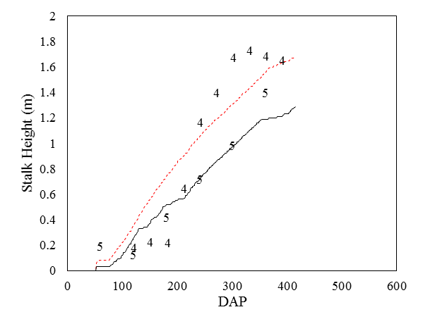

Figure 17. Sucrose content in fresh stalks (left) and stalk height (right) simulated (SIM) by SWAP-SAMUCA model and measured (MEA) data for several Brazilian conditions.

The model had the same performance as obtained for the standalone version (Fábio Ricardo Marin 2014). Although LAI results were not as accurate (Table 6) as other variables, the simulation pattern was reproduced during the season under different conditions. In addition, although not evaluated at other sites, soil water content simulations were improved by using the numerical solution of the Richards equation from SWAP algorithm.

Table 7. Statistical indexes of performance for SWAP-SAMUCA evaluated for some Brazilian regions

|  |  |  |  |  |  |
| --- | --- | --- | --- | --- | --- |
| **Variable** | **Units** | **Bias** | **RMSE** | **d** | **r2** |
| Stalk Dry Mass | t ha-1 | 2.95 | 3.44 | 0.93 | 0.93 |
| Stalk Fresh Mass | t ha-1 | -0.21 | 24.06 | 0.95 | 0.83 |
| POL | % | -0.20 | 1.49 | 0.95 | 0.85 |
| LAI | m2 m-2 | -0.23 | 0.85 | 0.64 | 0.18 |
| Tillering | tillers m-2 | 0.46 | 3.26 | 0.89 | 0.67 |
| Height | m | 0.03 | 0.23 | 0.95 | 0.88 |

Besides soil water relations, SWAP has also been used for solute transport simulation and soil salinization studies (Jiang et al. 2011; Noory et al. 2011). Moreover, salt stress in the vadose zone can also be included in root water uptake simulations as function of soil water electrical conductivity (Kroes et al. 2009). In many Brazilian sugarcane fields in expanding and traditional regions, emergency irrigation is required to maintain very young plants alive during the dry season. To save water and fertilizer resources, growers add vinasse (a byproduct of ethanol production) to irrigation water on sugarcane fields (Christofoletti et al. 2013; dos Santos et al. 2013). Moreover, vinasse applications on sugarcane fields has been adopted as an alternative water and fertilizer source on water scarcity regions (Barbosa et al. 2017; Franco, Marques, and de Melo 2008). These strategies are considered as good environmental practices in soil restoration, however, the inadequate and indiscriminate disposal of sugarcane vinasse in soils and water bodies has received much attention since decades ago, due to environmental problems associated to this practice (Christofoletti et al. 2013). The threshold of the amount of these alternative water resources and the potential salt stress and soil salinization impact on sugarcane production and groundwater contamination could be assessed by using SWAP. Further experimental data on solute transport and salinization stress could be used to evaluate the model’s ability to simulate these for use in decision making studies regarding these management on sugarcane (Kumar et al. 2015).

# CONCLUSIONS

The coupling of a new sugarcane PBM to a robust agro-hydrological model (SWAP) was accomplished, enabling an improved simulation of crop water consumption. In this paper, we describe the coupling of SAMUCA to SWAP model, and evaluate the resulting new approach for dynamic simulating sugarcane growth and development under Brazilian conditions, besides consistently considering soil water and irrigation. The coupled model (SWAP-SAMUCA) is expected to reduce prediction uncertainty and to provide a better tool for predicting crop water use and vadose zone hydrology under sugarcane.

Moreover, it opens room for improvements and testing sugarcane water consumption and its response to soil temperature, agrohydrology and salt stress at the PBM level. Since any Brazilian PBM is available or developed for sugarcane (or any crop), efforts on crop modelling may be a reasonable good strategy not only to support decision of policy makers, farmers and investors, but as a tool for education and scientific guiding. Further modifications on these models aiming to overcome limitations and additions of more detailed outputs on crop water consumption and key plant processes (tillering, sugar accumulation, carbon partitioning) interaction among weather and managements are required to better assess and support sugarcane’s production in a sustainable way in Brazil.

# ACKNOWLEDGMENTS

This research was supported by FAPESP (*grants 2015/16214-5, 2014/05887-6 and 2014/12406-4*) and CNPq (301424/2015).

# REFERENCES

Adami, M., M.P. Mello, Daniel Alves de Aguiar, and B.F.T. Rudorff. 2012. “Web Platform Development to Perform Thematic Accuracy Assessment of Sugarcane Mapping in South-Central Brazil.” *Remote Sensing* 4: 3201–14. doi:10.3390/rs4103201.

Alvares, Clayton Alcarde, Jos?? Luiz Stape, Paulo Cesar Sentelhas, Jos?? Leonardo De Moraes Gon??alves, and Gerd Sparovek. 2013. “K??ppen’s Climate Classification Map for Brazil.” *Meteorologische Zeitschrift* 22 (6): 711–28. doi:10.1127/0941-2948/2013/0507.

ANA, (Agência Nacional de Águas). 2016. “Conjuntura Dos Recursos Hídricos No Brasil: Informe 2016,” 95. http://www3.snirh.gov.br/portal/snirh/centrais-de-conteudos/conjuntura-dos-recursos-hidricos/informe-conjuntura-2016.pdf.

Asseng, S. 2013. “Uncertainty in Simulating Wheat Yields under Climate Change.” *Nature Climate Change* 3 (9): 627–32. doi:10.1038/ncliamte1916.

Baker, C. J., M. Sterling, and P. Berry. 2014. “A Generalised Model of Crop Lodging.” *Journal of Theoretical Biology* 363. Elsevier: 1–12. doi:10.1016/j.jtbi.2014.07.032.

Barbosa, Eduardo Augusto Agnellos, Edson Eiji Matsura, Leonardo Naz??rio Silva dos Santos, Ivo Zution Gon??alves, Aline Azevedo Naz??rio, and Daniel Rodrigues Cavalcante Feitosa. 2017. “Water Footprint of Sugarcane Irrigated with Treated Sewage and Freshwater under Subsurface Drip Irrigation, in Southeast Brazil.” *Journal of Cleaner Production* 153: 448–56. doi:10.1016/j.jclepro.2017.01.167.

Battisti, Rafael, Paulo C. Sentelhas, and Kenneth J. Boote. 2017. “Inter-Comparison of Performance of Soybean Crop Simulation Models and Their Ensemble in Southern Brazil.” *Field Crops Research* 200. Elsevier B.V.: 28–37. doi:10.1016/j.fcr.2016.10.004.

Bezuidenhout, C. N., G. J. O’Leary, A. Singels, and V. B. Bajic. 2003. “A Process-Based Model to Simulate Changes in Tiller Density and Light Interception of Sugarcane Crops.” *Agricultural Systems* 76 (2): 589–99. doi:10.1016/S0308-521X(02)00076-8.

Brisson, Nadine, Bruno Mary, Dominique Ripoche, Marie Hélène Jeuffroy, Françoise Ruget, Bernard Nicoullaud, Philippe Gate, et al. 1998. “STICS: A Generic Model for the Simulation of Crops and Their Water and Nitrogen Balances. I. Theory and Parameterization Applied to Wheat and Corn.” *Agronomie* 18 (5–6): 311–46. doi:10.1051/agro:19980501.

Buckingham, Edgar. 1907. “Studies on the Movement of Soil Moisture.” Govt. Print. Off.

Byrd, Richard H., Peihuang Lu, Jorge Nocedal, and Ciyou Zhu. 1995. “A Limited Memory Algorithm for Bound Constrained Optimization.” *SIAM Journal on Scientific Computing* 16 (5): 1190–1208. doi:10.1137/0916069.

Christofoletti, Cintya Aparecida, Janaína Pedro Escher, Jorge Evangelista Correia, Julia Fernanda Urbano Marinho, and Carmem Silvia Fontanetti. 2013. “Sugarcane Vinasse: Environmental Implications of Its Use.” *Waste Management* 33 (12). Elsevier Ltd: 2752–61. doi:10.1016/j.wasman.2013.09.005.

Costa, Leandro G, F. R. Marin, Daniel S P Nassif, Helena M S Pinto, and Maria L R C Lopes-Assad. 2014. “Simulação Do Efeito Do Manejo Da Palha E Do Nitrogênio Na Produtividade Da Cana-de-Açúcar.” *Revista Brasileira de Engenharia Agrícola E Ambiental* 18 (5): 469–74. doi:10.1590/S1415-43662014000500001.

CTC, (Centro de Tecnologia Canavieira). 2012. “Censo Varietal E de Produtividade Em 2012,” 19.

Darcy, Henry Philibert Gaspard. 1856. *D{è}termination Des Lois D’{è}coulement de L’eau {à} Travers Le Sable*.

de Aquino, Gisele Silva, and Cristiane de Conti Medina. 2014. “Produtividade E Índices Biométricos E Fisiológicos de Cana-de-Açúcar Cultivada Sob Diferentes Quantidades de Palhada.” *Pesquisa Agropecuaria Brasileira* 49 (3): 173–80. doi:10.1590/S0100_204X2014000300003.

De Souza, Zigomar Menezes, R. D M Prado, A. C S Paixão, and Luiz Gilberto Cesarin. 2005. “Sistemas de Colheita E Manejo Da Palhada de Cana-de-Açúcar.” *Pesquisa Agropecuaria Brasileira* 40 (3): 271–78. doi:10.1590/S0100-204X2005000300011.

Donk, S J Van, E W Tollner, J L Steiner, and S R Evett. 2004. “SOIL TEMPERATURE UNDER A DORMANT BERMUDAGRASS MULCH: SIMULATION AND MEASUREMENT.” *American Society of Agricultural Engineers* 47 (1): 91–98.

dos Santos, José Darcy, André Luís Lopes da Silva, Jefferson da Luz Costa, Gessiel Newton Scheidt, Alessandra Cristine Novak, Eduardo Bittencourt Sydney, and Carlos Ricardo Soccol. 2013. “Development of a Vinasse Nutritive Solution for Hydroponics.” *Journal of Environmental Management* 114: 8–12. doi:http://dx.doi.org/10.1016/j.jenvman.2012.10.045.

EITZINGER, J., M. TRNKA, J. HOSCH, Z. ZALUD, and M. DUBROVSKY. 2004. “Comparison of CERES, WOFOST and SWAP Models Simulating Soil Water Content during Growing Season under Different Soil Conditions.” *Ecological Modelling* 171: 223–46.

EPE. 2015. “Balanço Energético Nacional.” *National Report*. https://ben.epe.gov.br/.

Everingham, Yvette, Geoff Inman-bamber, Justin Sexton, and Chris Stokes. 2015. “A Dual Ensemble Agroclimate Modelling Procedure to Assess Climate Change Impacts on Sugarcane Production in Australia.” *Agricultural Sciences*, no. August: 870–88. doi:10.4236/as.2015.68084.

FAO. 2016. “FAOSTAT DataBase.” http://faostat.fao.org/.

Feddes, Reinder A., P.J. Kowalik, and H. Zaradny. 1978. “Simulation of Field Water Use and Crop Yield.” *Simulation Monographs* Pudoc (Wageningen): 194–209.

Fortunato, Felipe M., Alan L. Vieira, José A. Gomes Neto, George L. Donati, and Bradley T. Jones. 2017. “Expanding the Potentialities of Standard Dilution Analysis: Determination of Ethanol in Gasoline by Raman Spectroscopy.” *Microchemical Journal* 133: 76–80. doi:10.1016/j.microc.2017.03.015.

Franco, Ademir, Marcos Omir Marques, and Wnaderley Jose de Melo. 2008. “Sugarcane Grown in an Oxisol Amended With Sewage Sludge and Vinasse : Nitrogen Contents in Soil and Plant.” *Scientia Agricola* 65 (4): 408–14. doi:10.1590/S0103-90162008000400013.

Heilman, J.L., C.L. Brittin, and C.M.U. Neale. 1989. “Fetch Requirements for Bowen Ratio Measurements of Latent and Sensible Heat Fluxes.” *Agricultural and Forest Meteorology* 44 (3–4): 261–73. doi:10.1016/0168-1923(89)90021-X.

Inman-Bamber, N. G. 2004. “Sugarcane Water Stress Criteria for Irrigation and Drying off.” *Field Crops Research* 89 (1): 107–22. doi:10.1016/j.fcr.2004.01.018.

Inman-Bamber, N. G., and M. G. McGlinchey. 2003. “Crop Coefficients and Water-Use Estimates for Sugarcane Based on Long-Term Bowen Ratio Energy Balance Measurements.” *Field Crops Research* 83 (2): 125–38. doi:10.1016/S0378-4290(03)00069-8.

Inman-Bamber, N. G., R. C. Muchow, and M. J. Robertson. 2002. “Dry Matter Partitioning of Sugarcane in Australia and South Africa.” *Field Crops Research* 76 (1): 71–84. doi:10.1016/S0378-4290(02)00044-8.

Inman-Bamber, N.G. 1991. “A Growth Model for Sugarcane Based on a Simple Carbon Balance and the CERES-Maize Water Balance.” *South African Journal of Plant Soil* 8: 93–99.

J. R. Williams, J. R., C. A. C. A. Jones, J. R. J. R. Kiniry, and D. A. D. A. Spanel. 1989. “The EPIC Crop Growth Model.” *Transactions of the ASAE* 32 (2): 0497–0511. doi:10.13031/2013.31032.

J.F., Martiné, and P. Todoroff. 2002. “Le Modèle de Croissance Mosicas et Sa Plateforme de Simulation Simulex: État Des Lieux et Perspectives.” In *Congrès de La Sociéte de Technologie Agricole et Sucrière de Maurice.*, 133–47. http://publications.cirad.fr/en/une_notice.php?dk=519377.

Jarvis, N J. 1989. “A Simple Empirical Model of Root Water Uptake.” *Journal of Hydrology* 107 (1–4). Elsevier: 57–72.

Jiang, Jing, Shaoyuan Feng, Zailin Huo, Zhicai Zhao, and Bin Jia. 2011. “Application of the SWAP Model to Simulate Water-Salt Transport under Deficit Irrigation with Saline Water.” *Mathematical and Computer Modelling* 54 (3–4). Elsevier Ltd: 902–11. doi:10.1016/j.mcm.2010.11.014.

Jones, C Allan, James Robert Kiniry, and P T Dyke. 1986. *CERES-Maize: A Simulation Model of Maize Growth and Development*. Texas A&​ M University Press.

Jones, J. W., G. Hoogenboom, C. H. Porter, K. J. Boote, W. D. Batchelor, L. A. Hunt, P. W. Wilkens, U. Singh, A. J. Gijsman, and J. T. Ritchie. 2003. *The DSSAT Cropping System Model*. *European Journal of Agronomy*. Vol. 18. doi:10.1016/S1161-0301(02)00107-7.

Keating, B. A., P. S. Carberry, G. L. Hammer, M. E. Probert, M. J. Robertson, D. Holzworth, N. I. Huth, et al. 2003. “An Overview of APSIM, a Model Designed for Farming Systems Simulation.” *European Journal of Agronomy* 18 (3–4): 267–88. doi:10.1016/S1161-0301(02)00108-9.

Keating, B. A., M. J. Robertson, R. C. Muchow, and N. I. Huth. 1999. “Modelling Sugarcane Production Systems I. Development and Performance of the Sugarcane Module.” *Field Crops Research* 61 (3): 253–71. doi:10.1016/S0378-4290(98)00167-1.

Kendy, E., P. Gerard-Marchant, M.T. Walter, Y. Zhang, C. Liu, and T.S. Steenhuis. 2003. “A Soil-Water-Balance Approach to Quantify Groundwater Recharge from Irrigated Cropland in the North China Plain.” *Hydrological Processes* 17: 2011–31.

Knight, John, and Peter Raats. 2016. “The Contributions of Lewis Fry Richardson to Drainage Theory, Soil Physics, and the Soil-Plant-Atmosphere Continuum.” In *EGU General Assembly Conference Abstracts*, 18:10980.

Knox, J. W., J. A. Rodr??guez D??az, D. J. Nixon, and M. Mkhwanazi. 2010. “A Preliminary Assessment of Climate Change Impacts on Sugarcane in Swaziland.” *Agricultural Systems* 103 (2). Elsevier Ltd: 63–72. doi:10.1016/j.agsy.2009.09.002.

Kraalingen, D W G Van, and C Rappoldt. 2002. “Reference Manual of the FORTRAN Utility Library TTUTIL v . 4.” *Language* 13 (April).

Kroes, J G, J C Van Dam, P Groenendijk, R F a Hendriks, and C M J Jacobs. 2009. “SWAP Version 3.2. Theory and User Manual.” *Update*, no. August: 284. http://www.swap.alterra.nl/.

Kumar, P., A. Sarangi, D. K. Singh, S. S. Parihar, and R. N. Sahoo. 2015. “Simulation of Salt Dynamics in the Root Zone and Yield of Wheat Crop under Irrigated Saline Regimes Using SWAP Model.” *Agricultural Water Management* 148. Elsevier B.V.: 72–83. doi:10.1016/j.agwat.2014.09.014.

Laclau, Patricia, and Jean Paul Laclau. 2009. “Growth of the Whole Root System for a Plant Crop of Sugarcane under Rainfed and Irrigated Environments in Brazil.” *Field Crops Research* 114 (3): 351–60. doi:10.1016/j.fcr.2009.09.004.

LAUDE, HORTON M. 1972. “Chapter 11 - External Factors Affecting Tiller Development.” In *The Biology and Utilization of Grasses*, edited by V B Younger and C M McKell, 146–54. Academic Press. doi:http://dx.doi.org/10.1016/B978-0-12-774750-7.50017-8.

Lier, Quirijn De Jong Van, J Van Dam, K. Metselaar, R. de Jong, and W. H. M. Duijnisveld. 2008. “Macroscopic Root Water Uptake Distribution Using a Matric Flux Potential Approach.” *Vadose Zone J* 7: 1065–1078. doi:10.2136.

Liu, D L, and T A Bull. 2001. “Simulation of Biomass and Sugar Accumulation in Sugarcane Using a Process-Based Model” 144: 181–211.

López-cedrón, Francisco X, Kenneth J Boote, Juan Piñeiro, and Federico Sau. 2008. “Improving the CERES-Maize Model Ability to Simulate Water De Fi Cit Impact on Maize Production and Yield Components.” doi:10.2134/agronj2007.0088.

Marin, F. R., and James W. Jones. 2014. “Process-Based Simple Model for Simulating Sugarcane Growth and Production.” *Scientia Agricola* 71 (1): 1–16. doi:10.1590/S0103-90162014000100001.

Marin, F. R., James W. Jones, Frederick Royce, Carlos Suguitani, Jorge L. Donzeli, Wander J Pallone Filho, and Daniel S P Nassif. 2011. “Parameterization and Evaluation of Predictions of DSSAT/CANEGRO for Brazilian Sugarcane.” *Agronomy Journal* 103 (2): 304–15. doi:10.2134/agronj2010.0302.

Marin, F. R., James W. Jones, Abraham Singels, Frederick Royce, Eduardo D. Assad, Giampaolo Q. Pellegrino, and Flávio Justino. 2013. “Climate Change Impacts on Sugarcane Attainable Yield in Southern Brazil.” *Climatic Change* 117 (1–2): 227–39. doi:10.1007/s10584-012-0561-y.

Marin, F. R., Peter J. Thorburn, Daniel S.P. Nassif, and Leandro G. Costa. 2015. “Sugarcane Model Intercomparison: Structural Differences and Uncertainties under Current and Potential Future Climates.” *Environmental Modelling & Software* 72: 372–86. doi:10.1016/j.envsoft.2015.02.019.

Marin, Fábio Ricardo. 2014. “Universidade de São Paulo Escola Superior de A Gricultura ‘ Luiz de Queiroz ’ Eficiência de Produção Da Cana-de-Açúcar Brasileira : Estado Atual E Cenários Futuros Baseados Em Simulações Multimodelos Fábio Ricardo Marin Engenheiro Agrônomo Piracicaba – SP,” 0–262.

Martine, J.F., and P. Lebret. 2001. “Modelling the Water Content of the Sugarcane Stalk.” In , 211–14.

Martre, Pierre, Daniel Wallach, Senthold Asseng, Frank Ewert, James W. Jones, Reimund P. R??tter, Kenneth J. Boote, et al. 2015. “Multimodel Ensembles of Wheat Growth: Many Models Are Better than One.” *Global Change Biology* 21 (2): 911–25. doi:10.1111/gcb.12768.

Moore, Paul H, and Frederik C Botha. 2014. *Sugarcane: Physiology, Biochemistry, and Functional Biology*. Edited by Paul H Moore and Frederik C Botha. WILEY Blackwell.

Nash, J C. 1990. *Compact Methods for Computers. Linear Algebra and Function Minimisation*. *New York*.

Nelder, J. A., and R. Mead. 1965. “A Simplex Algorithm for Function Minimization.” *Computer Journal* 7: 308–313.

Noory, H., S. E A T M Van Der Zee, A. M. Liaghat, M. Parsinejad, and J. C. van Dam. 2011. “Distributed Agro-Hydrological Modeling with SWAP to Improve Water and Salt Management of the Voshmgir Irrigation and Drainage Network in Northern Iran.” *Agricultural Water Management* 98 (6). Elsevier B.V.: 1062–70. doi:10.1016/j.agwat.2011.01.013.

Perez, P. J., F. Castellvi, M. Iba??ez, and J. I. Rosell. 1999. “Assessment of Reliability of Bowen Ratio Method for Partitioning Fluxes.” *Agricultural and Forest Meteorology* 97 (3): 141–50. doi:10.1016/S0168-1923(99)00080-5.

Qureshi, S.A. 1999. “SIMULATION MODELING OF IRRIGATION REQUIREMENTS fOR SUGARCANE PRODUCTION IN SlNDH PROVINCE, PAKlSTAN.” McGill University Montr{é}al, Qu{é}bec, Canada.

Qureshi, S A, C A Madramootoo, and G T Dodds. 2002. “Evaluation of Irrigation Schemes for Sugarcane in Sindh , Pakistan , Using SWAP93” 54: 37–48.

R., Fletcher, and M. Reeves. 1964. “Function Minimization by Conjugate Gradients.” *Computer Journal* 7: 148–154.

Richards, Lorenzo Adolph. 1931. “Capillary Conduction of Liquids through Porous Mediums.” *Physics* 1 (5). AIP: 318–33.

Ritchie, J T. 1998. “Soil Water Balance and Plant Water Stress.” In *Understanding Options for Agricultural Production*, edited by Gordon Y Tsuji, Gerrit Hoogenboom, and Philip K Thornton, 41–54. Dordrecht: Springer Netherlands. doi:10.1007/978-94-017-3624-4_3.

Scarpare, Fábio Vale. 2011. “Simula{ç}{ã}o Do Crescimento Da Cana-de-A{ç}{ú}car Pelo Modelo Agrohidrol{ó}gico SWAP/WOFOST.” PhD Dissertation. Piracicaba: Universidade de Sao Paulo.

Scarpare, Fábio Vale., Thayse Aparecida Dourado. Hernandes, Simone Toni. Ruiz-Corrêa, Oriel Tiago. Kolln, Glauber José De Castro. Gava, Leonardo Nazário Silva. Dos Santos, and Reynaldo Luiz. Victoria. 2016. “Sugarcane Water Footprint under Different Management Practices in Brazil: Tietê/Jacaré Watershed Assessment.” *Journal of Cleaner Production* 112: 4576–84. doi:10.1016/j.jclepro.2015.05.107.

Scarpare, F. V., T. A. D. Hernandes, S. T. Ruiz-Corrêa, M. C. A. Picoli, Bridget R.. Scanlon, Mateus Ferreira. Chagas, Daniel Garbelini. Duft, and Terezinha de Fátima. Cardoso. 2016. “Sugarcane Land Use and Water Resources Assessment in the Expansion Area in Brazil.” *Journal of Cleaner Production* 133: 1318–27. doi:10.1016/j.jclepro.2016.06.074.

Scheiterle, Lilli, Alina Ulmer, Regina Birner, and Andreas Pyka. 2017. “From Commodity-Based Value Chains to Biomass-Based Value Webs: The Case of Sugarcane in Brazil’s Bioeconomy.” *Journal of Cleaner Production*. Elsevier B.V. doi:10.1016/j.jclepro.2017.05.150.

Silva Dias, Maria A F, Juliana Dias, Leila M V Carvalho, Edmilson D Freitas, and Pedro L Silva Dias. 2013. “Changes in Extreme Daily Rainfall for S{ã}o Paulo, Brazil.” *Climatic Change* 116 (3): 705–22. doi:10.1007/s10584-012-0504-7.

Singels, A., M. van den Berg, M. A. Smit, M. R. Jones, and R. van Antwerpen. 2010. “Modelling Water Uptake, Growth and Sucrose Accumulation of Sugarcane Subjected to Water Stress.” *Field Crops Research* 117 (1). Elsevier B.V.: 59–69. doi:10.1016/j.fcr.2010.02.003.

Singels, A, and R. A. Donaldson. 2000. “A Simple Model of Unstressed Sugarcane Canopy Development.” *Proceedings of the South African Sugar Technologists’ Association* 74: 151–54.

Singels, A, M Jones, and M Van Den Berg. 2008. “DSSAT v4. 5 Canegro Sugarcane Plant Module: Scientific Documentation.” *South African Sugarcane Research Inst. Mount …*, 1–34.

Singels, A, Matthew Jones, Fábio Ricardo Marin, Alexander Ruane, and Peter Thorburn. 2014. “Predicting Climate Change Impacts on Sugarcane Production at Sites in Australia, Brazil and South Africa Using the Canegro Model.” *Sugar Tech* 16 (4): 347–55. doi:10.1007/s12355-013-0274-1.

Tapia Carpio, Lucio Guido, and Fábio Simone de Souza. 2017. “Optimal Allocation of Sugarcane Bagasse for Producing Bioelectricity and Second Generation Ethanol in Brazil: Scenarios of Cost Reductions.” *Renewable Energy* 111. doi:10.1016/j.renene.2017.05.015.

Tebaldi, Claudia, Reto Knutti, M.R. Allen, P.A. Stott, J.F.B. Mitchell, R. Schnur, T.L. Delworth, et al. 2007. “The Use of the Multi-Model Ensemble in Probabilistic Climate Projections.” *Philosophical Transactions. Series A, Mathematical, Physical, and Engineering Sciences* 365 (1857): 2053–75. doi:10.1098/rsta.2007.2076.

Teh, Christopher. 2006. *Introduction to Mathematical Modeling of Crop Growth: How the Equations Are Derived and Assembled into a Computer Model*. 1st ed. Boca Raton, Florida (USA): Brown Walker Press.

Uys, Lafras, Frederik C Botha, Jan-hendrik S Hofmeyr, and Johann M Rohwer. 2007. “Kinetic Model of Sucrose Accumulation in Maturing Sugarcane Culm Tissue” 68: 2375–92. doi:10.1016/j.phytochem.2007.04.023.

van Dam, J C, P Groenendijk, R F A Hendriks, and J G Kroes. 2008. “Advances of Modeling Water Flow in Variably Saturated Soils with SWAP.” *Vadose Zone Journal* 7 (2).

van Diepen, C. A., J Wolf, H Van Keulen, and C. Rappoldt. 1989. “WOFOST: A Simulation Model of Crop Production.” *Soil Use and Management* 5 (1): 16–24.

van Genuchten, M. T., F. J. Leij, and S. R. Yates. 1991. “The RETC Code for Quantifying the Hydraulic Functions of Unsaturated Soils.” *United States Environmental Reseach Laboratory*, no. December: 93. doi:10.1002/9781118616871.

Van Genuchten, M Th, and D R Nielsen. 1985. “On Describing and Predicting the Hydraulic Properties.” In *Annales Geophysicae*, 3:615–28.

van Heerden, P.D.R., a. Singels, a. Paraskevopoulos, and R. Rossler. 2015. “Negative Effects of Lodging on Irrigated Sugarcane productivity—An Experimental and Crop Modelling Assessment.” *Field Crops Research* 180. Elsevier B.V.: 135–42. doi:10.1016/j.fcr.2015.05.019.

Vanderplaats, G.N. 1995. *Numerical Optimization*. *International ADAMS User Conference*. doi:10.1007/BF01068601.

VAZIFEDOUST, M., J Van. Dam, Reinder A. Feddes, and M. FEIZI. 2008. “Increasing Water Productivity of Irrigated Crops under Limited Water Supply at Field Scale.” *Agricultural Water Management* 95: 89–102.

Vianna, Murilo, and Paulo Cesar Sentelhas. 2016. “Performance of DSSAT CSM-CANEGRO Under Operational Conditions and Its Use in Determining the ‘Saving Irrigation’ Impact on Sugarcane Crop.” *Sugar Tech* 18 (1): 75–86. doi:10.1007/s12355-015-0367-0.

Vianna, Santos, and Cesar Sentelhas. 2014. “Risco de Deficit Hídrico Para a Cultura Da Cana ‑ de ‑ Açúcar Em Diferentes Regiões Brasileiras,” no. 1: 1–10. doi:10.1590/S0100-204X201400040000x.

Villegas, Fernando D, Frazier Rogers Hall, P O Box, James W Jones, Frazier Rogers Hall, P O Box, Frederick S Royce, Frazier Rogers Hall, and P O Box. 2005. “CASUPRO : An Industry-Driven Sugarcane Model” 300 (5).

Wallach, Daniel, David Makowski, James W. Jones, and François Brun. 2014. *Working with Dynamic Crop Models*. *Working with Dynamic Crop Models*. doi:10.1016/B978-0-12-397008-4.00008-3.

Walter, Arnaldo, Marcelo Valadares Galdos, Fabio Vale Scarpare, Manoel Regis Lima Verde Leal, Joaquim Eug??nio Abel Seabra, Marcelo Pereira da Cunha, Michelle Cristina Araujo Picoli, and Camila Ortolan Fernandes de Oliveira. 2014. “Brazilian Sugarcane Ethanol: Developments so Far and Challenges for the Future.” *Wiley Interdisciplinary Reviews: Energy and Environment* 3 (1): 70–92. doi:10.1002/wene.87.

Wang, Jianping, Spurthi Nayak, Karen Koch, and Ray Ming. 2013. “Carbon Partitioning in Sugarcane ( Saccharum Species ).” *Frontiers in Plant Science* 4 (June): 2005–10. doi:10.3389/fpls.2013.00201.