DIVINER CALIBRATION – FAZ. AREÃO, PIRACICABA, BRAZIL

Three repetitions of undisturbed soil were taken at 5, 15, 30, 60 and 100 cm depth and on four random locations of sugarcane field experiment (total of 60 samples). Monoliths were collected with metal cylinders (v = 53.8 cm3) immediately sealed in plastic bags, weighted and taken to laboratory for deriving soil water retention curves and Mualen-van Genuchten coefficients (Mualem, 1976) (Fig 1 and Table 1). Scaled Frequencies (SF) were taken at same moment and depths of soil sampling with a Frequency Domain Reflectometry (FDR) probe (model Diviner 2000, SENTEK). Soil water contents (cm3 cm-3) derived by gravimetric method and the monoliths weights were paired with the corresponding SF values. Soil sampling occurred after a rain event; hence the majority of soil samples were at field capacity. Thus, we used the Mualen-van Genuchten method to determine the soil water content at wilting and saturation points (*Ψs = -15,000 hPA and Ψs = -10 hPA*, respectively) and compare with SF at dry and wet conditions. The lowest SF of the dry season were paired to wilting point, whereas the highest SF just after irrigation events were paired to saturation point. Paired SF and soil moisture were then used to adjust the calibration equation of the FDR equipment (Provenzano et al., 2015) with R-script. The A, B and C coefficients were, respectively, 0.14, 0.498 and 0.009 with a precision index (r2) of 0.87 (Fig 2).

D:\Murilo\sw_sc\doc\excel\ret_curv.tif

Fig 1. Soil Water Content (SWC) samples at 5, 15, 30, 60 and 100 cm depth related with soil matric potential (n = 12), determined for the Piracicaba experiment. STP, FCP and WPP are the saturation (ψs = 10 hPa), field capacity (ψs = 330 hPa) and wilting (ψs = 15,000 hPa) points respectively

Table 1. Soil depth (DP), wilting point (WPP), field capacity (FCP), saturation point (STP) and Mualen-van Genuchten Coefficients (θres, θsat α, n) adjusted to soil moisture at variable matric potentials (-10 > ψs > -15,000 hPa).

|  |  |  |  |  |  |  |  |
| --- | --- | --- | --- | --- | --- | --- | --- |
| DP | WPp | FCp | STp | θres | θsat | α | n |
| (cm) | (cm3 cm-3) | (cm3 cm-3) | (cm3 cm-3) | (cm3 cm-3) | (cm3 cm-3) | (cm-1) | (-) |
| 5 | 0.216 | 0.285 | 0.380 | 0.122 | 0.421 | 0.198 | 1.145 |
| 15 | 0.240 | 0.303 | 0.352 | 0.021 | 0.359 | 0.043 | 1.067 |
| 30 | 0.278 | 0.347 | 0.390 | 0.000 | 0.394 | 0.023 | 1.060 |
| 60 | 0.307 | 0.394 | 0.428 | 0.000 | 0.430 | 0.008 | 1.071 |
| 100 | 0.253 | 0.393 | 0.456 | 0.008 | 0.459 | 0.008 | 1.127 |

*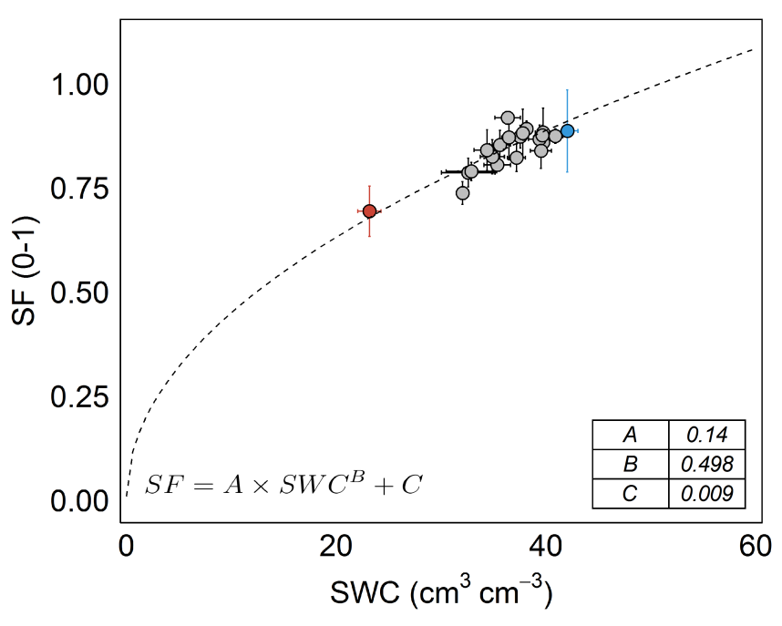*

Fig. Paired Scaled Frequency (SF) and Soil Water Content (SWC) measured by gravimetric method (grey circles) and calculated using the Mualen-van Genuchten equation (Mualem, 1976) at the wilting (red circles, Ψs = -15,000 hPA) and saturation (blue circles, Ψs = -10 hPA) points. The lowest SF of the dry season were paired to wilting point (red), whereas the highest SF after irrigation were paired to saturation point (blue). Dashed line is the adjusted calibration equation of the FDR equipment (Provenzano et al., 2015) and solid lines are the standard deviations.

References

Mualem, Yechezkel. "A new model for predicting the hydraulic conductivity of unsaturated porous media." Water resources research 12.3 (1976): 513-522.

Provenzano, Giuseppe, Giovanni Rallo, and Hiba Ghazouani. "Assessing field and laboratory calibration protocols for the diviner 2000 probe in a range of soils with different textures." Journal of Irrigation and Drainage Engineering 142.2 (2015): 04015040.