INTRODUCTION
In this semester we learned system-level modeling using systemc. Systemc is a set of c++ classes and micros which provide simulation interface.

LANGUAGE FEATURES
systemc comprises of the following features:

Modules
Modules are the basic building blocks of a systemc design hierarchy. A systemc model usually consists of several modules which communicate via ports.

Ports
Ports allow communication from inside a module to the outside(usually to other modules) via channels.

Exports
Exports incorporate channels and allow communication from inside a module to the outside(usually to other modules).

Processes
Processes are the main computation elements. They are concurrent

Channels
Channels are the communication elements. They can be be either simple wires or complex communication mechanisms like FIFOs or bus channels.
The channels are:
- signal
- buffer
- FIFO
- mutex
- semaphore
Interfaces
Ports use interfaces to communicate with channels

Events
Events allow synchronization between processes and must be defined during initialization

SYSTEMC PROJECT 1
in this project I was supposed to modify the design of the 1 by 2 decoder to 2 by 4 decoder.

TRUTH TABLES
1 by 2 decoder
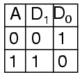
2 by 4 decoder

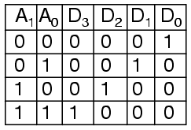
MODULES
The module diagram is as shown below:

d_a0
d_a1
a0
a1
driver
decoder
d0
d1
d2
d3
m_a0
m_a1
m_d0
m_d1
m_d2
m_d3
monitor
in1
in2
out1
out2
out3
out4
- driver: this module produced the input signals for the decoder.
- Decoder: implemented the working of the decoder
- monitor: displayed the variation of signals in the program.

FILES DESCRIPTION
driver2.h
This file defined the driver module
I declared two output ports of type bool named d_a0 and d_a1.
The function drive was to run in a while loop sending a combination of 1s and 0s to the decoder module.

decoder2.h
This file defined the decoder module
I declared two input ports of type bool as a0 and a1 and four output ports as d0,d1,d2,d3.
The implementation of the decode function is as follows:
- if input a0 was 0 and input a1 0,output d1,d2, and d3 were to be 0 and d0 to be 1.
- if input a0 was 1 and input a1 0, output d0,d2 and d3 were to be 0 and d1 to be 1.
- if input a0 was 0 and input a1 1, output d0,d1 and d3 were to be 0 and d2 to be 1.
- if input a0 was 1 and input a1 1, output d0,d1 and d2 were to be 0 and d3 to be 1.
monitor2.h
This file defined the monitor module
I declared six input ports of type bool as m_a0,m_a1,m_d0,m_d1,m_d2 and m_d3
the function monita was to output the values read from the ports.

decoder2.cc
this file implemented the connection between the three modules.
I defined six signals of type bool as in1,in2, out1, out2,out3 and out4.
I connected the corresponding ports as shown in the diagram above using the signals.
I also declared a trace file ft and a timing diagram file called timing_diagram to be used in the simulation.
makefile
This file automated the process of compiling the different files and linking their object files into an executable called decoder.

SIMULATION
For the simulation I used gtkwave and the output is as shown below.

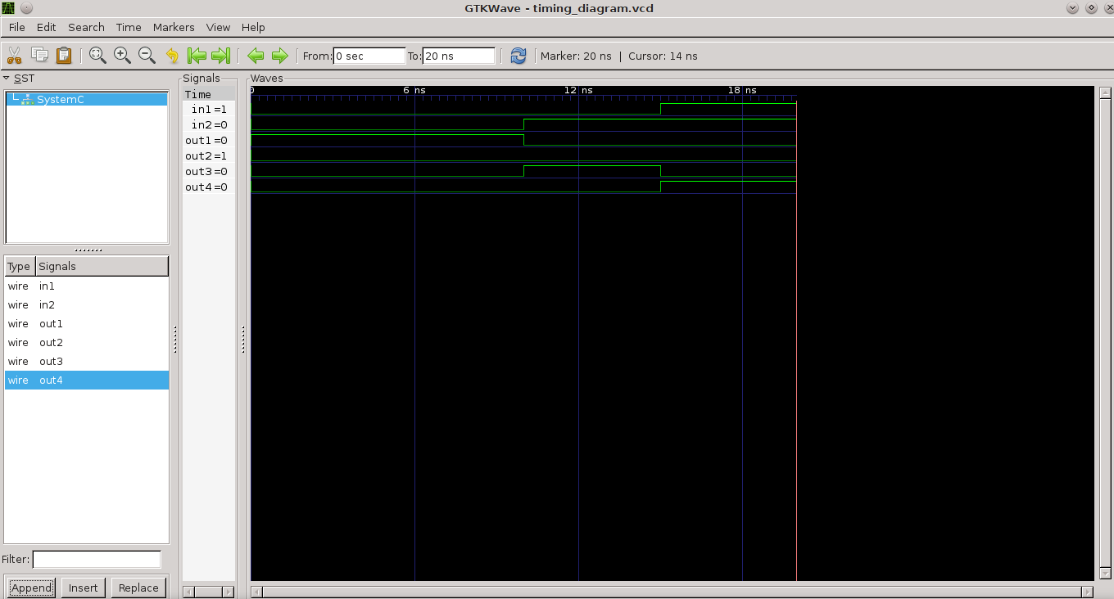

RESULTS FROM THE SIMULATION
The results from the simulation are as shown below:

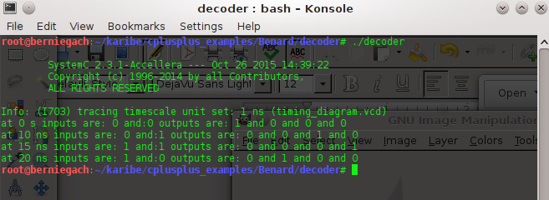

SYSTEMC PROJECT 2
In this project, I was supposed to design a sequential circuit of my choice using systemc and simulate it. I chose an S-R flip-flop as my circuit.

SEQUENTIAL CIRCUIT DIAGRAM
The circuit diagram for the sequential circuit is shown below:
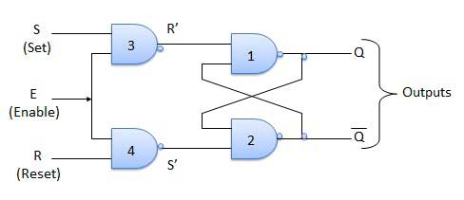
MODULES
The module diagram is as shown below:

I used vi as my c++ editor and g++ as the compiler.
The module diagram is as shown below:
- driver: this modules produced the input signals for the flip flop
d_s
d_e
d_r
s
e
r
q
q_not
m_s
m_e
m_r
m_q
m_q_not
driver
flip
monitor
in_s
in_e
in_r
out_q
out_q_not
- flip: this module implemented the working of the flip flop
- monitor: this module displayed the variation of signals present in the program

FILES DECRIPTION
For this project, I used five different files to make the sequential circuit. These are

driver_seq.h
This file defined the driver module
I declared three output ports of type bool as d_s, d_r and d_e.
I named the only function as drive and it was supposed to run in a while loop sending a combination of 1 and 0 to the flip module with a wait of 5ns.

seque.h
This file defined the flip module.
I declared three output ports of type bool as s, e and r and two output ports of of type bool as q and q_not.
I declared the function as flip_do and its operation is as follows:
- read the signals from s and e, carry out the boolean and on them, do the boolean not on the result and store in a temporary variable temp1.
- read the signals from e and r, carry out the boolean and on them, do the boolean not on the result and store the result in a temporary variable temp2.
- read the signal from q_not, do the boolean and with variable temp1, do the boolean not on the result and store the result in variable q.
- read the signal from q, do the boolean and with variable temp2, do the boolean not on the result and store the result in variable q_not.

monitor_seq,h
This file defined the monitor module
I declared five input ports of type bool as m_e,m_s,m_r, m_q and m_q_not.
The function monita was to output the values read from this ports

seque.cc
This file implemented the connection between the three modules.
I declared five signals of type bool as in_s,in_e,in_r,out_q and out_q_not.
I connected the corresponding ports as shown in the diagrams using the signals.
I also declared a trace file ft and a timing diagram file called timing_diagram to be used in the simulation.

makefile
This file automated the process of compiling the different files and linking their object files into an executable called seque.

SIMULATION
For the simulation I used gtkwave and the output is as shown below.

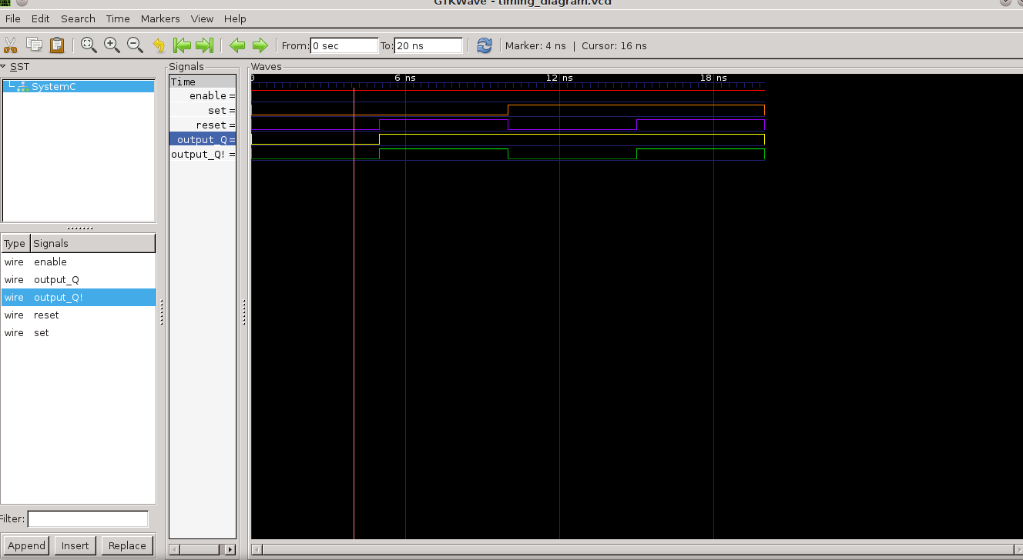

EXPECTED RESULTS
The theoretical expected results from the simulation is as shown in the table below.
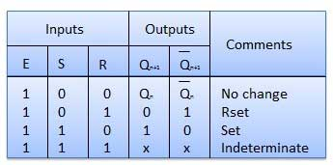

RESULTS FROM THE SIMULATION
The results from the simulation are as shown below

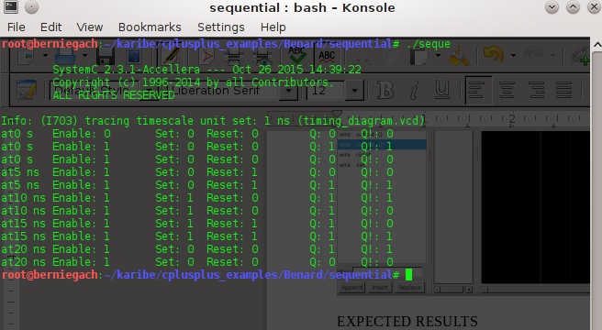
OBSERVATION
In the first project, the results from the simulation were the same as those in the truth table.
The project was successfully done.
The results from the simulation in project 2 were not fully the same as the expected results. There was some variation. This source of this error is the implementation of the flip_do method in seque.h file.

CONCLUSION
The objective of the unit was to teach me the skills of system modeling using systemc. Although in the last project the obtained results varied from the expected results I was still successful in learning how to use the systemc libraries to model various systems and do interpretation from the results obtained after simulation with gtkwave accordingly.

