Joshua Nyantika
I39/2129/2012
Tutorial 2

2 by 4 Decoder

The 2 by 4 decoder changes input code into a set of signals.
This decoder is a combination of two 1 by 2 decoders, with two inputs and four outputs.

Truth table

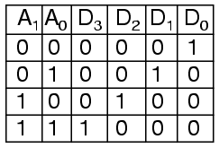

Circuit

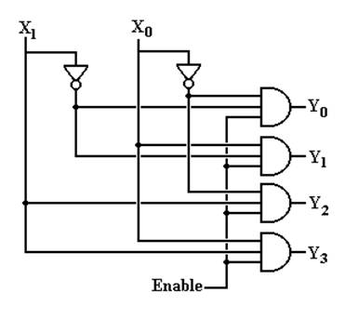

Model of computation

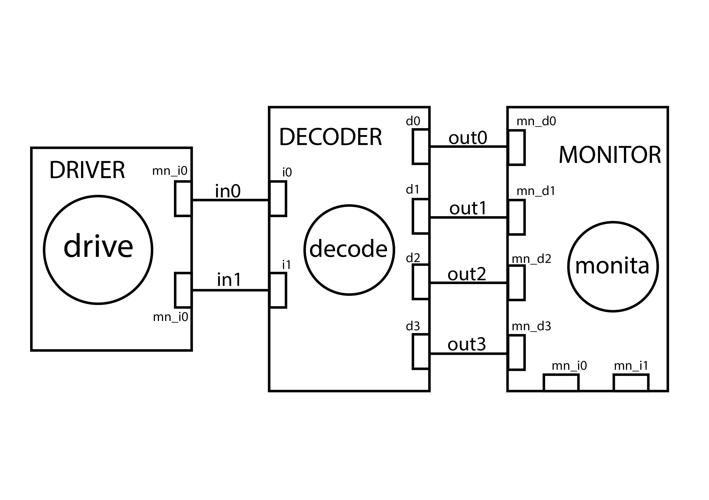

Traced signals timing diagram

