1)

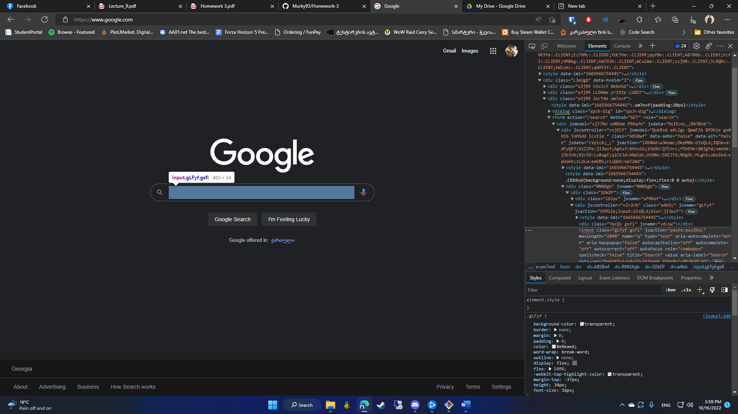

/html/body/div[1]/div[3]/form/div[1]/div[1]/div[1]/div/div[2]/input

2)

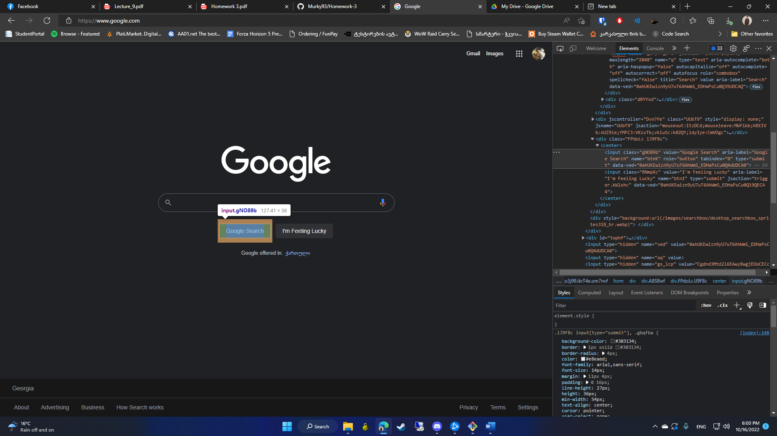

/html/body/div[1]/div[3]/form/div[1]/div[1]/div[3]/center/input[1]

3)

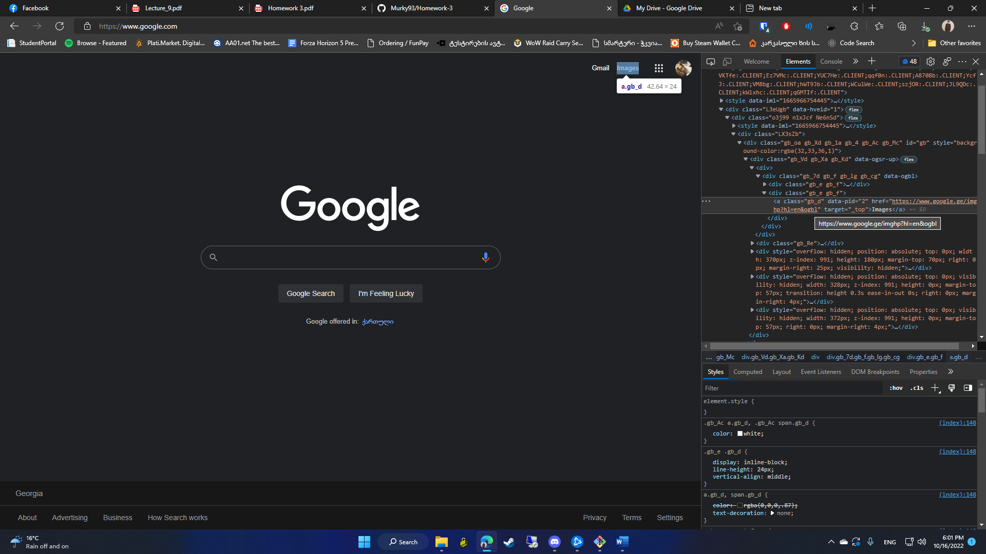//\*[@id="gb"]/div/div[1]/div/div[2]/a