同济大学计算机系

计算机组成原理实验报告



学 号 2152809
姓 名 曾崇然
专 业 计算机科学与技术
授课老师 张冬冬老师

- 实验内容
学习了解除法器的原理，实现一个32位无符号除法器和一个32位带符号除法器
- 模块建模
32位无符号除法器：
功能描述：将两个32位无符号数相除，得到一个32位商和32位余数。
verilog代码：
module DIVU(
input [31:0]dividend,
input [31:0]divisor,
input start,
input clock,
input reset,
output [31:0]q,
output [31:0]r,
output reg busy
);
reg[4:0]count;
reg [31:0] reg_q;
reg [31:0] reg_r;
reg [31:0] reg_b;
reg r_sign;
wire [32:0] sub_add=r_sign?({reg_r,reg_q[31]}+{1'b0,reg_b}):({reg_r,reg_q[31]}-{1'b0,reg_b});
assign r = r_sign? reg_r + reg_b : reg_r;
assign q = reg_q;
always @ (posedge clock or posedge reset)
begin
if(reset == 1)
begin
count <=5'b0;
busy <= 0;
end
else
begin
if (start)
begin
reg_r <= 32'b0;
r_sign <= 0;
reg_q <= dividend;
reg_b <= divisor;
count <= 5'b0;
busy <= 1'b1;
end
else if (busy)
begin
reg_r <= sub_add[31:0];
r_sign <= sub_add[32];
reg_q <= {reg_q[30:0],~sub_add[32]};
count <= count +5'b1;
if (count == 5'h1f)
busy <= 0;
end
end
end
endmodule

32位带符号除法器：
功能描述：将两个32位带符号数相除，得到带符号的32位商和32位余数
verilog代码：
module DIV(
input [31:0] dividend,
input [31:0] divisor,
input start,
input clock,
input reset,
output [31:0] q,
output [31:0] r,
output reg busy
);
reg[4:0]count;
reg [31:0] reg_q;
reg [31:0] reg_r;
reg [31:0] reg_b;
reg r_sign;
reg sign_d,sign_r;
wire [31:0] mid_q;
wire [31:0] mid_r;
wire [32:0] sub_add=r_sign?({reg_r,reg_q[31]}+{1'b0,reg_b}):({reg_r,reg_q[31]}-{1'b0,reg_b});
assign mid_r = r_sign? reg_r + reg_b : reg_r;
assign mid_q = reg_q;
assign r=sign_d?-mid_r:mid_r;
assign q=(sign_d^sign_r)?-mid_q:mid_q;
always @ (posedge clock or posedge reset)
begin
if(reset == 1)
begin
count <=5'b0;
busy <= 0;
end
else
begin
if (start)
begin
reg_r <= 32'b0;
r_sign <= 0;
if(dividend[31]==0)
reg_q <= dividend;
else
reg_q<=-dividend;
if(divisor[31]==0)
reg_b <= divisor;
else
reg_b=-divisor;
sign_d<=dividend[31];
sign_r<=divisor[31];
count <= 5'b0;
busy <= 1'b1;
end
else if (busy)
begin
reg_r <= sub_add[31:0];
r_sign <= sub_add[32];
reg_q <= {reg_q[30:0],~sub_add[32]};
count <= count +5'b1;
if (count == 5'h1f)
begin
busy <= 0;
end
end
end
end
endmodule
- 测试模块建模
32位无符号除法器：
module DIVU_tb();
reg [31:0] dividend;
reg [31:0] divisor;
wire start;
reg is_div;
reg clock;
reg reset;
wire [31:0] q;
wire [31:0] r;
wire busy;
assign start=is_div&~busy;
DIVU DIVU_inst(dividend,divisor,start,clock,reset,q,r,busy);
initial
begin
clock=0;
reset=1;
is_div=0;
dividend=524;
divisor=13;
#50 reset=0;
#5 is_div=1;
#20 is_div=0;
end
always
begin
#10 clock=~clock;
end
endmodule

32位带符号除法器：
module DIV_tb();
reg [31:0] dividend;
reg [31:0] divisor;
wire start;
reg is_div;
reg clock;
reg reset;
wire [31:0] q;
wire [31:0] r;
wire busy;
assign start=is_div&~busy;
DIV DIV_inst(dividend,divisor,start,clock,reset,q,r,busy);
initial
begin
clock=0;
reset=1;
is_div=0;
dividend=-5;
divisor=-2;
#50 reset=0;
#5 is_div=1;
#20 is_div=0;
end
always
begin
#10 clock=~clock;
end
endmodule
- 实验结果
32位无符号除法器：
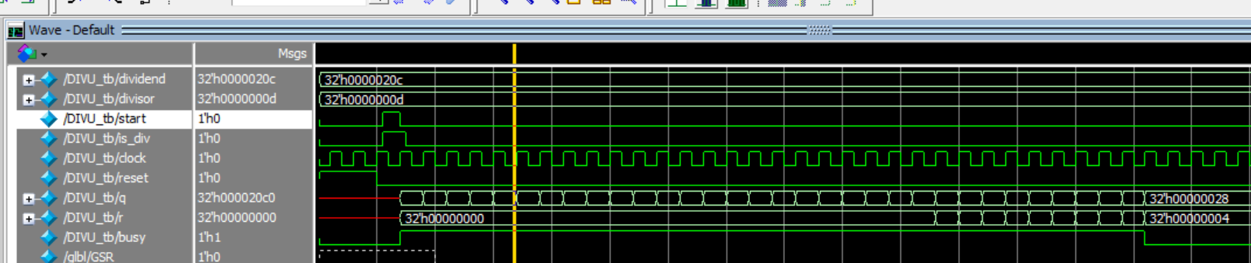
32位带符号除法器：
