1. 课上测试完善：

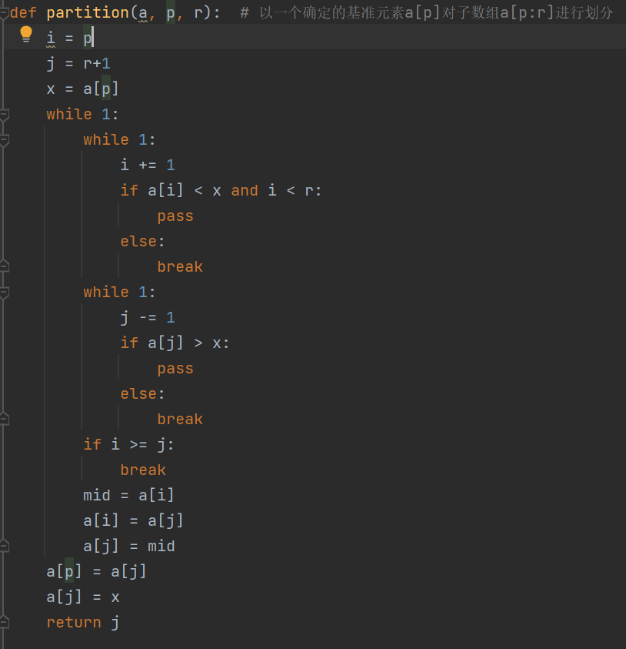

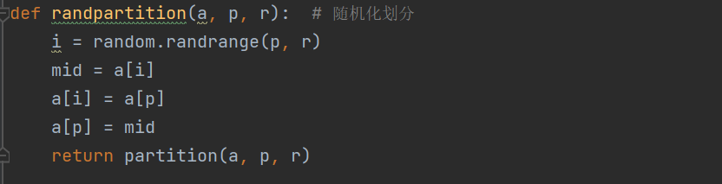

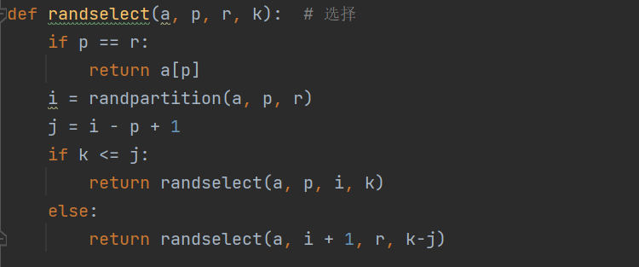

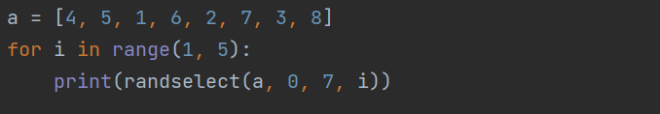



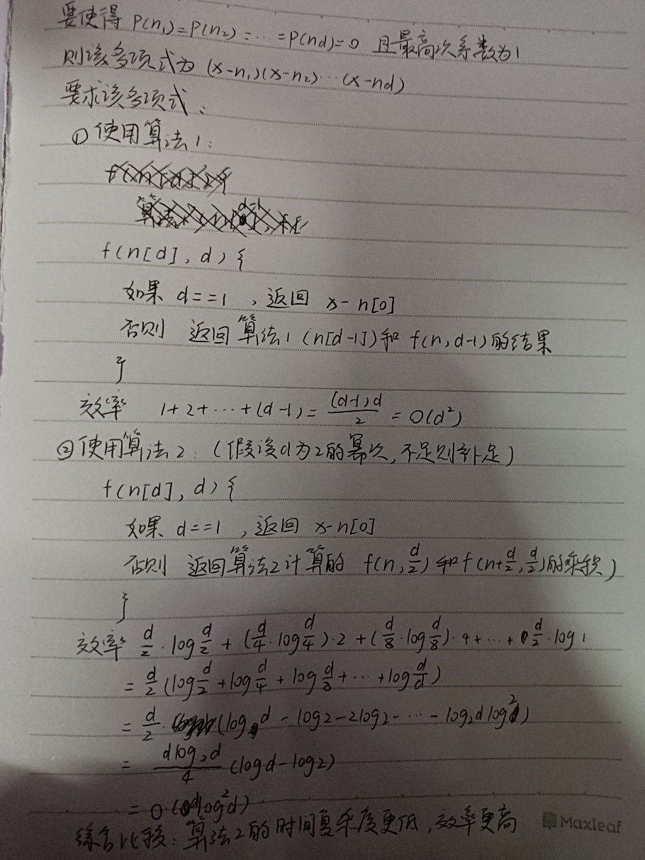



代码如下：

#include <iostream>

#include <fstream>

using namespace std;

int factorial(int n)

{

int C = 1;

while (n >= 1)

{

C = C \* n;

--n;

}

return C;

}//计算n的阶乘

int dic(int arrange[], int n)

{

int head, tail, count = 0;

if (n == 1)

return 1;

for (int i = 0; i < n - 1; ++i)

{

if (arrange[n - 1] > arrange[i])

++count;

}

head = factorial(n - 1) \* count;

tail = dic(arrange, n - 1);

return tail + head;

}//递归计算字典序

void redic(int arrange[], int n, int order)

{

int num, mid, \* array, count;

array = (int\*)malloc(n \* sizeof(int));

if (!array)

exit(-1);

for (int i = 0; i < n; ++i)

\*(array + i) = 1;

for (int i = 0; i < n; ++i)

{

num = factorial(n - i - 1);

mid = order / num;

order = order - mid \* num;

++mid;

count = 0;

for (int k = 0; k < n; ++k)

{

if (\*(array + k) == 1)

++count;

if (count == mid)

{

arrange[i] = k + 1;

array[k] = 0;

break;

}

}

}

}//循环计算下一个排列

int main()

{

int n, \* arrange, \* mid, order;

ifstream in;

ofstream out;

in.open("input.txt", ios::in);

if (!in)

{

cout << "文件打开失败！" << endl;

exit(-1);

}

in >> n;

arrange = (int\*)malloc(n \* sizeof(int));

if (!arrange)

exit(-1);

mid = (int\*)malloc(n \* sizeof(int));

if (!mid)

exit(-1);

for (int i = 0; i < n; ++i)

in >> \*(mid + i);

in.close();

for (int i = 0; i < n; ++i)

\*(arrange + i) = \*(mid + (n - i - 1));

out.open("output.txt", ios::out);

if (!out)

{

cout << "文件打开失败！" << endl;

exit(-1);

}

order = dic(arrange, n) - 1;

out << order << endl;

redic(arrange, n, order + 1);

for (int i = 0; i < n; ++i)

out << \*(arrange + i) << " ";

return 0;

}

运行结果如下图：

