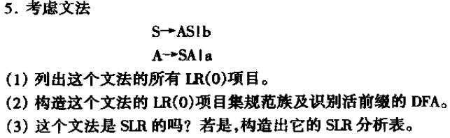

**其增广文法为：**

S’->S

S->AS | b

A->SA | a

**(1)其LR(0)项目为：**

1. S’->.S 2. S’->S.

3. S->.AS 4. S->A.S 5. S->AS. 6. S->.b 7. S->b.

8. A->.SA 9. A->S.A 10. A->SA. 11. A->.a 12. A->a.

**(2)构造过程如下：**

CLOSURE(S’->·S)={S’->.S, S->.AS, S->.b, A->.SA, A->.a}={1, 3, 6, 8, 11}=I0

GOTO的过程总结为下表

|  |  |  |  |  |
| --- | --- | --- | --- | --- |
| 状态\符号 | S | A | a | b |
| I0{1, 3, 6, 8, 11} | I1 | I2 | I3 | I4 |
| I1{2, 3, 6, 8, 9, 11} | I5 | I6 | I3 | I4 |
| I2{4, 3, 6, 8, 11} | I7 | I2 | I3 | I4 |
| I3{12} | / | / | / | / |
| I4{7} | / | / | / | / |
| I5{9, 8, 11, 3, 6} | I5 | I6 | I3 | I4 |
| I6{4, 10, 3, 6, 8, 11} | I7 | I2 | I3 | I4 |
| I7{5, 9, 8, 11, 3, 6} | I5 | I6 | I3 | I4 |

I1={S’->S., S->.AS, S->.b, A->.SA, A->S.A, A->.a}

I2={S->A.S, S->.AS, S->.b, A->.SA, A->.a}

I3={A->a.}

I4={S->b.}

I5={A->S.A, A->.SA, A->.a, S->.AS, S->.b}

I6={S->A.S, A->SA., S->.AS, S->.b, A->.SA, A->.a}

I7={S->AS., A->S.A, A->.SA, A->.a, S->.AS, S->.b}

所以I1~I7即为该文法的LR(0)项目集规范族

画出来的DFA如图：

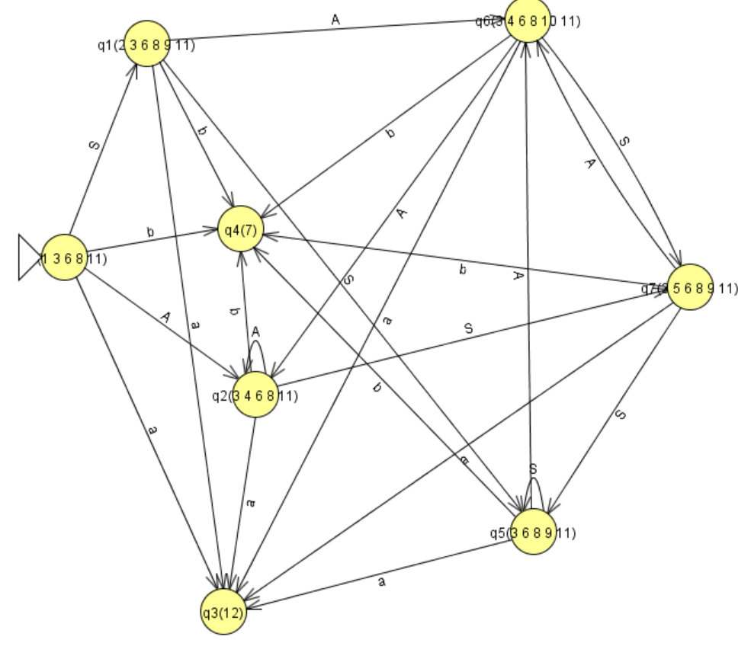

(3)

