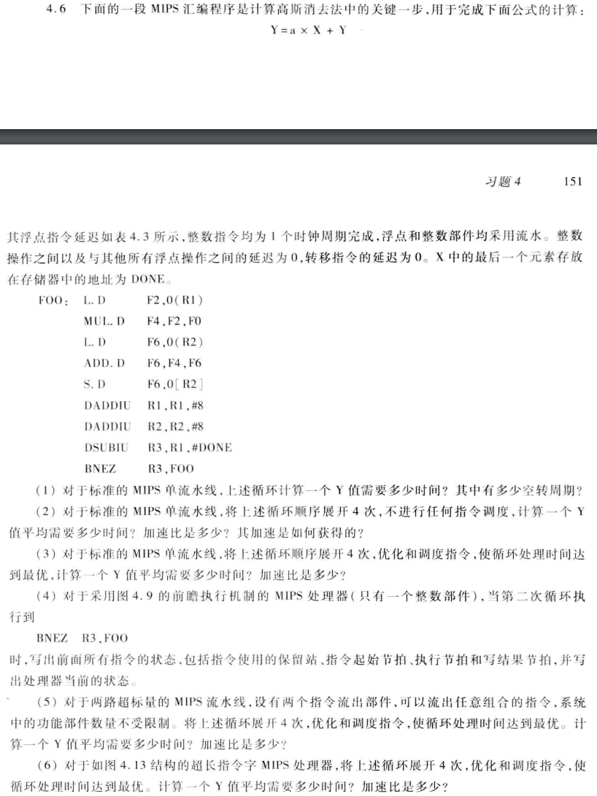



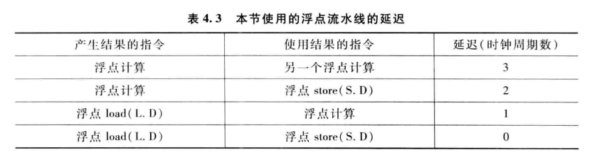

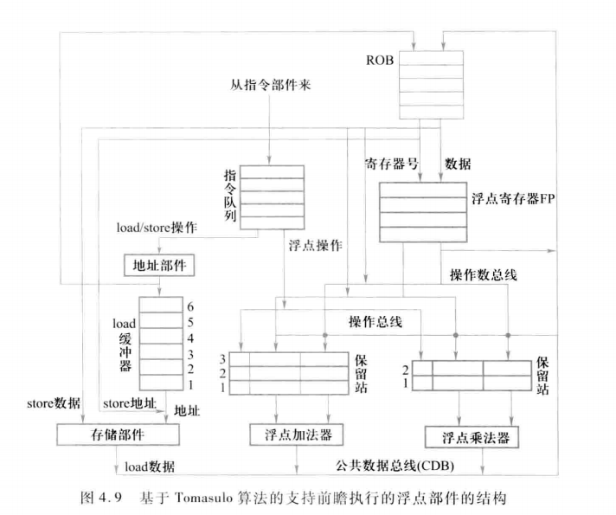

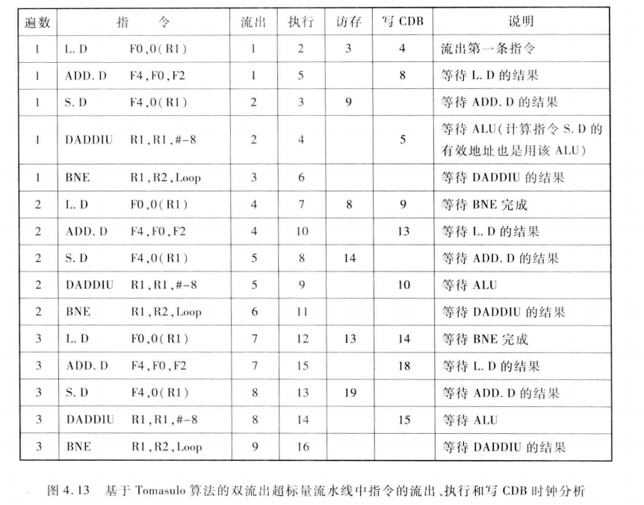

(1)

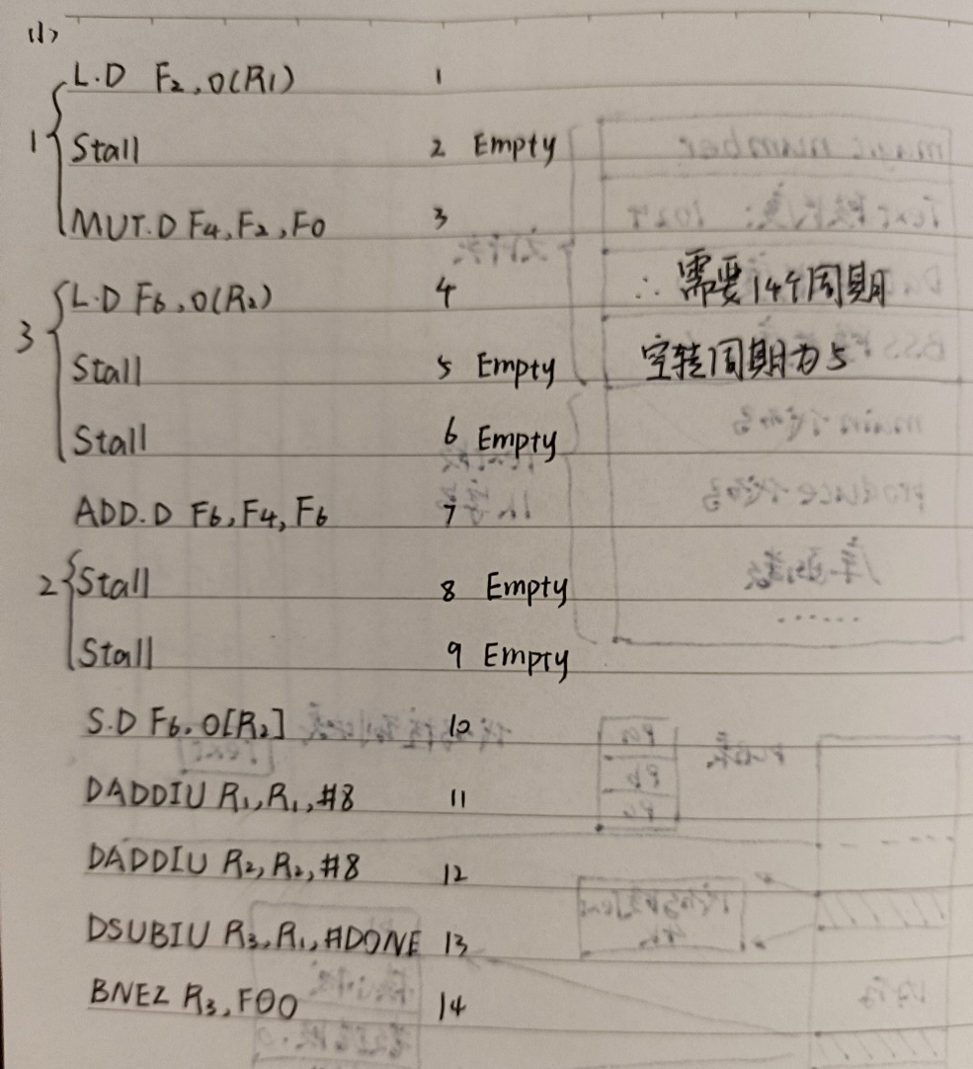

(2)

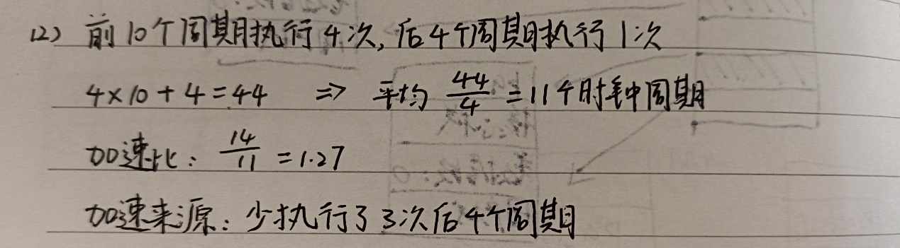

(3)

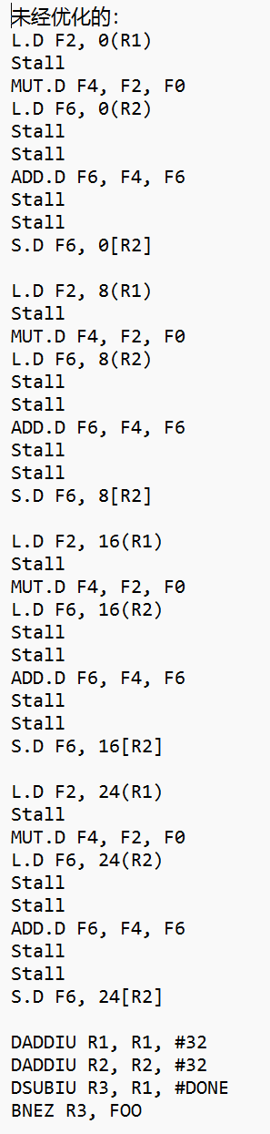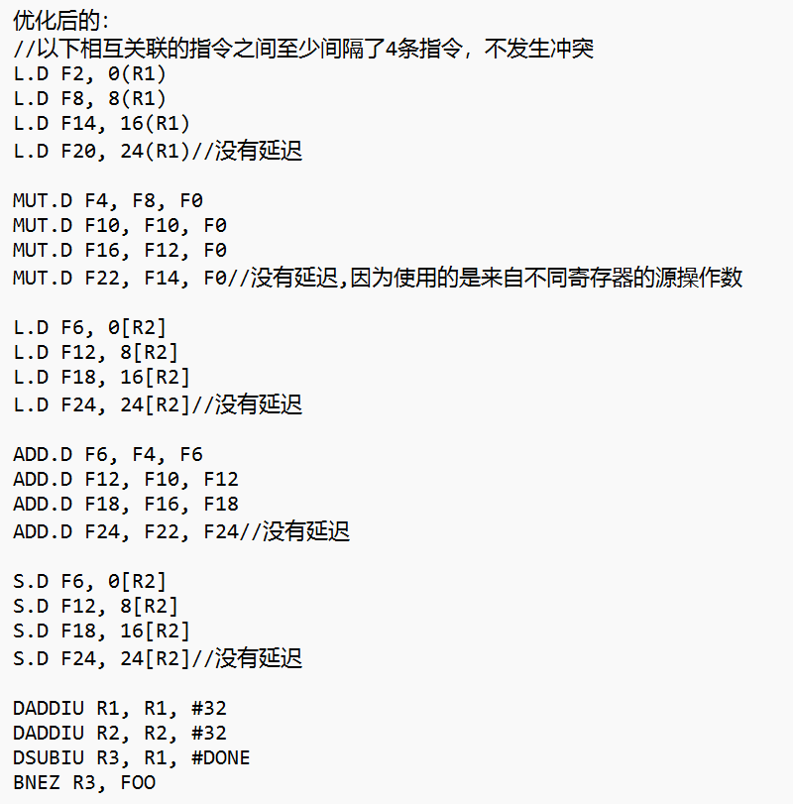

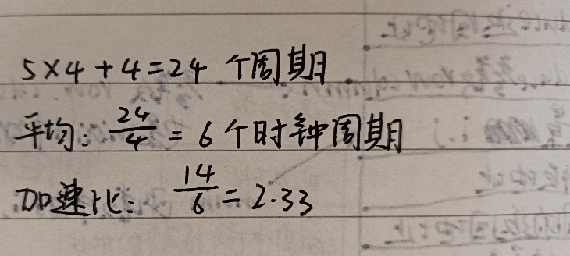

(4)

指令状态：

|  |  |  |  |
| --- | --- | --- | --- |
| 指令 | 执行时钟 | | |
| 发射 | 执行 | 写回结果 |
| L.D F2, 0(R1) | 1 | 2 | 3 |
| MUL.D F4, F2, F0 | 2 | 4 | 5 |
| L.D F6, 0(R2) | 3 | 4 | 6 |
| ADD.D F6, F4, F6 | 4 | 8 | 9 |
| S.D F6, 0[R2] | 5 | 11 | 12 |
| DADDIU R1, R1, #8 | 6 | 7 | 8 |
| DADDIU R2, R2, #8 | 7 | 8 | 9 |
| DSUBIU R3, R1, #DONE | 8 | 9 | 10 |
| BNEZ R3, FOO | 9 | 10 |  |
| L.D F2, 0(R1) | 10 | 11 | 12 |
| MUL.D F4, F2, F0 | 11 | 13 | 14 |
| L.D F6, 0(R2) | 12 | 13 | 15 |
| ADD.D F6, F4, F6 | 13 | 17 | 18 |
| S.D F6, 0[R2] | 14 | 20 | 21 |
| DADDIU R1, R1, #8 | 15 | 16 | 17 |
| DADDIU R2, R2, #8 | 16 | 17 | 18 |
| DSUBIU R3, R1, #DONE | 17 | 18 | 19 |
| BNEZ R3, FOO | 18 |  |  |

|  |  |  |  |  |  |  |  |
| --- | --- | --- | --- | --- | --- | --- | --- |
| 名称 | 保留站 | | | | | | |
| Busy | Op | Vj | Vk | Qj | Qk | A |
| Load1 |  |  |  |  |  |  |  |
| Load2 |  |  |  |  |  |  |  |
| Store1 |  |  |  |  |  |  |  |
| Store2 |  |  |  |  |  |  |  |
| Add1 | Y | ADD | Reg[F4] | Reg[F6] |  |  |  |
| Add2 |  |  |  |  |  |  |  |
| Add3 |  |  |  |  |  |  |  |
| Mult1 |  |  |  |  |  |  |  |
| Mult2 |  |  |  |  |  |  |  |

|  |  |  |  |  |  |  |  |  |
| --- | --- | --- | --- | --- | --- | --- | --- | --- |
| 字段 | 浮点寄存器状态 | | | | | | | |
| F0 | F2 | F4 | F6 | F8 | F10 | ...... | F30 |
| Qi |  |  |  | Add1 |  |  |  |  |

(5)

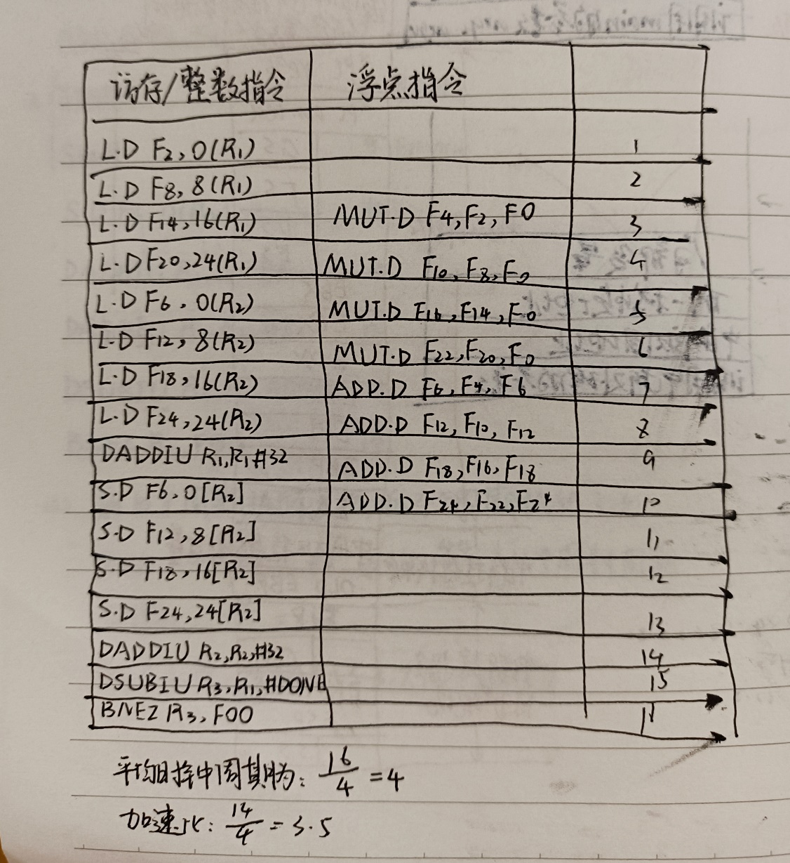

(6)

