Murali b

MARKET RISK

CONTENTS Page numbers

Table

1.1 Head of the data 3  
1.2 Tail of the data 3  
1.4 Describe the data 4  
1.27 Head of the stock dataset 14   
1.28 Stock data dataset 14  
1.29 Stock mean 15  
1.30 Stock deviation 15

Output

1.3 Shape of the data 3  
1.5 Column names 4  
1.6 Duplicate values 4  
1.7 Datatype details 4  
1.8 Info of the data 5  
1.9 Before removing the outliers 5  
1.10 After removing the outliers 6  
1.11 Missing values 6  
1.13 Correlation 7  
1.26 Shape of the stock dataset 14  
1.33 Dataframe details by Average 17  
1.34 Dataframe details by Std dev 17

Figure:

1.12 Univariate Analysis 7  
1.14 Heatmap 8  
1.15 Multivariate Analysis 8  
1.16 Jet airways stock 9  
1.17 Idea Vodafone stock 9  
1.18 Jindal steel stock 10  
1.19 Sun Pharma stock 10  
1.20 Shree Cement Stock 11  
1.21 Sail stock 11  
1.22 Axis bank stock 12  
1.23 Mahindra & Mahindra stock 12  
1.24 Indian hotel stock 13  
1.25 Infosys stock 13  
1.31 Plot of stock avg vs std dev 16  
1.32 Stock means vs std dev 16

Market Risk

The dataset contains 6 years of information (weekly stock information) on the stock prices of 10 different Indian Stocks. Calculate the mean and standard deviation on the stock returns and share insights. Please find attached the files to be referred.

Top 5 rows of the data:

Table 1.1 Head of the data

Last 5 rows of the data:

Table 1.2 Tail of the data

Shape of the data:

  
Output 1.3 Shape of the data

There are 314 observations with 11 columns.

Describe the data:

Table 1.4 Describe the data.

Columns names:

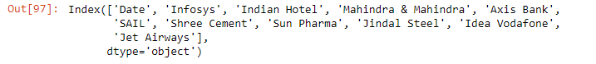

Output 1.5 Column names

Checking for duplicate values:



Output 1.6 Duplicate values

There are no duplicate values in the dataset.

Datatypes details:

Output 1.7 Datatype details

Info of the data:

Output 1.8 Info of the data

We can see 2 columns with datetime datatype and remaining 10 columns as integer datatype.

Outlier Treatment:

Output 1.9 Before removing Outliers.

We see outliers are present only in Mahindra & Mahindra and Jinda Steel columns. Let’s fix it.

After removing outliers:

Outliers 1.10 After removing outliers.

Now after treating the outliers, we see that there is no outliers present in the dataset.

Missing Value Treatment:

Output 1.11 Missing values

There are no missing values present in the dataset.

Fig 1.12 Univariate Analysis

Correlation:

Output 1.13 Correlation

Fig 1.14 Heatmap

Fig 1.15 Multivariate Analysis

2.1 Draw Stock Price Graph (Stock Price vs Time) for any 2 given stocks with inference.

Fig 1.16 Jet Airways stock

Stock price of Jet Airways reached maximum value of 200 to 800 in the year 2018 but again decreased to 0 in the year 2021.

Fig 1.17 Idea Vodafone stock

Stock price of Idea Vodafone reached maximum value of 100 to 120 in the year 22016 but again decreased to 0 in the year 2021.

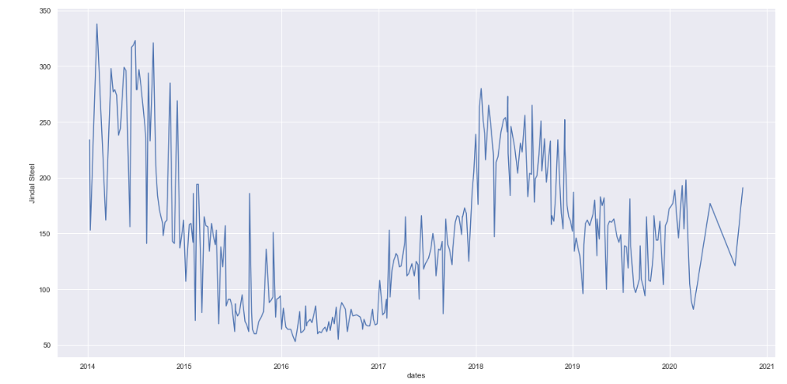  
Fig 1.18 Jindal Steel stock

Fig 1.19 Sun Pharma stock

Fig 1.20 Shree Cement stock   
Fig 1.21 Sail stock  
Fig 1.22 Axis bank stock   
Fig 1.23 Mahindra & Mahindra stock   
Fig 1.24 Indian hotel stock

Fig 1.25 Infosys stock

2.2 Calculate Returns for all stocks with inference.

Shape of the stock dataset:

  
Output 1.26 Shape of the stock dataset.   
  
We can see that there are 314 observations with 10 columns.

Table 1.27 Top 5 rows of the stock dataset.

Stock data details:

Table 1.28 Stock data details

Returns of all stocks is calculated based on taking logarithms and taking differences that is difference of log price at t and the log price at t-1.

2.3 Calculate Stock Means and Standard Deviation for all stocks with inference.

Stock mean:

Output 1.29 Stock mean

We can see hereby that Shree Cement has the highest returns and Idea Vodafone has the lowest return based on week-to-week basis. Mean is basically a average return that the stocking is making.

Standard Deviation:   
Output 1.30 Standard deviation

Here we see that Infosys has the least risk factor for investment, but Idea Vodafone has the highest risk factor for investment. Standard deviation is mainly a measure of volatility which means the more a stock return varies from the stock average return.

2.4 Draw a plot of Stock Means vs Standard Deviation and state your inference.

Plot of stock means vs standard deviation:

Fig 1.31 Plot of stock means vs standard deviation

Stock means vs stock standard deviation:

Fig 1.32 Stock means vs stock standard deviation

So mainly during the investment, the above-mentioned plot is very helpful in determining the risk of different companies. Stocks which are on the bottom right side of the graph indicates a low volatility with high returns but on the other side stocks which are higher up on the left side indicates high volatility with low returns.

Dataframe with includes stocks of Average mean and volatility details sorted by Average:

Output 1.33 Dataframe details based on Average mean.

Dataframe with includes stocks of Standard deviation and volatility details sorted by Standard deviation:

Output 1.34 Dataframe details based on Standard deviation.

2.5 Conclusion and Recommendations

Conclusion:

So, stocks with lower mean value and higher standard deviation value will not play a significant role in a portfolio which has competitive stocks with high returns and less risk. Hence Shree Cement, Infosys, Mahindra & Mahindra, and Axis bank has lowest risk and highest return.

Recommendations:

The lesser the standard deviation value then the risk of investment will be less. So based on the plot with related to stock means vs standard deviation we can determine the risk to reward ration. Hence, if the variance if large and standard deviation then the volatile is more secured which in turn will give short term gains and is not a good sign of investment in the longer duration. So, anything the greater the number of possible outcomes the greater the risk of choosing the wrong one. Therefore, low volatile stock might not be a good sign of investment for short term, but it gives good return in the long term.