Murali B

PREDICTIVE MODELLING

**Contents : Page Number:**

**PROBLEM 1:**

**Table :**

**1.1 Top 5 data 2  
1.2 Bottom 5 data 2  
1.3 Check Info 3  
1.4 Describe Data 3  
1.5 Correlation 6**

**OUTPUT :**

**1.5 Shape of the data 4  
1.6 Check columns 4  
1.7 Check for Null values 4  
1.8 Check for duplicates 5  
1.9 Check for datatypes 5  
1.31 Check for Null values 19  
1.32 Treating Null values 20  
1.33 Check for Null values 21  
1.34 Check for Duplicate values 21  
1.37 Check for datatypes 23  
1.38 Rows and cols of test, train data 24  
1.39 Logistic Regression 25  
1.40 R-square of Train data 25  
1.41 R-square of test data 25  
1.42 Predictions on test data 25  
1.43 Prediction on train data 25  
1.44 RMSE of test data 25  
1.45 RMSE of train data 25  
1.46 Regression model co-efficient 25  
1.47 Model score of test data 26  
1.48 Model score of train data 26  
1.49 Regression model Intercept 26**

**FIGURES:**

**Univariate Analysis**

**1.11 7-8  
1.12 8  
1.13 9  
1.14 9  
1.15 10  
1.16 10**

**Bivariate Analysis**

**1.17 11  
1.18 12  
1.19 12  
1.20 12  
1.21 13  
1.22 13  
1.24 14  
1.25 15  
1.26 15  
1.27 16  
1.28 16  
1.29 17**

**Multivariate Analysis**

**1.30 18  
1.35 Before treating Outliers 22  
1.36 After Treating outliers 23  
1.50 Statsmodel 27**

**PROBLEM 2 :**

**Contents: Page number**

**2.1 Confusion matrix of train data 52  
2.8 Confusion matrix of test data 55**

**Figure:**

**2.2 Confusion matrix of test data 52  
2.3 Confusion matrix of test data 53  
2.4 Logistic Regression RUC curve-train 53  
2.5 Logistic Regression RUC curve-test 54  
2.6 LDA RUC curve-train 56  
2.16 LDA RUC curve-test 57  
2.17 CART RUC curve-train 57  
2.18 CART RUC curve-test 58  
2.19 Decision tree 59**

**Problem 1**: Linear Regression

The comp-activ databases is a collection of a computer systems activity measures .  
The data was collected from a Sun Sparcstation 20/712 with 128 Mbytes of memory running in a multi-user university department. Users would typically be doing a large variety of tasks ranging from accessing the internet, editing files or running very cpu-bound programs.

As you are a budding data scientist you thought to find out a linear equation to build a model to predict 'usr'(Portion of time (%) that cpus run in user mode) and to find out how each attribute affects the system to be in 'usr' mode using a list of system attributes.

**Dataset for Problem 1:**[**compactiv.xlsx**](https://olympus.mygreatlearning.com/courses/81615/files/6885948/download?verifier=y4L3YBUgAO6XU52sk3CCwCaCcxoVXsuXTxrbiojD&wrap=1)

DATA DICTIONARY:  
-----------------------  
System measures used:

lread - Reads (transfers per second ) between system memory and user memory  
lwrite - writes (transfers per second) between system memory and user memory  
scall - Number of system calls of all types per second  
sread - Number of system read calls per second .  
swrite - Number of system write calls per second .  
fork - Number of system fork calls per second.  
exec - Number of system exec calls per second.  
rchar - Number of characters transferred per second by system read calls  
wchar - Number of characters transfreed per second by system write calls  
pgout - Number of page out requests per second  
ppgout - Number of pages, paged out per second  
pgfree - Number of pages per second placed on the free list.  
pgscan - Number of pages checked if they can be freed per second  
atch - Number of page attaches (satisfying a page fault by reclaiming a page in memory) per second  
pgin - Number of page-in requests per second  
ppgin - Number of pages paged in per second  
pflt - Number of page faults caused by protection errors (copy-on-writes).  
vflt - Number of page faults caused by address translation .  
runqsz - Process run queue size (The number of kernel threads in memory that are waiting for a CPU to run.  
Typically, this value should be less than 2. Consistently higher values mean that the system might be CPU-bound.)  
freemem - Number of memory pages available to user processes  
freeswap - Number of disk blocks available for page swapping.  
------------------------  
usr - Portion of time (%) that cpus run in user mode

**1.1 Read the data and do exploratory data analysis. Describe the data briefly. (Check the Data types, shape, EDA, 5 point summary). Perform Univariate, Bivariate Analysis, Multivariate Analysis.**

**Top 5 data** :  
Table 1.1   
  
**Bottom 5 data :**   
Table 1.2

**Checking the Info :**   
Table 1.3

We can see 22 columns and in which 13 columns are float datatypes , 8 columns are Integer datatypes and 1 object column.

**Describe the data :**   
Table 1.4  
  
It describes the 5 point summary such as count , mean , standard deviation , minimum value , 25th percentile , 50th percentile , 75th percentile and maximum value details.

**Shape of the data :**

  
Output 1.5

We can see 22 columns with 8192 observations.

**Check the columns :**   
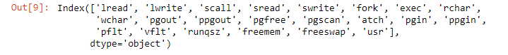  
Output 1.6  
  
**Checking for Null values :**   
Output 1.7  
  
We can see 104 null values in rchar and wchar fields and no other null values present in other fields.   
  
**Checking for duplicate values:**   
  
Output 1.8

So we can see no duplicate values present in the dataset.

**Checking for datatypes :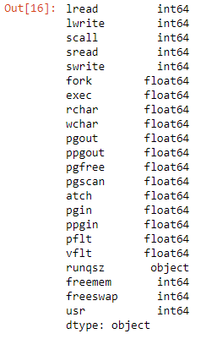 Output 1.9**It displays the datatypes of each fields.

Table 1.10**

Fig 1.11**

The histogram displays the univariate analysis of each, and all datasets present in the dataframe. We can see linear representation in each graph.

Fig 1.12  
Here in runqsz field, we can see two unique values such as CPU_Bound and Not_CPU_Bound. We can see the above plot representation using countplot.

Fig 1.13  
  
So using countplot, we can see the pictorial graph representation of lread component and the data seems to be very compressed from 0 to 1000.

Fig 1.14

The above plot using countplot, we can see that lwrite component data is very minimal found within the range between 1500.

Fig 1.15

Here scall data is scattered across all various points between the count of 0 to 8 and the data are plotted with the help of countplot.   
  
Fig 1.16

Here sread data is represented across all various points linearly between the count of 0 to 40 and the data are plotted with the help of countplot.

**Bivariate Analysis :**

**Fig 1.17**

Here we have taken lread values and represented through the help of histplot and boxplot. From the graph, we can see datapoints lying between 0 to1250.

**Fig 1.18**

In this, lwrite data points is being represented using histplot and boxplot and we can see data ranging from 0 to 2750.

Fig 1.19

Here we can see clear datapoints of scall datapoints through boxplot and histplot. The data range lies between 0 to 8000.   
  
Fig 1.20  
  
Here we can see the representation of datapoints of sread datapoints through boxplot and histplot. The data range lies between 0 to 500.

Fig 1.21

Through the help of scatterplot, we can see the relationship of lread and lwrite components and more datapoints are lying between 0 to 1000.

Fig 1.22

With the help of scatterplot, we can see the relationship of scall and sread components and more datapoints are lying between 0 to 10000.

Fig 1.23

Using the help of scatterplot, we can see the relationship of swrite and fork components and more datapoints are lying between 0 to 2000.

Fig 1.24

Through the help of scatterplot, we can see the relationship of exec and rchar components and more datapoints are lying between 0 to 40.

Fig 1.25  
  
From the above boxplot, we can see discrete representation of scall values across sread values in a linear way. It covers most part of the all the datapoints.

Fig 1.26

From the above boxplot, we can see curve type representation of lread values across lwrite values. The datapoints are plotted in a curve fashioned way across each values.

Fig 1.27

Here we can see the datapoints are hugely crowded when plotted across exec and rchar values with the help of boxplot.

Fig 1.28

From the above boxplot, we can see the data are roughly organized and scattered across all the data values when plotted swrite again fork.

Fig 1.29**

The above heatmap depicts that strong correlation relationship between each datasets and we can see strong relationship ranging within 0.6 to 0.94.

Fig 1.30**

The above plot is represented using the help of pairplot which shows multivariate analysis of each and every components present in the dataset.

**1.2 Impute null values if present, also check for the values which are equal to zero. Do they have any meaning or do we need to change them or drop them? Check for the possibility of creating new features if required. Also check for outliers and duplicates if there.**

**Checking for Null values:**

Output 1.31

We can see there are 104 null values present in rchar and 15 null values present in wchar.

**Treating Null values :**

So we have imputed the Null values with the help of mean values.

After treating the Null values then checking for Null values :

Output 1.32

We can still 3 Null values in rchar.

**Treating Null Values :**   
  
We have filled the Null values with 0 in rchar.

**Checking for Null values:**   
Output 1.33

Now, we can see no null values present in the dataset.

**Checking for duplicates :**

 **Output 1.34**

We can see no duplicate values present in the dataframe.

** **Fig 1.35**

We can see outliers present in almost all the datasets present in the dataframe.

So we have treated outliers and checking for outliers :

Fig 1.36

We have tretaed the outliers with the help of boxplot and we can see now no outliers present in the dataset.

**1.3 Encode the data (having string values) for Modelling. Split the data into train and test (70:30). Apply Linear regression using scikit learn. Perform checks for significant variables using appropriate method from statsmodel. Create multiple models and check the performance of Predictions on Train and Test sets using Rsquare, RMSE & Adj Rsquare. Compare these models and select the best one with appropriate reasoning.**

**Encode the data (having String values) for Modelling :**

So we have converted the runqsz field object datatype to int datatype.

Checking for datatypes after converting:   
Output 1.37  
Now, we can see runqsz has been converted to int datatype.

**Split the data into train and test (70:30) :**

**Output 1.38**

The above screenshot shows the number of rows present in the test and train set.

**Apply LinearRegression :**   
  
Output 1.39

**R square on training data :**   
  
Output 1.40

**R square on test data :** **Output 1.41**

**Predictions on Test data :** **Output 1.42**

**Predictions on Train data :** **Output 1.43  
  
Root Mean Squared Error of Test data :** **Output 1.44  
  
Root Mean Squared Error of train data :**

**Output 1.45  
  
Regression model coefficient :**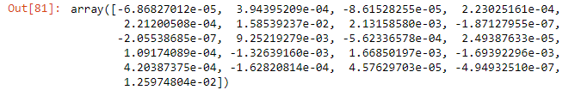

**Output 1.46**

**Model score on Test data :** **Output 1.47**

**Model score on Train data :** **Output 1.48  
  
regression model intercept :** **Output 1.49**

**Perform checks for significant variables using appropriate method form statsmodel :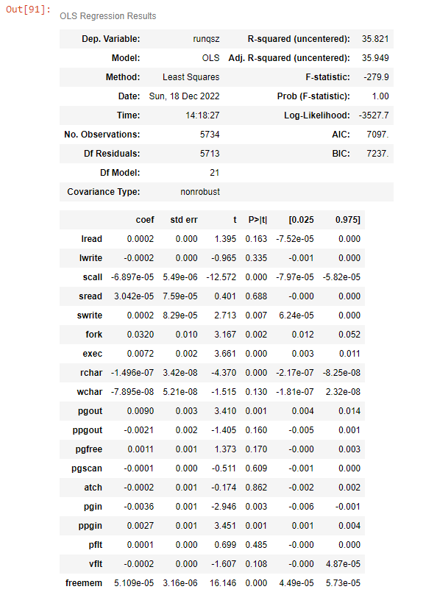 Fig 1.50**We can see R Square is computed without centering (uncentered) since the model does not contain a constant. Standard Errors assume that the covariance matrix of the errors is correctly specified. The condition number is large ,2.42e+06. This might indicate that there are strong multicollinearity or other numerical problems.

**Variation of independent variable :**   
Output 1.51  
  
**Coefficient determination R square on Train set :**   
Output 1.52

**Coefficient determination R square on Test set :**  **Output 1.53**

Output 1.54**

**We can see test data model produces good results compared to train data.**

**1.4 Inference: Basis on these predictions, what are the business insights and recommendations.**

**Please explain and summarise the various steps performed in this project. There should be proper business interpretation and actionable insights present.**

**From all the analysis made, we can see prediction of test data is more than train data and R-square, RMSE , model score and co-efficient values of test data is more so training data is less efficient when compared so we can choose test data and based on the test data outcome we can modify some components in test data to yield even more between results than train data.**

**Here, we did exploratory data analysis , checked and treated null values, duplicate values and outliers. We encode the data for modelling and did split of data into train and test 70:30. We performed statsmodel check and checked the performance of tran and test model through raquare, RMSE and Adj Rsquare. We can conclude that test data model produces good results compared to train data in all the performance metrics.**

**Problem 2: Logistic Regression, LDA and CART**

**You are a statistician at the Republic of Indonesia Ministry of Health and you are provided with a data of 1473 females collected from a Contraceptive Prevalence Survey. The samples are married women who were either not pregnant or do not know if they were at the time of the survey.**

**The problem is to predict do/don't they use a contraceptive method of choice based on their demographic and socio-economic characteristics.**

**Dataset for Problem 2: Contraceptive_method_dataset.xlsx**

**Data Dictionary:**

**1. Wife's age (numerical)**

**2. Wife's education (categorical) 1=uneducated, 2, 3, 4=tertiary**

**3. Husband's education (categorical) 1=uneducated, 2, 3, 4=tertiary**

**4. Number of children ever born (numerical)**

**5. Wife's religion (binary) Non-Scientology, Scientology**

**6. Wife's now working? (binary) Yes, No**

**7. Husband's occupation (categorical) 1, 2, 3, 4(random)**

**8. Standard-of-living index (categorical) 1=verlow, 2, 3, 4=high**

**9. Media exposure (binary) Good, Not good**

**10. Contraceptive method used (class attribute) No,Yes**

**2.1 Data Ingestion: Read the dataset. Do the descriptive statistics and do null value condition check, check for duplicates and outliers and write an inference on it. Perform Univariate and Bivariate Analysis and Multivariate Analysis.**

Table 1.55**

Table 1.56**

Output 1.57**

**We can see that there are 2 datasets having float datatype and 1 integer datatype and 7 object datatypes.**

Table 1.58**

**Here, we can see data description of the dataframe such as count, mean , standard deviation , minimum , 25th percentile, 50th percentile, 75th percentile , maximum values.**

**Shape of the data :** **Output 1.59  
We can see there are 10 columns with 1473 observations.**

**Checking for Null values :**

**Output 1.60**

**We can see 71 Null values in Wife_age dataset and 21 Null values present in No_of_children_born dataset.**

Output 1.61**

**Checking for correlation : 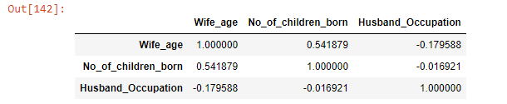 Output 1.62**

**We can see three datasets correlation details.**

**Treating Null values**

**So we have treated Null values with mean values and let’s check for Null values :**

**Output 1.63**

**We still 21 Null values present in No_of_children_born dataset.**

Output 1.64**

**We have renamed column names of Media_exposure and Wife_education.**

**Treating Null values:**

**So we have treated remaining Null values with the help of filling it with 0 and checking for Null values:**

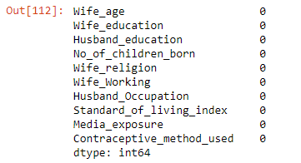 **Output 1.65**

**Now, we can see no Null values present in the dataset.**

Output 1.66  
We can see 80 duplicate values.**

**Treating duplicate values :** **Output 1.67**

**So no duplicate values present in the dataset.**

Fig 1.68**

**We can see outliers present in No_of_children_born dataset.**

Fig 1.69**

**We have treated the outliers with the help of boxplot and we can see no outliers present in the dataset.**

**  
Fig 1.70

We can see univariate analysis of Wife_age , No_of_Children_born , Husband_occupation with the help of histplot and there is a linear represnetation in each datasets.

**Bivariate Analysis : 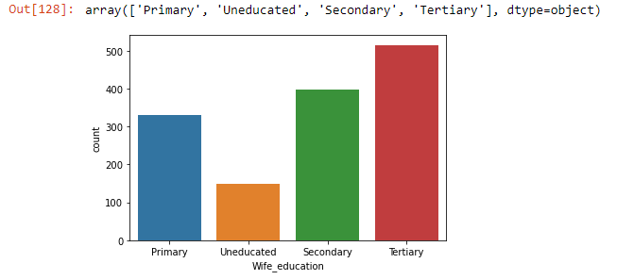 Fig 1.71**

We can see 4 unique values present in Wife_education dataset such as Primary , Uneducated , Secondary and Tertiary and we can see Tertairy values is more in the dataset.

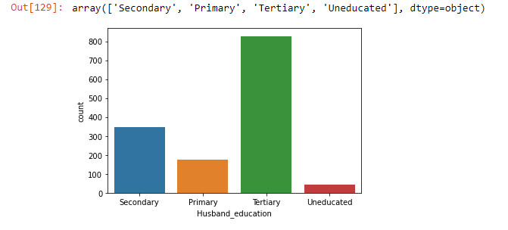  
Fig 1.72

We can see 4 unique values present in Husband_education dataset such as Primary , Uneducated , Secondary and Tertiary and we can see Tertairy values is more in the dataset.

Fig 1.73

We can see Scientology values is more than Non-Scientology values in Wife_religion dataset.

Fig 1.74

We can see working of wife numbers is more than wife who are working in Wife_Working dataset.

Fig 1.75

With the help of boxplot and histplot, we can see representation of Wife_age as upside curve down with non-linear represenation.

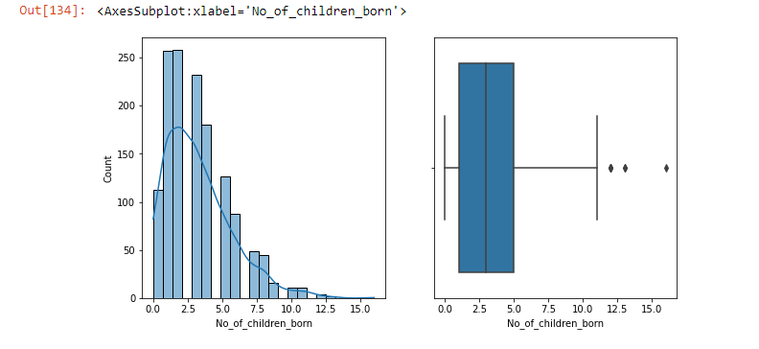  
Fig 1.76

Here, we can see the values are steep raised initially and then falls apart when we see the datapoints shown in No_of_Children_born using histplot.

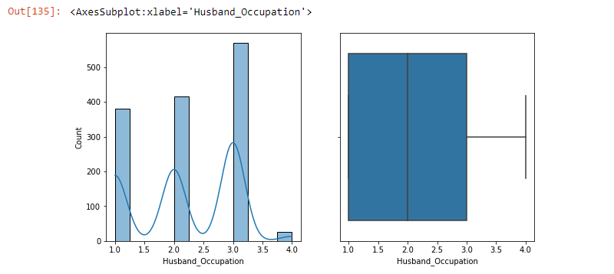  
Fig 1.77

We see here curve shaped linear representation data formation of Husband_Occupation datasets with the help of histplot.

Fig 1.78

Using scatterplot, we can see straight line relationship between Wife_age and Wife_education using scatterplot.

Fig 1.79

Here we can see, linear way of data representation between Husband_occupation and No_of_children_born through scatterplot.

Fig 1.80

The datapoints are not properly segregated when plotted Husband_occupation across standard_of_living_index using scatterplot.

Fig 1.81

Using boxplot, we can see relationship between Wife_age and Wife_education and Uneducated values is more.

Fig 1.82

Through the help of boxplot, we can see relationship between Husband_education and No_of_children_born and Uneducated values is more.

Fig 1.83

From the above screenshot, we can see when plotted Husband_Occupation along with Standard_of_living_index there shows values ranging between 2.0 to 3.0 and are equally segregrated.

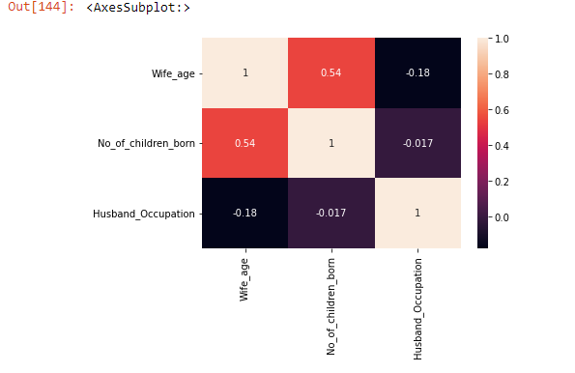  
Fig 1.84

From the above heatmap, we can see there is strong relationship between Wife_age and No_of_children_born ranging between values 0.54.

**Multivariate Analysis :**

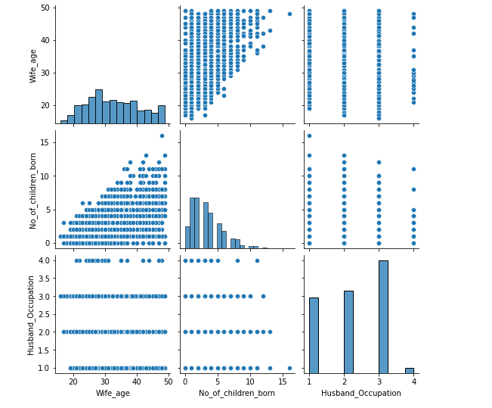 **Fig 1.85**

**We can see multivariate analysis of wife_age , no_of_children_born and husband_occupation using pairplot.**

**2.2 Do not scale the data. Encode the data (having string values) for Modelling. Data Split: Split the data into train and test (70:30). Apply Logistic Regression and LDA (linear discriminant analysis) and CART.**

**Encode the data (having string values) for Modelling :**

**We have converted the object datatypes to float and int datatypes.**

**Output 1.86**

**Data Split: Split the data into train and test (70:30).**

**LogisticRegression :**

 **Output 1.87**

 **Output 1.88**

**LDA :**

 **Output 1.89**

**Coefficient values :**  **Output 1.90**

**Intercept values:**

 **Output 1.91** **Output 1.92**

Table 1.93**

**CART :**

 **Output 1.94**

 **Output 1.95**

**Important Features :**

**Fig 1.96**

**From the above plot, we can see Wife_age fetaure has more important values.**

**2.3 Performance Metrics: Check the performance of Predictions on Train and Test sets using Accuracy, Confusion Matrix, Plot ROC curve and get ROC_AUC score for each model Final Model: Compare Both the models and write inference which model is best/optimized.**

**Logistic Regression :**

**Accuracy score of Test data :** **Output 1.97**

**Accuracy score of Training data :**

 **Output 1.98**

**Confusion Matrix of test data: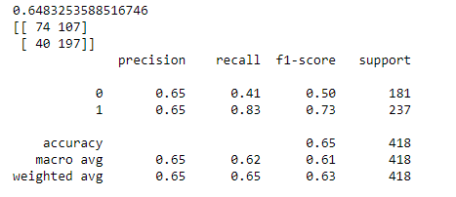 Output 1.99  
  
  
Confusion Matrix of train data: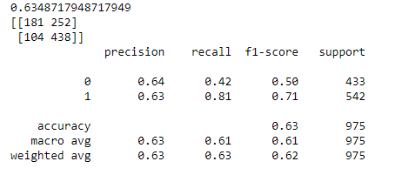 Output 2.1**

Fig 2.2**

**Confusion matrix of test data :**

**Fig 2.3**

Fig 2.4**

**AUC values and ROC curve of test data :**

**Fig 2.5**

**LDA :**

**Accuracy score of test data :** **Output 2.6**

**Accuracy score of train data :** **Output 2.7**

**Confusion matrix of test data :**

**Output 2.8**

**Confusion matrix of train data :**

**Output 2.9**

Fig 2.10**

Fig 2.11**

**CART :   
  
Accuracy score of test data :** **Output 2.12**

**Accuracy of train data :** **Output 2.13**

**Confusion matrix of test data :**

**Output 2.14**

**Confusion matrix of train data:**

**Output 2.15**

Fig 2.16**

Fig 2.17**

**  
Fig 2.18

Cart model is best and optimised model based on the various techniques tried on both test and train data.

**2.4 Inference: Basis on these predictions, what are the insights and recommendations.**

**Please explain and summarise the various steps performed in this project. There should be proper business interpretation and actionable insights present.**

**We have done various descriptive analysis and drawn many infrences and build a model using Logistic regression , LDA and CART. We have treated Null values , checked for duplicate values and treated outliers. We have split the data to 70:30 , and did many data ingestion and performance metrics.**

**CART model is best suited since its prediction values, accuarcy values , confusion matrix values and ROC curve and AUC score values are better than other 2 models so we can still cutsomize the model in CART based on the business requirement.**