Jose Manuel Rodríguez Calvo ERASMUS

SECURITY PROTOCOLS: MODELING AND VERIFICATION
SCYTHER 1

1. Open in Scyther the file nsl3-broken.spdl (from Scyther installation directory). This is a
version of the Needham-Schroeder-Lowe protocol.

a. Verify the security claims in the protocol using Scyther. You find several attacks.
Explain the attacks: why is the property violated in each case?
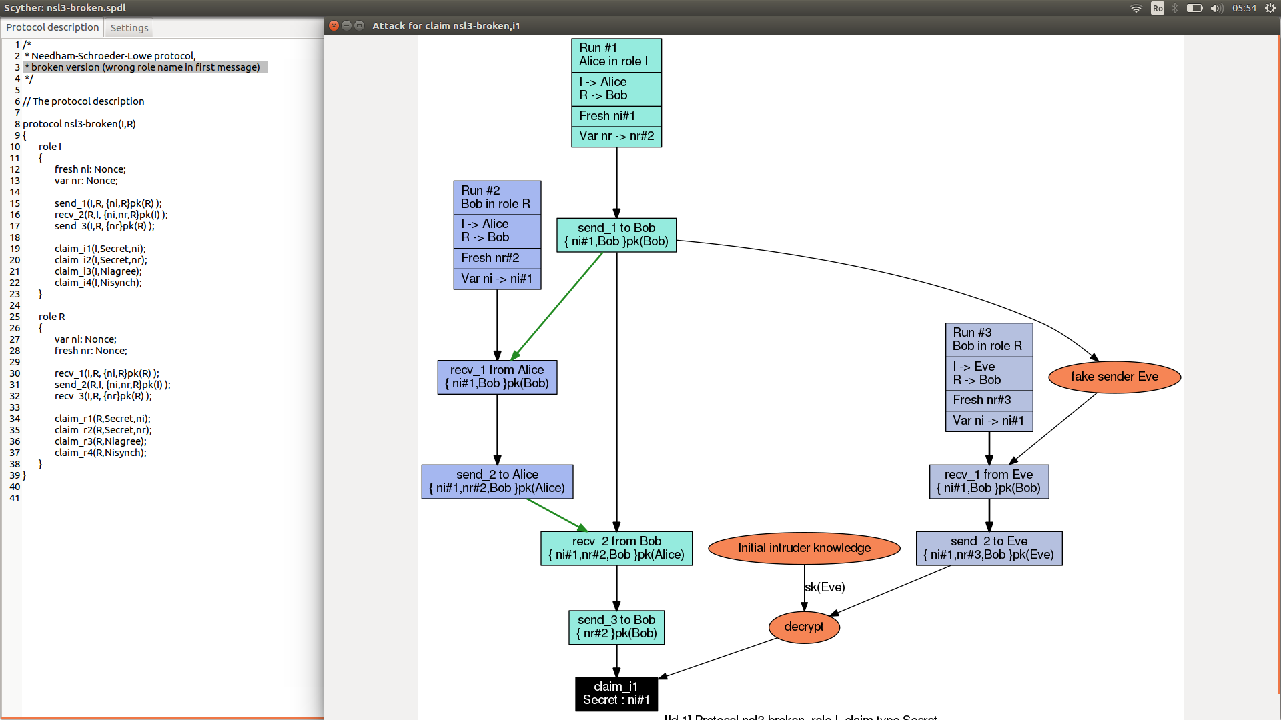
The property is violated because the intruder is capable of caught the message sent by alice, then the intruder will send this message to bob and when bob try to send a new message to alice, this is intercepted by the intruder who is able of decrypt it.
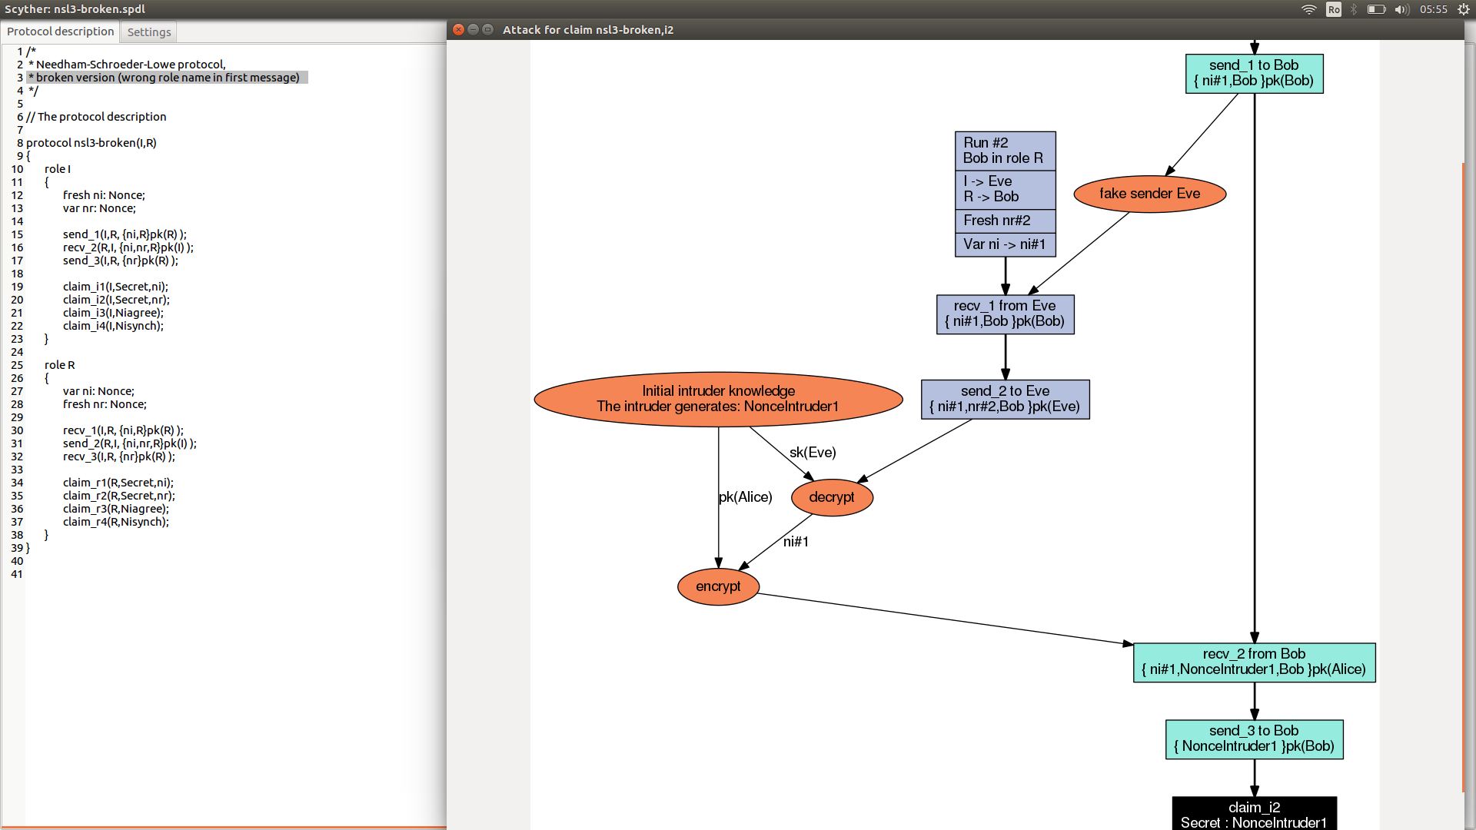
In this case,like before alice send the message but the intruder intercept it and resend it to bob and when bob try to send it back, it is intercepted by the intruder who generated a nonce and encrypted it by the public key of alice and send it to her.

b. Copy the protocol file to your own directory, and call it nsl3-broken-fixed.spdl. In the
file, make sure you change nsl3-broken to nsl3-broken-fixed. Improve the protocol
such that the properties now holds, and use Scyther to show that your improved
protocol indeed meets the requirements.
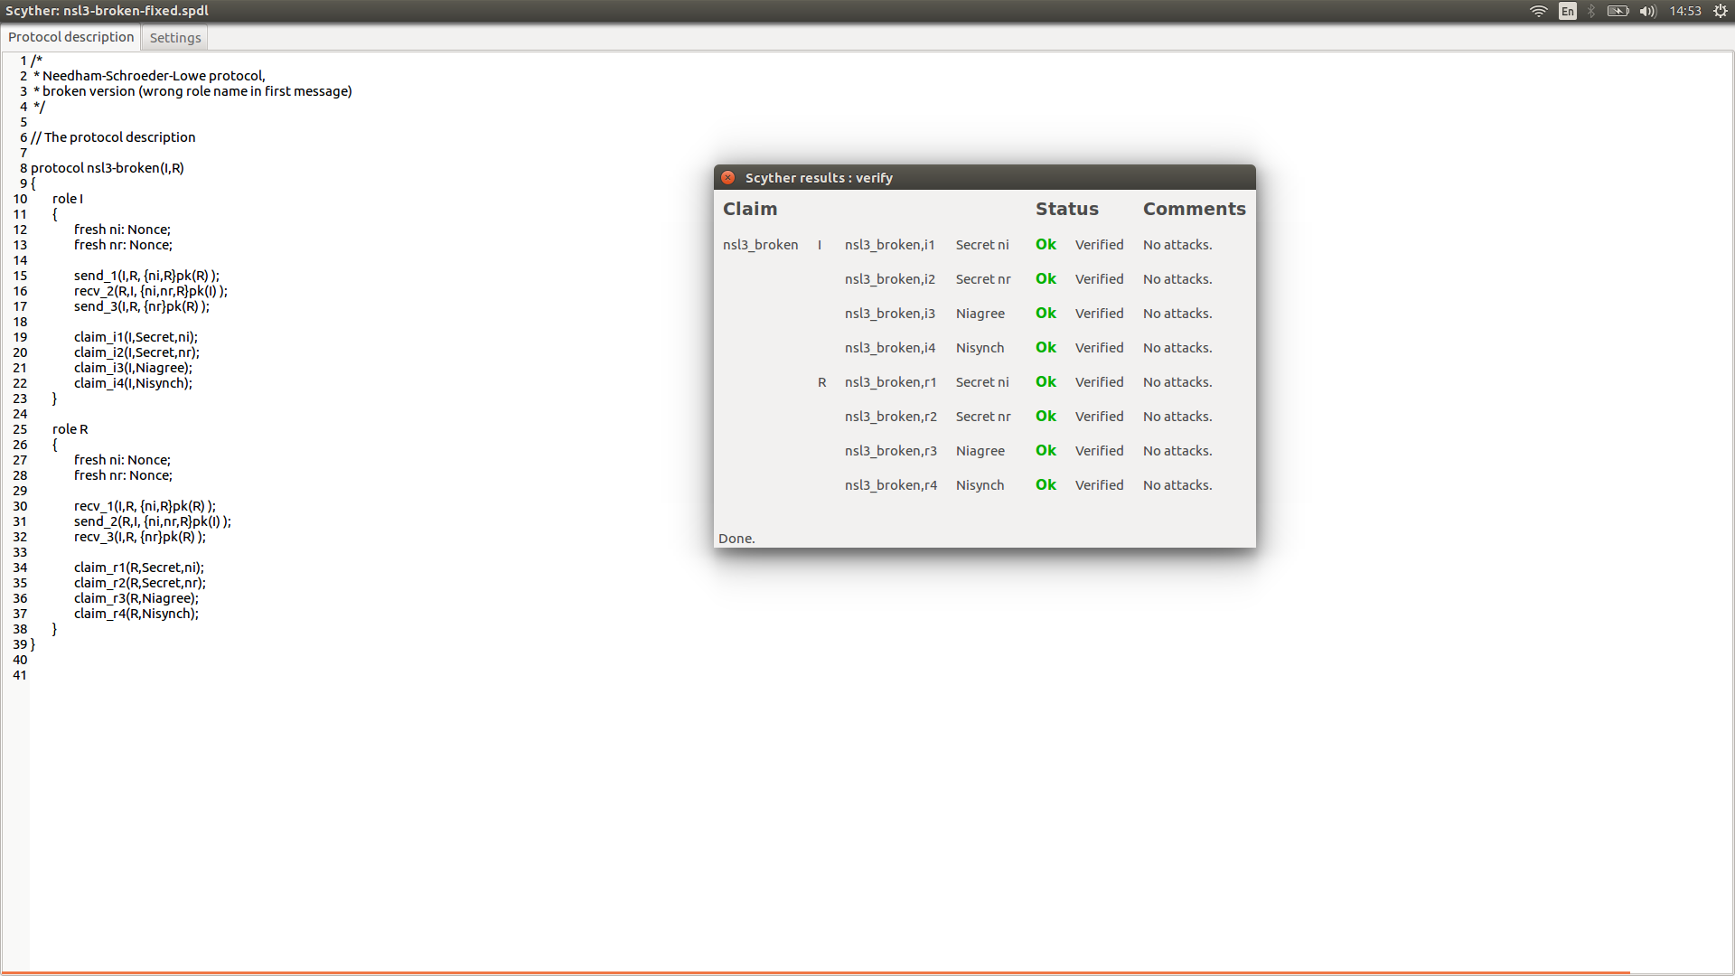

2. Updating a protocol to a new version, while some users are still using the old one, can lead
to problems.

a. Verify the concatenation of the original protocol and your fixed version from
exercise 1., using Scyther. (Concatenate the two files: nsl3-broken.spdl and nsl3-
broken-fixed.spdl. Open the resulting file in Scyther and verify it.) If there are
violations of the security claims, report the attacks and explain them. If it is correct,
explain why.

b. In general it is safe to label the protocols using unique strings. Consider the nsl3-
broken protocol from exercise 1. Add the following declaration to the start of the
protocol file:
usertype String;
const V1: String;
These global constants will be used to represent version strings in protocol. For the
protocols, add the version strings like this:
send 1(I,R, ...pk(R)); becomes: send 1(I,R, V1, ...pk(R));
. . .
Also add the declarations to your protocol (nsl3-broken-fixed.spdl):
usertype String;
const V2: String;
Modify the messages also to include version strings, but use V2. Concatenate the
two input files. Open the resulting file in Scyther and verify it. Explain the result.

c. If you found an attack in the exercise 2.b., apply the labels in a different way such
that the concatenation is correct. Explain why your new method does work.

