Jose Manuel Rodríguez Calvo ERASMUS

SECURITY PROTOCOLS: MODELING AND VERIFICATION
AVISPA 2

1.Specify the secrecy property for Nb, verify this property with the CL-AtSe tool and explain the results you get.

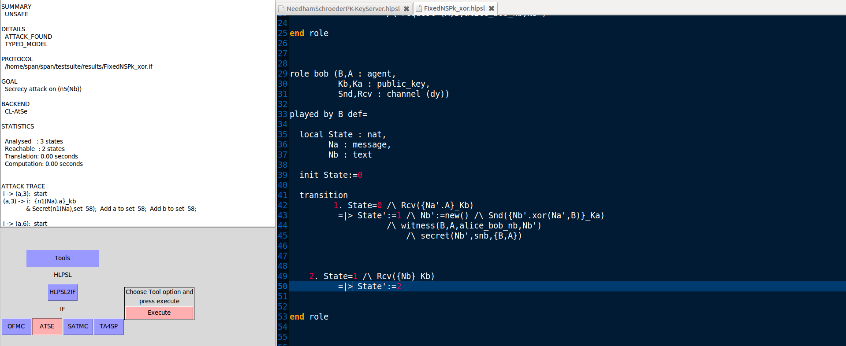
SUMMARY
UNSAFE

DETAILS
ATTACK_FOUND
TYPED_MODEL

PROTOCOL
/home/span/span/testsuite/results/FixedNSPk_xor.if

GOAL
Secrecy attack on (n5(Nb))

BACKEND
CL-AtSe

STATISTICS

Analysed : 3 states
Reachable : 2 states
Translation: 0.00 seconds
Computation: 0.00 seconds

ATTACK TRACE

i -> (a,3): start
(a,3) -> i: {n1(Na).a}_kb
& Secret(n1(Na),set_58); Add a to set_58; Add b to set_58;

i -> (a,6): start
(a,6) -> i: {n9(Na).a}_ki
& Secret(n9(Na),set_71); Add a to set_71; Add i to set_71;

i -> (b,4): {xor(i,b,n9(Na)).a}_kb
(b,4) -> i: {n5(Nb).xor(i,n9(Na))}_ka
& Secret(n5(Nb),set_67); Witness(b,a,alice_bob_nb,n5(Nb));
& Add b to set_67; Add a to set_67;

i -> (a,6): {n5(Nb).xor(i,n9(Na))}_ka
(a,6) -> i: {n5(Nb)}_ki

2.Specify the strong authentication property of Alice to Bob, verify this property with the CL-AtSe tool and explain the results you get.
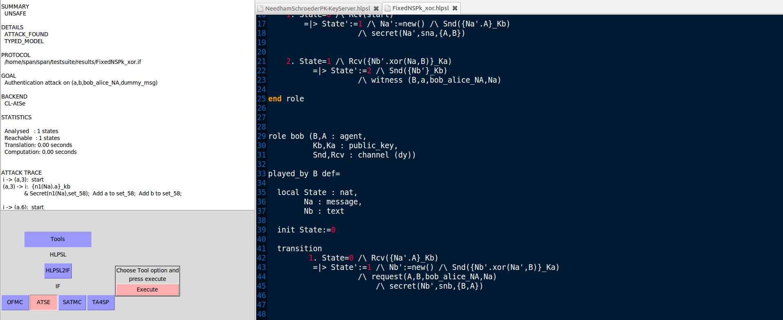

SUMMARY
UNSAFE

DETAILS
ATTACK_FOUND
TYPED_MODEL

PROTOCOL
/home/span/span/testsuite/results/FixedNSPk_xor.if

GOAL
Authentication attack on (a,b,bob_alice_NA,dummy_msg)

BACKEND
CL-AtSe

STATISTICS

Analysed : 1 states
Reachable : 1 states
Translation: 0.00 seconds
Computation: 0.00 seconds

ATTACK TRACE

i -> (a,3): start
(a,3) -> i: {n1(Na).a}_kb
& Secret(n1(Na),set_58); Add a to set_58; Add b to set_58;

i -> (a,6): start
(a,6) -> i: {n9(Na).a}_ki
& Secret(n9(Na),set_71); Add a to set_71; Add i to set_71;

i -> (b,4): {n1(Na).a}_kb
(b,4) -> i: {n5(Nb).xor(b,n1(Na))}_ka
& Secret(n5(Nb),set_67); Request(a,b,bob_alice_NA,dummy_msg);
& Add b to set_67; Add a to set_67;
3.Specify the weak authentication property of Alice to Bob, verify this property with the CL-AtSe tool and explain the results you get.
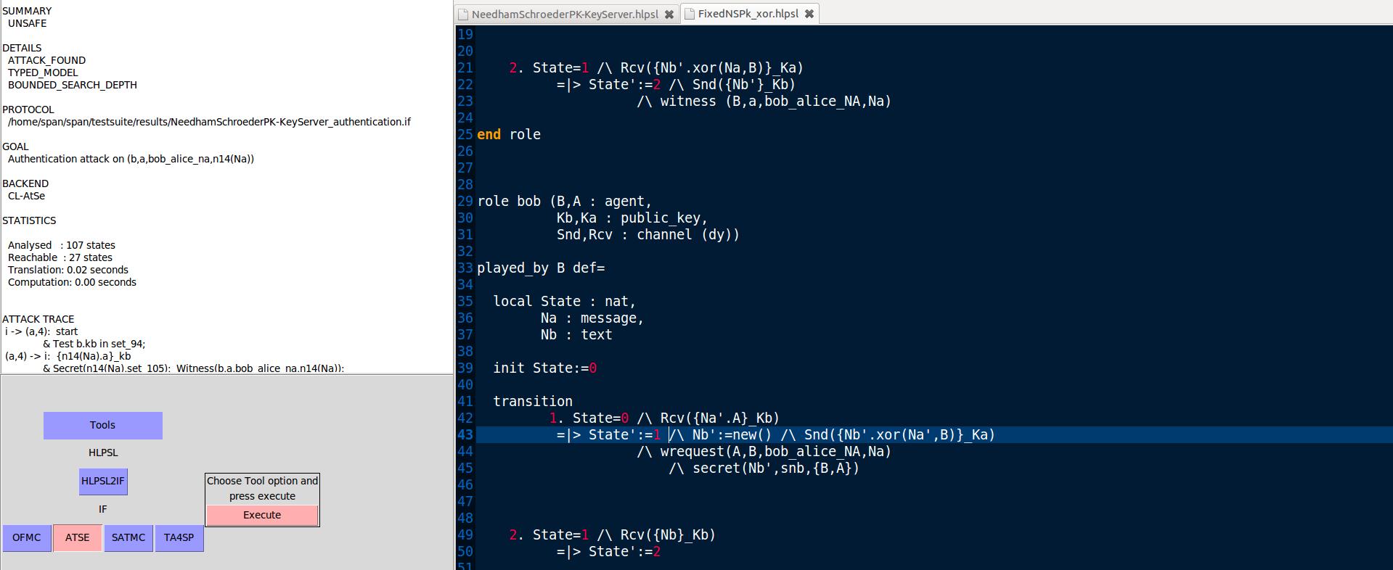

SUMMARY
UNSAFE

DETAILS
ATTACK_FOUND
TYPED_MODEL
BOUNDED_SEARCH_DEPTH

PROTOCOL
/home/span/span/testsuite/results/NeedhamSchroederPK-KeyServer_authentication.if

GOAL
Authentication attack on (b,a,bob_alice_na,n14(Na))

BACKEND
CL-AtSe

STATISTICS

Analysed : 107 states
Reachable : 27 states
Translation: 0.02 seconds
Computation: 0.00 seconds

ATTACK TRACE

i -> (a,4): start
& Test b.kb in set_94;
(a,4) -> i: {n14(Na).a}_kb
& Secret(n14(Na),set_105); Witness(b,a,bob_alice_na,n14(Na));
& Add a to set_105; Add b to set_105;

i -> (s,2): X(1).a
& Test a.ka in set_93;
(s,2) -> i: {a.ka}_(inv(ks))

i -> (b,5): {n14(Na).a}_kb
& Test a.Ka(18) not in set_95;
(b,5) -> i: b.a

i -> (b,5): {a.ka}_(inv(ks))
(b,5) -> i: {n14(Na).n19(Nb)}_ka
& Secret(n19(Nb),set_116); Add a.ka to set_95; Add b to set_116;
& Add a to set_116;

i -> (s,2): X(2).i
& Test i.ki in set_93;
(s,2) -> i: {i.ki}_(inv(ks))

i -> (a,7): start
& Test i.Kb(28) not in set_94;
(a,7) -> i: a.i

i -> (a,7): {i.ki}_(inv(ks))
(a,7) -> i: {n29(Na).a}_ki
& Secret(n29(Na),set_125); Add i.ki to set_94; Add a to set_125;
& Add i to set_125;

i -> (a,4): {n14(Na).n19(Nb)}_ka
(a,4) -> i: {n19(Nb)}_kb

i -> (b,5): {n19(Nb)}_kb
(b,5) -> i: ()
& Secret(n19(Nb),set_118); Request(b,a,bob_alice_na,n14(Na));
& Add a to set_118; Add b to set_118;

4.Add a new session between the agents i and b. Results obtained by analysis are changed by adding this new session? Explain the results you get.

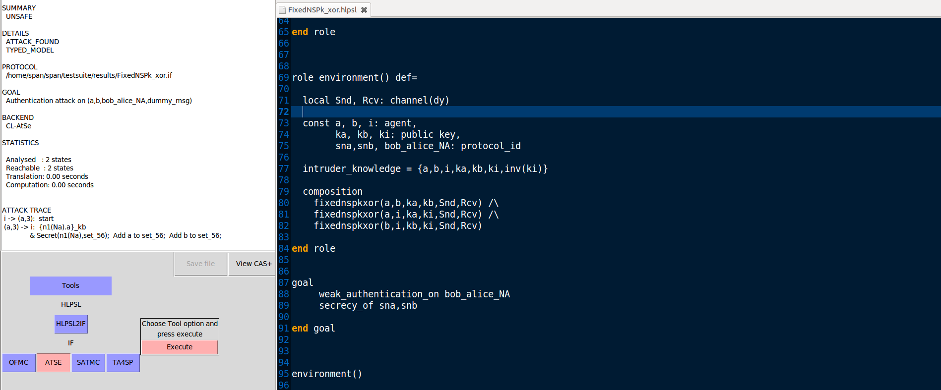
SUMMARY
UNSAFE

DETAILS
ATTACK_FOUND
TYPED_MODEL

PROTOCOL
/home/span/span/testsuite/results/FixedNSPk_xor.if

GOAL
Authentication attack on (a,b,bob_alice_NA,dummy_msg)

BACKEND
CL-AtSe

STATISTICS

Analysed : 2 states
Reachable : 2 states
Translation: 0.00 seconds
Computation: 0.00 seconds

ATTACK TRACE
i -> (a,3): start
(a,3) -> i: {n1(Na).a}_kb
& Secret(n1(Na),set_56); Add a to set_56; Add b to set_56;

i -> (b,9): start
(b,9) -> i: {n13(Na).b}_ki
& Secret(n13(Na),set_72); Add b to set_72; Add i to set_72;

i -> (a,6): start
(a,6) -> i: {n9(Na).a}_ki
& Secret(n9(Na),set_69); Add a to set_69; Add i to set_69;

i -> (b,4): {n1(Na).a}_kb
(b,4) -> i: {n5(Nb).xor(b,n1(Na))}_ka
& Secret(n5(Nb),set_65);

WRequest(a,b,bob_alice_NA,dummy_msg);
& Add b to set_65; Add a to set_65;

5.Declare Na variable as nonce, verify the option Typed/Untyped model(Typed model is set by default) and interpret the results you get.

Untyped
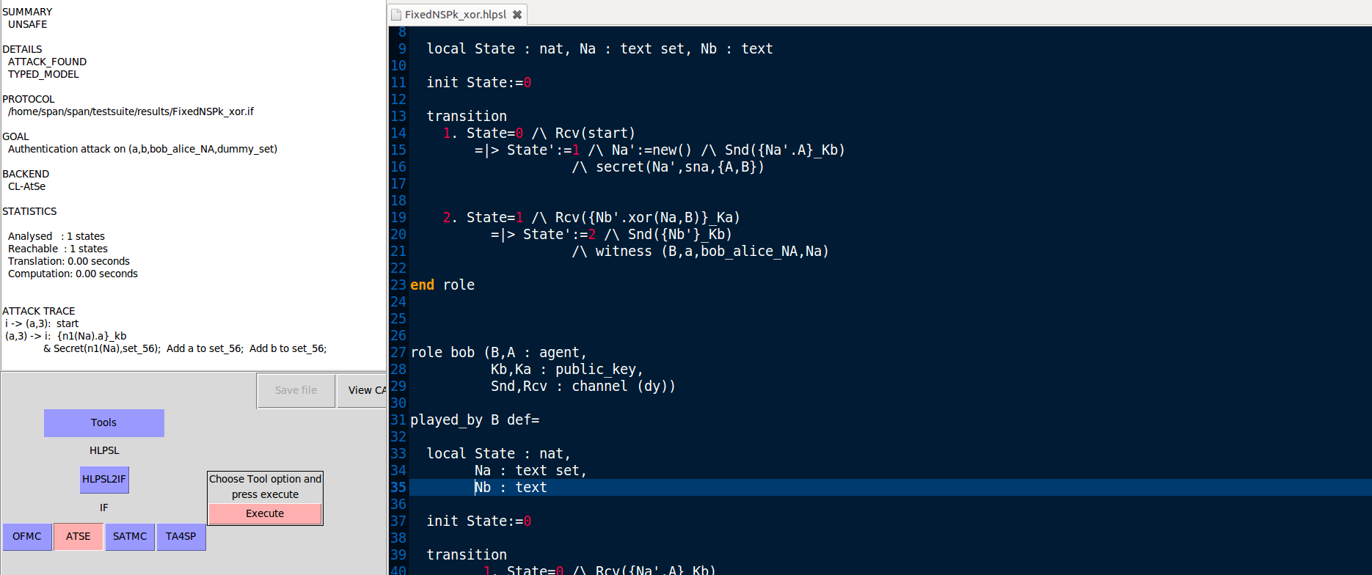

i -> (a,3): start
(a,3) -> i: {n1(Na).a}_kb
& Secret(n1(Na),set_56); Add a to set_56; Add b to set_56;

i -> (a,6): start
(a,6) -> i: {n9(Na).a}_ki
& Secret(n9(Na),set_69); Add a to set_69; Add i to set_69;

i -> (b,4): {Na(5).a}_kb
(b,4) -> i: {n5(Nb).xor(Na(5),b)}_ka
& Secret(n5(Nb),set_65); WRequest(a,b,bob_alice_NA,dummy_set);
& Add b to set_65; Add a to set_65;

Typed
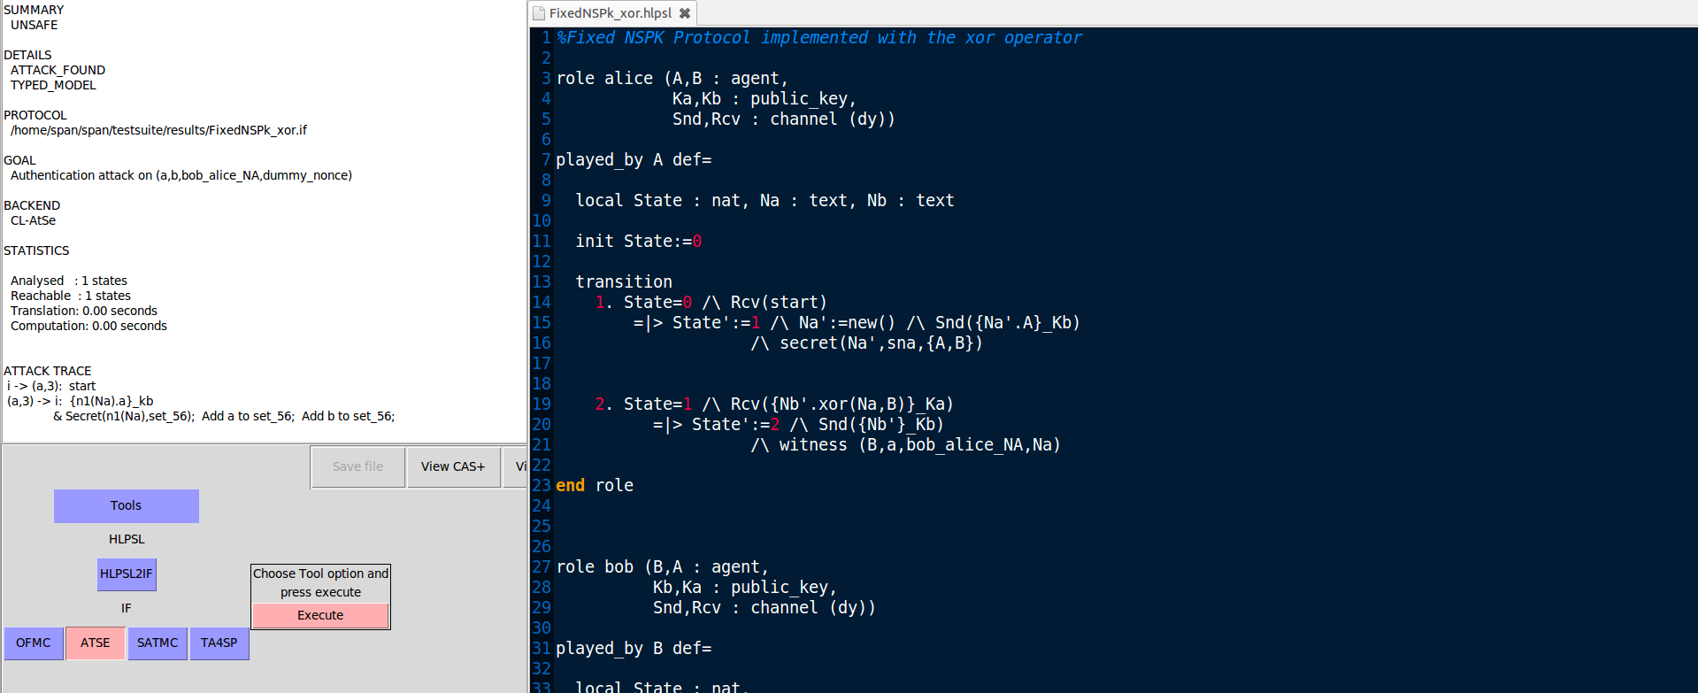
i -> (a,3): start
(a,3) -> i: {n1(Na).a}_kb
& Secret(n1(Na),set_56); Add a to set_56; Add b to set_56;

i -> (a,6): start
(a,6) -> i: {n9(Na).a}_ki
& Secret(n9(Na),set_68); Add a to set_68; Add i to set_68;

i -> (b,4): {Na(5).a}_kb
(b,4) -> i: {n5(Nb).xor(Na(5),b)}_ka
& Secret(n5(Nb),set_64); WRequest(a,b,bob_alice_NA,dummy_nonce);
& Add b to set_64; Add a to set_64;

