Jose Manuel Rodríguez Calvo ERASMUS

SECURITY PROTOCOLS: MODELING AND VERIFICATION
AVISPA

- To the already existing specification from the hlpsl file and explained in the AVISPA.pdf file from, you must:
  - Specify the secrecy property for Nb, verify this property with the CL-AtSe tool and explain the results you get.
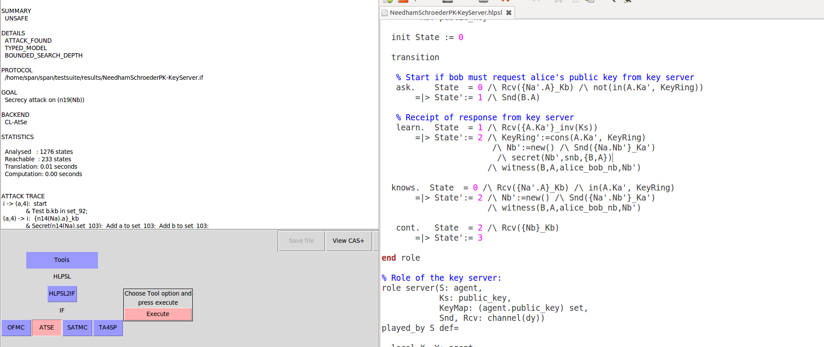

SUMMARY
UNSAFE

DETAILS
ATTACK_FOUND
TYPED_MODEL
BOUNDED_SEARCH_DEPTH

PROTOCOL
/home/span/span/testsuite/results/NeedhamSchroederPK-KeyServer.if

GOAL
Secrecy attack on (n19(Nb))

BACKEND
CL-AtSe

STATISTICS

Analysed : 1276 states
Reachable : 233 states
Translation: 0.01 seconds
Computation: 0.00 seconds

ATTACK TRACE

i -> (a,4): start
& Test b.kb in set_92;

The intruder initiate initiate the first session with agent a by sending start message,

(a,4) -> i: {n14(Na).a}_kb
& Secret(n14(Na),set_103); Add a to set_103; Add b to set_103;

The agent ‘a’ respond to the intruder encrypted with the Kb, which is a key shared

i -> (s,2): X(1).a
& Test a.ka in set_91;
(s,2) -> i: {a.ka}_(inv(ks))

i -> (s,2): X(2).i
& Test i.ki in set_91;
(s,2) -> i: {i.ki}_(inv(ks))

the intruder send to the the server X(1) with the key of a, and the server return to the intrude the key of ‘a’ encrypted with the inverse of the public key ks. Then the intruder sends the message X(2) encrypted with a key of the intruder and the server return to i the key of i encrypted with the inverse of ks

i -> (a,7): start
& Test i.Kb(28) not in set_92;
(a,7) -> i: a.i

the intruder start sending to a, with a different instance(7) and a respond to i whit the key a encrypted with the key of i

i -> (a,7): {i.ki}_(inv(ks))
(a,7) -> i: {n29(Na).a}_ki
& Secret(n29(Na),set_119); Add i.ki to set_92; Add a to set_119;
& Add i to set_119;

the intruder send to a the key i encrypted with the inverse of the public key ks, and the agent ‘a’ respond to i with the Na encrypted by a with the public key ki. So the intruder has descrypted Na.

i -> (b,11): {Na(38).i}_kb
& Test i.Ka(38) not in set_93;
(b,11) -> i: b.i

the intruder sends to b the message encrypted with the public key of kb, then b respond to the intruder with b encrypted with the key of i.

i -> (b,11): {i.ki}_(inv(ks))
(b,11) -> i: {Na(38).n39(Nb)}_ki
& Secret(n39(Nb),set_125); Add i.ki to set_93;
& Add b to set_125; Add i to set_125;

the intruder sends to b the message encrypted with the inverse of ks, and b responds to i with a message encrypted with ki.

i -> (s,2): X(3).b
& Test b.kb in set_91;
(s,2) -> i: {b.kb}_(inv(ks))

the intruder i send to the server a message encrypted with the key of b, and the server respond to the intruder encrypted with the inverse of ks.

i -> (b,5): {n29(Na).a}_kb
& Test a.Ka(18) not in set_93;
(b,5) -> i: b.a

the intruder send to b the message encrypted with the public key kb, and b respond to the intruder with the key of b encrypted with the key of a.

i -> (b,5): {a.ka}_(inv(ks))
(b,5) -> i: {n29(Na).n19(Nb)}_ka
& Secret(n19(Nb),set_114); Witness(b,a,alice_bob_nb,n19(Nb));
& Add a.ka to set_93; Add b to set_114; Add a to set_114;

the intruder sends to b the message encrypted with the key of a and the inverse of the public key ks, the b respond to the intruder with the message encrypted with the public key ka,

i -> (a,7): {n29(Na).n19(Nb)}_ka
(a,7) -> i: {n19(Nb)}_ki

Finally the intruder sends to a the message encrypted with the public key ka, and the agent ‘a’ respond to the intruder with Nb encrypted with the public key ki, which is known by the intruder.

  - Specify the strong authentication property of Alice to Bob, verify this property with the CL-AtSe tool and explain the results you get.

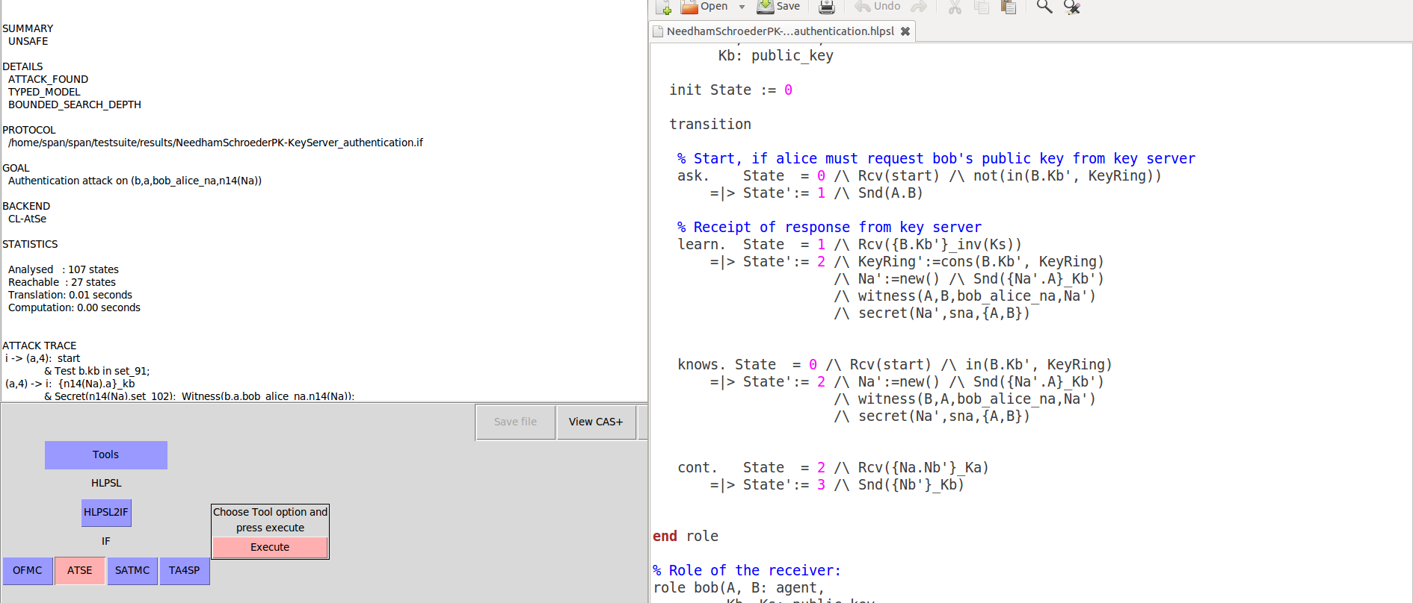
SUMMARY
UNSAFE

DETAILS
ATTACK_FOUND
TYPED_MODEL
BOUNDED_SEARCH_DEPTH

PROTOCOL
/home/span/span/testsuite/results/NeedhamSchroederPK-KeyServer_authentication.if

GOAL
Authentication attack on (b,a,bob_alice_na,n14(Na))

BACKEND
CL-AtSe

STATISTICS

Analysed : 107 states
Reachable : 27 states
Translation: 0.02 seconds
Computation: 0.00 seconds

ATTACK TRACE
i -> (a,4): start
& Test b.kb in set_91;
(a,4) -> i: {n14(Na).a}_kb
& Secret(n14(Na),set_102); Witness(b,a,bob_alice_na,n14(Na));
& Add a to set_102; Add b to set_102;

The intruder initiate the first session with the agent ‘a’ by sending start message, then a respond to the intruder with message Na encrypted with and a with public key kb

i -> (s,2): X(1).a
& Test a.ka in set_90;
(s,2) -> i: {a.ka}_(inv(ks))

The intruder send to the server a message X(1) encrypted with a, and the server respond to the intruder, the key of a encrypted with the pubblic key ka and the inverse public key ks

i -> (b,5): {n14(Na).a}_kb
& Test a.Ka(18) not in set_92;
(b,5) -> i: b.a

the intruder sends to b the Na encrypted with the key of a and the public key of kb, then b respond to the intruder with its own key encrypted with the key of a.

i -> (b,5): {a.ka}_(inv(ks))
(b,5) -> i: {n14(Na).n19(Nb)}_ka
& Secret(n19(Nb),set_113); Add a.ka to set_92; Add b to set_113;
& Add a to set_113;

The intuder sends to b the key of a encrypted with the inverse of the public key of ks, then b respond to the intruder with the message encrypted with the public key ks

i -> (s,2): X(2).i
& Test i.ki in set_90;
(s,2) -> i: {i.ki}_(inv(ks))

the intruder sends to s the message encrypted with its key, and the server responds to the intruder with the key ki encrypted with the inverse of the public key ks.

i -> (a,7): start
& Test i.Kb(28) not in set_91;
(a,7) -> i: a.i

the intruder initiate with ‘a’ another session by sending start message, and the agent a sends to the intruder the key of a encrypted with the key of i.

i -> (a,7): {i.ki}_(inv(ks))
(a,7) -> i: {n29(Na).a}_ki
& Secret(n29(Na),set_120); Add i.ki to set_91; Add a to set_120;
& Add i to set_120;

the intruder sends to a its key encrypted with the inverse of the public key of ks, and a responds to the intruder the message Na encrypted with the key of ‘a’ and the public key ki.

i -> (a,4): {n14(Na).n19(Nb)}_ka
(a,4) -> i: {n19(Nb)}_kb

The intruder sends to a the message encrypted with the public key ka, and the agent ‘a’ respond to the intruder with the message Nb encrypted with public key kb

i -> (b,5): {n19(Nb)}_kb
(b,5) -> i: ()
& Request(b,a,bob_alice_na,n14(Na));

the intruder sends to b the message Nb encrypted with the public key kb, and finally b gets desencrypt Nb.

  - Provide a solution to fix the attacks you obtain above.

A posible solution is the what is detailed down:
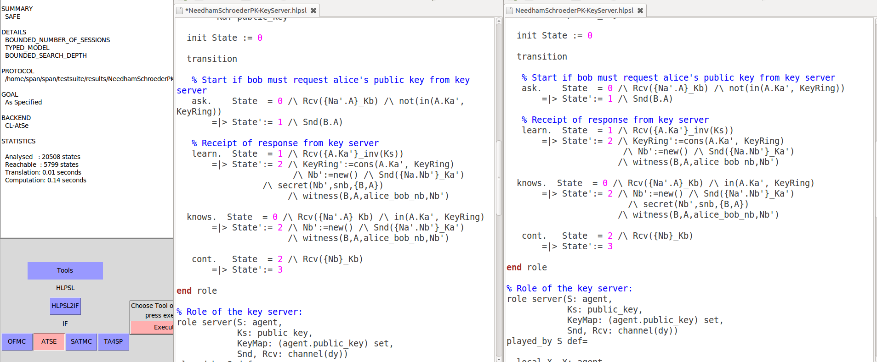
supossing that the agent B like the agent A knows the secret Nb.

