GRADE 8 RATIONALIZED INTEGRATED SCIENCE
LESSON NOTES COMPLETE
STRAND 1- MIXTURES, ELEMENTS AND COMPOUNDS.
ELEMENTS AND COMPUNDS
Meaning of Atoms, Elements, molecules and Compounds.
- Matter is anything that occupies space and has mass.
- Matter is composed of pure substances and mixtures.
- The pure substances are can be element and compounds while the mixtures can either be uniform or non-uniform.
- An element is a substance that cannot be decomposed into simpler substances by chemical or physical means.
- An element is a pure substance which cannot be made simpler using chemical means.
- Elements are the building blocks of matter. Everything around is made up of an element or elements.
- An element is made of atoms.
- Atoms of the same element are identical.
- A compound is pure substance that consists of atoms of two or more elements that are chemically joined together.
- Compounds are formed when atoms of different elements react.
- Compounds can be broken down into elements through chemical reactions.
- Sodium and chlorine are elements that combine chemically to form sodium chloride which is a compound.

Relating common elements to their symbols.
- Pure substances either elements or compounds has a unique name and symbol.
- A symbol is a sort -hand notation for the chemical name of an element.
- Chemical symbols are used instead of names by scientists because they are much easier, convenient and universally recognized.
- Compounds are represented by a chemical formula.
- A chemical symbol is usually derived from first letter of the English name of the element.  It is also derived from Latin name of the element.

For example,
- H is the chemical symbol of hydrogen.
- O is the chemical symbol of Oxygen.
- K is the chemical symbol of potassium. For potassium the K is derived from Latin word Kalium.
- Some elements might start with same first letters, such as Carbon, Calcium, Chlorine and Copper have their names starting with letter C, therefore letter C can not be used to represent all of them as chemical symbol.
- The first letter C is assigned to represent Carbon, while the rest of the elements are assigned two letters from their name as follows.

  - Carbon represented by C.
  - Calcium represented by Ca.
  - Chlorine represented by Cl
  - Copper represented by Cu from Latin word cuprum
- The first letter of a symbol is always capitalized, while the second letter is written in small letters.
▪ | The symbols of some elements derived from English names are as follows:
 |  | Name of element | Chemical symbol |  | Name of element | Chemical symbol
 | 1 | Hydrogen | H |  | Nitrogen | N
 | 2 | Helium | He | 8 | Oxygen | O
 | 3 | Lithium | Li | 9 | Fluorine | F
 | 4 | Beryllium | Be | 10 | Neon | Ne
 | 5 | Boron | B | 11 | Magnesium | Mg
 | 6 | Carbon | C | 12 | Aluminium | Al

▪ | The symbols of some elements derived from Latin names are as follows:
 |  | Name of element | Latin name. | Chemical symbol |  | Name of element | Latin name | Chemical symbol
 | 1 | Sodium | Natrium | Na |  | Silver | Argentum | Ag
 | 2 | Iron | Ferrum | Fe | 8 | Tin | Stannum | Sn
 | 3 | Copper | Cuprum | Cu | 9 | Zinc | Zincum | Zn
 | 4 | Lead | Plumbum | Pb
 | 5 | Gold | Aurum | Au
 | 6 | Mercury | hydrargyrum | Hg

- Compounds are combinations of two or more elements.
- A chemical formula is an expression that shows the elements in a compound and the relative proportions of those elements.
- Water is composed of Hydrogen and Oxygen in the ration 2:1.
- The chemical formula of water is H₂O.
- Sodium chloride also called common salt is composed of Sodium and Chlorine in the ration 1:1. The chemical formula for Sodium chloride is NaCl.

Application of common elements in our day-to-day life.
- Food nutrients are chemical compounds found in foods. These nutrients are used by the body to function properly and maintain health.
- Examples of food nutrients include:
  - Proteins.
  - Fats.
  - Carbohydrates.
  - Vitamins.
  - Mineral salts.
- Food nutrients are made up o various elements such as: carbon, hydrogen, oxygen and nitrogen.
Various food sources that contain various elements.
Mineral element of compound | Examples of food sources
Carbon | present in all foods
Nitrogen | Meat, chicken, fish, milk and eggs.
Flouride | Fish, potatoes, spinach and black tea.
Calcium | Milk, cheese, green leafy vegetables, soya beans, bread and fish
Copper | Nuts and shellfish.
Iron | Liver, meat, beans, nuts and whole grain.
Magnesium | Spinach, bread, fish, meat and dairy foods.
Phosphorus | Read meat, dairy foods, fish, bread and rice.
Potassium | Banana, vegetables, milk, fish, beef, chicken and bread.
Sodium chloride | Salt is found naturally at low levels in all foods.  Some salt is added to processed foods and meat products.

- Plants receive water, mineral and other nutrients from the soil which are carried to the other parts of the plant
- There are various mineral elements present in the soil that are absorbed by the roots of plants.
- The following are some of the important mineral elements required by plants:
  - Phosphorus & magnesium – they are essential for the growth, development and reproduction of the plant.
  - Potassium – increases the quality of fruits and vegetables.

- Various elements are used in manufacture of different toiletries that we use in day-to-day life.
- Some toiletries, for example toothpaste contains flouride compounds to prevent tooth decay while soaps and detergents contain a compound of potassium.

Importance of various elements and compounds.
- Gold:
  - Gold is a precious metal.
  - It is widely used to make jewellery as it is fairly soft and easy to work with.  It is attractive in appearance and neither rust or discolours.

- Silver:
  - It is a precious metal.
  - It is used in making jewellery but it tends to discolour.  It is also used in making cutlery, teapots and medals.  Iron:
  - It is one of the most useful metals.
  - It is strong, can be sharpened and it is easy to work with.
  - Many items are made of iron or steel.
  - Steel is a combination of iron and carbon.
  - Steel is important in construction.

- Gold and silver:
  - They are precious metals elements that occur naturally and have high market value.
  - In some cases, Gold and silver can be used as currency.
  - In other cases, these precious metals have various uses such as in electronics, medical technology and awards therefore gold and silver valuable to many businesses.
  - Gold is more valuable because it is rare than silver.

Information on Packaging labels.
- Substances purchased contain various elements that are part of ingredients.
- The elements present are usually indicated in the information found on the packaging labels.
- Few examples are given below.
    - Toothpaste- contains sodium flouride, zinc sulphate and sodium hydroxide.
    - Body lotion– contains sodium hydroxide and other compounds
    - Liquid handwash– contains sodium chloride.
    - Baking powder–contains sodium hydroxide carbonate.
    - Curry powder–contains sodium.
    - Tomato source–contains a compound of sodium.
    - Margarine-contains a preservative that is a compound of potassium.
    - Beef cubes-contains a compound of iron and a compound of sodium.
    - Bottled water-contains calcium, sodium, potassium, magnesium and other common elements.

1.2 -Physical and Chemical changes.
- Matter is anything that occupies space and has mass.
- All solids, liquids and gases are made up of matter.
- The three states of matter have different physical properties.
- These properties depend on intermolecular forces.
- Intermolecular forces are forces that hold the particles of matter together.

Properties of different states of matter.
a) Solids, liquids and gases are different in terms of their shapes.
▪ Solids.
Solids have a definite shape which does not change on its own unless use of external forces such as breaking it into smaller pieces.
For example, when a stone is place on a table, or a plate or a tin, it does not change its shape according to the item it is place in or on.

▪ | Liquids.
A liquid has no definite shape.
That means a liquid changes its shape to take the shape of the container or vessel in which it is put.
A liquid also changes its shape when spilled on the floor.
For example, when a liquid id poured in two different containers, the liquid will display two different shapes that resemble or are similar to the container they are placed in. this means liquids lack a definite shape
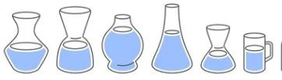

▪ | Gases.
Gases-a gas has no definite shape.
A gas changes its shape to look like that of container in which it is held in.
For example, when a balloon is inflated with air, the air inside takes the shape of the balloon.
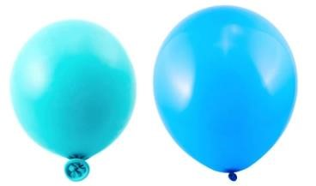
- Solids, liquids and gases are different in terms of their volumes.

Solids.
  - When a solid is totally immersed in a liquid, the volume of the displace liquid is equivalent, (equal) to the volume of the solid.
  - The volume of the stone remains the same when place in two different measuring cylinders. Therefore, solids have a definite shape.

Liquids.
  - The volume of water poured in a measuring cylinder remains unchanged even when it is transferred from one measuring cylinder to other measuring cylinders of different capacities.
  - For example, if you pour 30ml of water in a 50mli measuring cylinder, its reading will be 30ml.
  - If the same water is transferred to a 100ml measuring cylinder, the reading will still remain 30ml.
  - Therefore, liquids have a definite shape just like solids.

Gases.
  - A given mass of a gas can occupy different volumes in different containers. This is an indication that gases, do not have a fixed volume.

- Solids, liquids and gases are different in terms of their Compressibility.
Compressibility is the ability of a substance to be reduced in volume or size by applying force or pressure on it.
Compressibility can also be defined as how much a given volume of matter decreases when pressed.
- When a bottle id filled with air, it can easily be squeezed compared to one filled up with water.
- If the two are replaced with sand, we cannot squeeze the bottle anymore.
- This experiment proves that gases are highly compressible, liquids have little compressibility while solids are incompressible.

▪ | Gases.
- Occupies entire volume of container.
- Their particles move freely because the intermolecular forces are very weak.
- This makes particles to move far apart from each other and can be brough closer when pressure is applied. This is the reason gases are highly compressible.

▪ | Liquids.
- Their properties lie between those of gases and solids.
- Their intermolecular forces in liquids are weaker than in solids but stronger than in gases.
- The particles in liquids do not move freely as in gases, therefore, it is difficult to compress liquids since the liquid particles can move but keep same volume.
▪ | Solids.
- Particles in solids are very close to each other (closely packed) and the intermolecular forces between the particles are very strong. The strong forces keep the particles in fixed position.
- This is the reason why solids are hard, firm and rigid.  Therefore, solids are incompressible.

c.) Solids, liquids and gases are different in terms of their ability to flow.
- Particles in liquids can move from one place to another, therefore, a liquid can flow and change shape. This makes liquids such as water to flow from a tap to fill a jar or a bucket. This is applied when pouring tea in a cup.

- Solids have particle that do not move therefore solids cannot flow.

- Gases have freely moving particles which can be moved from an area. For example, when you breathe, you force air (gas) into and out of your lungs. This is an indication that gas flow in and out of the body. This is also applied when cooking gas flows from the gas cylinders to the burners when cooking.

- Therefore, liquids and gases can flow while solids cannot flow.

Summary of properties of different states of matter.
State of matter | Volume | Density | Shape | Ability to flow | Compressibility
Solid | Has fixed volume. | Generally higher than that of liquid and gas. | Has definite shape. | Does not flow. | Incompressible.
Liquid | Has fixed volume. | Generally higher than that of gas | Has definite shape. | Flows. | Little compressibility.
Gas | Has no fixed volume | Lower than both solids and liquids. | Has no definite shape. | Flows. | Highly compressible.

Pure and Impure substances.
- When two pure substances are mixed together, they form a mixture.
- A mixture is an impure substance. Therefore, a pure substance is any material that is not a mixture at all.
- The melting and boiling points of pure and impure substances can be determined.

Melting point of pure substances (Ice).
- It is the temperature at which a solid change into liquid state.
- The melting point of ice is the temperature at which ice is converted from its solid state to its liquid state.
- Heat from a heat source is used to melt the ice.
- The thermometer helps to note the temperature at which the ice melts.
- After the initial and final readings are taken, it will be observed that once the ice attained its melting temperature (0ºC), the temperature remains the same until all the ice is converted into liquid state.
- Pure solids have specific melting points. Therefore, it means that ice is a pure substance.

Melting point of Impure substances (Candle wax).
- The melting point of candle wax is the temperature at which the solid materials turns into liquid (by heating it).
- The melting point of candle wax ranges between 46ºC to 68 ºC. Therefore, it means that candle wax is an impure substance.
- Impure substances do not have specific melting points. The presence of impurities affects the melting point of the substances.

Determining Boiling points of Pure and Impure substances.
Requirements for the experiment
- Boiling tube.
- Thermometer.
- Heating apparatus.
- Distilled water.
- A spatula.
- Salt and water.
- 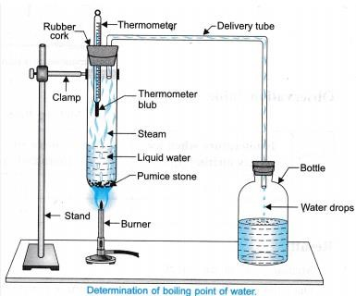

Procedure for the experiment above.
  - Put about 10cm³ of distilled water on a boiling tube.
  - Close the tube with a stopper that has two holes.
  - Pass a thermometer through one hole. Immerse the thermometer bulb into the water.
  - Push and ‘L’ shaped tube through the other hole as shown above.  Heat the apparatus using a small flame.
  - Observe the changes in temperature and record your observations.
  - Cool the apparatus and remove the stopper.
  - Add a spoonful of salt to some water/ stir to dissolve all the salt to form a salty water solution.
  - Repeat the above experiment using a salty water solution in place of pure distilled water.
  - Observe changes in temperature, record your observation. What conclusion have you made.
  - At what temperature does water (pure water) boil?
  - At what temperature does water with dissolved salt (impure water) boil/  Compare your observations.

Observations and conclusion & Explanation.
  - When distilled water is heated, the temperature of the water rises to about 100ºC.
  - After this, the temperature remains constant (not changing) for some time. The heat absorbed changes liquid water into water vapour or steam.
  - Pure water has a definite or specific boiling point.
  - Salty (impure) water has a range of boiling temperatures above 100ºC.
  - Impurities cause a rise in temperatures of the boiling point of liquids.
  - The greater the impurities in the given solution, the higher the boiling point. Therefore, we can use the boiling point to determine the purity of a liquid.
Temporary and Permanent Changes in Substances
Temporary Physical changes.
Experiment to demonstrate physical change.
Requirements:
- A pair of tongs.
- An iron pin.
- A source of heat such as burning candle or Bunsen burner and writing materials.
Procedure:
  - Hold iron pin using a pair of tongs over a burning flame from either a candle or Bunsen burner for sometime.
  - Remove the pin from the flame after noticing any changes you can observe.

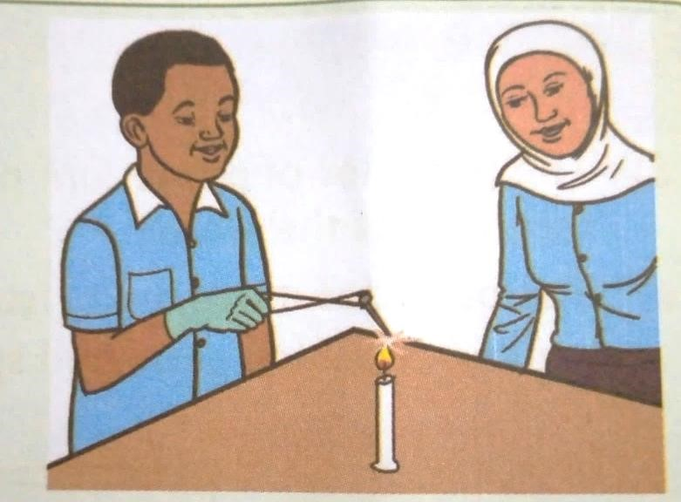
Observations, Explanation & conclusion.
  - Iron pin becomes red-hot when heated.
  - After sometime the iron pin regains its original colour on cooling.
  - This indicates that the iron pin went through a temporary change on heating.
  - Any change in properties such as shape, size, colour and state of a substance is called a physical change.
  - Physical changes are reversible.
  - When a change is reversible is said to be temporary. This is demonstrated when the heated red-hot iron pin regains its original colour after cooling.

Temporary chemical changes
Experiment to demonstrate temporary chemical changes.
Requirements:
- Safety googles.
- Two test tubes.
- Delivery tube (right-angled)  Beaker (250ml).
- Bunsen burner.
- Clamp.
- Stand.
- 5g of hydrated copper (II) sulphate.

Procedure:
- Put 5g of powdered blue hydrated copper (II) sulphate in the test tube. - Set up the experiment as shown below.
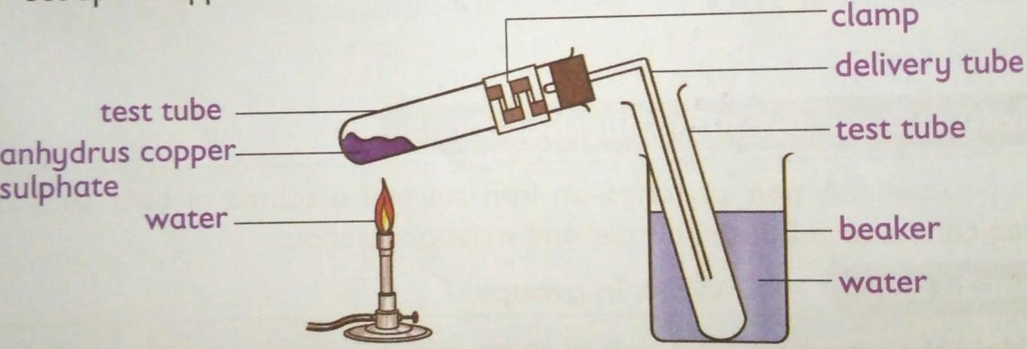 heating blue hydrated copper (II) sulphate

Observation, Explanation and Conclusion.
- When blue hydrated copper (II) sulphate is heated in the test tube as show above, it turns colour from blue to white. This because it loses water which was making it hydrated.
- After losing water, it become white anhydrous copper (II) sulphate.
- When water is added to the white anhydrous copper (II) sulphate, it turns back to its original blue colour.

- The chemical change that had occurred is reversed. Some chemical changes are therefore temporary and can be reversed easily. These changes are referred to as temporary chemical changes or reversible chemical changes.

Other examples of temporary chemical changes include the following;
- On mixing baking soda and vinegar, a chemical reaction produces carbon (IV) oxide gas. This gas causes the mixture to bubble. Once the gas escapes into the air, the reaction stops and the mixture returns to its original state.
- Freezing, melting and vapourisation of water

Permanent Chemical changes
Experiment to demonstrated permanent chemical change.
Requirements:
- 5cm magnesium ribbon.
- A source of heat.
- Sand paper.
- A pair of tongs.
- Writing materials.

Procedure:
- Clean the magnesium ribbon by rubbing it with sand paper. Examine the appearance of the magnesium ribbon.
- Hold the ribbon with a pair of tongs over a burning candle or Bunsen burner for a few minutes.

Caution:
Burning magnesium ribbon produces a very bright flame that can damage your eyes. Avoid looking directly at the flame.

Observation, Explanation & Conclusion.
- Magnesium ribbon burns with a bright light forming a white ash. If the magnesium ribbon is not shining it may take long to ignite. Therefore, is advisable to clean the ribbon by rubbing it with sand paper since it is coated with an oxide layer that prevents it from burning.

- Burning magnesium ribbon form a substance called magnesium oxide. A change in which one or more substances are formed is known as chemical change.
- A chemical change is also known as permanent change. Most chemical changes are irreversible in nature.
- Chemical changes are important in life. Example of chemical changes include:
- Digestion of food in the body. o Ripening of fruits.
- Fermentation of grapes.

Applications of changes of state of matter in day-to-day life.
Change of state of matter has many applications in day-to-day life. Some of these changes are:
  - Refrigerators.
- Liquids evaporate and absorbs heat in the process. A refrigerator works by using a liquid to remove heat from the food items inside and transfer it to the surrounding. The liquid is first heated and then cooled at the back of the fridge where the heat is removed. The process of changing liquid to gas cools the food.

  - Ice cream vendor.
- Ice cream vendors place ice inside their ice cream carts. The ice absorbs heat from the container surrounds and change to a gas. This leaves the inside of the ice cream cart cold, thus maintaining the ice cream in frozen state.

  - Melting metals.
- Metals are heated to a molten state making it possible to shape and form them into desired objects or structures.

  - Generating electricity.
- Water can be converted to steam, which can in turn be used to drive turbines to generate electricity.

  - Fog formation.
- Fog forms when water vapour (gaseous state) condenses. During condensation, molecule of water of water vapour combine to make tiny liquid water droplets that are suspended in the air. Fog reduces visibility. Some animals such as insects, depend on fog as a source of water, especially in desert climate.

-Classes of Fire.
- Fires can be classified between four and seven classes.
- The following are six classes of fire mostly widely used and accepted.
Class | Type | Involves
Class A | Ordinary fires. | Fires that burn materials such as wood, cloth, paper and plastics.
Class B | Flammable liquids. | Fires that involve liquids such as grease, oils, paraffin, petrol, diesel and alcohol.
Class C | Flammable gases. | Fires that involve gases such as propane, butane and methane.
Class D | Metallic fires. | Fires that are ignited by combustible metals such as potassium, sodium, aluminium and magnesium.
Class E | Electrical fires. | Fores that are caused by electricity or involve electrical equipment and appliances, for example mobile phone and computer chargers.
Class F | Cooking fires | These fires are ignited by cooking oil and animal fats.

Fire control measures.
- To prevent the start and spread of fire, one or more components should be removed from the fire triangle.
- A fire triangle in a simple model of understanding the components of fire which are fuel, heat and oxygen.
- Therefore, to control fire one or more components should be removed from the fire triangle as follows:
 Removing fuel:
- Use fire-resistant materials where possible.
- This will help to prevent the fire from starting and spreading.

 Removing heat:
- Water is mostly used to remove the heat from fire.
- A water fire extinguisher would be the safest way of doing this.
- However, these extinguishers cannot be used on all types of fire.\

 Removing oxygen:
- It is important to remove oxygen gas from fore triangle to prevent spread of a fire.
- This can be achieved by using either a carbon (IV) oxide or a form fire extinguisher.

Fire extinguisher come in different types depending on the kind of environment you are in. Some places such as school, work or home, one or more types of fire extinguishers may be required.
The following are different types of fire extinguishers and the classes of fire they put.
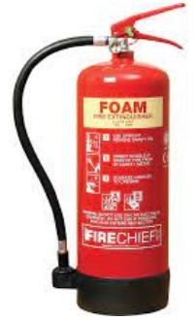  Form fire extinguisher  Used in classes A and B.  Dangerous for Class F. | 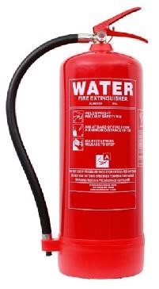  Water fire extinguisher  Used in class A.  Dangerous for classes E and F | 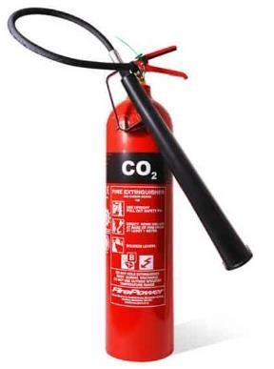  Carbon (IV) oxide fire extinguisher.  Used for classes B and E.  Dangerous for classes A and C
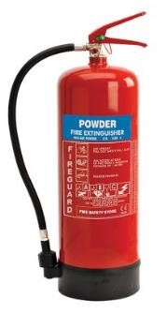  Powder fire extinguisher  Used for classes A, B, C and E.  Dangerous for class F. | 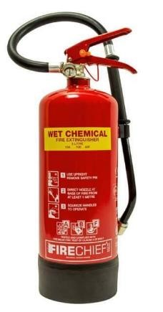  Wet chemical fire extinguisher  Use for Class F.
 | Dangerous for class B, C, D and E.
Other items that can be used to control fire.
In addition to the fire extinguishers, the following items can also be used to control fire.
- Sand-it absorbs heat and cuts off the supply of oxygen. Sand can be used to put out class A, D and F fires.
- Fire blanket-it is useful in putting out class F fires and wrapping around a person whose clothing is on fire.

Rights to safety and access to information.
 At school, home and workplace you are supposed to be safe. These paces should take the following precautions for our safety:
- Avoid build up of rubbish that can fuel fire.
- Put measures in place to detect fires and warn people quickly in case fires start. This can be done successfully by installing smoke detectors and fire alarms or bells.
- Have correct fire fighting equipment to put out a fire quickly.
- Keep fire exits and escape routes clearly marked and unobstructed at all times.
- Give proper training on emergency procedures to follow, including fire drills.
Access to information on flammable substances is important for the following reasons.
- It makes us aware of all hazards (fire and explosion) of the materials we are handling.
- Helps us to know which of the materials or products we are working with are flammable.
- Helps us to remove sources of ignition (sparks, smoking, flames or hot surfaces) when working with flammable and combustible products.
- Helps to use approved equipment, including labelled safety containers, for flammable liquids.
- Helps to know the proper personal protective equipment to use when handling hazardous liquids.
- Helps us to know how to handle emergencies (fires, spills, personal injury) involving the hazardous materials we work with.
Fire safety posters we should be aware in the environment we are in.
  In case of fire out break this is the point to assemble. | 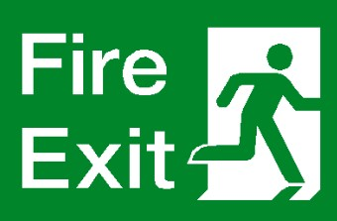  Show the route to use and exit the affected area in case of fire. | 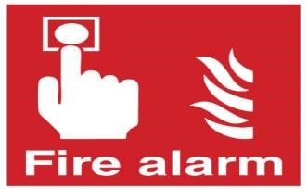  Used to alert the users of the premises to exit the area due to fire outbreak
  indicates the position of a fire extinguisher in the building or location. |   where one can make an emergency call in case of fire outbreak. | 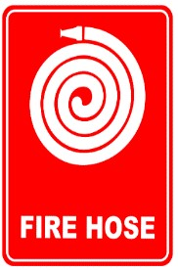  indicates location of a fire hose in the building or in the area.  Fire hose is a highpressure pipe used to carry water or retardant
Strand 2 LIVING THINGS & THEIR ENVIRONMENT.
2.1 The Cell.
- Cells make up the structure of living organisms and carry out various biological processes.
- Organisms such as amoeba are composed of a single cell hence are said to be unicellular.
- Organisms such as plants and animals are composed of many cells hence are said to be multicellular.
- Therefore, a cell is defined as the basic unit of structure and functions in organisms.
- To observe the cell, a powerful magnifying instrument called a microscope is used.
- A microscope enlarges the image of objects when observed and improves the resolution of the image.
Plant and animal cell structures as seen under a light microscope.
- The following diagram shows the components of a plant cell as seen under a light microscope.

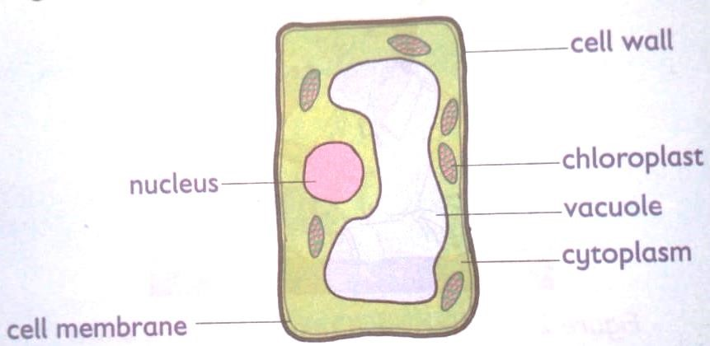

Components of a plant cell.

- The following diagram shows different components of the animal cell as seen under a light microscope.
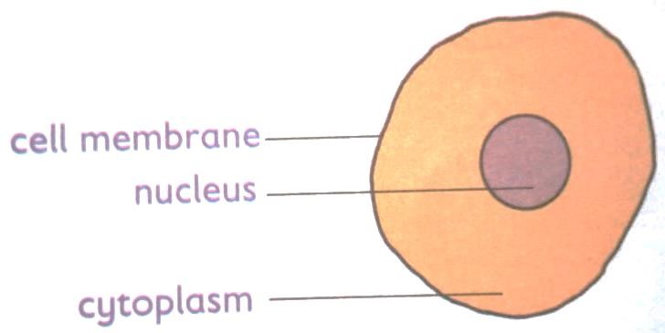
Components of an animal cell.

Comparing plant and animal cells.
- Plant and animal cells have slight differences in their internal structures while sone features are common in both.
- The figures below show the components of both plant and animal cells as seen under a light microscope.
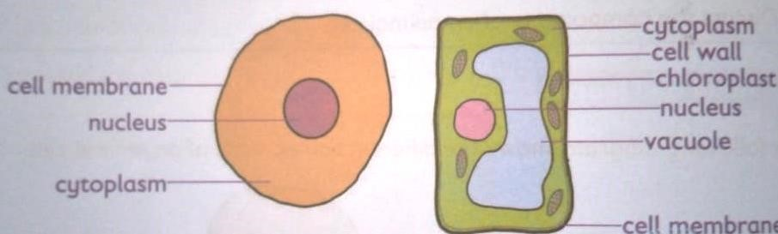

Plant cells | Animal cells.
They are large in size. | They are small compared to plant cells.
It has a cell wall. | It does not have a cell wall.
Some plant cells have chloroplast that give the plant its green colour. | It lacks chloroplast.
Plant cells have a permanent vacuole that occupies a large part of the cell. | Animal cells usually do not have vacuoles, however, small temporary vacuoles may occur

Similarities between a plant cell and an animal cell.
They both have the cell membrane.
Both have nucleus within them

Functions of the cell structures found in plants and animals’ cells.

Part/structure | Function | Found in
Vacuole | It is the space that has a watery fluid (cell sap) that contains dissolved water, mineral salts and waste products. | Both plant and animal cells.
Cell membrane | Cell membrane is a thin layer around the cell that holds the cell together.  It acts like a fence and controls what goes in and out of the cell.  Therefore, the cell can take in substances it needs and get rid of waste products. | Both plant and animal cells.
Cytoplasm. | It is a jelly-like liquid that fills inside the cell.  The cytoplasm is where chemical reactions of the cell take place.  It also contains small structures called organelles  which have special functions | Both plant and animal cells.
Nucleus | The nucleus carries genetic information and controls what happens or all the activities of the cell. | Both plant and animal cells.
Cell wall | It is a thick, tough layer made from cellulose found on the outside of the cell. It covers the cell membrane in plants cells.  Cell wall helps the cell to keep its shape.  It protects the cell form mechanical damages. | Plant cells.
Chloroplast | It is an organelle in the cytoplasm of plant cells. Chloroplast contain green pigment called chlorophyll.  Chlorophyll absorbs light that is used by plants to make their own food through photosynthesis. | Plant cells.

Magnification of Cells.
- Magnification of a specimen is the measure of how much bigger a specimen is when it is viewed through a hand lens or microscope compared to its original size.
- Magnification is usually expressed using “X” before the digits, for example, X2, X10 and X20. The X stands for ‘times.’
- It is a measure of how much bigger an object appears when viewed through a hand lens or microscope, for example X2 means the object has been magnified or enlarged two times or the image is twice bigger than the actual object.
- For alight microscope, the final magnified image of an object as seen by the observer is the product of the magnifying power of the lenses that are used. These lenses include eyepiece lens and the objective lens.
- The magnifying power of each of these lenses is marked on the sides of the objective and eye piece lens holder.
- In a light microscope, the revolving nosepiece holds three different objective lenses, each with a specific magnifying power of X4, X10 and X40. The eyepiece lens further magnifies the image formed by the objective lens.

Calculating the Total magnification.
- Finding total magnification of an image you are viewing in alight macroscope is done by:
- Take the power od the objective lens you are using e.g., X4, or X10 or X40 and multiply it by the power of the eyepiece lens, which is usually X10.

Total magnification =magnification of eyepiece lens x magnification of objective len.
Example.
Fill the table below with the correct magnification.
Objective lens magnification. | Eyepiece lens magnification | Total magnification.
X4 | 10 | X40
X10 | 10
 | X10

2.2 Movement of Material in and Out of the Cell.
Diffusion and Osmosis.
Meaning of Terms.
- Solutes and solvent.
When a solid is dissolved in a liquid, we get a solution formed.
The solid that dissolves in this solution is called the solute.
The liquid that dissolves the solid is known as the solvent.
For example,
Sugar and salt are examples of substances (solutes) that are soluble in water (solvent)
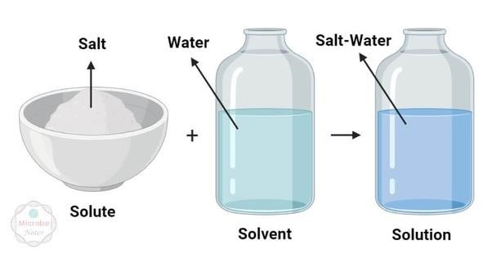

- Concentration.
- When there are more solute molecules compared to solvent molecules, a solution is said to be concentrated.
- When there are more solvent molecules compared to solute molecules, then the solution is said to be dilute.

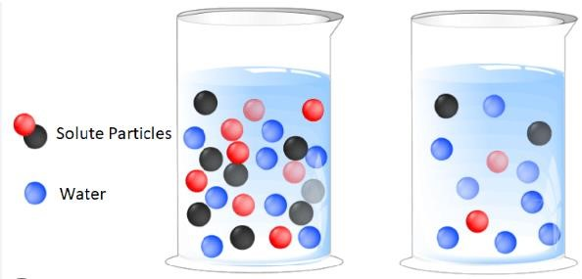

DIFFUSION.

An experiment to demonstrate diffusion in liquids.

Requirements:

✴

A beaker.

  - Water.
  - Dye or ink.
  - A dropper.
  - writing materials.

Procedure:
- pour some water in a beaker.
- Put a drop of the dye or ink in the water.
- What observations do you make after a few minutes?

Observation, explanation and conclusion.
- After a few minutes, the ink or dye spread throughout the water in the beaker.
- The ink pr dye spread from the region where it was highly concentrated to region in water where it was in low concentration.
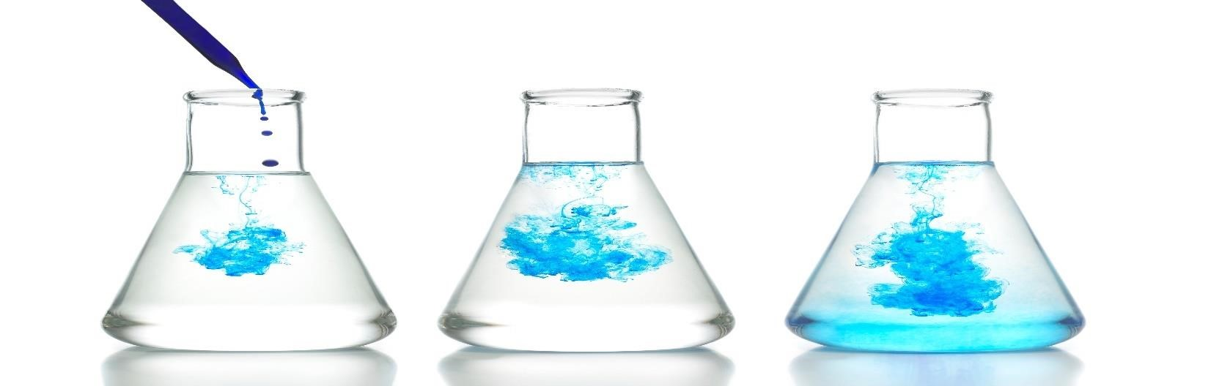
Diffusion is defined as the movement of molecules from a region of high concentration to a region of low concentration.

Experiment demonstrating diffusion in gases.
Requirements:
☞ A bottle of perfume of scented flowers.

Procedure:
- Place the scented flower in a corner of the classroom.
- Remove the stopper of the perfume, hold it a few centimetres away from your friend’s nose.

Observation, explanation and conclusion.
- After a few seconds, you and your classmates will be able to smell the scent of the flower or perfume. This is due to diffusion. The scent of the flower and perfume molecules diffuse the air to their nose.
- Molecules in the scent of flower or perfume moved from the region of high concentration and spread evenly towards the region of low concentration.
- Diffusion in gases also makes it possible for us to smell things, for example, flower, food being cooked and also foul smells.

Roles of diffusion in Living things.
- Plants absorb minerals salts from soil through diffusion.
- Nutrients such as glucose and amino acids move from the small intestines into bloodstream of animals by diffusion.
- Cells and unicellular organisms such as amoeba get rid of waste substance through diffusion.
- Gaseous exchange is the process through which gases are transferred across cell membrane to either enter or leave the blood. This process is done by diffusion in human beings in the alveoli in lungs. Oxygen gas moves from alveoli where is it is highly concentrated to the blood capillaries where it is lowly concentrated.
- On the other hand, carbon (IV) oxide moves from the capillaries where it is highly concentrated into the alveoli where it is lowly concentrated to be exhaled out.
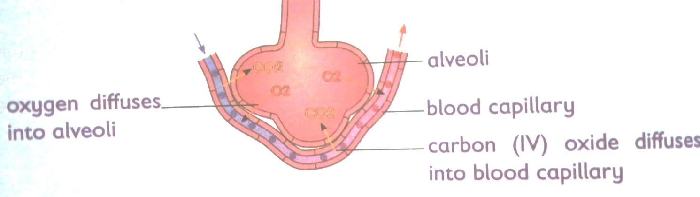
Factors that affect the rate of diffusion.
- Concentration gradient-molecules move from region of high concentration to that of low concentration. The greater the difference in concentration between high and low regions, the faster the rate of diffusion.

- Temperature-high temperature increases energy and therefore faster movement of molecules. This increases the rate of diffusion.

- Mass of particles- heavy particles move slowly hence slower rate of diffusion. Light particles on the other hand move fast hence faster rate of diffusion.
-
- Diffusion distance- rate of diffusion depends on distance that particles have to travel in order to be evenly distributed within available space.

- Medium of diffusion- particles diffuse faster through gases than liquids.

- Surface area to volume ration- diffusion occurs faster in smaller organisms as compared to larger organisms. This is because small organisms have a large surface area to volume ratio.

OSMOSIS.
Experiment to demonstrate osmosis process. Requirements:
- Capillary tube.  - A thread.  - A clamp.  - Distilled water. | - Visking tubing.  - Dyed concentrated sugar solution.  - A measuring cylinder.  - Writing material.

Procedures:
- Moisten a piece of visking tube and rubber between your fingers to open it. o Tie one end of the visking tubing tightly with a thread.
- Put the dye concentrated sugar solution in the Visking tubing using a measuring cylinder. o Insert one end of capillary tube to the open end of the visking tubing and tie that end.
- Slowly lower it into a beaker containing distilled water and hold the capillary tube with a clamp. o Mark the level of dyed concentrated sugar solution in the capillary tube at the beginning of the experiment.
- Leave the experiment for about 20 minutes. Observe and record your results
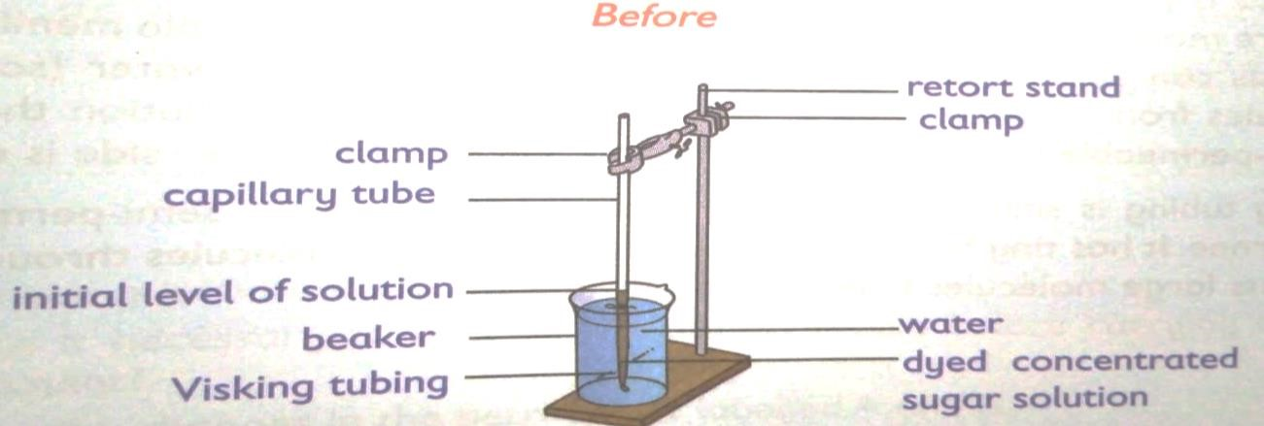

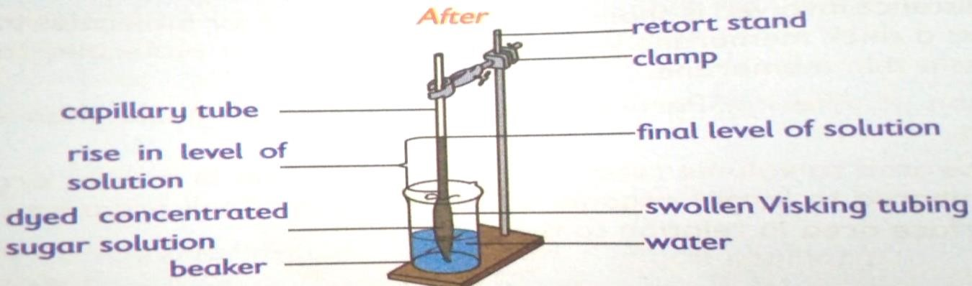
Questions to answer.
What happens to the level of the dye concentrated sugar solution in the capillary tube after 20 minutes?
The level of the dye concentrated sugar solution increases in the capillary tube.

Why did the above change take place?
Water is highly concentrated in the beaker than in the visking tubing. Water moves from where is it more into the visking tubing across the visking tubing where it is less hence making the visking tubing to swell.

Explain the biological process taking place in the experiment.
Osmosis takes place since water moves from the beaker where it is highly concentrated to the visking tube where is lowly concentrated.

What is the role of the visking tubing in the experiment? The visking tubing acts as a semipermeable membrane.

What can we compare the visking tubing with in living cells?
The cell membrane.

Observation and explanation.
- The concentration of water outside the visking tubing is higher than the concentration of water inside the visking tubing.
- Water moves in through the pores in the semi-permeable membrane of the Visking tubing by osmosis because of the differences in concentration inside and outside the visking tubing.

- Osmosis is the random movement of water (solvent) molecules from there they are more to where they are less through a semi-permeable membrane.
- Osmosis can also be defined as the random movement of water (solvent) molecules from a dilute solution to a more concentrated solution through a semi-permeable membrane until the concentration on each side is equal.
- Visking tubing is similar to the cell membrane. It is also a semi-permeable membrane, it has tiny holes (pores) that allows small molecules through but prevents large molecules from passing through.

Investigating the process of Osmosis using plant materials.
- Requirements:
  - Raw potato tuber. - Distilled water.
  - Table salt. - A measuring cylinder.
  - Boiled potato. - A scalpel.
  - Labels. - A spatula.
  - Petru dishes. - Writing material.
  - Clock or wrist watch.
- Procedure:
- Label two petri dish A and B.
- Half fill each petri dish with equal volume of distilled water.
- Using a scalpel, peel a raw potato tuber and trim both if its ends.
- Make a scoop (cavity) in one of the ends.
- Using a scapula, place a given amount of salt in the cavity.
- Carefully place the set-up in petri dish labelled A and note the time.
- Repeat step 3 and 5, this time using a previously boiled potato. Place it in a petri dish and label it B.
- Leave the set up for 40 minutes.
- Observe and record.

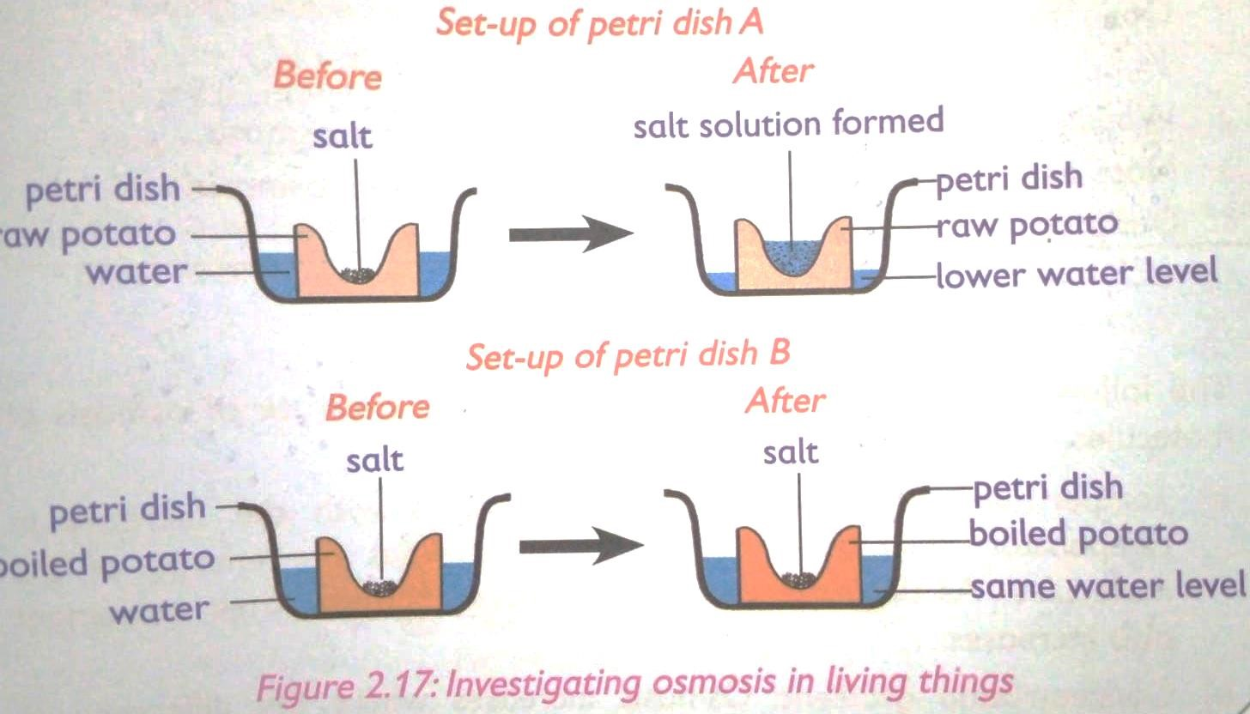

Questions to answer.
Why is it necessary to peel off the potato tuber before carrying out this experiment?
Explain the changes in the petri dish A and B.
What biological process is being investigated?

Observation and explanation.
- It is necessary to peel off potato tubers so as to expose large surface area and expose the inner cells that are permeable for osmosis.
- Petri dish A-water moves up by osmosis through the potato cells then dissolves the table salt in the cavity.

- Petri dish B-the slat did not dissolve because no water moved by osmosis in to the cavity. This is because the boiled potatoes have destroyed semi-permeable cells membranes that cannot carry out osmosis.
- The process being investigated is osmosis in living cells.

Factors affecting the rate of osmosis.
  - Temperatures -rate of osmosis increases with increase in temperature. This is because increase in temperature increases energy of the molecules.
  - Concentration gradient- osmosis increases where the difference in concentration of water molecules is higher.
  - Type of semi-permeable membrane- larger number of pores, the faster the rate of osmosis.

Role of osmosis in living things.
- In plants Osmosis plays the following roles:
  - Absorption of water from the soil-roots absorb water from the soil by osmosis.
  - Support-some plants have cells that absorb water, become turgid hence providing support to the plants.
  - Feeding in insectivorous plants-insectivorous plants such as pitcher plant prey on insects. They trap insects when there is a sudden change in their stiffness when disturbed by the insect. Trapped insects are digested to provide the plant with nitrogen.

- In animals, Osmosis plays the following roles:
- Absorption of water in the human body.
- Excretion-this is the removal of waste products from the body. Urine is the main product through which excess water is excreted from the body. Kidneys filter urine to control the amount of water lost. This happens through osmosis. Similarities and difference between osmosis and diffusion.

Similarities.
Both are mean to equalize concentration of two solutions.
Both are passive transport processes, i.e., they do not require any energy to occur.
In both, particles move from an area of higher concentration to an area of low concentration.

Differences.
- Osmosis happens in liquid medium while diffusion happens in liquids, gases and even solids.
- Semi-permeable membrane is required in osmosis while in diffusion no membrane is needed.
- Osmosis requires water for movement of particles while diffusion does not require water.
- In osmosis there is only one way for particles to flow while in diffusion particles can flow in any direction.

2.3 Reproduction in Human Beings.

 Menstrual cycle.
    - Menstrual cycle consists of natural changes that occur to the body of a female human being every month in preparation to pregnancy.
    - A menstrual cycle lasts between 28-35 days. However, this can vary between female and from one cycle to the next. The cycle depends on hormones.
    - Hormones are chemical messengers in the body.
    - They direct the body on what to do and when to do it.
    - The menstrual cycle is a process controlled by hormones in the female body.  The menstrual cycle is divided in to the following phases:
Approximate day(s) | Event(s)
1-5 day | - Bleeding from the vagina begins. This is caused by the loss of the lining of the uterus.  - This is called menstruation or monthly periods
6-14 days | - Blood loss stops.  - The lining of the uterus begins to regrow and an ovum starts to mature in one of the ovaries.
14-25 days | - Ovulation occurs.  - The ovum travels through the oviduct towards the uterus.
25-28 days | - If the egg becomes fertilized by a sperm and attaches itself to the uterus wall, the woman becomes pregnant.  - If pregnancy does not occur, the uterus lining begins to break down again, repeating the cycle.

Challenges related to the Human menstrual cycle.
 Irregular periods.
    - This can be determined by finding out how long your menstrual cycles are.
    - You can determine your personal menstrual length by counting from day 1 of your period to day 1 of your next period.
    - Day 1 means the first day of the actual flow.
    - It is normal to have menstrual cycles that are between 21 and 35 says.
    - Your periods are irregular if it tends to come more frequently than every 21 days or less often than 35 days.
    - If the circle length falls in the normal range but varies by 7 to 9 days from the cycle to cycle that is a sign of an irregular period too.
    - For example, if one is 25 days and the next is 33 days, your cycles would be considered irregular.

 Absent periods.
    - In some cases, some females may fail to get periods.
    - Others might not get their first period by the age of 16 years.
    - Other cases when some females stop getting their regular periods for 6 months or more.

 Irregular bleeding.
    - Bleeding very little or no bleeding at all with each menstrual cycle is another challenge related to the menstrual cycle.
    - Light or lack of bleeding can result from being extremely underweight or overweight.
    - If you are overweight, losing weight might help to make your periods regular.
    - If you are underweight, slow and steady weight gain may help to regulate your menstrual circle.
    - Excessive bleeding is another challenge related to the menstrual cycle.
    - Bleeding is considered heavy if it interferes with normal activities.
    - However, though common, you should see a doctor.  Heavy periods can be a sign of a health problem.

 Painful periods.
    - Most women experience menstrual cramps before or during their period at some point in their lives.
    - For some of them it is part of the regular monthly routine.
    - However, if the cramps are painful and persistent, you should see a doctor.
 | Management of Menstrual challenges | .
    - A doctor can prescribe hormonal medication that can help control heavy bleeding.
    - If one experiences heavy bleeding, an iron supplement might help to prevent anaemia.
    - Mild to moderate pain or cramps can be lessened (reduced) by taking an appropriate pain reliever.
    - Taking a warm bath might also help to relieve cramps.
    - Surgery can also be performed.
    - If symptoms persist, always visit a doctor.

Fertilization and Implantation.
    - Fertilization is the fusion of a sperm with an ovum in the oviduct (also called the fallopian tube.)
    - During sexual intercourse, thousands of sperms are released into the vagina by the penis.
    - Sperms swim through the cervix into the uterus up to the oviduct.

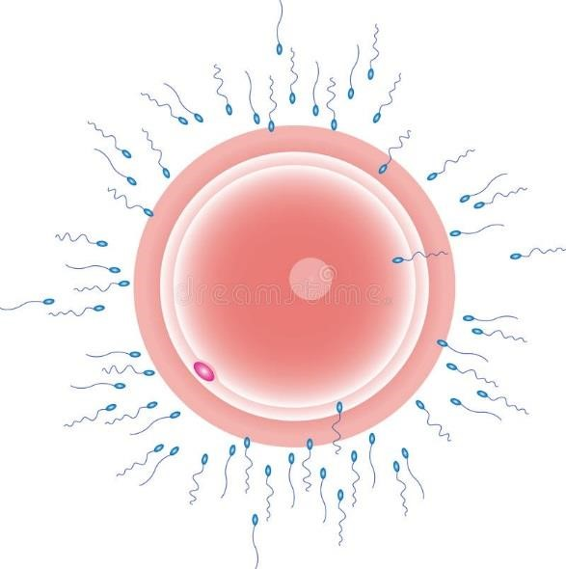
·

Sperm

Ovum

    - Few sperms that reach the ovum try to penetrate it.
    - Only one sperm penetrates the ovum.
    - When the sperm penetrates the ovum, the surface of the sperm fuses with the nucleus of the ovum to form a zygote.
    - The zygote moves from the oviduct and enters the uterus, attaching itself to the uterus walls.
    - This process is called implantation.
    - Once implantation has taken place, the zygote is now referred to as an embryo.
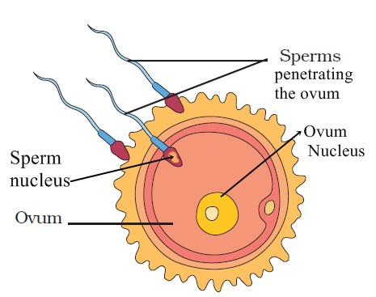

Symptoms and prevention of common STIs.
HIV & aid.
Symptoms.
- Chronic diarrhea.
- High fever and night sweating.
- Weight loss.
- Patient becomes very thin and weak.

Prevention.
  - Abstain from unnecessary sex.
  - Self control in drinking.
  - Carry out blood transfusion only in extreme need and consider safety.

Gonorrhea.
Symptoms.
Vaginal discharge with bad odours.
Penis becomes sore at the tip.
Urination is difficult and painful.
If untreated it spreads to rest of the organs blocking passages.

Prevention.
Avoid unnecessary sexual behaviours.
Abstain from sexual intercourse.
Faithfulness in marriage is encouraged.

Syphilis.
Symptoms.
Sore resembling blisters appear at site of infection.
Rashes appear on the skin.
Patient feels feverish, suffers body pains and loses hair.
Can be prevented by using same measures as in gonorrhea.

Herpes
Symptoms.
Painful sores on the genitals. Blisters may disappear.
Can be prevented by;
Not indulging in promiscuous sexual behavior.
Being faithful in marriage.
Avoiding sexual contact with an HSV-II infected person

Strand 3 FORCE & ENERGY.
3.1 Transformation of energy.
Energy is the ability to do work
Energy is not visible, has no mass and neither does it occupy space.
Energy exists in different forms.
Energy transformation is the process of changing one form of energy to another.
Forms of energy in nature.
Forms of energy in nature include:
- Heat or thermal energy.
- Sound energy.
- Electromagnetic energy.
- Nuclear energy.
- Electrical energy.  Chemical energy.
- Mechanical energy- divided into potential and kinetic energy.

Heat energy.
Heat is a form of energy transferred from one body to another due to difference in temperature. In an experiment where a metal rod on which different pins are attached using candle wax is heated on a source of heat, the pins start to fall starting with one closest to the source of heat. This means heat flows through the metallic rod from the burning candle to the other end of metallic rod.

Sound energy.
Sound energy is the energy associated with vibration or disturbance of bodies or particles. Such as striking a drum with a piece of wood or plucking the wire.

Nuclear energy.
Nuclear energy is the energy that results from nuclear reactions in the nucleus of atom.
Very large amounts of energy can be released when changes take place within the nucleus of an atom.
Examples of these changes are nuclear fission in which a nucleus breaks down to give two smaller nucleus or nuclear fusion where two small nuclei join to form one big nucleus and radioactive decay in which the nucleus of an element change to different nucleus by releasing certain particles.
Electrical energy.
Electrical energy is energy produced by flow of electric charges (electrons)
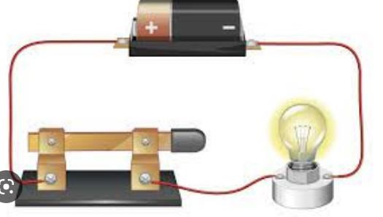
Chemical energy.
Is a type of energy stored in atoms and molecules that make up a substance.
For example, a thermometer records a higher temperature reading after the steel and vinegar are mixed. This reaction of vinegar and steel wool produces heat.
People and other living things get their energy needs from the chemical energy stored in food. Other sources are dry cells and fuels.

Mechanical energy.
Mechanical energy is the energy possessed by a body due to its motion or due to its position.
It can either be kinetic or potential energy or both.
When an object is falling down through air, it possesses both potential energy (PE) and kinetic energy (KE) due to its speed as it falls. The sum of its PE and KE is its mechanical energy.
Mechanical energy=kinetic energy + potential energy.\
In conclusion. Kinetic energy is possessed by a moving body while potential energy is possessed by a body due to its position.
The sum of an object’s kinetic energy and potential energy is its mechanical energy.

- Potential energy.
When a stone is held and released to fall on the ground, this indicates that the stone had stored energy due to its position that made it to start moving down after it had been released.
The energy possessed by a body (e.g., the stone) due to its position above the ground is known as gravitational potential energy.

In the same way, when a compressed spring or a stretched catapult is released, it goes back to its original shape and size. This indicates that the spring had stored energy due to compression. The energy possessed by a body dur to compression (for example the spring) or stretch (for example a catapult) is called elastic potential energy.

- Kinetic energy
Kinetic energy is the energy possessed by a moving object.
Examples of objects that possess Kinetic energy (KE) include:
- Moving air.
- Rotating windmills.
- Falling water.
- A person running.
- Any moving object in general.

Classifications of energy sources.
Energy sources are classified either as renewable sources and non-renewable sources. Renewable energy sources-this are energy sources that cannot be depleted or they can be used again and again. Examples are solar energy, water and wind.
Non-renewable energy sources are energy sources that can be depleted and are limited. That means they are completely used and can not be replaced such as fossil fuels like coal and petroleum.
Demonstrating energy transformation in nature.
  - Using a flash light.
When using a flashlight, the circuit closes.
Chemical energy is transformed into electrical energy in the dry cells.
The electrical energy is then converted into light energy.
The torch bulb therefore lights which is light energy.
Chemical energy to Electrical energy to Light energy
  - Using a basketball.
When you dribble a basketball, the ball had potential energy at its starting point above the ground.
The potentials energy is converted to kinetic energy as the ball starts o fall to the ground. Some of the energy is lost on impact (as it produces sound) and generate heat as it hits the floor) When the ball bounces back, it may not return to its starting height.
If your hand is there to put more energy into the ball (by pushing it down again), the ball can continue to bounce up and down and the energy will shift back and forth between potential and kinetic energy.
Potential energy to kinetic energy to potential energy.

Appliances whose working rely on energy transformation.
Bulb – electrical energy -light energy.
Solar panels-solar energy to electrical energy.
Hammer-potential energy to kinetic energy.
Diodes-electrical energy to light energy.
Moving coil microphone-electrical energy to sound energy.
Electrical heater-electrical energy to heat energy.
Dynamo-mechanical energy to electrical energy.
Motor-electrical energy to mechanical energy.

Safety measures associated with energy transformation.
Road accidents.
In case an accident, a moving vehicle has kinetic energy that is transformed into other forms incase of head-on collision with another vehicle or a stationery object.
Most of kinetic energy is converted to other forms of energy as the vehicle undergoes permanent deformation that causes it to bend and twist.
This is a destructive mechanical energy. Some kinetic energy is converted to heat energy and sound energy.

Accidents caused by fire.
Heat is produced during energy transformation from one form to another. Heat can cause fire accidents, especially when electrical energy is transformed to thermal energy through the use of various appliances. Accidental fires can also be caused by lighting when electrical energy is transformed into heat energy.
We should take precaution when handling electrical appliances. We should also observe safety measures during a thunderstorm.

Accident associated with the use of electricity.
At home various appliances that transform electrical energy into other forms of energy such as light, sound and heat.
These appliances include:
- Electrical heater.
- Television sets.
- Iron boxes etc.

Risks or accidents associated with use of electricity include electrical shocks, electrical burns and electric fires.
To reduce electricity accidents the following should be done:
  - Move electrical appliances away from water.
  - Repair any faulty wirings.
  - Replace faulty appliances.

Health hazard from bright light.
Some energy transformation produces very bright light that can damage the eyes, for example in welding Electrical energy is transformed into heat and light energy. This produces a very bright spark of flame that is a health hazard.
Welders and other people nearby should wear protective welding shield to avoid exposure to the bright light from the flame.

Loud sounds.
Various transformations of energy results in production of sound.
For example, a motor converts electrical energy into mechanical energy. The mechanical rotation of the fan, blenders and other appliance produces sound. In our environment, sound can be classified into loud or soft sound.
Loud sounds such as loud music and shouting or screaming are not good for the environment. Loud soud affect living things by:
- Causing irritation.
- Damaging our eardrums
To reduce loud sounds, we should do the following:
- Use more efficient appliances that minimise production of loud sound.
- Wear hearing protection devices to protect our ears from loud sounds.

Common types of hearing protection devices include:  Earplugs.
 earmuffs

3.2 Pressure I.
Meaning of pressure.
Pressure is defined as the force acting normally per unit area. Normally here means at a right angle or perpendicularly.

For example,
If two leaners of equal mass walked on mud and the boy pus on flat-sole shoes while the girl wears sharp-high heeled shoes, which of the two would make deeper impression on the muddy ground?
In the scenario above, the girl makes deeper impressions on the muddy ground than the boy. This is because the weight of the boy is spread over a large surface area than that of the girl. The greater the force (weight) acts on, the less the effect or impression made on the muddy surface.
The sharp heel shoes of the girl have a small surface area in contact with the ground. The smaller the area the deeper the impressions or more sinking than the shoes of the boy for the same weight

Example 2,
If a leaner has two identical bags, but one has wider shoulder strap and the other has narrow shoulder straps.
If the learner places same books with similar weight in the two bags, which bag will the learner feel the straps squeezing more into their shoulder?
In this case, the bag with narrow straps will produce more squeezing effect than that one with wider straps for the same force (weight) of books carried. This is because, pressure is high when the surface area is small, and it is low when the surface area is large.

Therefore, pressure is the force acting normally per unit area.

Pressure in liquids.
Pressure is represented by a symbol “P”
It is defined as force acting normally per unit area applied to the surface of an object.
Pressure increases as the force increases.
In mathematical terms, pressure can be expressed as:

Pressure = Force
Area

SI unit for Force is measured in Newtons (N) SI unit for Area is measured in m².
Therefore
Pressure = Force = F (N)
Area A (m² ) Form the equation, we obtain unit of pressure as (N/m²)
Pressure can also be measured in Pascal (Pa) where
1N/m² = 1 Pascal (Pa)

Experiment to demonstrate pressure in solids.
Use two different knives. One that is sharp and one that is blunt to cut an orange. Make an observation of the process.

From the observation, It is easier to cut an orange with a sharp knife than with a blunt knife.
This is because, while cutting, the sharp knife has very small area of contact with the orange. When using the blunt edge of the knife, the force requires to apply for cutting the orange is over a large area. The sharp knife has a smaller area that produces a greater cutting effect. The blunt knife has a large area that produces a lesser cutting effect.

The cutting effect is equivalent to pressure. For the same applied force, pressure is higher with a smaller area and it is less with a large area.
It is easier to cut with a sharp knife, axe, panga than trying to cut with a blunt knife, axe or panga.

A farm tractor has wide wheels that prevent it from sinking into the soil because pressure is distributed over a large area of the wide wheels.

A trailer or trailers are fitted with many wheels to reduce pressure exerted on the road since the wheels increase surface area.

Demonstrating pressure exerted by objects of different cross-sectional area. The block below has a weight of 20kg.
Use it to:
- Determine maximum pressure it exerts in a surface.
- Determine the minimum pressure it exerts on a surface. (g=10N/Kg



1m

1.5m
2m
Pressure is calculated by dividing Force over Area (F/A) From the block above Force, F is given as 20kg.
Change 20k into Newtons (N) this is done by multiplying the weight given in Kg by the gravitational force (g) =10N/kg Therefore, F =20 x 10N/kg = 200 N.

- To calculate the maximum m pressure the block exerts on the surface.
Use the force provided divided by the smallest area of the block.
Force = 200N
Smallest area of the block is
1mx1.5m = 1.5m².
Pressure is therefore =F/A
=200N/1.5m²
=133.33N/m²

- To calculate minimum pressure the block exerts on the surface.
Use the force provided divided by the largest area of the block.
Force = 200N
Largest area of the block is
2mx1.5m = 3.0m².
Pressure is therefore =F/A
=200N/3m²
=66.67N/m²

If a force is exerted on a small area of contact, it will exert higher or more pressure than if the same force is exerted over a large area.
Since weight of force of a brick is constant (does not change), a higher pressure is exerted on the sand when the brick lands on narrow face than when it lands on the wide face. The narrow face therefore, produces a deeper depression on the sand than the wide face.

Example 2.

Suppose the mass of a learner is 40kg and the total area of her feet is 500cm². What pressure does the girl exert when standing on one of her feet? Assume het feet have equal area. (g=10g/Kg) Solution.
Pressure =F/A.
Force the student exerts on the ground is her weight, which is 40kg x 10N/Kg.
=400 N.
Area =500cm² /2 =250 cm².
Change area form cm² to m².
1m² = 10000cm². ? = 250cm²
=250/10000
=0.025m²

Substitute the values into the formula.
Pressure =Force/Area
= 400N/0.025m²
16,000N/m²

Example 3.
A mass of 50kg exerts a pressure of 2000N/m². What area is in contact with the ground? Pressure =Force/Area/ Pressure =2000N/m².
Area? to be determined.

2000N/m² = 50kg x 10N/kg
Area
Therefore, area =Force/Pressure.
Force = 500N.
Pressure is given as 2000N/m² Area =500N/ 2000N/m².
= 0.25m².

Pressure in liquids.
Demonstrating that a liquid exerts equal pressure at the same depth.

- Use an empty bottle or cylindrical container.
- Drill holes all round near the bottom of the bottle at the same height from the bottom of the bottle.
- Close the holes using cellotape and fill the bottle with water, remove the cellotape at once.  Explain your observation.

Observation and explanation.
 If you observe the jest coming of the bottle, you will notice that they fall at equal distances on all sides of the bottle only if the pressure of water at the depth of the holes in the bottle is the same.
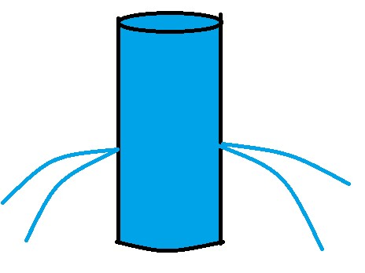

Therefore, we conclude that:
- A liquid exerts pressure on the walls of its container.
- A liquid exerts pressure at the same depth.
The formation of fountains of water from the leaking pipes of water supply tells is that water exerts pressure on the walls of its container.

Demonstrating that pressure in liquids increases with depth.
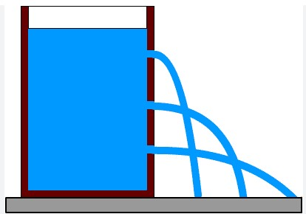
A
B
C

If a bottle is filled with water and equal size holes made from the bottom to the tops as show above.
- You will observe that after opening all the holes, water jet fall in different horizontal distances depending on the depth they are on the bottle.
- For example, in the diagram above. The water jet C is observed to move the farthest horizontally.
- As the depth from the surface decreases like in hole A and B, the distance from the container to where the jet strikes decrease, indicating a lower pressure by the water.
- The weight of the liquid acts downwards. The more the depth, the more the liquid is above the point. This increases the weight causing more pressure at that level.
- The pressure at this level acts on the container, on any object in water and on the liquid below this level.

Determining pressure in liquids.
The pressure exerted by a liquid at a particular point is determined by the following:
- Depth.
- Density of the liquid.
- Acceleration due to gravity (g=10N/Kg)

Formular for pressure at appoint in liquids
Pressure =Force/Area (F/A)


A
rea

L
iquid
density
,

ρ

h

Pressure exerted at the bottom of the cylinder = F/A Volume of the liquid =base are x height =Ah.
Mass of the liquid; m =volume x density =Ah x p.
Weight of the liquid =mass x gravitational field strength =force exerted. Weight of the liquid; W =F = mg =Ahρg.
Therefore pressure = Ahρg

A

P=hρg.

From the formula, pressure at a given point in liquids depends on the following:
- Depth or height of the liquid.
- Density of the liquid.
- Acceleration due to gravity (g=10N/kg)

Applications of pressure in solids and liquids in day-to-day life.
Applications of pressure in solids.
- Animals such as elephants and camels have broad feet to reduce the pressure exerted on the ground when walking.
- Cutting tool- cutting tools like a panga, saw and knives have very small surface area of contact at their cutting edges. When a force is applied to cut an object, the small surface area results in high pressure which makes cutting easier.
- Wooden plank- when a wooden plank is placed on a soft ground surface it increases the surface area in contact between the wheel barrow and the ground. As a result, the pressure exerted on the ground by the wheel barrow is reduced.
- Digging-edge of a jembe is sharp to reduce surface area when jembe is driven into the ground. This exerts high pressure making digging easier.
- Football boots-they have studs that are sharp to reduce area of contact and increase pressure on the football pitch. This provides a player with a better grip on the ground.
- School bag shoulder pads- they are made wide so that they reduce the pressure applied on the shoulder. This makes one comfortable as narrow strap increase pressure on the shoulders causing pain.

Application of pressure in liquids.
- Construction of dams-walls of a dam have thicker bottom to help withstand high pressure of water due to depth.
- Water supply-water tanks are erected high or elevated on high grounds so that water has enough pressure to flow to a house.
- Intravenous transfusion (IV)-this a is method of putting fluids, for example blood, into the bloodstream of a patient. In this method, a bottle is hung at high position to ensure that the fluid in the IV bottle have enough pressure to flow into the vein of the patient.

