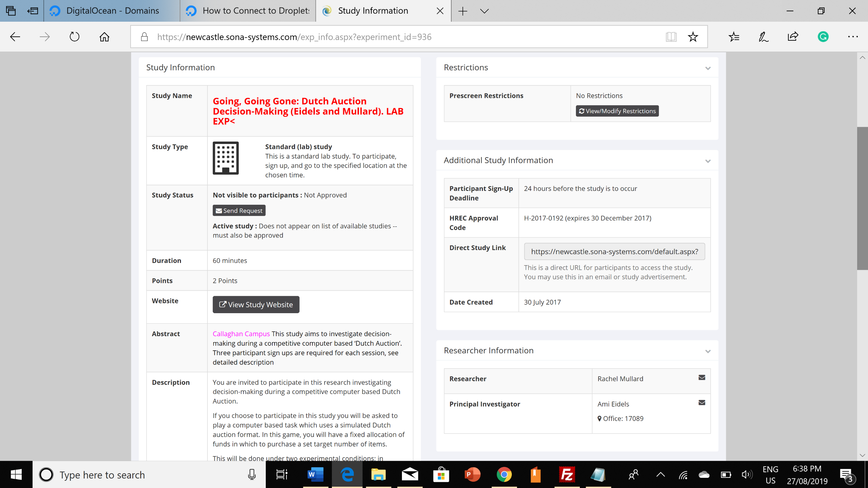

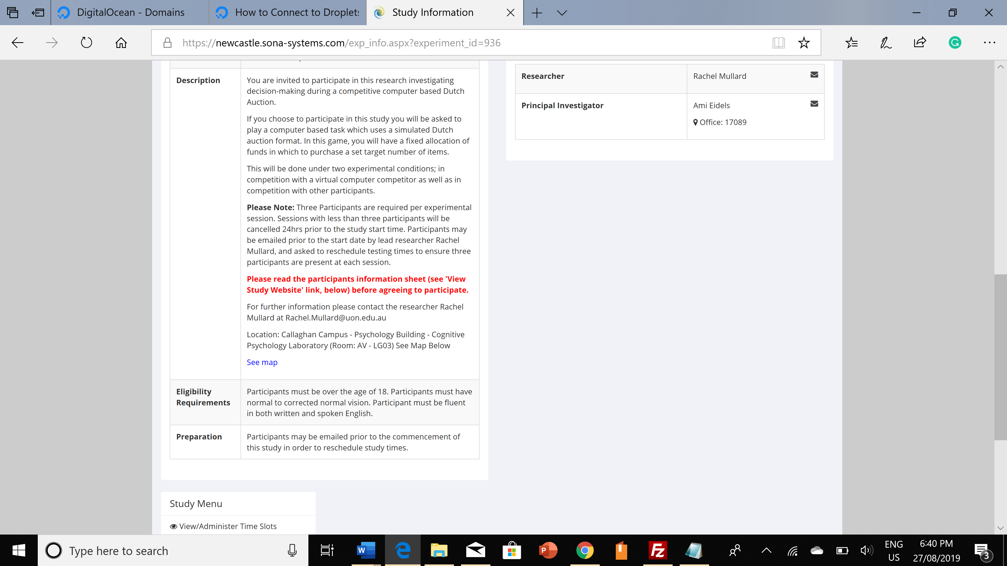

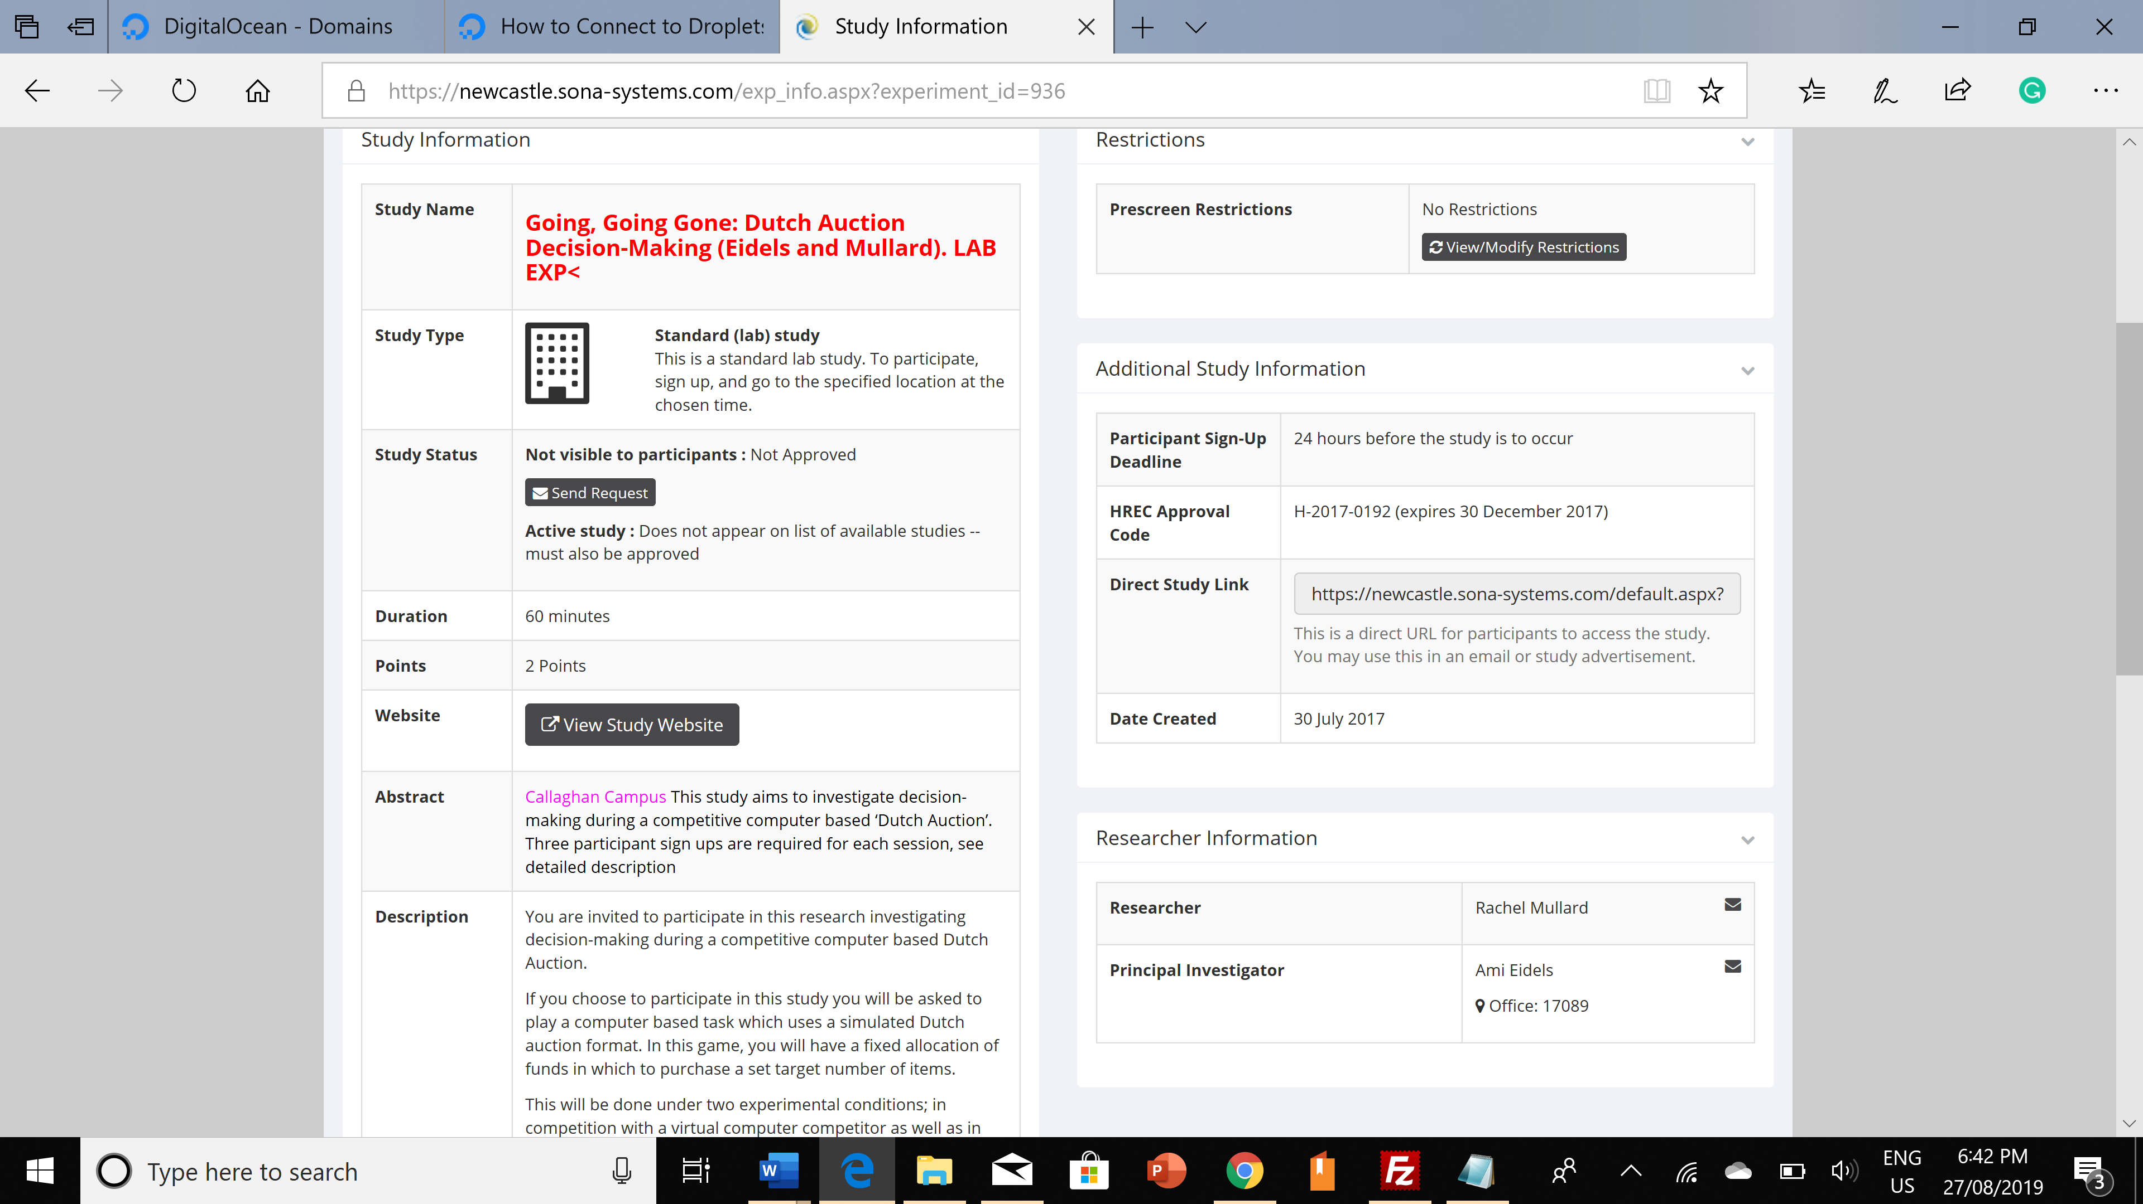

**Example Format:**

**Name:** <b><font color="RED">Take a Guess! (Waters, Garrett, Landy & Eidels) LAB EXP</font></b>

**Abstract:** <font color="Fuchsia">Callaghan Campus.<font color="Black"> This experiment will investigate the cognitive processes underlying numerical systems of estimation.</font></font>

**Description**:

 <p>You are invited to participate in an experiment that will investigate the cognitive processes behind estimation. This research will be conducted by Paul Garrett as part of his PhD Project for 2018, under the supervision of Dr Ami Eidels.

</p>

 <p>The experiment will be completed on a computer. You will see two sets of red and blue dots and decide if either set contains less than a predetermined number. Your response time and accuracy will be assessed. The task will take approximately one and a half hours to complete. </p><br>

 <font color="RED"><b>Please read the participant information sheet (see 'View Study Website' link, above) before agreeing to participate in this study.</b></font> <br><br>

 <p>The room in which this experiment will take place is AVG10 (old aviation building, now psychology). A map is provided below.</p>

 <p><a href="<https://psych.newcastle.edu.au/sona/2015/maps/MapAviation.jpg>"><font color="BLUE">See map</font></a></p>

 <p>Please contact Paul Garrett via email at [paul.garrett@uon.edu.au](mailto:paul.garrett@uon.edu.au) if you have further enquiries</p>

**Hrec code**: H-2013-0250

**Study URL**: <https://psych.newcastle.edu.au/sona/2016/H-2013-0250_THORPE_INFORMATIONSTATEMENT_V2.pdf>

**Basic Study Information**

*Study name*

<b><font color="RED">Going, Going Gone: Dutch Auction Decision-Making (Bennett, Eidels and Mullard). LAB EXP</font></b>

*Brief Abstract*

<font color="Fuchsia">Callaghan Campus.<font color="Black"> This study aims to investigate decision-making during a competitive computer based 'Dutch Auction'. Three participant sign-ups are required for each session. See detailed description.</font></font>

*Detailed Description*

<p>You are invited to participate in this research investigating decision-making during a competitive computer based Dutch Auction. </p>

<p>If you choose to participate in this study you will be asked to play a computer based task which uses a simulated Dutch Auction format. In this game, you will have a fixed allocation of funds in which to purchase a set target number of items.</p>

<p> This will be done under two experimental conditions; in competition with a virtual computer competitor as well as in competition with other participants.</p>

<p><b>Please Note:</b> Three participants are required per experimental session. Sessions with less than three participants will be cancelled 24hrs prior to the study start time. Participants may be emailed prior to the start date by lead researcher Murray Bennett, and asked to reschedule testing times to ensure three participants are present at each session.</p>

<p><b><font color = “RED”> Please read the participants information sheet (see ‘View Study Website’ link, below) before agreeing to participate.</font></b></p>

<p>For further information please contact the researcher Murray Bennett at Murray.Bennett@uon.edu.au</p>

<p>Location: Callaghan Campus – Psychology Building – Cognitive Psychology Laboratory (Room: AVG-10). See Map Below.

 <p><a href="<https://psych.newcastle.edu.au/sona/2015/maps/MapAviation.jpg>"><font color="BLUE">See map</font></a></p>

*Eligibility Requirements*

Participants must be over the age of 18. Participants must have normal to corrected-to-normal vision. Participants must be fluent in both written and spoken English.

*Duration*

60

*Points*

2

*Preparation*

Participants may be emailed prior to the commencement of this study in order to reschedule study times.

*Researcher*

Bennett, Murray

Mullard, Rachel

*Principal Investigator*

Eidels, Ami

*HREC Approval Code*

H-2017-0192

*HREC Approval Expiration*

Thursday 16 July, 2020

*Approved*

*Active Study*

**Advanced Settings**

*Pre-Requisites*

*Disqualifiers*

*Course Restrictions*

*Invitation Code*

*Participant Sign-Up Deadline*

*Should the Researcher receive an email notification when a participant signs up or cancels?*

*Researchers at Timeslot-Level*

*Automatic Credit Granting*

*Shared Comments*

*Private Comments*