

Going, Going, Gone: Investigating Decision-Making in
Dutch Auctions

Rachel Mullard

Fourth Year Thesis - 2017

School of
P S Y C H O L O G Y

Going, Going, Gone: Investigating Decision-Making in
Dutch Auctions

Rachel Mullard
University of Newcastle

Submitted in partial fulfilment of the requirements for the degree of Bachelor of Psychology
at the School of Psychology at the University Newcastle, Australia 2017

Word Count: 15474 (Main Body 10757)

Table of Contents

Declaration...................................................................................................................................i

Acknowledgements.....................................................................................................................ii

Abstract......................................................................................................................................iii

Introduction.................................................................................................................................1

Certainty vs Price: Effect of Certainty on Bidding Behaviours......................................2
Effect of Competitors on Bidding Behaviour.................................................................4
Effect of Clock Speed on Bidding Behaviour................................................................6
Developing a Computerised Platform for Testing Dutch-Auction Behaviour ..............7
Overview of the Current Study……………...................................................................9
The Dutch Auction Game…………………...................................................................9

Game Development ..................................................................................................................10
Method…..................................................................................................................................10

Fixed-Unit Dutch Auction Game………………………………………………………….….11
Results and Discussion ...............................................................…..............................11

Variable-Unit Dutch Auction Game…………………………...………………………......…12
Results and Discussion ................................................................….............................12

Overview of Experiments…………………………………………………………………….14

Experiment 1 Fixed-Unit….………………………………………………………………….14
Method….............................................................................................................................14
Participants…………………………………………………………………………....15
Design…………………………………………………………………………………15
Materials………………………………………………………………...…………….16
Procedure...……………………………………………………………………………19
Data Analysis.................................................................................................................23
Results and Discussion ................................................................…....................................23
Relationship Between Price and Step………………………………………………...23
Effect of Participant Group…………………………………………………………...24
Discrete vs Continuous Price Changes…………………………………..……...……26
Effect of Block……………………...……………………………………………...…28

Experiment 2 Variable-Unit…………………………………………………………….……30
Method….............................................................................................................................30
Participants…………………………………………………………………………....30
Materials………………………………………………………………………………30
Procedure...……………………………………………………………………………31
Results and Discussion ................................................................…....................................31
Relationship Between Price and Step……………………………………...…………31
Effect of Participant Group…………………………………………………………...32
Discrete vs Continuous Price Changes…………………………………..………...…34
Effect of Block……………………...………………………………………………...37

General Discussion...................................................................................................................38
Summary of Platform Parameters........................................................................….....38
Assessment of Platform Development.................................................................….....39
Experimental Phase…...................................................................................................40
Effect of Pattern of Price Changes on Bidding Behaviours.................................….....40
Effect of Learning on Bidding Behaviours..........................................................….....42
Limitations of the Current Study.........................................................................….....43
Conclusions and Future Directions......................................................................….....44

References.................................................................................................................................46

Appendices................................................................................................................................49

Appendix A: Glossary of Terms………………………………....................................49

Appendix B: Notices of Ethical and Methodological Approval...................................50

Appendix C: Information Statement and Consent Form...............................................54

Appendix D: Demographics Questionnaire .................................................................58

Appendix E: Experiment 1 Fixed-Unit PowerPoint Instructions ................................59

Appendix F: Experiment 2 Variable-Unit PowerPoint Instructions ............................64

Appendices on CD only

Appendix G: Raw Data

Appendix H: Full Analysis Output

Appendix I: Testing Platform

Declaration

- The contents of this Thesis are my own work and have not been submitted previously for the purpose of assessment for an Honours or any other degree.

Student Name: Rachel Mullard

Signed: 

Date: 25/10/2017

- The conduct of this thesis was approved by the Human Research Ethics Committee (Newcastle).

Approval number:

Student Name: Rachel Mullard

Signed:

Date: 25/10/2017

- My supervisor(s) has/have not read the Discussion section of this report or any drafts of the Discussion section of this report.

Student Name: Rachel Mullard

Signed: 

Date: 25/10/2017

Supervisor’s Name/s: Dr Ami Eidels

Signed (Primary Supervisor):

Date: 25/10/2017

Acknowledgements

Firstly, I would like to express my sincere gratitude to my supervisor Dr. Ami Eidels for his continuous support, patience and motivation throughout this year. I would also like to thank Dr. Marc Adam for his advice and guidance. Also, I would like to thank Jonathan Love and Paul Garrett for their assistance. Finally, I would like to thank my family for their continued support throughout the year.

Abstract
This paper examines decision making in the context of a Dutch auction and reviews previous research on how auction design can affect bidding behaviour. A computer program was developed to simulate a Dutch auction. The program provides the capacity for participants to compete against each other in bidding for items and allows various aspects of the auction design to be varied so that the effect on bidding behaviour and decision making can be assessed. The software also provides the option of having a computer competitor to compete against individuals. The program was tested by conducting two preliminary experiments to investigate the effect of patterns of price changes and bidding experience on bidding behaviour for both fixed and multi-unit Dutch auctions. The software may provide a framework for future research into Dutch auctions.

A Dutch Auction is a descending price auction where an item begins at a set maximum price. This price is gradually lowered over a fixed amount of time until a bidder makes a bid guaranteeing that bidder the purchase of the item at the current price (Thomas, 2012). To win the item at the best price bidders must consider both the item price and the behaviours of auction competitors to determine the best time to bid (Milgrom, 1989). These processes within a Dutch auction provide us with a useful context to study competitive decision making (Ku, Malhortra & Murnighan, 2005).
To illustrate considerations affecting bidding behaviour, suppose you are a florist and have a limited budget with which to restock your shop for the week. To do this you attend a Dutch auction where you compete with other florists to purchase flowers from a limited pool of flowers. To fully restock your shop using your limited budget, you must determine the best bidding strategy that allows you to purchase enough flowers at the lowest possible price. To purchase your flowers for the lowest price it would be best to wait as long as possible before making a bid. However, by waiting you risk losing the flowers to another florist who bids earlier. For a better chance of purchasing enough stock to fill your shop it would be better to bid early. Yet, by doing so you will be required to pay a higher price, potentially depleting your limited budget before you have obtained enough flowers to restock your shop. Therefore, to obtain enough flowers for your shop using a limited budget you must balance the price you are prepared to pay against the risk of losing to a competing florist to determine the best possible bidding strategy.
This scenario demonstrates how the decision-making behaviour in a Dutch auction requires participants to balance the speed of response (i.e. time of bid) with the consequence of that response (i.e. price). As highlighted by Vickrey (1961), by bidding earlier at a price equal to or greater than the value of the item the bidder increases the probability of winning but also of overpaying for the item, which would result in no resale profit. On the other hand, the longer a bidder delays in placing a bid the higher the likelihood the bidder increases their profit on resale, but the risk of losing to a competitor also increases. The way in which a bidder trades-off between the certainty of winning and the price they pay is the key to developing a bidding strategy within a Dutch auction (Easley & Kleinberg, 2010).
Despite the popularity of auctions in general, limited research has been done on Dutch auctions when compared to other auction formats and from a rather limited perspective (Adams, Eidels, Lux & Teubner, 2017). To date, much of the research on Dutch Auction followed the tradition of economical-commercial research, trying to identify conditions that yield optimal price (e.g., Adams et al. 2017; Coppinger, Smith & Titus, 1980). It is not entirely clear how various factors affect bidding behaviour and in particular the trade-off between price and speed (or timing) of bidding in the Dutch Auction. Therefore, the current study aims to develop a computerised testing platform that will enable further investigation into how different factors, operationalised as different design parameters, affect the decision-making processes involved within a Dutch auction.
In the following sections the trade-off between certainty and price in developing bidding strategies in Dutch auctions will be discussed. The effect of competitors on bidding behaviours will then be explored and then the effect of clock speed (the rate of price decline) will be described. Finally, the present paper will outline our development of a computerised task to examine the bidding behaviours and decision-making in Dutch auctions, and present results from two laboratory experiments using our novel platform.
Certainty vs Price: Effect of Certainty on Bidding Behaviours
A fundamental feature of a Dutch auction is that the first bidder to bid wins the available item with certainty (Turocy, Watson & Battalio, 2007). This is a unique component of Dutch auctions not present in other auction formats. Certainty matters; ample evidence suggests people prefer certainty over uncertainty in a variety of conditions (e.g., Kahneman & Tverskty, 1979, 1984). To gain certainty in the context of a Dutch Auction bidders are often required to pay a higher price by bidding as early as possible to ensure they are the first to bid. Therefore, when developing a bidding strategy, bidders must decide whether to prioritise the certainty of winning or the price they are willing to pay.
In Dutch Auctions, bidders may prioritise certainty of winning in an attempt to avoid the negative emotional state caused by losing. Adam, Kramer & Weinhardt (2012) found participants felt the loss of a Dutch auction more strongly than a win, and suggested participants were better able to cognitively prepare for the win, as, in placing a bid, they expected certainty in obtaining the item. A loss, on the other hand, was unexpected causing a greater emotional response.
Prioritising certainty helps bidders avoid any negative emotions associated with losing, yet it also increases the risk of falling victim to the winner’s curse. The winner’s curse is the potential for the winning bid to exceed the value of the item being auctioned (Easley, Wood & Barkataki, 2010). This phenomenon is particularly prevalent in common value auctions, where the value of the item is the same for all bidders, but bidders do not know this value and thus base their bids on their own information and private valuations (Kagel & Levin, 1986). As a result, the bidder with the highest estimation (or most optimistic) of the item’s true value will win the auction and as this value often exceeds the item’s true value this is what leads to the winner’s curse (Van Den Bos, Li, Lau, Maskin, Cohen, Montague & McClure, 2008).
To appreciate the potential effect of certainty on bidding behaviour, consider again the florist attending a Dutch auction to purchase stock for their shop. The florist may decide to pay a higher price for flowers to gain certainty of winning some stock to place in their shop. However, in doing so they not only risk depleting their limited budget before they have fully restocked but also risk paying more for the flowers then their potential resale value.
Research has shown the winner’s curse is a pervasive phenomenon in common value auctions (Kagel & Levin, 1986; Lind & Plott, 1991). However, Garvin and Kagel (1994) found that bidders could adapt their bidding strategies to reduce the winner’s curse. Their study showed that while inexperienced bidders initially had high rates of the winner’s curse, these bidders could learn to reduce the effect through feedback from their own bidding behaviours. Furthermore, they found this learning process was aided through the observations of the winner’s curse in other bidders. This suggests that an individual’s bidding behaviour is a dynamic and malleable process that can be continually adjusted through experience. However, while this study showed that bidders can adjust their bidding strategy through learning, the effect may not be as influential as first thought. Indeed, Lind & Plott (1991) found the winner’s curse was still present in experienced bidders albeit at a reduced magnitude.
It is clear that the way in which bidders trade-off between certainty of winning and price can have a range of different outcomes. Bidders must therefore consider carefully the way in which they determine this trade-off. The current study develops a platform that manipulates price over time and thus allows the assessment of how bidders trade-off price vs certainty. In addition, in two experiments we recorded bidding price over a number of blocks, which allowed us to examine possible effects of learning on bidding, as we report later.
Effect of Competitors on Bidding Behaviour
The presence and behaviour of other competitors can have a significant impact on bidding behaviours, particularly in the way a bidder trades-off between certainty and price. Cassady (1967) suggested that in a Dutch auction, bidders may experience as much, if not more, competitive pressure compared to other auction formats. Dutch auctions are unique in that while the auction clock is running any bidder can choose to win with certainty by biding first. However, with this certainty comes the increased risk of an immediate loss to another competitor. This risk may have a range of effects on how bidders determine the trade-off between certainty and price.
Ku et al. (2005) proposed that the level of perceived competition could result in an intense emotional state which they referred to as competitive arousal. They suggested that increased competitive arousal could cause individuals to lose the ability to think clearly and increase risk taking behaviours. Adam et al. (2012) suggested that in a Dutch auction this could lead bidders to delay their bid (i.e. place lower bids), increasing their risk of losing the auction to a competitor. Their findings supported this theory particularly in a fast Dutch auction (where the price decreased every 0.5 seconds for a maximum auction length of 1 minute) where participants not only felt higher levels of competitive arousal but also excitement when compared to slow Dutch auctions (where the price decreased every 5 seconds for a maximum auction length of 10 minute).
The way in which bidders perceive the level of competition can also be affected by the level of available information regarding competitors. Vickrey (1961) highlighted a bidder must take into account the bidding strategies of other bidding competitors by using any information they may have on the likely bids by other competitors, which in turn will be based on the competitor’s beliefs about how the original bidder will bid (Rafaeli & Noy, 2005). The effect of information concerning competitors has been investigated in a set of multi-unit Dutch auction experiments (Buchanan, Gjerstad & Porter, 2016). In multi-unit Dutch auctions many homogenous items are for sale within the same auction. The first to bid identifies the number of items they wish to purchase at that price. The auction then continues with the remaining items until all are sold (Mochón & Sáez, 2015). Buchanan et al. (2016) manipulated the presence versus absence of information concerning both the number of competitors and units remaining for sale. They found that when the number of bidders was known bidders decreased the price of bids relative to when the number of units remaining was unknown. When the number of bidders was unknown but the number of units remaining was known the price of bids was also lower. They concluded that the highest bids occur when bidders are ‘not provided information on either group size or units remaining’ (Buchanan et al., 2016).
In a one off Dutch auction, as the auction ends with the first bid, a bidder cannot base their bid on the behaviours of competitors and instead must rely on other sources of information (Nakajima, 2011). However, in a Dutch auction where bidders compete against each other over consecutive auctions it is possible to gain information about competitors bidding behaviours through repeated observations. In the current study we included a computer competitor as part of the platform development using a very simple computer model. However, a complete, realistic model for a Dutch-Auction-computer-model is beyond the scope of the current study.
The design of the current study allowed participants to compete against each other over multiple trials (i.e. auctions), such that they could form a view of competitors bidding strategies and adjust their behaviour accordingly. An appreciation of competitors’ strategy requires learning over time, and should be visible by observing examined changes in bidding behaviour across testing blocks, as we report in Experiments 1 and 2.
Effect of Clock Speed on Bidding Behaviour
The feature of certainty within Dutch auctions not only provides certainty in winning but also certainty in ending the auction itself. With this, bidders have the ability to control how long the Dutch auction will run, which in turn allows bidders the ability to trade-off between time saved and price. If a bidder prioritises time they may place an earlier bid. While this will result in a higher price it also enables bidders to save time in auction participation.
The idea of bidders ending auctions early to save time was proposed by Lucking-Reiley (1999) as a possible explanation for their finding of higher revenues in Dutch auctions compared to first-price sealed-bid auctions. In first-priced sealed-bid auctions bidders submit a bid by a set time. After this time the bids are examined with the highest priced bid winning the item (Lucking-Reiley, 1999). Lucking-Reiley (1999) suggested that bidders in the Dutch auction may have become impatient due to the extended auction period (i.e. days) resulting in early bids to end the auction quickly.
Katok and Kwasnica (2008) extended this line of research by examining the effect of systematic manipulations of the Dutch auction clock in a laboratory setting. They did this by manipulating the clock points at which the price would decrease (1, 10 and 30 seconds) while maintaining a constant start price of 100 tokens and a fixed-size decrement of 5 tokens. For example, in the 1 second condition price would be 100 tokens at start, 95 tokens after 1sec and so on, whereas in the 30 seconds condition price again starts at 100 tokens and remains fixed for 30secs, at which point it drops to 95 and so on. They found that the speed of the Dutch auction clock significantly affected the price of the winning bid in the slow condition (30sec) resulting in higher prices compared to the fast condition (1sec). Similar to Lucking-Reiley, they proposed that bidders view time as a valuable resource causing impatient bidders to bid early (and thus at higher prices) to end a slow Dutch auction early to save time.
Our current study extended the work of Katok and Kwasnica (2008) by examining the effect of different patterns of price changes, where the overall rate of price change over the time is held constant but the size of the price increments changes (large, small) creating what looks like discrete and continuous patterns of price changes, respectively. Discrete price changes are large decreases in prices slowly over time resulting in perceived jumps in price. Continuous price changes are small decreases in prices quickly over time resulting in what is perceived to be as a smooth change in price.
Developing a Computerised Platform for Testing Dutch-Auction Behaviour
In developing our testing platform, we aimed to design a computerised Dutch auction program that enables researchers to manipulate a range of design parameters that have been found to affect bidding behaviours (see Adam et al., 2017, for a comprehensive review).
Cox, Roberson and Smith (1982) identified three fundamental design parameters that affect bidding behaviours in Dutch auctions. First, the starting price of the available commodities needs to be set at a value greater than that of the highest price any bidder is willing to pay. This is normally at a value greater than the value of the commodities for sale. Second, there needs to be a set time between each price decrease. Within Dutch auctions this is reflected in the tick of the auction clock. Finally, there needs to be a set value by which the price decreases at each time point. The set time between price decreases and value of price decreases determines the speed of the Dutch auction clock. Any platform designed for testing behaviour in Dutch Auction experiments must satisfy these criteria.
Another important consideration in platform development was the parameter unit quantity (the amount of items presented on every sale). Research has shown information related to unit quantity can influence bidding behaviour in Dutch auctions (Buchanan et al., 2016). To address this, we included a design feature that enables the unit quantity to be fixed or varied. This feature not only allows this platform the potential to be used in both single-unit or multi-unit studies but also allows for further research into the effect of unit quantity information. With a fixed unit quantity, bidders are provided certainty in the number of available units available in each auction while in a varied unit quantity condition the number of units available on each auction is unknown, creating uncertainty.
Another important aspect of the design was to provide participants feedback on their performance. Garvin and Kagel (1994) highlighted bidder’s ability to adjust behaviours through both experience and observations. We therefore included a design feature that provides participants with information relating to their performance as well as the performance of competitors. This allows investigation of the effect of learning (both experiential and observational) on bidding behaviour in Dutch auctions.
Finally, we built into the platform the feature of a computer competitor. When used in experimental settings this would allow researchers to compare bidding behaviour when competing against a computer model and when competing against other human bidders. Constructing a suitable computer competitor model is a serious challenge and is well out of the scope of the current study. However, building this feature into our platform will allow future researchers to develop suitable computer models, and easily integrate them in the Dutch Auction context. This is an exciting avenue, discussed in the General Discussion.
Overview of the Current Study
The aim of the current study was to develop a computerised testing platform to examine decision making within the context of a Dutch auction. Using this testing platform, we conducted two preliminary experiments to investigate the effect of different patterns of price changes and bidding experience on bidding behaviours within a computerised Dutch auction. To investigate the effect of different patterns of price changes we examined the dependent variables of Price of the winning bid and Step (i.e. time at which participants bid) of winning bid in two different price change conditions (discrete vs continuous). To investigate the effect of experience we examined bidding price and step over testing blocks.
The Dutch Auction Game
The current report consists of the platform developing and testing phase, and two experiments in which participants took part in a computer simulated Dutch auction game. In Experiment 1 (“Fixed”) they were allocated funds to bid on a fixed amount of stock available on each trial to fill a virtual warehouse. In one condition they competed against a computer and in a separate condition against two other participants. In both competitive conditions participants played the game in a continuous price change condition, where the price of the stock decreased every 50ms, and in a discrete price change condition where the price of the stock decreased every 500ms. Experiment 2 (“Variable”) was similar to Experiment 1, except that the amount of stock available on each trial varied randomly (and uniformly) between 50 and 150 units.
To ensure they could stock their warehouse within their limited budget participants had to determine the best bidding strategy. By bidding early, they could gain an increased degree of certainty in winning the stock but pay a higher price, increasing the risk of depleting their limited funds before they filled their warehouse. In delaying their bids they could purchase the stock at a lower price but also increase the risk of losing the stock to a competitor.
Game Development
In the current study we developed a novel computerised platform for testing competitive human decision-making in the context of a Dutch auction. The novelty requires that we validate our testing procedure and especially that we confirm the new platform generates the correct structure of both fixed- and variable-unit Dutch auction. For a full description of the Dutch Auction game see the methods section of Experiment 1.
Method
We conducted a set of computer simulations in Matlab to test the settings and parameters of the Dutch auction game, which we report next. Simulation data was compared to data obtained by running 100,000 simulated experimental trials for both the fixed- and variable- unit Dutch Auction games. The critical comparisons will be presented as a set of figures, whereby the left panel in each figure illustrates the outcome of a particular parameter in the experimental code, and the right panel illustrates this parameter in our simulation testing. Agreement across panels indicates the novel experiment (left panel) is doing what we expect it to do (right panel).
Fixed-Unit Dutch Auction Game
Results and Discussion
First, we compared values of the unit-quantity parameters for experimental- and simulated trials. The results (not in a figure) showed that unit quantity in the experimental code was fixed at 100 units, consistent with the simulated data.
Parameter values of start price from the experimental and simulated data are summarised as histograms in Figure 1. Start price of available stock from the experimental data (Figure 1, left) was uniformly distributed between $50 and $150 (M = 99.74, SD = 28.84), consistent with the simulated start price (Figure 1, right).
Figure 1. Histograms comparing start price of experiment data and simulation data.

For the computer-competitor condition, we examined the program parameter of Computer Bid, which is the price at which the computer would place a bid. The histogram of Computer Bid from the experimental data (Figure 2, left) showed values between $0 and $150 (M = 49.96, SD = 33.31), again visually consistent with the simulated data (Figure 2, right).
Figure 2. Histograms comparing computer bid of experiment data and simulation data

The parameter values of Computer Bid were consistent between the simulated experimental trials and the Matlab computer simulations. It is important to note that the computer competitor did not have a fixed allocation of funds to bid with or any set goals in purchasing (i.e. no warehouse capacity). For this reason, the parameter of computer competitor bid was not examined further in this current study. However, the inclusion of the computer bid parameter in the development of this testing platform allows future researchers in this field the flexibility in determining a bidding strategy for the computer competitor.
Variable-Unit Dutch Auction Game
Results and Discussion
First, we compared values of the unit-quantity parameters for experimental- and simulated trials. The results showed that unit quantity in the experimental data was uniformly distributed between 50 to 149 units (M = 99.46, SD = 28.88), consistent with the simulated unit quantity (Figure 3).
Figure 3. Frequency distribution plots comparing unit quantity of experiment data and simulation data.

Parameter values of start price from the experimental and simulated data are summarised as histograms in Figure 4. The histogram of Start price from the experimental data (Figure 4, left) was distributed between $25 to $224 (M = 99.57, SD = 41.74), consistent with the simulated start price (Figure 4, right).
Figure 4. Frequency distribution plots comparing start price of experiment data and simulation data.

For the computer-competitor condition, the histogram of Computer Bid from the experimental data (Figure 5, left) showed values between $0 to $216 (M = 49.68, SD = 37.48), again consistent with the simulated data (Figure 5, right).
Figure 5. Frequency distribution plots comparing competitor bid of experiment data and simulation data.

Similar to the fixed Dutch auction game, while the program parameter of computer bid was consistent between the simulated experimental trials and the Matlab computer simulations we did not examine this parameter any further in this current study. Further details of this is outlined in the results and discussion section of the fixed Dutch auction game.
Overview of the Experiments
Participants were asked to take part in a computer simulated Dutch auction game where in half the session they competed against a computer and in another half against two other human players. In both versions of the game (computer, human group) participants were asked to use a set allocation of funds to purchase stock to fill a virtual warehouse.
In Experiment 1 the amount of stock available on each trial was fixed at 100 units. Experiment 2 was similar to Experiment 1, except that the amount of stock available on each trial varied randomly between 50 and 150 units.
Experiment 1 Fixed-Unit
Method
Participants
Fifteen students from the University of Newcastle, Australia, ten females (M = 26.3 years, SD = 9.6 years) and five males (M = 21.8 years, SD = 3.0 years) took part in this experiment. All participants used English as their first language, and had normal or corrected to normal vision, including colour vision. Participants completed a single one-hour testing session and were compensated with 2 course credits as part of the SONA system. Participants not enrolled in the SONA system were reimbursed with a $25 shopping voucher. This study was approved by the University of Newcastle Ethical Research committee.
Design
The experiment used a within-subjects 2 (task: computer competitor, human competitors) x 2 (pattern of price change: discrete, continuous). Our dependent variables were (i) price step of winning bid (the number of price changes from the onset of the trial until the winning bid for that trial) and (ii) the price of the winning bid. The design is summarised in Table 1.
 | Pattern of Price Change
Competitor | Continuous (C) | Discrete (D)
Computer (C) | CC | CD
Human (H) | HC | HD
Table 1. Experiment 1: Fixed Unit Within-Subjects Design. This experiment was a 2 (competitor: Computer, Human) by 2 (Pattern of Price Change: Continuous, Discrete) design.

Pattern of Price Change. The pattern of price change, that is the rate at which the price decreased, varied between the continuous and discrete conditions. In the Continuous condition, the price decreased every 50ms. On each 5,000ms trial, this allowed for a maximum of 100 price changes from start price to $0. In the Discrete condition, the price decreased every 500ms. On each 5,000ms trial, this allowed for a max of 10 price changes from start price to $0. For both the discrete and continuous conditions price changes were referred to as Steps with each trial starting from 0 steps which represented the start price.
Task. The tasks included the Computer Competitor task and the Human Competitor task. In the Computer Competitor task, a computer ‘competitor’ was programmed to bid on each trial, with the bidding offer calculated as a product of the starting price of the current trial times a random number between 0 and 1. Based on this formula the computer competitor bids were uniformly distributed between $0 and the starting price. In the Human Competitor task three participants played the Dutch auction game simultaneously (while the computer competitor was switched off).
Materials
A 5-item questionnaire was used to determine basic demographic information and ensure participants met eligibility requirements. In this questionnaire participants were asked their gender, age, handedness (Left/Right), normal to corrected vision (Yes/No) and intact colour vision (Yes/No).
The Dutch Auction game was coded in Java Script™ for online play to allow multiple players the ability to play the game simultaneously. Testing was conducted in the Newcastle Cognition Lab, using DELL OptiPlex 7040 desktop computer with a 23-inch DELL P2314H monitor. To respond (place a bid) participants pressed the ‘spacebar’ key on a standard Dell keyboard. Price step of winning bid and the price of the winning bid were recorded as CSV (comma separated values) file.
The game used a computer-simulated Dutch auction format, where the price of the items for sale was continually lowered until a bid was made, guaranteeing the bidder the purchase of the items for the current standing price. An example screen shot of the game display is shown in Figure 6 and illustrates the key components of the display and game. The game interface was a 16.9x12.7cm (representing a visual angle of 16.03˚ and 12.08˚, respectively) rectangle, in which players could view information about their available funds (marked a in Figure 6), current warehouse stock (marked b in Figure 6), available stock for purchase (marked c in Figure 6) and the available stock sale price (marked d in Figure 6).
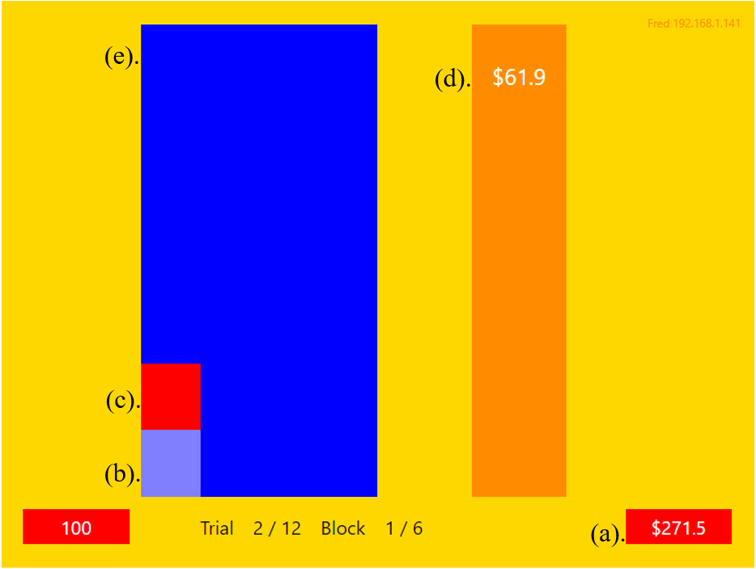
Figure 6. Example of the game interface. (a) Participants available funds, (b) Participants current warehouse stock, (c) Available stock for purchase, (d) Available stock sale price, (e) Participants virtual warehouse.

On each trial, participant’s available funds were written in white text in the 2.4x0.8cm (a visual angle of 2.29˚ and 0.76˚, respectively) box at the bottom right of the display (marked a in Figure 6). With each successful purchase the winning player’s available funds would visually decrease by the purchase amount. A fixed amount of 100 units of stock was available for purchase on each trial. This was displayed in the 5.3x10.6cm (5.06˚ and 10.09˚) box to the left of the display known as the players’ warehouse (marked e in Figure 6). Available stock was displayed as a red bar on top of players’ current stock amount (marked c in Figure 6). This red bar represented the projected change in players’ warehouse stock if they were successful in purchasing the stock available. For the successful player the stock became a part of their warehouse represented by the red bar turning light blue (marked b in Figure 6). While the warehouse stock of the remaining players remained unchanged.
The available-stocks price was visually displayed in the 2.1x10.6cm (2.00˚ and 10.09˚) box to the right of the display (marked d in Figure 6). The available-stocks start price was presented at the top of the box in white text. On each trial, the decreasing price of the available stock was represented both numerically with a count down in the written price and visually with a descending price bar. The starting price was randomly sampled from a uniform distribution between $50 and $150. At any point during a trial a player could bid to purchase the stock ending the trial shown by the decreasing price bar turning green with the decreasing price bar of unsuccessful players turned red on each trial. Players warehouses were deemed full once the light blue block bar reached the top of the box (see Figure 7).
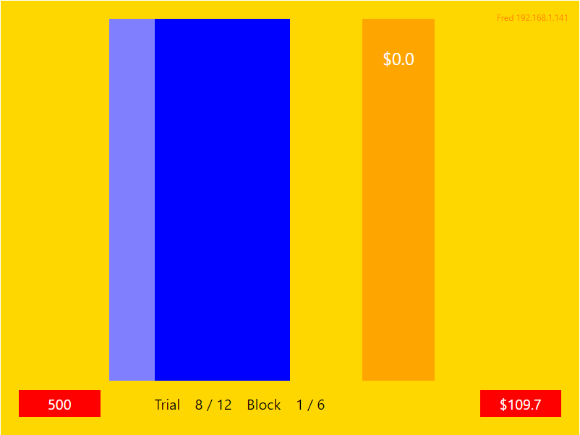
Figure 7. Illustrates the visual display once a participant fills their virtual warehouse to capacity.

At the completion of each block a feedback screen provided participants with information about their performance, including the total amount of stock purchased and their remaining funds (see Figure 8). In the Human competitor condition the feedback screen included the performance of other participants with each player identified as a pseudonym (Fred, Jim or Bob).
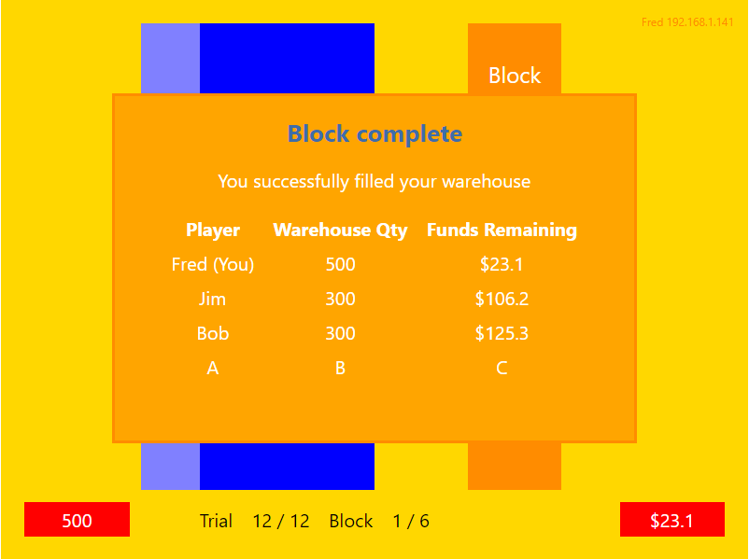
Figure 8. Illustrates the visual display of the feedback screen.

Procedure
Participants were always tested in triplets -- three participants at the same 60 min session. The study took place in the cognitive lab at the University of Newcastle, Callaghan campus in a well-lit testing room with four computers (one for each player plus a control computer for the experimenter). Each participant was seated at individual computer approximately 60cm from the monitor. Participants completed a short demographics questionnaire, followed by detailed instructions of the Dutch auction game on the computer display (complete instructions are available in Appendix E). Participants were asked to imagine they were a store manager who needed to restock their warehouse. They were told that to do this they were to participate in a computer simulated Dutch auction where the price of the stock for sale would decrease over time.
Each participant played the Dutch auction game under four conditions. These were continuous price change against a computer competitor, discrete price change against a computer competitor, continuous price change against two human competitors and discrete price change against two human competitors. Each participant played the four conditions of the Dutch auction game in the following order – the continuous price change against a computer competitor, discrete price change against a computer competitor, continuous price change against two human competitors and discrete price change against two human competitors. This was done for pragmatic reasons (counter balancing could have been appropriate, if possible): a group testing session required three players at the same time, but our participants rarely all arrived on time, forcing us to start with the computer condition to not make the early arrivals wait.
For each of the four conditions participants undertook 6 blocks consisting of 1 practice block followed by 5 testing blocks. Blocks were initiated by the researcher from the control computer, to ensure all players started at exactly the same time. At the beginning of each block participants were set a fixed allocation of funds to purchase stock with the goal of filling their virtual warehouse to capacity by the end of the block. The initial funds and the ultimate warehouse goals differed across conditions.
In the two computer-competitor conditions, Continuous price change against a computer competitor, and Discrete price changes against a computer competitor, participants were allocated $350 each and their warehouse capacity was set at 700 units. In the two human-competitions conditions, Continuous price change against two human competitors, and Discrete price changes against two human competitors, participants were allocated $250 each and their warehouse capacity was set at 500 units.
Each block was comprised of 12 trials with each trial an individual auction. On each trial a fixed number of 100 units of stock was available for purchase with the price of the stock continually decreasing until either the first bid was made guaranteeing that bidder the stock for the current standing price or the trial timed out. To bid participants pressed the ‘spacebar’ key on the keyboard. Each trial ran for a maximum of 5,000 ms with the price of the available stock decreasing from its start price to $0 over this time. Each trial began after a 2,000 ms delay. An example of the progression through a single trial is displayed in Figure 9.
Figure 9. Example of the progression through a single trial.

At the beginning of each block participants available funds reverted to its starting amount and their warehouse stock returned to 0. Participants progression through each condition was visible in black text at the bottom of the display stating the current trial (e.g. Trial 1/12) and block (Block 1/6).
Data Analysis
Data from each practice block was removed before beginning analysis. To allow for comparisons between the discrete and continuous condition in the Step of winning bid we normalised the Step variable in the discrete conditions by multiplying each score by 11. Experimental data was analysed using Matlab and JASP. Matlab was used to conduct t-tests and K-S tests. JASP was used to conduct Bayesian t-tests.
Results and Discussion
Throughout the Results section we report the results of the regular frequentist tests, as well as Bayes Factor (BF). The latter allows us to quantify the evidence supporting the null hypothesis compared to the alternative hypothesis with a BF₀₁ factor of 1 or greater representing evidence in support of the null hypothesis of no difference.
Relationship between Price and Step
The two dependent variables in this study, Price and Step of the winning bid, are naturally related by design. To investigate the relationship between the two measures (and to assess whether they need to both be reported) we calculated the correlation between winning-bid price and winning-bid step in both the discrete and continuous conditions. In the discrete price-change condition there was a significant though weak negative correlation between price and step (r = - .265, p < .001; see scatter plot in Figure 10a). In the continuous price-change condition there was also a significant yet weak negative correlation between price and step (r = - .229, p < .001; see scatter plot in Figure 10b). This analysis suggests only a very small proportion of explained variability across price and step (R² of about 7% and 5%, respectively), so in the following we report both measures.

Figure 10. Scatter plots showing the relationship between Price and Step in the discrete (a) and continuous (b) conditions. The solid line represents the least squared regression line.

Effect of Participant Group
Initial analysis was done separately for each of the five participant groups. To ensure we could collapse the data across participant groups, we examined the effect of participant group on the Price of the winning bid by conducting a one-way between subjects ANOVA for both the discrete and continuous conditions. There was no significant effect of participant group on the Price of the winning bid in either the discrete price change condition, F(4,295) = 0.341, p = 0.850 or the continuous price change condition, F(4,295) = 1.484, p = 0.207 (see means in Figure 11a and 11b, respectively). Thus, we collapsed the price data across participant groups in further analysis.
A similar ANOVA was conducted to examine the effect of participant group on the Step of the winning bid. There was no significant difference between participant groups on the Step of winning bid in either the discrete price change condition, F(4,295) = 0.419, p = 0.795 or the continuous price change condition, F(4,295) = 1.105, p = 0.354 (Figure 11c and 11d). Thus, we collapsed also the step data across participant groups in further analysis.
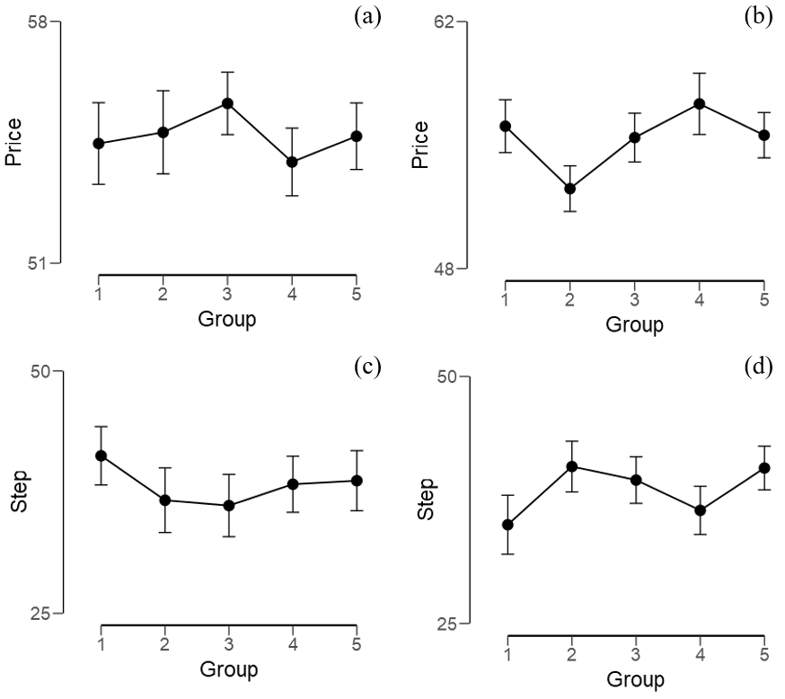
Figure 11. Mean price of the winning bid for each participant group in the discrete (a) and continuous (b) conditions. Mean step of the winning bid for each participant group in the discrete (c) and continuous (d) conditions. The error bars represent one standard error around the mean.

To quantify the evidence supporting the null hypothesis that there was no difference between participant groups in the Price and Step of the winning bid we performed Bayesian ANOVA. This analysis provided very strong support for the lack of difference in the Price of the winning bid between participant groups in the discrete condition (BF₀₁ = 72.11). This analysis also provided strong support for the lack of difference in the Price of the winning bid between participant groups in the continuous condition (BF₀₁ = 11.26).
For Step this analysis provided very strong support for no difference in the Step of the winning bid between participant groups in the discrete condition (BF₀₁ = 63.60). The analysis further provided strong support for no difference in the Step of the winning bid between participant groups in the continuous condition (BF₀₁ = 20.87).
Discrete vs Continuous Price Changes
A two tailed independent samples t-test was conducted to compare the Price of the winning bid in the discrete price-change and continuous price-change conditions. The assumptions of equal variance and normality were violated in both continuous (p < .001) and discrete (p < .001) conditions, so we ran the non-parametric Mann-Whitney U Test. There was no statistically significant difference in the Price of the winning bid between the discrete price-change condition (M = 54.70, SD = 8.12) and continuous price-change condition (M = 55.39, SD = 11.25), U = 42, 927, p = 0.329. Figures 12a and 12b show frequency histograms of Price in continuous and discrete condition, respectively.
A similar, two tailed independent samples t-test, examined the effect of discrete and continuous price changes on the Step of the winning bid. Again, the assumptions of equal variance and normality were violated, so we ran the non-parametric Mann-Whitney U Test. There was no statistically significant difference in the Step of the winning bid between the discrete price-change condition (M = 38.21, SD = 24.03) and continuous price-change condition (M = 38.52, SD = 19.56), U = 44, 763, p = 0.911. Figure 12c and 12d show frequency histograms of Step in continuous and discrete conditions, respectively.
Figure 12. Frequency histograms of the price of the winning bid in the continuous (a) and discrete (b) conditions. Frequency histograms of the step of the winning bid in the continuous (c) and discrete (d) conditions.

Due to the violations in the t-test assumptions we supplemented our analysis with the Kolmogorov–Smirnov test to compare the cumulative distributions of Price of the winning bid in the discrete and continuous conditions. There was no significant difference in cumulative distributions of the Price of the winning bid in the discrete and continuous conditions (D = 0.1, p = 0.093). The results are presented in Figure 13b.
For consistency in analysis we also conducted a Kolmogorov–Smirnov test on the Step of the winning bid in the discrete and continuous conditions (Figure 13a). This showed there was a significant difference in cumulative distributions of the step of the winning bid in the discrete and continuous conditions (D = 0.16, p < .001). However, this result needs to be treated with caution as the variable of Step in the discrete condition had undergone normalisation to allow for comparisons between the discrete and continuous conditions (see Data Analysis section). This has made the variable of Step in the discrete condition to appear continuous despite only having a limited number of possible values.
Figure 13. Cumulative frequency distributions of Step (a) and Price (b) in the Discrete and Continuous conditions.

To quantify the evidence supporting the null hypothesis compared to the alternative hypothesis we performed Bayesian independent samples t-tests on the Price and Step of the winning bid in the discrete and continuous conditions. This analysis provided moderate support for the lack of a difference in the Price of the winning bid between the discrete and continuous conditions (BF₀₁ = 7.65), and strong support for no difference in the Step of the winning bid between the discrete and continuous conditions (BF₀₁ = 10.83).
Effect of Block
We conducted a 2 (Condition: Discrete, Continuous) x 5 (Block: First, Second, Third, Fourth, Fifth) two-way within subjects ANOVA on the mean Price of the winning bid. There was no main effect of condition, i.e., no difference in the Price of the winning bid between the discrete (M = 54.70, SD = 8.12) and continuous conditions (M = 55.39, SD = 11.25), F(1, 4) = 0.539, p = 0.504). There was also no main effect of block, i.e., no difference in the Price of the winning bid between blocks (F(4, 16) = 1.261, p = 0.326). There was no significant interaction between condition and block (F(4, 16) = 0.376, p = 0.822). Means of price across blocks are presented in Figure 14a.
A similar ANOVA was also conducted on the mean Step of the winning bid. There was no main effect of condition, i.e., no difference in the Step of the winning bid between the discrete (M = 38.21, SD = 24.03) and continuous (M = 38.52, SD = 19.56) conditions, F(1, 4) = 0.025, p = 0.881. For the analysis of block the Mauchly’s test of sphericity showed the assumption of sphericity was violated (X² = 2.385e-5, p = 0.008). As the Greenhouse-Geisser epsilon was < .75 (ℇ = 0.594) we used the Greenhouse-Geisser correction. This showed no main effect of block i.e., no difference in the Step of the winning bid between blocks, F(2.376, 9.503) = 1.527, p = 0.268. There was no significant interaction between condition and block, F(4, 16) = 1.270, p = 0.331. Means of Step across blocks are presented in Figure 14b.
Figure 14. Mean price of the winning for each block in the discrete and continuous conditions (a). Mean step of the winning for each block in the discrete and continuous conditions (b). The error bars represent one standard error around the mean.

Looking at Figure 14a and b it is tempting to conclude there is a trend of decreasing average Price and increasing average Step over blocks, but the statistical analysis did not reveal significant difference in Price or Step of winning bid across blocks in either the discrete or continuous condition
Experiment 2 Variable-Unit
Method
The design was similar to Experiment 1, a within-subjects 2 (task: computer competitor, human competitors) x 2 (pattern of price change: discrete, continuous), as depicted in Table 1. Our dependent variables were (i) price step of winning bid (the number of price changes from the onset of the trial until the winning bid for that trial) and (ii) the price of the winning bid. The materials and procedure for Experiment 2 followed closely those of Experiment 1 with minor changes that will be outlined below. For the design please refer again to Experiment 1.
Participants
Fifteen students from the University of Newcastle, Australia, eleven females (M = 22.6 years, SD = 3.4 years) and four males (M = 23.8 years, SD = 2.5 years), who had not participated in Experiment 1, took part in this experiment. All participants used English as their first language, and had normal or corrected to normal vision, including colour vision. Participants completed a single one-hour testing session and were compensated with 2 course credits as part of the SONA system. Participants not enrolled in the SONA system were reimbursed with a $25 shopping voucher.
Materials
Materials were the same as Experiment 1 but the amount of stock available for sale randomly varied between 50 and 150 units of stock with a uniform distribution. An example of the varying stock amounts between trials is shown in Figure 15.
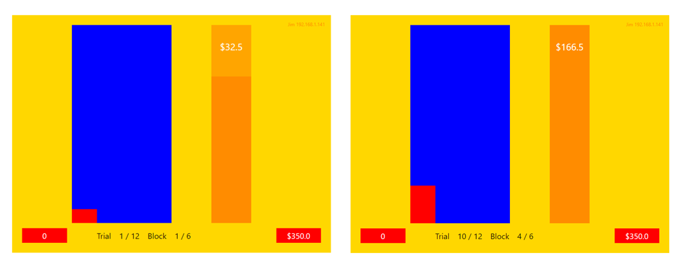
Figure 15. Example display of how available stock varied between trials.

Procedure
Experiment 2 followed the procedure of Experiment 1 except for the following variation. On each trial the amount of available stock for purchase varied between 50 and 150 units with the price of the stock continually decreasing until either the first bid was made guaranteeing that bidder the stock for the current standing price or the trial timed out.
Results and Discussion
Relationship between Price and Step
To investigate the relationship between Price and Step we calculated the correlation between winning-bid price and winning-bid step in both the discrete and continuous conditions. In the discrete price-change condition there was a significant though weak negative correlation between price and step (r = - .181, p = 0.002; see scatter plot in Figure 16a). In the continuous price-change condition there was non-significant weak negative correlation between price and step (r = - .026, p = 0.656; see scatter plot in Figure 16b). This analysis suggests only a very small proportion of explained variability across price and step (R² of about 0.7% and 0.1%, respectively), so in the following we report both measures.
Figure 16. Scatter plots showing the relationship between Price and Step in the discrete (a) and continuous (b) conditions. The solid line represents the least squared regression line.

Effect of Participant Group
Initial analysis was done separately for each of the five participant groups. To ensure we could collapse the data across participant groups, we examined the effect of participant group on the Price of the winning bid by conducting a one-way between-subjects ANOVA for both the discrete and continuous price change conditions. There was no significant effect of participant group on the Price of the winning bid in either the discrete (F(4,295) = 0.366, p = 0.833) or continuous (F(4,295) = 0.562, p = 0.691) conditions, for means see Figure 17a and 17b respectively. Thus, we collapsed the price data across participant groups in further analysis
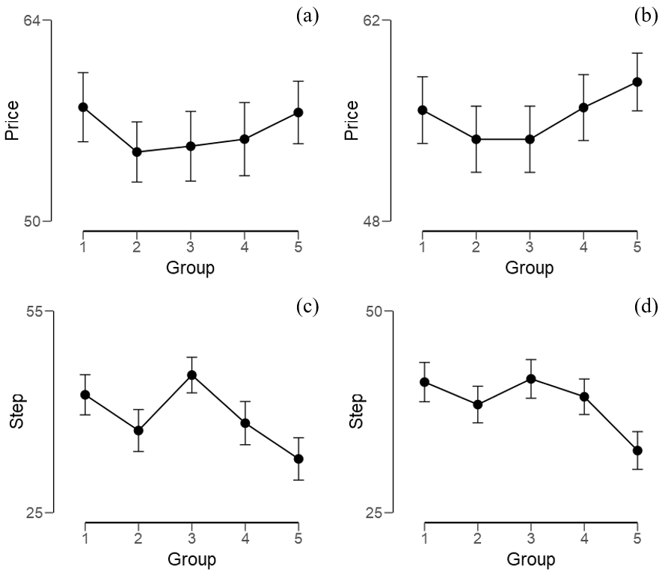
Figure 17. Mean price of the winning bid for each participant group in the discrete (a) and continuous (b) conditions. Mean step of the winning bid for each participant group in the discrete (c) and continuous (d) conditions. The error bars represent one standard error around the mean.

A similar ANOVA was conducted to examine the effect of participant group on the Step of the winning bid. There was a significant effect of participant group on the Step of winning bid in the discrete, F(4,295) = 2.545, p = 0.040, condition, see means in Figure 17c. A post-hoc analysis using the Bonferroni correction for multiple comparisons was conducted to compare every possible pair-wise combination of specific participant groups. There were no significant differences, except for group 5 (M = 33.00, SD = 24.39) that had a significantly lower Step of winning bid compared to participant group 3 (M = 45.47, SD = 20.50), F(4,295) = 2.090, p = 0.039). However, prior to the normalisation of the Step variable in the discrete price change condition this represented a difference of 0.84 Steps (see Table 2). We therefore repeated the ANOVA to compare the effect of participant group on the Step of winning bid using the raw data. The difference between participant group in Step of the winning bid was no longer significant (F(4,295) = 2.326, p = 0.056).
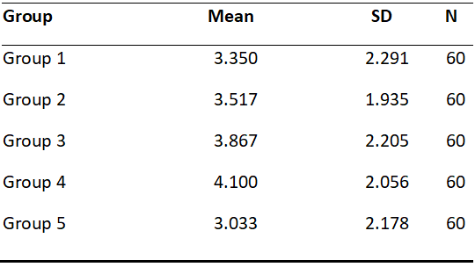
Table 2. Descriptive statistics of step including mean, standard deviation (SD) and sample size (N) for each participant group in the discrete condition using the raw data.

In the continuous price change condition there was no significant effect of participant group on the step of winning bid (F(4,295) = 2.351, p = 0.054), for means see Figure 17d. Combined with the a-priory small number of groups we were able to recruit, we decided to keep Group 5 data in the analysis.
Bayesian ANOVA provided very strong support for the lack of difference in the Price of the winning bid between participant groups in the discrete condition (BF₀₁ = 69.23). This analysis also provided very strong support for the lack of difference in the Price of the winning bid between participant groups in the continuous condition (BF₀₁ = 50.44).
For Step this analysis provided anecdotal support for the lack of difference in the Step of the winning bid between participant groups in the discrete condition (BF₀₁ = 1.99). This analysis also provided anecdotal support for the lack of difference in the Step of the winning bid between participant groups in the continuous condition (BF₀₁ = 2.73).
Discrete vs Continuous Price Change
A two tailed independent samples t-test was conducted to compare the Price of the winning bid in the discrete price change and continuous price change conditions. The assumption of normality in both the continuous (p = 0.010) and discrete (p = 0.023) was violated, so we ran the non-parametric Mann-Whitney U Test. There was no significant difference in the Price of the winning bid between the discrete (M = 56.25, SD = 18.00) and continuous (M = 55.35, SD = 17.36) conditions (U = 43, 713, p .545). Figure 18a and 18b show frequency histograms of Price in continuous and discrete conditions, respectively.
A similar two tailed independent samples t-test, examined the effect of discrete and continuous price changes on the Step of the winning bid. The assumptions of equal variance and normality were again violated in the continuous and discrete conditions (p <.001 in both), so we ran the non-parametric Mann-Whitney U Test. There was no significant difference in the Step of the winning bid between the discrete (M = 39.31, SD = 23.71) and continuous (M = 38.65, SD = 18.20) conditions (U = 43, 198, p = 0.395). Figure 18c and 18d show frequency histograms of Step in continuous and discrete conditions, respectively.
Figure 18. Frequency histograms of the price of the winning bid in the continuous (a) and discrete (b) conditions. Frequency histograms of the step of the winning bid in the continuous (c) and discrete (d) conditions.

We supplemented our t-test analysis with the Kolmogorov–Smirnov test and found no significant difference in cumulative distributions of the Price of the winning bid in the discrete and continuous conditions (D = 0.05, p = 0.838), see Figure 19a.
The Kolmogorov–Smirnov test on the Step of the winning bid in the discrete and continuous conditions showed a significant difference in the cumulative distributions of the step of the winning bid in the discrete and continuous conditions (D = 0.197, p <.001), see Figure 19b. However, this result needs to be treated with caution as the variable step in the discrete price change condition has undergone normalisation to allow for comparisons between the discrete and continuous conditions.
Figure 19. Cumulative frequency distributions of Step (a) and Price (b) in the Discrete and Continuous conditions.

To quantify the evidence supporting the null hypothesis compared to the alternative hypothesis we performed Bayesian independent samples t-tests on the Price and Step of the winning bid in the discrete and continuous conditions. This analysis provided moderate support for there being no difference between the Price of the winning bid in the discrete and continuous conditions (BF₀₁ = 9.08). For Step this analysis provided strong support for there being no difference in the Step of the winning bid between the discrete and continuous conditions (BF₀₁ = 10.24).
Effect of Block
We conducted a 2 (Condition: Discrete, Continuous) x 5 (Block: First, Second, Third, Fourth and Fifth) two-way within subjects ANOVA on the mean Price of the winning bid. There was no main effect of condition, i.e., no difference in the Price of the winning bid between the discrete (M = 56.25, SD = 18.00) and continuous conditions (M = 55.35, SD = 17.36), F(1, 4) = 3.732, p = 0.126). There was also no main effect of block, i.e., no difference in the Price of the winning bid between blocks (F(4, 16) = 0.333, p = 0.852). There was no significant interaction between condition and block (F(4, 16) = 1.149, p = 0.369). Means of price across blocks are presented in Figure 20a.
A similar ANOVA was also conducted on the mean Step of the winning bid. There was no main effect of condition, i.e., no difference in the Step of the winning bid between the discrete (M = 39.31, SD = 23.71) and continuous (M = 38.65, SD = 18.20) conditions, F(1, 4) = 0.502, p = 0.518. There was a main effect of block i.e., there was a difference in the Step of the winning bid between blocks, F(4, 16) = 3.337, p = 0.036. There was no significant interaction between condition and block, F(4, 16) = 1.971, p = 0.148. Means of step across blocks are presented in Figure 20b.
Figure 20. Mean price of the winning for each block in the discrete and continuous conditions (a). Mean step of the winning for each block in the discrete and continuous conditions (b). The error bars represent one standard error around the mean.

General Discussion
As my study constitutes both Platform Development as well as Experimental phases, I will discuss them separately beginning with a discussion of our testing platform followed by discussion of the experimental phases.
Summary of Platform Parameters
Analysis of our testing platform showed the experimental data from the program parameters of start price, unit quantity and computer bid was consistent with the simulation data generated in Matlab. This showed that the program parameters of start price, unit quantity and computer bid were all consistent with the expected values based on the program code. The program code allowed for manipulations to the rate of price changes (i.e. the time between price drops) and the size of price changes (i.e. the amount by which the price drops). This enabled us to program discrete and continuous price change patterns for testing in the experimental phase of this study. Finally, at the end of each block the program provided participants feedback on both their own and competitors bidding performance including the number of units purchased and funds remaining.
Assessment of Platform Development
Our testing platform successfully contained the three fundamental design features (i.e. start price, rate of price change and size of price change) outlined by Cox et al. (1982). Furthermore, our program code allows for the easy manipulation of all three design features. To run a Dutch auction the start price needs to be set at a value greater than any bidder is willing to pay which can vary depending on the value of the item itself (Coppinger et al., 1980). As the testing platform allows for manipulations to the start price parameter it enables this platform to be used in a variety of studies investigating the effect of different start prices of items with varying values. With the successful inclusion of both the rate of price change and size of price change parameters the testing platform allows for manipulations to both the pattern of price changes and the overall length of the auction. Research has consistently shown variations to these factors can have a significant effect on bidding behaviours in Dutch auctions (Lucking-Reiley, 1999; Katok & Kwasnica, 2008). As our platform allows for the manipulation of each parameter separately it has the potential to provide further insights into the effect of specific timing factors on bidding behaviours.
Buchanan et al. (2016) study showed that bidding behaviours changed based on what information bidders had regarding the number of remaining units for sale (certainty vs uncertainty). By enabling manipulations to the unit quantity in the testing platform we have enabled further investigation into the effect of certainty and uncertainty but also the ability to create different versions of the program itself. We did some preliminary tests of this in the experimental phase of this study by creating two versions of the platform one with fixed unit quantity providing certainty and one with variable unit quantity providing uncertainty. However, as the platform currently does not allow bidders to select the number of items they want to purchase in a single auction it cannot be used for the study of multi-unit Dutch auctions. The platform instead uses a sequential design where bidders participate in consecutive single-unit Dutch auctions. This design allows for further investigation into the effect of competitors bidding behaviours because consecutive auctions allows bidders to have the opportunity to adjust their behaviours based on the observations of competitors’ behaviours. A preliminary examination of this feature is discussed in the experimental phase section of this discussion.
Learning can also be facilitated by the inclusion of the feedback screen which is visible to each bidder at the end of each block. An important feature of the feedback screen in this testing platform is that it not only provides bidders feedback on their own performance but also the performance of the competitors. This enables the testing platform to be used to examine the effect of both experiential (i.e. experience through repeated participation) and observational (i.e. viewing the performance of others) learning.
Experimental Phase
In Experiment 1 and Experiment 2, we found no significant difference in the Price of the winning bid between the discrete price change and continuous price change conditions. We also found no significant difference in the Step (i.e. time at which participants bid) of the winning bid between the discrete price change and continuous price change conditions.
In Experiment 1, we found no significant difference in either the Price or Step of the winning bid between testing blocks. In Experiment 2, there was no significant difference in the Price of the winning bid between testing blocks. However, there was a significant difference in the Step of the winning bid between testing blocks.
Effect of Pattern of Price Changes on Bidding Behaviours
The findings of the current study suggest there was no significant difference in the Price or Step of the winning bid between discrete patterns of price changes and continuous patterns of price changes. This suggests the findings obtained by Katok and Kwasnica, (2008) was not the result of differences in patterns of price changes but rather the effect of the overall length of the auction itself.
The study by Katok and Kwasnica, (2008) found that Dutch auctions with slow (i.e. larger time intervals between price decreases) price changes resulted in higher priced winning bids when compared to Dutch auctions with fast (i.e. small time intervals between price decreases) price changes. However, in their study manipulations to the speed of price changes resulted in changes in the overall length of the auctions. The slow price change auction ran for a maximum of 10 minutes while the fast price change auction ran for a maximum of 20 seconds. In the current study by keeping the overall length of the auctions constant between the discrete and continuous price change conditions we focused on the effect of different patterns of price changes rather than the overall length of the auction. As we observed no difference in bidding behaviours between the discrete and continuous condition it appears that it is the overall length of the auction that affects bidding behaviours rather than the pattern of price changes.
Our finding provides support for Katok and Kwasnica, (2008) theory that difference in bidding behaviours is caused by bidders viewing time as a valuable resource which results in a trade-off between time saved and price. In the current study, as the overall length of the auctions were held constant between price change conditions, there was no need for bidders to trade-off between time saved and price. This resulted in similar Price and Step of winning bids between the discrete and continuous price change conditions.
It is important to note that this result may have been affected by the short length of individual auctions used in the current study. Each individual auction in both the discrete and continuous price change conditions ran for a maximum of 5 seconds. It may be possible that the short length of individual auctions did not allow for the perceptual differences in the different patterns of price changes to effect bidding behaviour. This may be particularly relevant to the current study, as differences in the patterns of price changes was only reflected in the written price and not in the decreasing price bar (this was discussed further in platform development). Future research may examine the effect of different patterns of price changes over longer time auctions where the perceptual difference is more clearly conveyed.
Effect of Learning on Bidding Behaviours
The findings of Experiment 1 suggest that that participants did not adjust their bidding behaviour through participation in consecutive auctions. This may have been the result of the overall design of the experiment. In each block participants were asked to use a fixed allocation of funds to purchase stock to fill their virtual warehouse. By providing each participant with $250 to spend and a warehouse capacity of 500 units a participant had to win a total of 5 trials (i.e. auctions) at an average of $50 each to successfully fill their warehouse. Our results suggest participants had already determined this optimal strategy resulting in an average winning bid of around $55 across all blocks in both conditions.
The quick adoption of the optimal bidding strategy by participants may have been the result of the order in which they completed the experimental conditions. As the human competitive condition required all three participants to play the Dutch auction game simultaneously each testing session began with the computer competitive conditions to allow time for late arrivals. By doing this, participants gained substantial experience in the game prior to beginning the human competitive conditions allowing them time to develop their bidding strategy.
Garvin & Kagel (1994) found that inexperienced bidders initially bid earlier at high prices resulting in the winner’s curse but through experience and observations they could adjust their bidding behaviours, reducing the magnitude of the winner’s curse. In the current study it is possible that participants showed similar learning patterns during the computer competitive conditions as they began these conditions as inexperienced bidders. However, as we did not examine the results of these conditions it remains unclear if participants adjusted their behaviour in the current study. For a better understanding into the effect of learning future research would need to better counterbalance experimental conditions.
While Experiment 2 findings were consistent with Experiment 1 in the Price of the winning bid, its findings did differ in the Step of the winning bid. Experiment 2 showed a significant difference in the Step of the winning bid between testing blocks. This suggests the time point at which the winning bid was placed varied significantly between blocks in Experiment 2. This finding is most likely the result of the significant difference between participant groups in the Step of the winning bid. Our results showed participant group 5 had a significantly lower average Step of winning bid compared to participant group 3. However due to our small sample size participant group 5 was not excluded from further analysis. Therefore, this result must be treated with caution as it may only be the reflection of variance of a specific participant group rather than an overall difference.
Limitations of the Current Study
A major limitation of the current study was that the small sample size. While sufficient for preliminary testing of the platform, it was insufficient to allow for extensive analysis of bidding behaviours during the experimental phase. The sample size is particularly important in the study of Dutch auctions as in these studies multiple participants are required to run an auction but we only obtain data from the winning bidder on each auction.
The current study was also limited by the extremely short auction times. The time frame of each testing session only allowed for short duration auctions of maximum length of 5 seconds. This may have affected our ability to observe difference in the patterns of price changes as individual auctions may have been too short to allow for perceptual differences to affect bidding behaviour. This problem may have been heightened by the way the graphical interface displayed price changes. Currently, the decreases in price are represented numerically with the written price and graphically with a decreasing price bar. However, the testing platform only reflects differences in patterns of price changes in the written price and not in the decreasing price bar (the price bar decreases continuously in both pattern of price change conditions). This may have affected participants perception of the different patterns of price changes. If participants only focused on the decreasing price bar during the auction there would have appeared to be no difference in the discrete and continuous price conditions.
In the design of our testing platform we included a computer competitor known as the computer bid parameter. In its current form the computer competitor has only basic functionality with no bidding goals or constraints (e.g. warehouse capacity or limitations on available funds). While further development of this feature was outside the scope of the current study the way we have designed the computer competitor in the program code allows for manipulations to its bidding strategy. This will enable future researchers to implement different bidding models for the computer competitor based on the individual requirements of their study. However, a limitation of the computer competitor parameter is that currently the testing platform only allows for a single computer competitor. As the number of competitors has been shown to influence bidding behaviours it is important that future development of this testing platform allows for the manipulation to the number of computer competitors.
Conclusion and Future Directions
The current study aimed to develop a computerised testing platform to investigate how different design parameters affect the decision-making processes involved within a Dutch auction. The testing platform that we developed successfully enables researchers to manipulate a range of design parameters that have been identified as affecting bidding behaviours (Adams et al., 2017). It also integrates these design parameters into a single graphical interface that is engaging, easily understood and conveys relevant information to participants.
The experimental phase of this study showed no significant effect of different patterns of price changes on the Price or Step of the winning bid. Our findings also showed no difference in the Price or Step of the winning bid between testing blocks. This suggests participants did not change their bidding behaviours through experience. While Experiment 2 did show a significant difference in the Step of the winning bid between blocks this was most likely due to individual group differences. The constraints of the testing methodology and the preliminary nature of our platform may have contributed to the lack of significant effects. Further investigation is required to better understand the effect of different patterns of price changes and experience on bidding behaviours within Dutch auctions.
The experimental phase of this study enabled us to identify specific areas of the platform design which require further development to enhance its utility as a research tool. In particular improvements to the graphical interface to ensure relevant information is clearly conveyed to participants. Further development of the computer competitor is required so that more realistic bidding models can be implemented and tested against human competitors. Overall, our testing platform provides an exciting avenue for future research into Dutch auctions.

References
Adam, M. T., Eidels, A., Lux, E., & Teubner, T. (2017). Bidding Behavior in Dutch Auctions: Insights from a Structured Literature Review. International Journal of Electronic Commerce, 21(3), 363-397.
Adam, M. T. P., Krämer, J., & Weinhardt, C. (2012). Excitement Up! Price Down! Measuring Emotions in Dutch Auctions. International Journal of Electronic Commerce, 17(2), 7-40.
Buchanan, J., Gjerstad, S., & Porter, D. (2016). Information Effects in Uniform Price Multi-Unit Dutch Auctions. Southern Economic Journal, 83(1), 126-145. doi:10.1002/soej.12145
Cassady, R. (1967). Auctions and auctioneering: University of California Press.
Coppinger, V. M., Smith, V. L., & Titus, J. A. (1980). INCENTIVES AND BEHAVIOR IN ENGLISH, DUTCH AND SEALED‐BID AUCTIONS. Economic inquiry, 18(1), 1-22.
Cox, J. C., Roberson, B., & Smith, V. L. (1982). Theory and behavior of single object auctions. Research in experimental economics, 2(1), 1-43.
Easley, D., & Kleinberg, J. (2010). Networks, crowds, and markets: Reasoning about a highly connected world: Cambridge University Press.
Easley, R. F., Wood, C. A., & Barkataki, S. (2010). Bidding patterns, experience, and avoiding the winner's curse in online auctions. Journal of Management Information Systems, 27(3), 241-268.
Garvin, S., & Kagel, J. H. (1994). Learning in common value auctions: Some initial observations. Journal of Economic Behavior & Organization, 25(3), 351-372.
Kagel, J. H., & Levin, D. (1986). The winner's curse and public information in common value auctions. The American Economic Review, 894-920.
Kahneman, D., & Tversky, A. (1979). Prospect theory: An analysis of decision under risk. Econometrica: Journal of the Econometric Society, 263-291.
Kahneman, D., & Tversky, A. (1984). Choices, values, and frames. American psychologist, 39(4), 341.
Katok, E., & Kwasnica, A. M. (2008). Time is money: The effect of clock speed on seller’s revenue in Dutch auctions. Experimental Economics, 11(4), 344-357.
Ku, G., Malhotra, D., & Murnighan, J. K. (2005). Towards a competitive arousal model of decision-making: A study of auction fever in live and Internet auctions. Organizational Behavior and Human Decision Processes, 96(2), 89-103.
Lind, B., & Plott, C. R. (1991). The winner's curse: experiments with buyers and with sellers. The American Economic Review, 81(1), 335-346.
Lucking-Reiley, D. (1999). Using field experiments to test equivalence between auction formats: Magic on the Internet. American Economic Review, 1063-1080.
Milgrom, P. (1989). Auctions and bidding: A primer. The Journal of Economic Perspectives, 3(3), 3-22.
Mochón, A., & Sáez, Y. (2015). Understanding auctions: Springer.
Nakajima, D. (2011). First-price auctions. Dutch auctions, and buy-it-now-prices with Allais paradox bidders, 6(3).
Rafaeli, S., & Noy, A. (2005). Social Presence: Influence on Bidders in Internet Auctions. Electronic Markets, 15(2), 158.
Thomas, L. C. (2012). Games, theory and applications: Courier Corporation.
Turocy, T. L., Watson, E., & Battalio, R. C. (2007). Framing the first-price auction. Experimental Economics, 10(1), 37-51.
Van Den Bos, W., Li, J., Lau, T., Maskin, E., Cohen, J. D., Montague, P. R., & McClure, S. M. (2008). The value of victory: social origins of the winner's curse in common value auctions. Judgment and decision making, 3(7), 483.
Vickrey, W. (1961). Counterspeculation, auctions, and competitive sealed tenders. The Journal of finance, 16(1), 8-37.

Appendix A. Glossary of Key Terms

Term | Definition
Dutch Auction | descending price auction where an items price is decreased from begins at a set maximum price until a bidder accepts the current price purchasing the item.
Winner’s Curse | The price of the winning bid exceeds the value of the item been auctioned.
Common Value Auctions | the value of the item is the same for all bidders, but bidders do not know this value and thus base their bids on their own information and private valuations
Competitive arousal | Heightened emotional arousal caused by perceived competition
Multi-unit Dutch Auction | Many homogenous items are for sale within the same auction. The first to bid identifies the number of items they wish to purchase at that price. The auction then continues with the remaining items until all are sold
First-Price Sealed-Bid Auctions | auctions bidders submit a bid by a set time. After this time the bids are examined with the highest priced bid winning the item.
Discrete Price Changes | large decreases in prices slowly over time resulting in perceived jumps in price
Continuous Price Changes | small decreases in prices quickly over time resulting in what is perceived to be as a smooth change in price.
Price | The price of the winning bid.
Step | The number of price changes that has occurred from the auction start price to the first bid. Represents the time of the winning bid.

Appendix B. Notices of Ethical and Methodological Approval


HUMAN RESEARCH ETHICS COMMITTEE

Notification of Expedited Approval

To Chief Investigator or Project Supervisor: | Doctor Ami Eidels
Cc Co-investigators / Research Students: | Miss Rachel Mullard
 | Mr Paul Garrett
 | Doctor Marc Adam
Re Protocol: | Competitive Decision Making
Date: | 17-Jul-2017
Reference No: | H-2017-0192
Date of Initial Approval: | 17-Jul-2017

Thank you for your Response to Conditional Approval (minor amendments) submission to the Human Research Ethics Committee (HREC) seeking approval in relation to the above protocol.

Your submission was considered under Expedited review by the Ethics Administrator.

I am pleased to advise that the decision on your submission is Approved effective 17-Jul-2017.

In approving this protocol, the Human Research Ethics Committee (HREC) is of the opinion that the project complies with the provisions contained in the National Statement on Ethical Conduct in Human Research, 2007, and the requirements within this University relating to human research.

Approval will remain valid subject to the submission, and satisfactory assessment, of annual progress reports. If the approval of an External HREC has been "noted" the approval period is as determined by that HREC.

The full Committee will be asked to ratify this decision at its next scheduled meeting. A formal Certificate of Approval will be available upon request. Your approval number is H-2017-0192.

If the research requires the use of an Information Statement, ensure this number is inserted at the relevant point in the Complaints paragraph prior to distribution to potential participants You may then proceed with the research.

Conditions of Approval

This approval has been granted subject to you complying with the requirements for Monitoring of Progress, Reporting of Adverse Events, and Variations to the Approved Protocol as detailed below.

PLEASE NOTE:

In the case where the HREC has "noted" the approval of an External HREC, progress reports and reports of adverse events are to be submitted to the External HREC only. In the case of Variations to the approved protocol, or a Renewal of approval, you will apply to the External HREC for approval in the first instance and then Register that approval with the University's HREC.

- Monitoring Progress

Other than above, the University is obliged to monitor the progress of research projects involving human participants to ensure that they are conducted according to the protocol as approved by the HREC. A progress report is required on an annual basis. Continuation of your HREC approval for this project is conditional upon receipt, and satisfactory assessment, of annual progress reports. You will be advised when a report is due.

Reporting of Adverse Events
- It is the responsibility of the person first named on this Approval Advice to report adverse events.

- Adverse events, however minor, must be recorded by the investigator as observed by the investigator or as volunteered by a participant in the research. Full details are to be documented, whether or not the investigator, or his/her deputies, consider the event to be related to the research substance or procedure.
- Serious or unforeseen adverse events that occur during the research or within six (6) months of completion of the research, must be reported by the person first named on the Approval Advice to the (HREC) by way of the Adverse Event Report form (via RIMS at https://rims.newcastle.edu.au/login.asp) within 72 hours of the occurrence of the event or the investigator receiving advice of the event.
- Serious adverse events are defined as:

Causing death, life threatening or serious disability.

Causing or prolonging hospitalisation.

Overdoses, cancers, congenital abnormalities, tissue damage, whether or not they are judged to be caused by the investigational agent or procedure.
Causing psycho-social and/or financial harm. This covers everything from perceived invasion of privacy, breach of confidentiality, or the diminution of social reputation, to the creation of psychological fears and trauma.

Any other event which might affect the continued ethical acceptability of the project.

5. Reports of adverse events must include:

Participant's study identification number;

date of birth;

date of entry into the study;

treatment arm (if applicable);

date of event;

details of event;

the investigator's opinion as to whether the event is related to the research procedures; and action taken in response to the event.

- Adverse events which do not fall within the definition of serious or unexpected, including those reported from other sites involved in the research, are to be reported in detail at the time of the annual progress report to the HREC.

Variations to approved protocol
If you wish to change, or deviate from, the approved protocol, you will need to submit an Application for Variation to Approved Human Research (via RIMS at https://rims.newcastle.edu.au/login.asp). Variations may include, but are not limited to, changes or additions to investigators, study design, study population, number of participants, methods of recruitment, or participant information/consent documentation. Variations must be approved by the (HREC) before they are implemented except when Registering an approval of a variation from an external HREC which has been designated the lead HREC, in which case you may proceed as soon as you receive an acknowledgement of your Registration.
Linkage of ethics approval to a new Grant

HREC approvals cannot be assigned to a new grant or award (ie those that were not identified on the application for ethics approval) without confirmation of the approval from the Human Research Ethics Officer on behalf of the HREC.

Best wishes for a successful project.

Associate Professor Helen Warren-Forward

Chair, Human Research Ethics Committee

For communications and enquiries:

Human Research Ethics Administration

Research & Innovation Services

Research Integrity Unit

NIER, Block C

The University of Newcastle

Callaghan NSW 2308

T +61 2 492 17894

Human-Ethics@newcastle.edu.au

RIMS website - https://RIMS.newcastle.edu.au/login.asp

Methodology Approval for 4th Year Research Project in Psychology 2017
Student to complete this section prior to submitting form for review:

Project Title: Effect of Competition in Speeded Decision-Making Tasks

Supervisor: Ami Eidels

Student Researcher: Rachel Mullard

I declare that the above research protocol has been peer reviewed by the 4th year Methodology Review Panel consisting of the 4th year coordinators and staff from the School of Psychology.

Name:
A/Prof Frances Martin

Fourth Year Coordinator
Position:
School of Psychology


Signature:

Date: 6/5/2017

The panel is satisfied that the project:

- is suitable for an Honours thesis in Psychology

- is methodologically sound

- has a suitable design to address the research questions

- is realistic and achievable

- will yield useable data

Any methodological limitations that have been raised by the Panel but cannot be addressed due to practical reasons or that arise during the course of the research and require deviation from the approved protocol must be addressed in the submitted Critical Review and/or Research Report.

Where any major deviations in paradigm or research question arise after this approval has been signed, it is the student’s responsibility to bring them to the attention of the 4th year research coordinator and gain approval of the revised project.

Appendix C. Information Statement and Consent Form

Dr Ami Eidels
School of Psychology / Faculty of Science
AVG-21 Aviation Building, University of Newcastle, Callaghan, NSW 2308, Australia
Telephone: (02) 4921 7089
Ami.Eidels@newcastle.edu.au

Information Statement for the Research Project:
Competitive Decision-Making – The Dutch Auction Game
Document Version 4; dated 01/09/2017
We would like to invite you to participate in the above research project. This project is being conducted by Rachel Mullard under the supervision of Dr Ami Eidels from the School of Psychology at the University of Newcastle, Callaghan campus in conjunction with researchers Marc Adam and Paul Garrett. This project will be used to fulfil the requirements of the Bachelor of Psychology for Rachel Mullard.
Why is the research being done?
The aim of this research is to investigate the effect that social competition has on decision-making. Specifically, this project will examine the decision-making processes in speeded decision tasks performed while in competition with other participants. This research will contribute to a wider understanding of decision-making processes, in particular those processes involved in the speed-accuracy trade-off.
Who can participate in the research?
We are seeking participants over the age of 18. We require that participants have normal or corrected normal vision with intact colour vision. Also, that you are fluent in both written and spoken English.
You should not volunteer for this study if you have: any history of or ongoing mental illness, any serious past head trauma, any current use of medications that might affect your ability to perform the computerised tasks, any history of seizures or epilepsy.
What choice do you have?
Participation in this research is completely voluntary. Only people who give their informed consent will be included in this study. If you choose to participate you can, at any time during the study withdraw without explanation and with no consequence. You will also have the option to withdraw any data you have provided.
What would you be asked to do?
If you meet the above inclusion criteria for this study and consent to participate you will be asked to attend one or two 1-hour in-lab testing sessions. If you participate in two sessions they will be held on separate days. On arrival for the first testing session you will be asked to complete a short demographics questionnaire. Once completed the researcher will sit you in a room with a computer to complete the computer based task ‘the Dutch auction game’.
In ‘the Dutch auction game’ participants will play a computer based task which uses a simulated Dutch auction format. In this game participants will have a fixed allocation of funds in which to purchase a set target number of items. In each trial participants will be presented with varying amounts of the target item with a set maximum starting price. Over a fixed timed trial, the price of the product will slowly reduce until either a participant purchases the product for the current displayed price or the trial times out. Responding will be done using designated response keys on the keyboard. In one testing session, this will be done in isolation. In the other session, the task will be done in the presence and in competition with other participants.
This study will take place in the cognitive lab in the Aviation building at the Callaghan Campus of the University of Newcastle.
How much time will it take?
Participation in one session takes approximately 60 minutes. Participation in two sessions will take approximately 120 minutes in total.
What are the risks and benefits of participating?
The computerised task in this project requires prolonged periods of sitting still while maintaining high levels of concentration which may result in some mild physical discomfort and minor fatigue. To minimise these risks there will be several breaks throughout both testing sessions.
Furthermore, some participants may find the competitive phase of the study distressing due to the increased level of stress the presence of competitors may cause. To combat this every participant will be debriefed at the conclusion of the study. All participant will also be able withdraw from the study at any point without explanation or penalty with the option of removing their data.
Students who are participating as a part of the research awareness component of their undergraduate courses will be compensated with 2 SONA points per 1-hour session, 4 SONA points if you participate in two sessions. Participants not a part of this system will be reimbursed with a $25 voucher per session.
Aside from specific reimbursements mentioned above there is no direct benefit to the individual. However, participants may benefit from gaining an understanding of the research process. For the broader scientific community, this study will contribute better understanding of the processes involved in decision making while in social contexts.
How will your privacy be protected?
All data collected in this study will be stored digitally on a secure server at the University of Newcastle. Only the research team which includes project supervisor Dr Ami Eidels, student researcher Rachel Mullard as well as contributing researchers Marc Adam and Paul Garrett will have access to the data. Any publications resulting from this study will use only de-identified data.
How will the information collected be used?
The data collected in this study will be analysed to examine the decision-making processes that occur when in the presence of social competition compared to those in isolation. You will be asked by the researcher if you would like to receive a summary of the results via email once available. Individual participants will not be identifiable in any academic work resulting from this study. Data from this project will be reported in Rachel’s thesis and presented as part of the Fourth Year Conference. Data will be retained for at least five years following publication. Any information that may identify any individual participant will be recorded and stored separately from the data in a secure location at the University of Newcastle using coded reference numbers known only to the research team. Furthermore, non-identifiable data may be shared with other parties to further research or as required by law.
What do you need to do to participate?
Please ensure you have read this information statement and understand its contents before you consent to participate. If there is anything you do not understand, or if you have any questions, contact the researcher.
To participate via SONA, please log on to the SONA Research Participant System website, select our study and select a session time. Once you have booked a session you will be sent a confirmation email. A reminder email will be sent to you closer to the date of your selected session time through SONA, or you will be contacted by a researcher to confirm participation. If you need to cancel or reschedule your session time this can be done through the SONA System website. However, if you need to cancel or reschedule within 24 hours of your session time, do not use the SONA system and please contact Rachel Mullard directly. Written consent will be recorded at the beginning of your booked session. If you experience any other problems with booking, please contact Rachel Mullard (Rachel.Mullard@uon.edu.au).
Concerns raised by the study
If you are concerned about your participation in this experiment, or if you are experiencing any distress in relation to this, please contact counselling services available at Newcastle University to make an appointment either at the Callaghan campus on 4921 5801, or at Ourimbah campus on 4348 4060. For assistance when the offices are closed please contact Lifeline on 13 11 14.
Further information
If you would like further information, please contact Rachel Mullard at Rachel.Mullard@uon.edu.au

Thank You for consideration

Complaints about this research
This project has been approved by the University’s Human Research Ethics Committee [H-2017-0192].

Should you have concerns about your rights as a participant in this research, or you have a complaint about the manner in which the research is conducted, it may be given to the researcher, or, if an independent person is preferred, to the Human Research Ethics Officer, Research & Innovation Services, The University of Newcastle, University Drive, Callaghan NSW 2308, Australia, telephone (02) 4921 6333, email Human-Ethics@newcastle.edu.au.



Dr Ami Eidels
School of Psychology / Faculty of Science
AVG-21 Aviation Building, University of Newcastle,
Callaghan, NSW 2308, Australia
Telephone: (02) 4921 7089
Ami.Eidels@newcastle.edu.au

Consent Form for the Research Project (version 2, updated 10/7/2017):
Competitive Decision-Making
Dr Ami Eidels
Rachel Mullard
Marc Adam
Paul Garrett
I agree to participate in the above research project being conducted by Rachel Mullard under the supervision of Dr Ami Eidels (School of Psychology).

I give my consent by signing this form to participate in the Competitive Decision-Making research project. I understand that:

- I have been given an information sheet describing how the study will be conducted.

- My consent to participate is voluntary and I am free to withdraw from the study at any point without explanation or penalty.

- Any information I provide researchers with be completely confidential and de-identified with only the research team having access to the data.

- This project may be used for publication purposes.

I, (Please print name) __________________________________________ have read and understand the information above. I have been given a copy the information statement to keep. I have asked any questions I have and had them answered to my satisfaction.

Signature: _________________________________________ Date: _______________

Enquiries about this study may be directed to Dr. Ami Eidels, School of Psychology, Faculty of Science, The University of Newcastle, telephone: (02) 4921 7089.
Appendix D. Demographics Questionnaire

Demographics

Gender: ______________________ Age:_________________________

Handedness (Left/Right): _______________________________________

Normal to Corrected Normal Vision: YES / NO

Intact Colour Vision: YES / NO

Appendix E. Experiment 1 Fixed-Unit PowerPoint Instructions

Slide 1
Slide 2
Slide 3

Slide 4
Slide 5
Slide 6

Slide 7
Slide 8
Slide 9
Slide 10
Slide 11
Slide 12

Slide 13

Appendix F. Experiment 2 Variable-Unit PowerPoint Instructions

Slide 1
Slide 2
Slide 3

Slide 4
Slide 5
Slide 6

Slide 7
Slide 8
Slide 9

Slide 10
Slide 11
Slide 12

Slide 13



