Melanoma GRT study

* The experiment is a perceptual judgment task that asks you to judge a skin lesion image as being “greater” or “lesser” along **two** specific perceptual dimensions compared to a reference image. For example, you may be asked to judge the skin lesion according to the two dimensions of (i) shape symmetry and (ii) border regularity.
* The experiment runs online so you’ll need a computer, browser, and an internet connection – Firefox and Chrome are recommended, but other browsers should be fine. I have a step-by-step guide (with images) below on setting up the experiment and downloading the data.
* **The data does not save automatically**, so please read through these instructions entirely before running the experiment.

**Loading the study**

1. Open a browser (preferably Chrome or Firefox) and go to <https://labjs.felixhenninger.com/>.
2. On the top left of the screen, select the dropdown arrow (to the right of the floppy disk/save icon) and select “Open” – see the light-blue highlights in Figure 1.

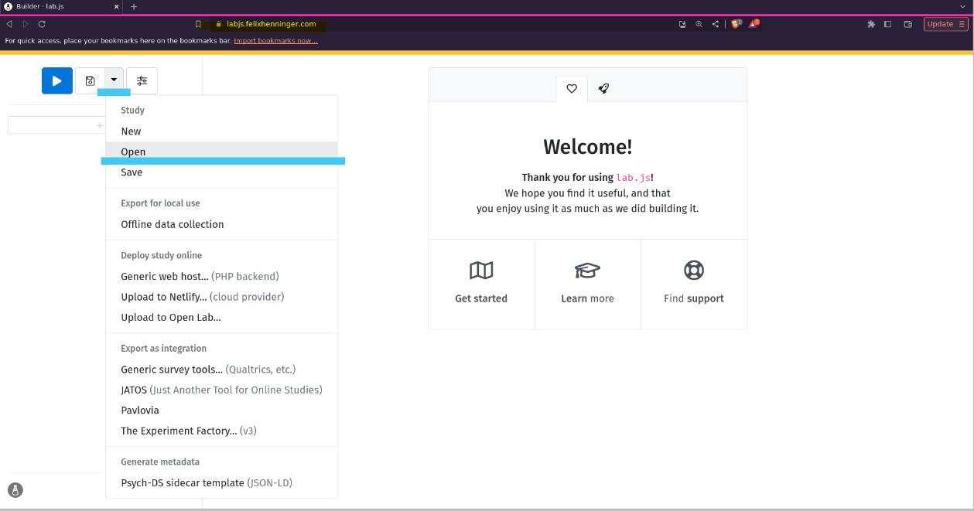

Figure 1. Lab JS Experiment Builder Webpage. Select the dropdown arrow in the top right and click 'Open' (blue highlight).

1. A pop-up window will appear. Navigate to where you saved the “XX_melanoma-grt.study.json” file and select it to load the experiment (see Figure 2).

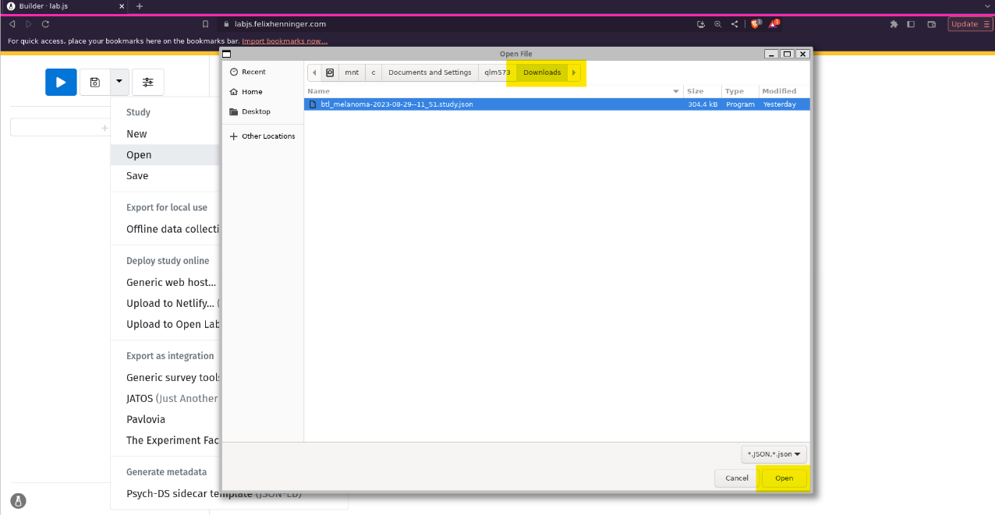

Figure 2. A pop-up window will appear for you to select the experiment file. Navigate to where you saved the file (mine is in my 'Downloads' folder, but yours is where you saved it in Step 1.

1. When you are ready, have 45-60 minutes, and have read through these instructions on how to save the data, click on the big blue ‘play’ button in the top left (highlighted in yellow in Figure 3).

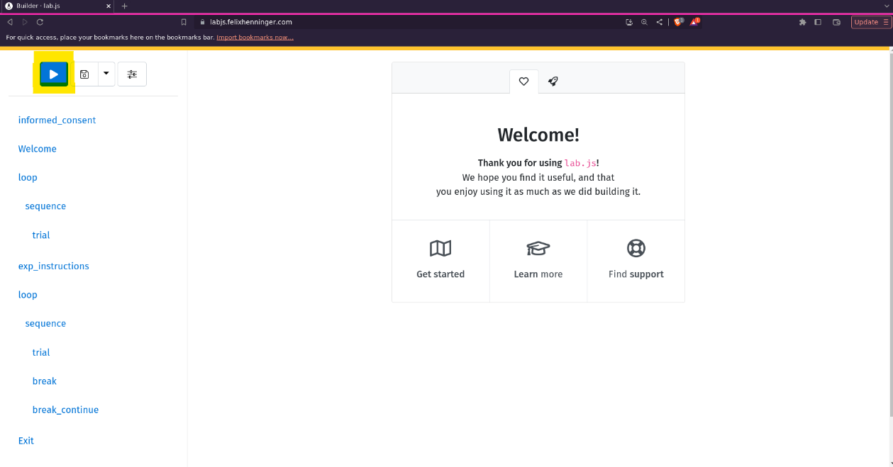

Figure 3. Experiment successfully loaded. Press 'Play' to begin!

1. The experiment will open in a pop-up window (Figure 4). If your browser is set to block pop-ups, you may need to switch browsers or allow popups in your browser settings. Follow the onscreen prompts and have fun!

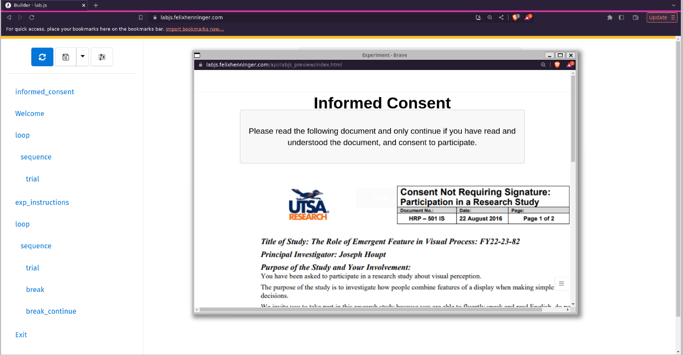

Figure 4. The experiment loads in a pop-up window. Please maximise the window and continue.

1. You will be shown an ‘Exit screen’ at the end of the experiment. **Please do not exit!** Click on the green ‘Credit’ button – a ‘*Download data*’ tab drops down from the top of the screen (see Figure 5). **Click on the ‘*Download data*’ tab** **to save the data**. The data will save automatically to your Downloads folder each and every time you click the tab, so once should be enough.
2. Check your “Downloads” folder for a brand-new file (e.g., XX-melanoma-grt-07/07/2024--14_02_08.csv – the date and time will reflect when you completed it).

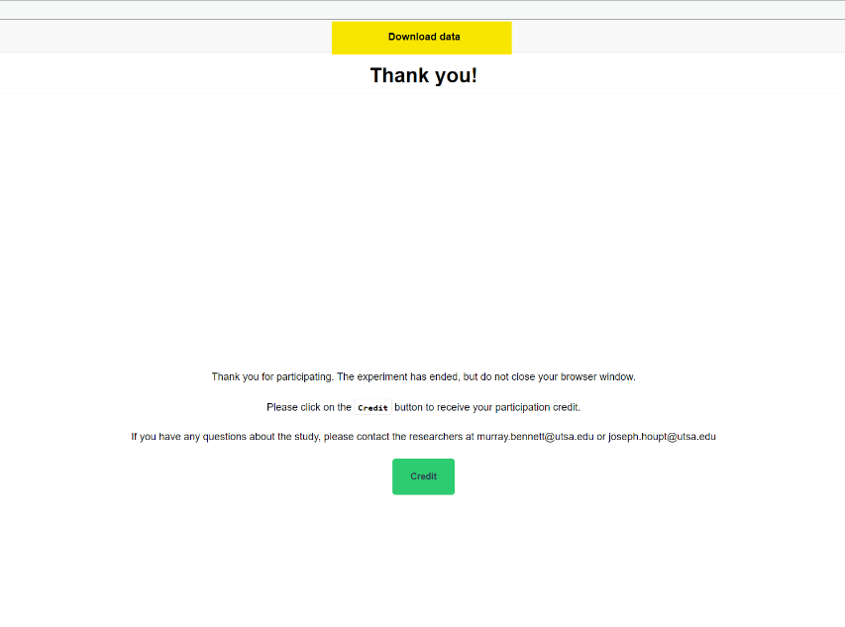

Figure . Exit screen. Please do not close the window. Please DO click the 'Credit' button. A prompt to download your data will then appear at the top of the screen (yellow highlight). **Click the download data tab.**