|  |  |  |
| --- | --- | --- |
|  | **CMPS 312 Project Phase 1 – UI Design and Implementation**  **(20% of the course grade)** | |
| **Group Id:** | |  |
| **Group Members:** | | Murshed AL-Muhannadi  Saoud AL-Rumaihi  Mohammed Al-Sayegh  **Emails:**  Murshed [ma1706102@qu.edu.qa](mailto:ma1706102@qu.edu.qa)  Saoud sa1707776@qu.edu.qa |

**Grading Rubric - In the Functionality column please specify either: *Working (completed x%)*, *Not Working (completed x%)* or *Not done*.**

|  |  |  |  |  |
| --- | --- | --- | --- | --- |
| Criteria | | % | Functionality* | Quality of the implementation |
| 1. **Application Design:** Repositories or Providers Class Diagram | | 5% |  |  |
| **2) Design and implement** | | **90%** |  |  |
|  | U1 – Login | 5 |  |  |
| U2 - YalaPay Dashboard | 5 |  |  |
| U3 - List/Search/Add/ Update and Delete a customer:  1. List Customers (5 pts)  2. Search Customers (4 pts)  3. Add Customer (6 pts)  4. Update Customer (4 pts)  5. Delete Customer (3 pts) | 22 |  |  |
| U4 - List/Search/Add/ Update and Delete an Invoice  1. List Invoices (5 pts)  2. Search Invoices (4 pts)  3. Add Invoice (6 pts)  4. Update Invoice (4 pts)  5. Delete Invoice (3 pts) | 22 |  |  |
| U5 - List/Search/Add/ Update and Delete payments for an invoice  1. List Payments (5 pts)  2. Search Payments (4 pts)  3. Add Payment (8 pts)  4. Update Payment (5 pts)  5. Delete Payment (3 pts) | 25 |  |  |
| U6 - Manage Cashing Cheques  1. Add Cheques Deposit (10 pts)  2. List Cheque Deposits (5 pts)  3. Update Cheques Deposit (15 pts) | 30 |  |  |
| U7 - Invoices Report | 8 |  |  |
| U8 - Cheques Report | 8 |  |  |
| **3) Testing documentation** using screen shots illustrating the app testing.  - Discussion of the project contribution of each team member [-10pts if not done] | | 5% |  |  |
| **Total** | | 100 |  |  |
| Copying and/or plagiarism or not being able to explain or answer questions about the implementation | | -  100 |  |  |

**\* Possible grading for functionality** - ***Working*** (get 70% of the assigned grade), ***Not*** ***working*** (lose 40% of assigned grade and ***Not done*** (get 0). The remaining grade is assigned to the quality of the implementation.

In case your implementation is not working then 40% of the grade will be lost and the remaining 60% will be determined based on of the code quality and how close your solution to the working implementation.

Solution quality also includes meaningful naming of identifiers (according to Flutter/Dart naming conventions), no redundant code, simple and efficient design, clean implementation without unnecessary files/code, use of comments where necessary, proper code formatting and indentation.

**Marks will be reduced** forcode duplication, poor/inefficient coding practices, poor naming of identifiers, unclean/untidy submission, and unnecessary complex/poor user interface design.

# Application Design – Repositories or Providers Class Diagram

User class:

Invoice class:

Customer class

Payment class:

Cheque class

Cheque Deposit class

Customer Provider

Invoice Provider

Cheque Provider

User Provider

Cheque Deposit Provider

# Testing

# U1 – Login

# U2 - YalaPay Dashboard

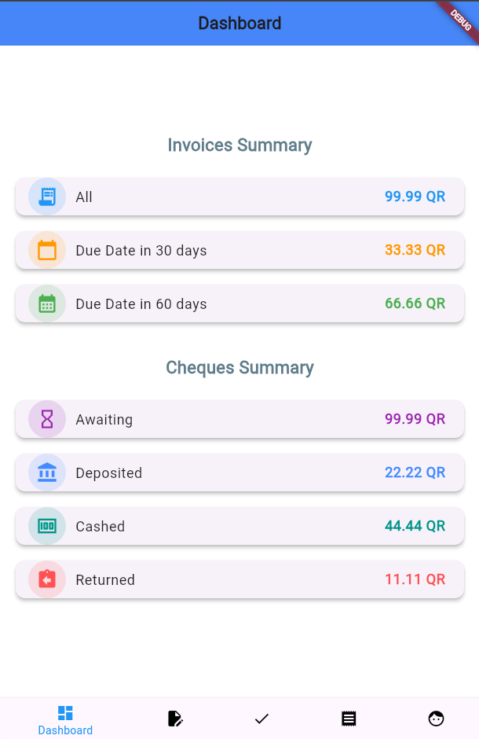

# U3 - List/Search/Add/ Update and Delete a Customer

# List Customers

1. A screenshot of a computer

   Description automatically generated

# Search Customers

1. A screenshot of a phone

   Description automatically generated

# Add Customer

1. A screenshot of a phone

   Description automatically generated

# Update Customer

1. A screenshot of a phone

   Description automatically generated

# Delete Customer

1. A screenshot of a phone

   Description automatically generated

# U4 - List/Search/Add/ Update and Delete an Invoice

# List Invoices

1. A screenshot of a phone

   Description automatically generated

# Search Invoices

1. A screenshot of a phone

   Description automatically generated

# Add Invoice

1. A screenshot of a phone

   Description automatically generated

# Update Invoice

1. A screenshot of a phone

   Description automatically generated

# Delete Invoice

1. 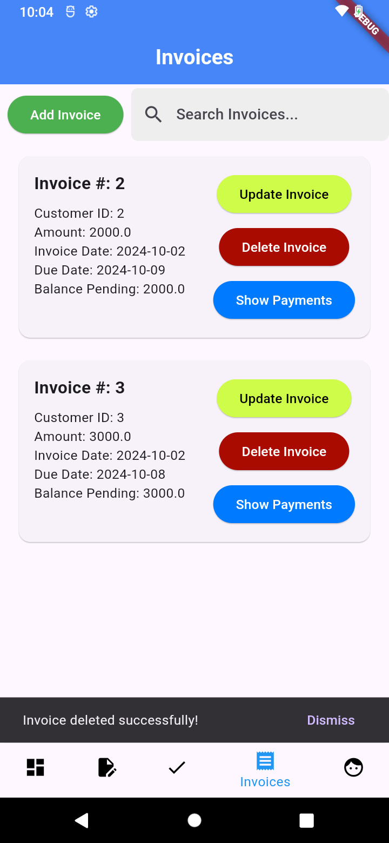

# U5 - List/Search/Add/ Update and Delete payments for an invoice

# List Payments

1. A screenshot of a phone

   Description automatically generated

# Search Payments

# Add Payment

1. A screenshot of a computer

   Description automatically generated

# Update Payment

1. A screenshot of a phone

   Description automatically generated

**Delete Payment**

# U6 - Manage Cashing Cheques

# Add Cheques Deposit

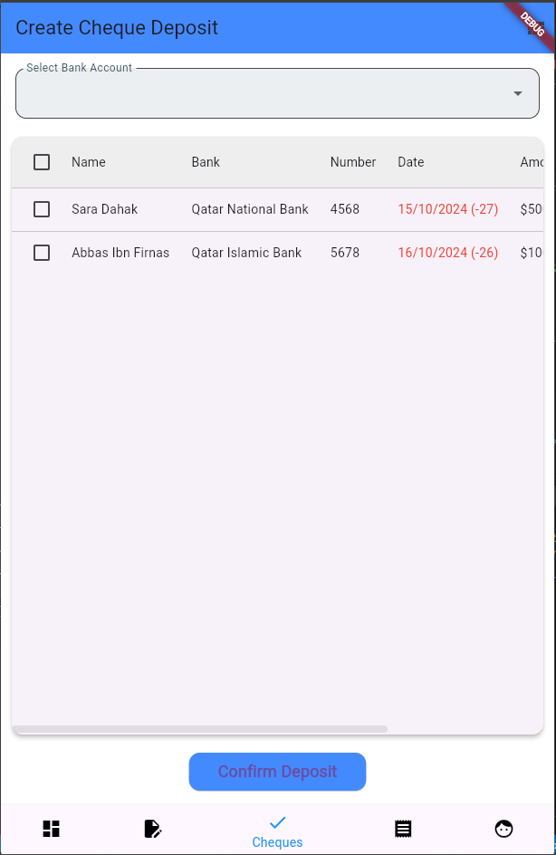

# List Cheque Deposits

# Update Cheques Deposit

# U7 - Invoices Report

1. A screenshot of a phone

   Description automatically generated

# U8 - Cheques Report

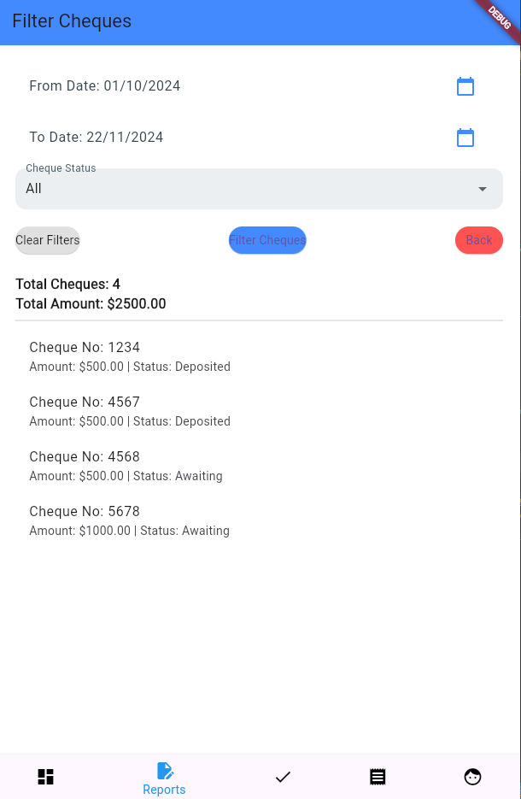

# Summary of team member contributions

|  |  |
| --- | --- |
| 1. **Member** | **Completed use cases / tasks** |
| Murshed | Invoices – Customers – Payments – Invoice Report |
| Saoud | Login – dashboard – cheque – Cheque Report |
| Mohammed |  |
|  |  |