**PHASE – 5**

**PROJECT DOCUMENT AND SUBMMISION**

|  |  |
| --- | --- |
| **DATE** | **01/11/2023** |
| **TEAM ID / TEAM NAME** | **Proj_224028_Team_4** |
| **PROJECT NAME** | **AI- Based Diabetes Prediction System** |
| **STUDENT NAME WITH ID** | **ARUNKAKARTHICK.S - au610521243004**  **THARUN.A - au610521243045**  **MURSITHROSAN.S - au610521243029**  **ABITH VARSHAN.S - au610521243003**  **MITHUNMANOJ.K - au610521243026** |

**TITLE: AI -Based Diabetes Prediction System**

**Problem Definition :**

The problem is to build an AI-powered diabetes prediction system that uses machine learning algorithms to analyze medical data and predict the likelihood of an individual developing diabetes. The system aims to provide early risk assessment and personalized preventive measures, allowing individuals to take proactive actions to manage their health.

**INTRODUCTION:**

The AI-based Diabetes Prediction System leverages machine learning models, often trained on extensive datasets containing diverse patient information, such as demographics, medical history, lifestyle factors, and genetic markers. By processing this information, the system can predict an individual's risk of developing diabetes, thus enabling proactive healthcare interventions and personalized recommendations to prevent or manage the condition effectively.

This predictive system not only benefits patients but also healthcare professionals and the broader healthcare system. It allows for more efficient allocation of resources, early identification of at-risk individuals, and the development of targeted prevention strategies. Additionally, it aids in reducing healthcare costs by minimizing the need for intensive treatments and hospitalizations through early intervention and lifestyle modification.

In this era of data-driven healthcare, the AI-based Diabetes Prediction System represents a significant advancement. However, its implementation also raises important ethical andprivacy concerns related to data security and patient consent. This introduction sets the stage for exploring the key components and implications of an AI-based Diabetes Prediction System in greater detail. In the subsequent sections, we will delve deeper into its technology, benefits, challenges, and ethical considerations, ultimately highlighting its potential to revolutionize diabetes care and improve public health outcomes.

**DESIGN THINKING PROCESS:**

**1. Environment Setup and Tools**

* **Select Development Tools:** Choose the programming language (e.g., Python) and development frameworks (e.g., TensorFlow, PyTorch) that are suitable for building machine learning models.
* **Setup Development Environment:** Install necessary libraries, packages, and IDEs to support the development of the system.

**2. Data Collection and Preparation**

* **Data Collection:** Acquire a diverse and representative dataset of health records, ensuring it covers relevant features like age, gender, BMI, family history, glucose levels, etc.
* **Data Preprocessing:** Clean the dataset by handling missing values, outliers, and inconsistencies. Perform feature scaling and encoding if required.
* **Feature Selection:** Utilize feature selection techniques to identify the most relevant features for prediction.
* **Data Splitting:** Split the dataset into training, validation, and testing sets.

**3. Model Development**

* **Model Selection:** Choose appropriate machine learning algorithms or deep learning architectures suitable for binary classification (diabetes prediction).
* **Model Architecture**: Design the neural network architecture or select the algorithm's parameters.
* **Model Training:** Train the selected model using the training dataset. Implement techniques like cross-validation and early stopping to prevent overfitting.
* **Hyperparameter Tuning:** Optimize hyperparameters to improve model performance.
* **Ensemble Methods:** Experiment with ensemble techniques (e.g., stacking, bagging) to enhance prediction accuracy.

**4. User Interface Development**

* **Frontend Development:** Create a user-friendly web or mobile application for data input and result presentation. Use technologies like HTML, CSS, and JavaScript (or relevant frameworks like React or Angular).
* **Backend Development:** Develop a robust backend server that handles user requests, invokes the trained model, and returns predictions. Use web frameworks like Django, Flask, or Node.js.
* **User Authentication:** Implement user authentication and authorization mechanisms to ensure data privacy.
* **Data Validation:** Validate user inputs to ensure data quality and format compliance.

5. **Deployment**

* **Scalable Cloud Deployment:** Deploy the system on a scalable cloud platform such as AWS, Azure, or Google Cloud to handle multiple users and ensure availability.
* **Database Setup:** Configure a database to store user data securely.
* **API Development:** Create RESTful APIs to facilitate communication between the frontend and backend.
* **Security Measures:** Implement security protocols (e.g., HTTPS, encryption) to protect user data and adhere to data privacy regulations.
* **Load Testing:** Conduct load testing to ensure the system can handle simultaneous user requests without performance degradation.

**6. Continuous Monitoring and Maintenance**

* **Monitoring and Logging:** Set up monitoring tools to track system performance, usage, and errors. Implement comprehensive logging to aid in debugging.
* **Feedback Collection:** Collect user feedback to identify issues and areas for improvement.
* **Regular Updates:** Continuously update the model with new data to adapt to changing health trends and improve prediction accuracy.
* **Bug Fixing:** Address and fix bugs or issues reported by users.
* **Documentation:** Maintain comprehensive documentation for users, administrators, and developers. Update the user manual and system architecture documentation as necessary.

**7. Compliance and Regulations**

* **Data Privacy:** Ensure compliance with data privacy regulations like GDPR or HIPAA.
* **Ethical Considerations:** Adhere to ethical guidelines in AI development, particularly regarding the handling of sensitive health data.
* **User Consent:** Obtain informed consent from users for data usage and processing.

**8. Testing and Quality Assurance**

* **Unit Testing:** Conduct unit testing for individual components (backend functions, API endpoints, etc.).
* **Integration Testing:** Test the interaction between frontend and backend components.
* **User Acceptance Testing (UAT):** Involve users in testing the system to validate its usability and functionality.
* **Performance Testing:** Verify system performance under various loads and conditions.

**9. Rollout and Training**

* **User Training:** Train medical professionals or users on how to use the system effectively.
* **Gradual Rollout:** Initially, release the system to a limited user base to identify and address any unforeseen issues before a full-scale launch.

**10. Support and Feedback**

* **User Support:** Provide ongoing support to users, including assistance with technical issues and questions.
* **Feedback Loop:** Establish a feedback loop to collect user feedback and make continuous improvements to the system.

**CONCEPT USED IN THIS:**

**Machine Learning:**

* **Machine learning** is a branch of artificial intelligence where computers learn from data to make predictions, find patterns, or make decisions without explicit programming. It's used in various fields to automate tasks, analyze vast amounts of data, and improve decision-making, making it a powerful tool for solving complex problems.There are Several type of Machine learning Algorithm in that we have used Random Forest in our Project.
* **Random Forest** is a popular machine learning algorithm that combines the power of multiple decision trees to make more accurate predictions. It works by creating a "forest" of decision trees, each trained on a different subset of the data. These trees vote on the outcome, and the majority vote determines the final prediction. Random Forest is robust, handles a variety of data types, and is effective for both classification and regression tasks. It's known for its ability to reduce overfitting and provide feature importance rankings.

**SOURCE CODE:**

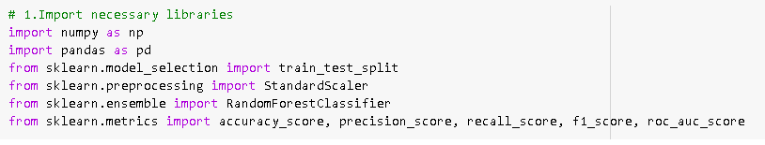

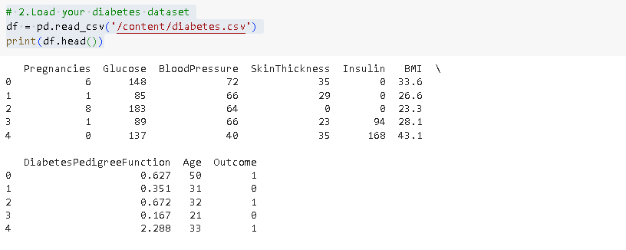

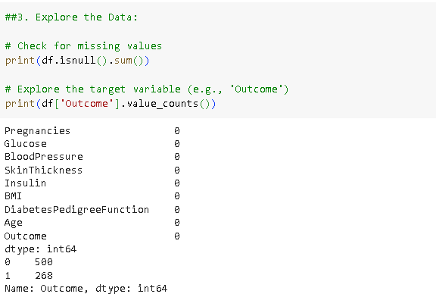

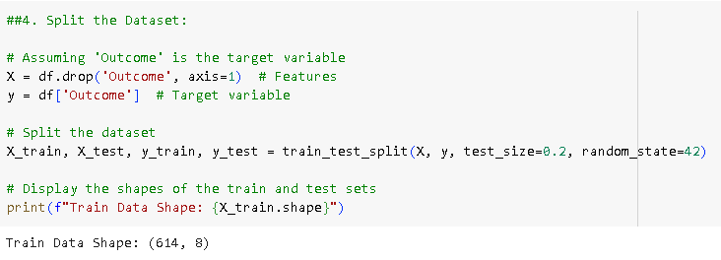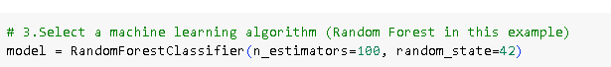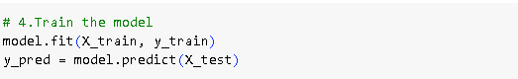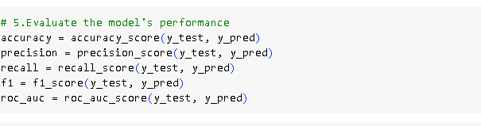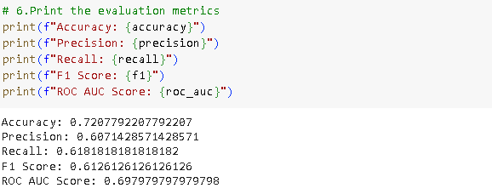

**ADVANTAGES OF DIABETES PREDICTION SYSTEM :**

* Early Detection:

AI can analyze vast amounts of data to identify potential diabetes risk factors and symptoms, allowing for early detection and intervention.

* Personalized Care:

These systems can provide personalized recommendations for individuals based on their unique health data, helping to manage and prevent diabetes more effectively.

* Improved Accuracy:

AI can make predictions with high accuracy by considering a wide range of variables, leading to more reliable results compared to traditional risk assessment methods.

* Continuous Monitoring:

AI can provide real-time monitoring of health data, enabling proactive management of diabetes and reducing the risk of complications.

**DISADVANTAGES OF DIABETES PREDICTION SYSTEM :**

* Data Quality:

The accuracy of AI predictions heavily relies on the quality of the input data. Inaccurate or biased data can lead to unreliable predictions.

* Privacy Concerns:

Collecting and storing personal health data for AI analysis can raise privacy concerns, and there is a risk of data breaches or misuse.

* Ethical Concerns:

AI algorithms may inadvertently reinforce biases in healthcare, such as disparities in access to care or misdiagnosis in certain demographic groups.

* Lack of Transparency:

Complex AI models can be difficult to interpret, making it challenging to understand how predictions are generated, which may reduce trust in the system.

**Conclusion:**

The AI-Based Diabetes Prediction System is a vital tool that can contribute to early diabetes risk detection and prevention. By following the outlined approach, we aim to create a reliable and user-friendly system that can provide accurate predictions while ensuring data security and privacy. Continuous improvement and maintenance will be key to the long-term success of this system, making it a valuable asset in the field of healthcare.